Home Equity Reverse Mortgage Information Technology
(HERMIT)

HERMIT System Changes – Release 8.2

Release Date: 12/20/2025
Document Date: 12/18/2025
Version 1.0

December 2025

INTRODUCTION
The Home Equity Reverse Mortgage Information Technology (HERMIT) software release version 8.2 consists of the following system changes:
Table of Contents
Servicer Related Changes 3
1. Prevent Terminated-to-Endorsed Status Change Post Claim Payment (596894) 3
2. Exclude S305 State Prohibited Legal Transactions from CT22 (596888) 3
3. Monthly Lender Reconciliation File (595765) 3
Servicer and NSC / HUD Related Changes: 3
4. Updates to Claim Type 22 – Assignment Timeline (581234) 3
5. Loan: System will Automatically add Presidentially Declared Major Disaster Areas Alerts (594425) 3
6. Timeline: Update the number of days after which the nightly job will add the Denial Step to the Claim Type 22 Timeline and Request for HUD Advance Timeline (597368) 4
NSC / HUD Related Changes: 5
7. Alerts: Updates to existing Compliance Alerts (596173) 5
8. Auto populate last 4 digits of Social Security Number on Statement of Account (SOA) Form (596806) 5
9. Non-Borrowing Spouse (NBS) Contact Set Up Change (596678) 6
10. New Report: NBS Missing SSN (596836) 7

If you have any questions regarding the functionality of the software release, please contact the HERMIT Help Desk at 561-899-2610 or at servicingsupport@hermitsp.com. If you have any policy related questions, please send an email to HUD at answers@hud.gov.

Servicer Related Changes

Prevent Terminated-to-Endorsed Status Change Post Claim Payment (596894)
Updates were made upon entry of a Loan Balance transaction on a Terminated Claim Type 21 or Claim Type 23, the Case Status remains Terminated and is not updated to Endorsed. This update also includes the removal of existing warning and validation messages that currently advise users these transactions will change the Case Status to Endorsed.

Exclude S305 State Prohibited Legal Transactions from CT22 (596888)
Updates were made to exclude transactions categorized as “Corporate Advances – Section 305 – State Prohibited Legal” as well as adjustment transactions from populating the Claim Type 22 Advice of Payment (AOP) Expenses field.

Monthly Lender Reconciliation File (595765)
Updates were made to the monthly Lender Reconciliation file as follows:
- Changes to Item #55, previously labeled “CORP ADV”, was updated to “Bor Recov Corp Adv” and the field is the sum of all Borrower Recoverable Corporate Advances, marked as TRUE in the Loan > Transactions screen.
- New: item #82, was added as “TOT LC” to provide the sum of all Late Charges amount located in the Loan > Transactions screen.
- New: item #83, was added as “TOT PI” to provide the sum of all Penalty Interest amount located in the Loan > Transactions screen.
- New: Item #84, was added as “NON Bor Recov Corp Adv” and the field is the sum of all Borrower Recoverable Corporate Advances, marked as FALSE in the Loan > Transactions screen.

Servicer and NSC / HUD Related Changes:

Updates to Claim Type 22 – Assignment Timeline (581234)
Updates were implemented in the CT22 Assignment Timeline to prevent duplicate Timeline steps. This enhancement ensures that repeated actions—such as multiple clicks on a completed step, multiple clicks on the submit button, or a page refresh—no longer create duplicate steps within the Timeline.

Loan: System will Automatically add Presidentially Declared Major Disaster Areas Alerts (594425)
Updates were made to automatically import Presidentially Declared Major Disaster Areas (PDMDA) data directly from FEMA and generate an alert for loans that meet the criteria in those impacted areas.
- The new critical PDMDA Alert will appear on the required loans with a Declaration Date on or after the Release Date 12/20/2025.
- The new critical Alert Description will include “PDMDA (disaster number) (declaration type) (Property State) (declaration title), Declaration Date (MM/DD/YYYY)
- The Alert Expiration Date will be set to 90 days from the Declaration Date
- The PDMDA Alert will Inactivate when Today’s date is after the Alert Expiration Date
- The Alert Expiration Date can only be revised via Date Change Request (DCR), if necessary
- Previously Inactivated Alerts will be reactivated if an Alert Expiration Date is revised and the revised Alert Expiration Date is after Today’s date.

Timeline: Update the number of days after which the nightly job will add the Denial Step to the Claim Type 22 Timeline and Request for HUD Advance Timeline (597368)
The number of days after which the nightly job will add the Denial Steps to the Endorsed > Claim > Claim Type 22 – Assignment and Endorsed > Requests > Request for HUD Advance (Assignment) Timelines has been updated from 30 days to 90 days, calculated from the Complete Date of Step “Request for HUD Advance Processed”. The Step Note has been updated for the automatically added Denial Step on the Claim Type 22 Timeline.
- The Step “Assignment Denied/Payoff Issued” will be added to the Endorsed > Request > Request for HUD Advance (Assignment) Timeline when Today’s date is over 90 days from the Complete Date of the Step “Request for HUD Advance Processed” on the Endorsed > Request > Request for HUD Advance (Assignment).
- The Step “Assignment Denied – Funds Due HUD” will be added to the Endorsed > Claims > Claim Type 22 – Assignment Timeline when Today’s date is over 90 days from the Complete Date of the Step “Request for HUD Advance Processed” on the Endorsed > Request > Request for HUD Advance (Assignment) and No “Preliminary Title Approval” Decision on the Claim Type 22 Timeline exists.
- The Step Note which is automatically added to the Step “Assignment Denied – Funds Due HUD” on the Endorsed > Claims > Claim Type 22 – Assignment Timeline has been updated.
- The text has been updated to read, “The Step has been automatically added by the system to the CT22 because the timeframe following the ‘Request for HUD Advance Processed’ step on the Endorsed > Request for HUD Advance Timeline has passed and No CT22 Assignment Claim has been submitted.”
- The prior text before the update read “The Step has been automatically added by the system to the CT 22 due to Today’s date being greater than 30 days from the Step “Request for HUD Advance Processed” on the Endorsed > Request for HUD Advance Timeline and No Decision has been made on the CT22.”

NSC / HUD Related Changes:

Alerts: Updates to existing Compliance Alerts (596173)
Updates were made to the following Alerts on Assigned loans: “Occupancy Certification Required (SYS)”, “Annual Occupancy Certificate has not been received (SYS)” and “Cash Management Approval Required (SYS)”. These Alerts are now inactivated when either of the following apply:
- There is no Non-Borrowing Spouse (NBS) and Death date reported for all Borrowers in the Loan > Contacts screen, OR
- There is at least one Non-Borrowing Spouse (NBS) and Death date reported for all Borrowers and Death date reported for all Non-Borrowing Spouses (NBS) in the Loan > Contacts screen

Auto populate last 4 digits of Social Security Number on Statement of Account (SOA) Form (596806)
Updates were made to the Social Security Number (SSN) on the Assigned > Foreclosure > Statement of Account (SOA) Form to display the last four digits of the Borrower SSN in field 4 and Co-Borrower SSN in field 6.
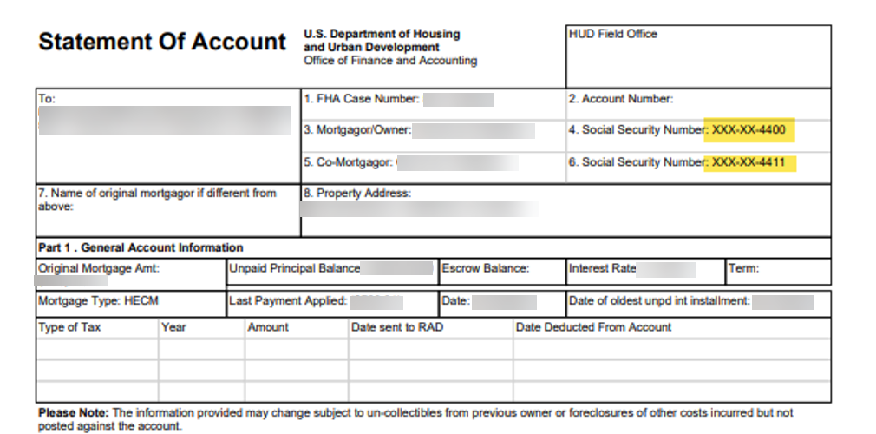

Non-Borrowing Spouse (NBS) Contact Set Up Change (596678)
- Updates were made to the handling of the Social Security Number (SSN) for Non-Borrowing Spouse (NBS). The Social Security Number is required when the Eligible NBS Checkbox is selected, and it must consist of exactly 9 digits. The user will receive an error message if the SSN is blank or consist of fewer than 9 digits. When the Eligible NBS Checkbox is not selected, the Non-Borrowing Spouse (NBS) can be entered without a Social Security Number (SSN) and will not receive an error message.

- Updates were also made to the contact Type Non-Borrowing Spouse (NBS) removing from the dropdown list for loans with FHA Case # Assigned Date After 08/04/2014. Additionally, for loans with FHA Case# Assigned Date before 08/04/2014, up to 3 Non-Borrowing Spouses can only be added and are marked as Mort Opt Election (MOE) in the Contact Information page. When the Contact Type of Non-Borrowing Spouse is first selected, the eligible NBS checkbox on the New Contacts page is automatically checked. and is editable and can be un-checked.

- User roles permitted to add a Non-Borrowing Spouse (NBS) to a loan are:
- Contractor – Cash
- Contactor – Cash Supervisor
- Contactor – Default
- Contactor – First Mortgage
- Contractor – Supervisor/Management
- HUD NSC Manager
- HUD SF Premium Manager
- HUD – SF Staff
- Lender – Manager
- Lender – Staff
- Servicer – Manager
- Servicer – Staff

- User roles permitted to view and edit a Non-Borrowing Spouse SSN are:
- Contractor – Default
- Contractor – Supervisor Manager
- Contractor – Cash Supervisor
- HUD NSC Manager

New Report: NBS Missing SSN (596836)
A new report called “NBS missing SSN” was added to the Reports module under Assigned Notes Reports > Daily Reports which determines loans where the Social Security Number (SSN) has not been entered for Non-Borrowing Spouse.
NBS Missing SSN Report Search Criteria:
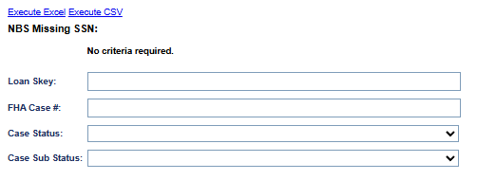
- Search criteria includes:
- Loan Skey
- FHA Case #
- Case Status
- Case Sub Status
- The output is available in CSV and Excel formats and includes the following fields:
- FHA Case #:
- Loan Skey:
- FHA Case # Assigned Date
- Eligible NBS: (Results are displayed as Yes or No)
- Mort Opt Election (MOE): (Results are displayed as Yes or No)
- Case Status:
- Case Sub- Status:
- Non-Borrowing Spouse First Name:
- Non-Borrowing Spouse Middle Name:
- Non-Borrowing Spouse Last Name:
- NBS record create date
- SSN

------ End of Document -----

