
United States Department of Housing and Urban Development

Home Equity Conversion Mortgage Business Service Provider (HECM BSP)

NSC Bulk Pages and B2G File Format & Layout For HERMIT/P271

HERMIT Release 8.10

Document Version 1.6

September 27, 2025
Revision History

COPIES CONTROLLED BY: Configuration Management

Version | Date | Revision Description | Author
1.0 | 06/24/2023 | Initial release | HECM BSP
1.1 | 09/26/2023 | Add new Batch pages: Alerts Import and Loan Details/ Transaction PDF’s. Revise section 2 and move items formerly in Appendix to related topic within section 2. | HECM BSP
1.2 | 01/26/2024 | Updated Table 15 | HECM BSP
1.3 | 03/23/2024 | Added Notes Uploads to Section 2.1. In Section 2.3 Vendor Disbursement Import was renamed to Inspection Disbursement Import and Release Fee Disbursement was added. | HECM BSP
1.4 | 09/28/2024 | Added NSC Bulk Disbursements to Section 2.1 and added NSC Bulk Servicing Steps to Section 2.2. Added Error message tables to all Sections under 2.2. | HECM BSP
1.5 | 02/22/2025 | Added State Prohib Legal – Appraisal Disbursements and State Prohib Legal – Inspection Disbursements to Section 2.5 NSC Disbursement Uploads | HECM BSP
1.6 | 09/23/2025 | Added a New Error message to Table 5 in section 2.1.4 and Table 34 in section 2.5.5. | HECM BSP

Table of Contents

1 General Information 8
1.1 Purpose and Scope 8
1.2 Contents 8
1.3 Points of Contact 8
1.4 Acronyms 9
1.5 Security Controls 9
2 Technical specifications 10
2.1 NSC Bulk Disbursements 10
2.1.1 Bulk Disbursements Requirements 10
2.1.2 Bulk Disbursements Feature Details 10
2.1.3 Bulk Disbursements Field Description 13
2.1.4 Bulk Disbursements Errors 13
2.2 NSC Bulk Servicing Steps 16
2.2.1 Bulk Servicing Steps Requirements 16
2.2.2 Bulk Servicing Steps Feature Details 16
2.2.3 Bulk Servicing Steps Field Description 17
2.2.4 Bulk Servicing Steps Errors 17
2.3 Note Uploads 19
2.3.1 Upload File Requirements 19
2.3.2 Notes Import – Record Layout 21
2.3.3 Notes Import Transaction Codes and Descriptions 21
2.3.4 Notes Import – B2G File layout 22
2.3.5 Note Upload Errors 22
2.4 Alert Uploads 24
2.4.1 Upload File Requirements 24
2.4.2 Alerts Import – Record Layout 26
2.4.3 Alerts Import Transaction Codes and Descriptions 26
2.4.4 NSC Alert Import – B2G File layout 29
2.4.5 Alert Upload Errors 29
2.5 NSC Disbursement Uploads 30
2.5.1 Upload File Requirements 30
2.5.2 Disbursement Import – Record Layout 33
2.5.3 Disbursement Transaction Codes and Descriptions 34
2.5.4 Disbursement Import – B2G File layout 41
2.5.5 NSC Disbursement Upload Errors 42
2.6 NSC File Uploads 45
2.6.1 Upload File Requirements 46
2.6.2 NSC Transaction Import – Record Layout 48
2.6.3 NSC Transaction Import - Transaction Codes and Descriptions 48
2.6.4 NSC Transaction Import – B2G File layout 49
2.6.5 Asset Sale Reports - Record Layout 49
2.6.6 Asset Sale Reports – B2G File Layout 49
2.6.7 Loan Details/Transactions PDFs - Record Layout 50
2.6.8 Loan Details & Transactions PDFs – B2G File Layout 50
2.6.9 NSC File Upload Errors 50
3 Quality Control and Verification 53
3.1 File Verification 53

List of Tables

Table 1: HERMIT System Support Points of Contact 9
Table 2: HERMIT Program Organization Points of Contact 9
Table 3: Acronyms, Abbreviations, System Names/Codes 9
Table 4: NSC Bulk Disbursement Fields 13
Table 5: Data conditions for NSC Bulk Disbursement Errors 13
Table 6: NSC Bulk Servicing Steps Fields 17
Table 7: Data conditions for NSC Bulk Servicing Steps Errors 18
Table 8: HECM File Upload Types 20
Table 9: Data Item Descriptions for File NotesImport 21
Table 10: Transaction Codes and Descriptions 21
Table 11: Data conditions for Note Upload Errors 23
Table 12: HECM File Upload Types 25
Table 13: Data Item Descriptions for File AlertsImport 26
Table 14: Alert Type Codes and Descriptions 26
Table 15: Data conditions for Alert Upload Errors 29
Table 16: HECM File Upload Types 32
Table 17: Data Item Descriptions for DisbursmentsImport File 33
Table 18: Transaction Category Codes and Descriptions 34
Table 19: Transaction Codes and Descriptions 35
Table 20: Vendor Codes and Descriptions 35
Table 21: Payee/Pay to Codes and Descriptions 35
Table 22: Transaction Category Codes and Descriptions 36
Table 23: Transaction Codes and Descriptions 36
Table 24: Vendor Codes and Descriptions 36
Table 25: Payee/Pay to Codes and Descriptions 36
Table 26: Transaction Category Codes and Descriptions 37
Table 27: Transaction Codes and Descriptions 37
Table 28: Vendor Codes and Descriptions 38
Table 29: Payee/Pay to Codes and Descriptions 38
Table 30: Transaction Category Codes and Descriptions 39
Table 31: Transaction Codes and Descriptions 40
Table 32: Vendor Codes and Descriptions 40
Table 33: Payee/Pay to Codes and Descriptions 40
Table 34: Data conditions for NSC Disbursement Upload Errors 42
Table 35: HECM File Upload Types 47
Table 36: Data Item Descriptions for File NSCImport 48
Table 37: Transaction Codes and Descriptions 48
Table 38: Data Item Description for File B2GAssetSaleReports 49
Table 39: Data Item Description for File LoanDeatilsAndTransactionsPDF 50
Table 40: Data conditions for NSC File Upload Errors 50

List of Figures
Figure 1: NSC Batch Left Menu 10
Figure 2: NSC Bulk Disbursements page 12
Figure 3: NSC Bulk Servicing Steps page 17
Figure 4: Note Upload Screen 19
Figure 5: File Processing In HERMIT 20
Figure 6: Notes Import File 22
Figure 7: HERMIT Upload Screen 24
Figure 8: File Processing In HERMIT 25
Figure 9:: Alerts Upload File 29
Figure 10: HERMIT Upload Screen 31
Figure 11: File Processing In HERMIT 32
Figure 12: Inspection Disbursement Upload File 41
Figure 13: Release Fee Disbursement Upload File 41
Figure 14: State Prohib Legal Appraisal Disbursements Upload File 42
Figure 15: State Prohib Legal Inspection Disbursements Upload File 42
Figure 16: HERMIT Upload Screen 46
Figure 17: File Processing In HERMIT 47
Figure 18: NSC Transactions Upload File 49
Figure 19: B2G Asset Sales Upload File 49
Figure 20: Loan Details & Transactions PDFs Upload File 50

General Information
This document serves as a reference for authorized users in the HERMIT application who are responsible for enabling the functionality to upload data to the Home Equity Reverse Mortgage Information Technology (HERMIT) system. The specification describes the file layouts and outlines the upload processes a HUD/HUD Contractor may consider.
This document is organized to provide:
- General information
- Technical specifications for upload
- Quality control and verification
- HERMIT – system categorization

Purpose and Scope
The function of this document is to define and describe the data upload process into the HERMIT system. This document specifies the file record layout required for the upload of loan-level HECM data to the HERMIT system.

Contents
The data upload process described in this document comprises the method and data elements involved in the data upload into the HERMIT system. The specifications presented are:
- Define the requirements, design, procedures, and other relevant characteristics required for data uploads to HERMIT.
- Provide the syntax rules (file formats) and the semantic conventions (names, meanings, and physical units) used to upload data into the HERMIT system.
Note: Please be advised that this is the current up to date NSC B2G File Layout document. It is imminent that changes will be made to the NSC B2G File Layout document in the future when system changes are made. When those system changes are prioritized for release by HUD, this document will be updated and distributed per direction from HUD.

Points of Contact
Questions about specifications within this document should be directed to the servicingsupport@hermitsp.com email address. The key points of contact for the HERMIT system are displayed below for escalation purposes.
Table 1: HERMIT System Support Points of Contact
Function | Name | Phone | E-mail Address
HERMIT Help Desk | HERMIT Help Desk | 561-899-2610 | servicingsupport@hermitsp.com

Table 2: HERMIT Program Organization Points of Contact
Function | Name | Phone | E-mail Address
NSC SME | Terra Flaming | 405-609-8486 | Terra.L.Flaming@hud.gov

Acronyms
Table 3: Acronyms, Abbreviations, System Names/Codes
Acronym/Abbreviation/System Name | Definition
FHA | Federal Housing Administration
B2G | Business To Government
HECM | Home Equity Conversion Mortgage
HERMIT | Home Equity Reverse Mortgage Information Technology
HUD | U.S. Department of Housing and Urban Development
HECM SP | Home Equity Conversion Mortgage Service Provider
.csv | Comma Separated Values File extension
.txt | Flat Text File extension
Seq. # | Sequence Number

Security Controls
HERMIT system security is under the ownership, operation, and maintenance of an external service provider, HECM BSP. It follows the guidance and directives of the HUD Technical Reference Model, Federal Security Standard: NIST Special Publication 800-53 Revision 4, and HUD Handbook 2400.25 Information Technology Security Policy.

Technical specifications
The Batch area for NSC and NSC Contractor includes four pages, each with different upload types.
- NSC Bulk Disbursements
- NSC Bulk Servicing Steps
- Note Uploads
- Alert Uploads
- NSC Disbursement Uploads
- NSC File Uploads
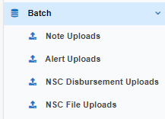
Figure 1: NSC Batch Left Menu

This section documents the method of upload and the file requirements for each upload type. This section also addresses the data transfer process and operational requirements. A sample record layout for each upload file type can be found in each section.

NSC Bulk Disbursements
This page is different from a B2G upload and is used for a user to input loan level Disbursements. Only Authorized users can use and view this page. This page allows the user to add “Disb – Unscheduled from LOC Utilities,” “Disb – Refunds/Payments Remittance Overage” and/or “Corp Adv – S305 – State Prohibited Legal” disbursement transactions to multiple loans in one bulk submission in lieu of having to add them manually to each loan.

Bulk Disbursements Requirements
The user inputs data in the columns starting from the left to right. The user must fill out all required fields with accurate data in order for the data to pass validation and allow the user to submit the data into HERMIT. The user can submit up to 50 disbursements at a time into HERMIT. The user can copy the data in row for certain columns using the checkbox feature located next to the column name.

Bulk Disbursements Feature Details
- The fields Transaction Category, Transaction Description, Payee Type, Vendor Type, Payee, and Disb Amount have a Checkbox which allows the user to copy the first row’s data for that column. Once the user clicks the checkbox on a column with the checkbox feature, the data from row one for that column cascades down all 50 rows. Note: The Transaction Description is dependent on Transaction Category; the Payee Type is dependent on Transaction Description; and the Vendor Type and/or Payee is dependent on Payee Type. The user will need to work left to right when entering data and using the checkbox features.
- The Checkbox is Read Only for the fields Payee Type, Vendor Type, and Payee when the Payee Type is not Vendor.
- The link Export to Excel is displayed at the top left of the page and can be used at any time.
- The user can delete a single row except for the first row by clicking the red X next to the FHA Case #. The user can Clear all data on the page by clicking the Clear button on the bottom right of the page.
- Once the user clicks the Validate Button on the bottom right of the page, the validation column displays one of the following: Pending, Warning message, or Error message.
- Pending indicates all the data entered for that row has passed validation.
- A Warning message notifies the user but does not prevent the user from submitting the data.
- An Error message displays when the user enters inaccurate data and prevents the user from submitting the data.
- The user only sees the Submit Button on the bottom right of the page once all data has passed validation. If further changes are made after the validation process and before the user clicks submit, the submit button disappears and the user will need to validate the data again.
- After the user clicks the Submit button the validation column displays Processed which indicates the Disbursements have been added to the loan. Only the Clear Button appears on the bottom right of the page once all data has been processed.
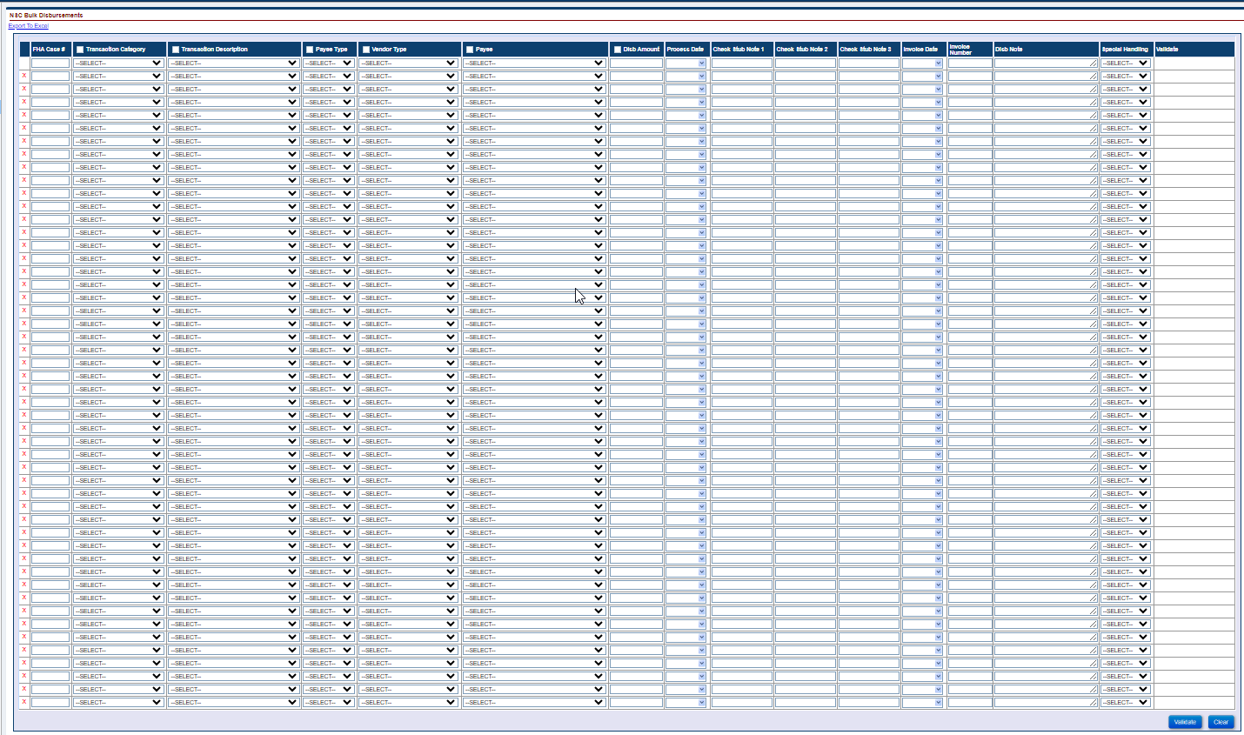
Figure 2: NSC Bulk Disbursements page

Bulk Disbursements Field Description
This table describes the required data fields.
Table 4: NSC Bulk Disbursement Fields
Field Description | Required Field
FHA Case # | N
Transaction Category | Y
Transaction Description | Y
Payee Type | Y
Vendor Type | Conditionally Required when Payee Type = Vendor
Payee | Y
Disb Amount | Y
Process Date | Y
Check Stub 1 | N
Check Stub 2 | N
Check Stub 3 | N
Invoice Date | N
Invoice Number | Conditionally Required when Payee Type = Vendor
Disb Note | N
Special Handling | N
Validation | Read Only field

Bulk Disbursements Errors
This table describes the Error Messages that could occur based on the data condition inputted by the user.
Table 5: Data conditions for NSC Bulk Disbursement Errors
Error Condition | Error Message
The loan the user is attempting to update through the NSC Bulk Disbursements page must have a valid FHA Case Number. | The FHA Case Number is Invalid
The user is attempting to submit a Disbursement without a Disbursement Transaction Category through the NSC Bulk Disbursements page. | Disbursement Transaction Category is required
The user is attempting to submit a Disbursement without a Disbursement Transaction Description through the NSC Bulk Disbursements page. | Disbursement Transaction Description is required
The user is attempting to submit a Disbursement without a Vendor Type when the Payee Type Vendor is selected through the NSC Bulk Disbursements page. | Vendor Type is required
The user is attempting to submit a Disbursement without a Payee/Pay to through the NSC Bulk Disbursements page. | Payee/Pay to is required
The user is attempting to submit a Disbursement Amount through the NSC Bulk Disbursements page. | Disbursement Amount is required
The user is attempting to upload a Disbursement without a Process Date through the Assigned Bulk Disbursements page. | Process Date is required
The loan the user is attempting to update through the NSC Bulk Disbursements page cannot have a Case Status of Cancelled. | To add the Disbursement Transaction to this Case, the Case Status cannot be “Cancelled
The loan the user is attempting to update through the NSC Bulk Disbursements page the Servicer must be the HUD NSC Contractor. | To Add the Disbursement to this Case, the Servicer must be the HUD NSC Contractor
The user is attempting to submit a Disbursement Amount <= $0.00 through the NSC Bulk Disbursements page. | The Disbursement Transaction Amount must be > $0.00 and <= $1,000,000.00
The user is attempting to submit a Disbursement with a Disbursement Amount of Zero through the NSC Bulk Disbursements page. | Zero value is not allowed to create Disbursement. Please enter valid Disbursement Amount
The user is attempting to submit an Invoice # that is greater than 25 characters through the NSC Bulk Disbursements page. | Invoice # exceeds 25 characters
The user is attempting to submit a Disbursement that has more than 55 characters for Check Stub Note 1 when the Payment Method is Check. | Check Stub Note 1 exceeds 55 characters
The user is attempting to submit a Disbursement that has more than 55 characters for Check Stub Note 2 when the Payment Method is Check. | Check Stub Note 2 exceeds 55 characters
The user is attempting to submit a Disbursement that has more than 55 characters for Check Stub Note 3 when the Payment Method is Check. | Check Stub Note 3 exceeds 55 characters
The user is attempting to submit a Disbursement Note greater than 255 characters through the NSC Bulk Disbursements page. | Disbursement Note exceeds 255 characters
The user is attempting to submit a Disbursement that does not have the City, State, and/or Zip Code listed for the Vendor Payee when the user select the Payee Type Vendor through the NSC Bulk Disbursements page. | City, State, and Zip are required fields for the Vendor. Please update in the Admin > Vendor area for the chosen Vendor Payee selected
The user is attempting to submit a Disbursement that does not have a 9-digit Tax ID listed for the selected Payee. | Tax ID of 9 digits is required. Please update in the appropriate area.
The user is attempting to submit a Refund/Payment Remittance Overage Disbursement Amount that is greater than the available Overage amount through the NSC Bulk Disbursements page. | Disb Amount must be <= maximum refund amount of $xxxx.xx for Refund Remittance Overage
The user is attempting to submit a Refund/Payment Remittance Overage Disbursement when there is no Overage Transaction on the loan. | Refund disbursement cannot be created. Refund disbursement amount exceeds negative Corp Adv balance plus any pending refund disbursements
The user is attempting to submit a Disbursement for the Payee Type “Payoff Refund” and there is no Active Assigned > Payoff Request Timeline. | There is no active Assigned > Payoff Request timeline. Please create this timeline and enter Payee Information on this timeline’s Svc. Mgmt. page
The user is attempting to submit a Disbursement for the Payee Type “Borrower” and there is not a valid Routing # for the Borrower for that loan. | Bank Routing Number for borrower cannot be found in the Treasury Master Routing Number data. Please enter a valid Routing Number
The user is attempting to submit a Disbursement for the Payee Type “Payoff Refund” and there is an Active Assigned > Payoff Request Timeline with a Payee but there is no Address, City, State, and/or Zip listed on the Servicing Mgmt page. | Address, City, State, and Zip are required fields. Please update these fields on the Assigned > Payoff Request Svc. Mgmt page
The user is attempting to submit a Disbursement for the Payee Type “Tax Authority” and there is no City, State, and/or Zip listed for the Payee selected. | City, State, and Zip are required fields. Please update in the appropriate area

NSC Bulk Servicing Steps
This page is not a B2G upload, this is used for a user to input loan level Steps. Only Authorized users will be able to use and view this page. This page allows the user to add the HUD Contractor Step “Assignment of Mortgage (AOM) Rejected” to multiple loans for either an Endorsed > Claim Type 20 – Demand Assignment timeline or an Endorsed > Claim Type 22 – Assignment timeline in lieu of having to manually add the step in each timeline.

Bulk Servicing Steps Requirements
The user inputs data in the columns starting from the left to right. The user must fill out all required fields with accurate data in order for the data to pass validation and allow the user to submit the data into HERMIT. The user can submit up to 50 disbursements at a time into HERMIT. The user can copy the data in row for certain columns using the checkbox feature located next to the column name.

Bulk Servicing Steps Feature Details
- The fields Timeline Group, Timeline Category, Servicing Type, and Step Name have a Checkbox which allows the user to copy the first row’s data for that column. Once the user clicks the checkbox on a column with the checkbox feature, the data from row one for that column cascades down all 50 rows. Note: The Timeline Category is dependent on Timeline Group; an the Servicing Type is dependent on Timeline Category; and the Step Name is dependent on Servicing Type. The user will need to work left to right when entering data and using the checkbox features.
- The link Export to Excel is displayed at the top left of the page and can be used at any time.
- The user can delete a single row except for the first row by clicking the red X next to the FHA Case #. The user can Clear all data on the page by clicking the Clear button on the bottom right of the page.
- Once the user clicks the Validate Button on the bottom right of the page, the validation column displays one of the following: Pending, Warning message, or Error message.
- Pending indicates all the data entered for that row has passed validation.
- A Warning message notifies the user but does not prevent the user from submitting the data.
- An Error message displays when the user enters inaccurate data and prevents the user from submitting the data.
- The user only sees the Submit Button on the bottom right of the page once all data has passed validation. If further changes are made after the validation process and before the user clicks submit, the submit button disappears and the user will need to validate the data again.
- After the user clicks the Submit button the validation column displays Processed which indicates the Steps have been added to the Timeline. Only the Clear Button appears on the bottom right of the page once all data has been processed.
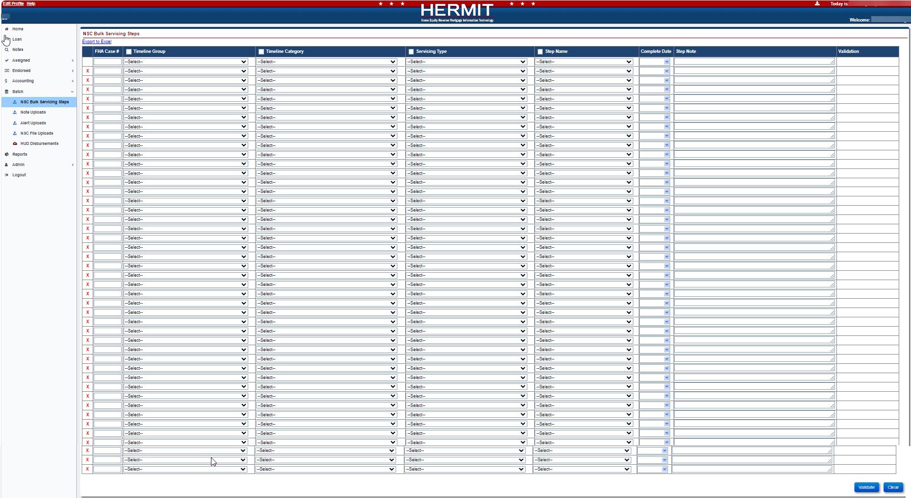
Figure 3: NSC Bulk Servicing Steps page

Bulk Servicing Steps Field Description
This table describes the required data fields.
Table 6: NSC Bulk Servicing Steps Fields
Field Description | Required Field
FHA Case # | N
Timeline Group | Y
Timeline Category | Y
Servicing Type | Y
Step Name | Y
Complete Date | Y
Step Note | N
Validation | Read Only Field

Bulk Servicing Steps Errors
This table describes the Error Messages that could occur based on the data condition inputted by the user.
Table 7: Data conditions for NSC Bulk Servicing Steps Errors
Error Condition | Error Message
The loan the user is attempting to update must have a valid FHA Case #. | The FHA Case # is Invalid
The loan the user is attempting to update is missing the Timeline Group. | The Timeline Group is required
The loan the user is attempting to update is missing the Timeline Category | The Timeline Category is required
The loan the user is attempting to update is missing the Servicing Type. | The Servicing Type is required
The loan the user is attempting to update is missing the Step Name. | The Step Name is required
The Step Complete Date is blank. | The Step Complete Date is required
The loan the user is attempting to update must have an Active/Open Timeline of the same type. | To add the Step to this loan, the Timeline Status cannot be Inactive
The Step Complete Date must be <= today. | Complete Date cannot be a future date
The user is attempting to add a Step Note that is greater than 255 characters. | Step Note exceeds 255 characters
The loan the user is attempting to update does not have an existing Timeline. | Timeline for the FHA Case Number does not exist

Note Uploads
Note Uploads: There is one upload type that can be used to update loan-level data from this page.
- Notes

Upload File Requirements
This section documents the record layout requirements used to generate a file that will successfully upload Notes to the HERMIT system. Below is a view of the HERMIT Note Uploads Screen. It allows the authorized user to browse their internal sources for HECM data to retrieve the various files to be uploaded for the day. Once a file is selected using the Choose File button, the authorized user clicks the Upload button for immediate processing of the file into HERMIT. The user would repeat this process for each file type as needed.
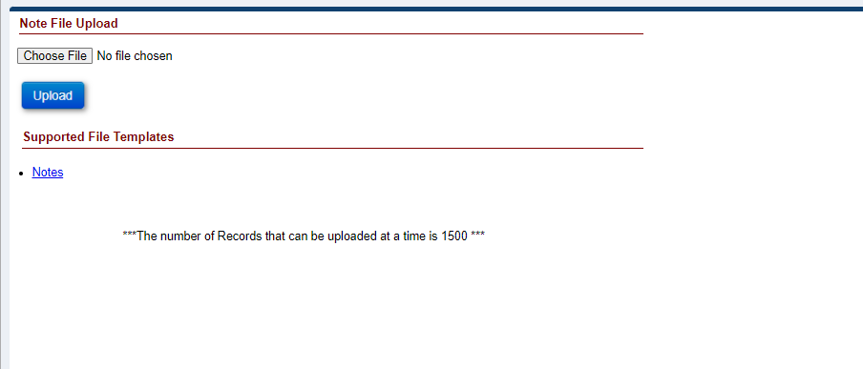
Figure 4: Note Upload Screen

Each file may contain up to 1,500 records. The processing time to upload a file containing up to 1,500 records will normally take a few minutes. If there are any posting errors, the user will be notified during the process. The upload is deemed to be complete when the user is notified via a success or failure message on the screen. The message consists of three types of notifications:
- Error records
- Warnings/success records
- Success records
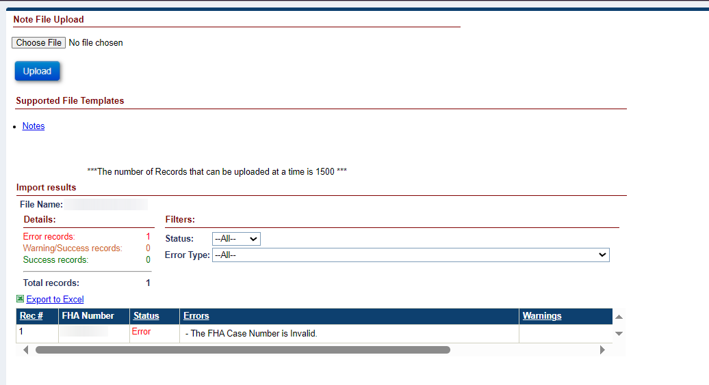
Figure 5: File Processing In HERMIT
File name and type:
- Any file name may be used, there are no naming requirements.
- A flat Text (Tab delimited) file is required. The valid file extension is .txt
- Each row must contain only one record.
Frequency of upload file:
There is no restriction on the number of files uploaded on a given day. File layout examples can be found in each section.
The Servicing Module provides a feature to allow a Servicer and HUD to upload a volume of transactions for the following activities in Table 4.
Table 8: HECM File Upload Types
File Upload Type | Description
Notes | Is used to inform HERMIT of all Notes

Data formatting:
Dashes (-) and decimal points (.) are permitted within the upload file; no other special characters or symbols should be present.
File Header Description:
The first row of each file must contain the file type identifier. No other header row or header information is permitted. The presence of any other header information will result in file upload failure.
The valid file type identifier is as follows:
- “NotesImport”

Notes Import – Record Layout
This table describes the required data elements, formats, and their sequence within the file.
Table 9: Data Item Descriptions for File NotesImport
File Type Identifier: NotesImport
Data Item | Description | Format/Range of Values | Required | Seq. #
FHA Case # | FHA case number | Numeric(10); | Yes | 1
Note Type Code | Note Type | String(3);  See Table for Note Type Codes and Description reference; | Yes | 2
Note | Informational field | String(500) | No | 3

Notes Import Transaction Codes and Descriptions

Table 10: Transaction Codes and Descriptions
Category | Note Type Code | Note Type | Note
Notes
 | 10 | Compliance
 | 19 | Closing Docs
 | 20 | Insurance
 | 30 | Servicer
 | 45 | Foreclosure - Assigned
 | 50 | Bankruptcy
 | 60 | Release
 | 80 | Taxes
 | 112 | Deleted Image
 | 113 | F12/IACS Foreclosure
 | 114 | F12/IACS Payoff
 | 120 | REO
 | 121 | Disposition
 | 130 | Contractor
 | 140 | HUD Specialist
 | 150 | EVARS
 | 180 | Claims
 | 270 | Request for HUD Advance
 | 280 | Request for Unsch. Adv(Assgn.)
 | 330 | Foreclosure
 | 500 | General Information
 | 520 | Congressional
 | 530 | Customer Service
 | 540 | HECM Complaint
 | 550 | Warning Note
 | 580 | Requests
 | 590 | Short Sale
 | 600 | SMART Alternate Contact
 | 610 | Extension
 | 630 | Repayment Plan

Notes Import – B2G File layout
This embedded template can be used as a guide for creating the upload file. It can also be found on the upload screen within HERMIT.

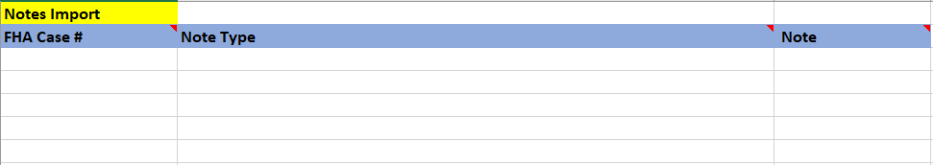
Figure 6: Notes Import File

Note Upload Errors
This table describes the Error Messages that could occur based on the data condition uploaded by the user.
Table 11: Data conditions for Note Upload Errors
Error Condition | Error Message
The loan the user is attempting to update through the Note B2G must have a valid FHA Case Number. | The FHA Case Number is Invalid
The loan the user is attempting to update through the Note B2G must have an FHA Case Number. | FHA Case Number is required
The loan the servicer (not the HUD Contractor) is attempting to update through the Note B2G must be the servicer on the loan. | Servicer does not have access to FHA Case #
The loan the lender (Not HUD) is attempting to update through the Notes B2G must be the lender on the loan. | Lender does not have access to FHA Case #
The loan the user is attempting to update through the Note B2G cannot have a Case Status of Cancelled. | To Add Note on this Case, the Case Status cannot be “Cancelled
The loan the user is attempting to update through the Note B2G cannot have a Case Status of Suspense. | To Add Note on this Case, the Case Status cannot be “Suspense
The user is attempting to upload an invalid Note Type. | The Note Type is invalid
The loan the user is attempting to update through the Note B2G must have a Note Type. | Note Type is required
The user is attempting to upload a File with a Note greater than 500 characters. | To Add a Note on this Case, the Note cannot be greater than 500 characters
The user is attempting to upload a File without a Note. | The Note is required
The user is attempting to upload a duplicate file. | File is Duplicated
The user is attempting to upload a File with invalid data. (Example: The user attempts to upload a file that has an extra column or tab in the file) | Row xxxx has invalid data
The File Format the user is attempting to upload is not a .txt (tab delimited) | File (Name of Document), Error: Invalid

Alert Uploads
Alert Uploads: There is one upload type that can be used to update loan-level data from this page.
- Alerts

Upload File Requirements
This section documents the record layout requirements used to generate a file that will successfully upload Alerts to the HERMIT system. Below is a view of the HERMIT Alert Uploads Screen. It allows the authorized user to browse their internal sources for HECM data to retrieve the various files to be uploaded for the day. Once a file is selected using the Choose File button, the authorized user clicks the Upload button for immediate processing of the file into HERMIT. The user would repeat this process for each file type as needed.
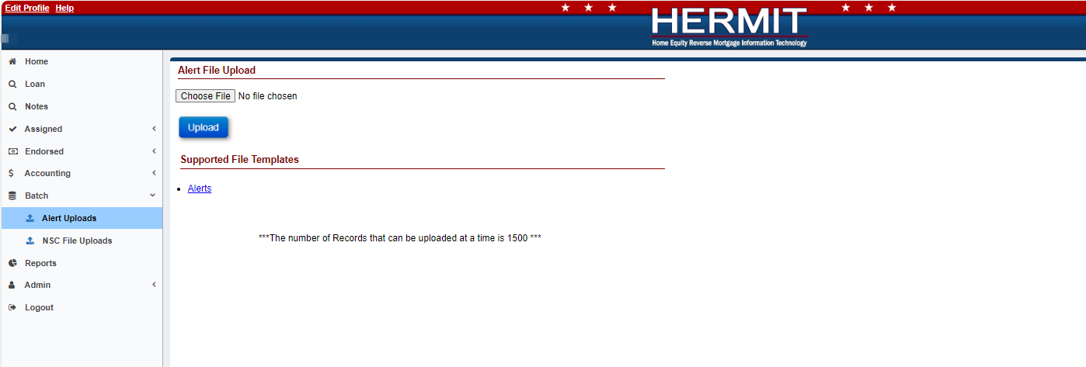
Figure 7: HERMIT Upload Screen

Each file may contain up to 1,500 records. The processing time to upload a file containing up to 1,500 records will normally take a few minutes. If there are any posting errors, the user will be notified during the process. The upload is deemed to be complete when the user is notified via a success or failure message on the screen. The message consists of three types of notifications:
- Error records
- Warnings/success records
- Success records
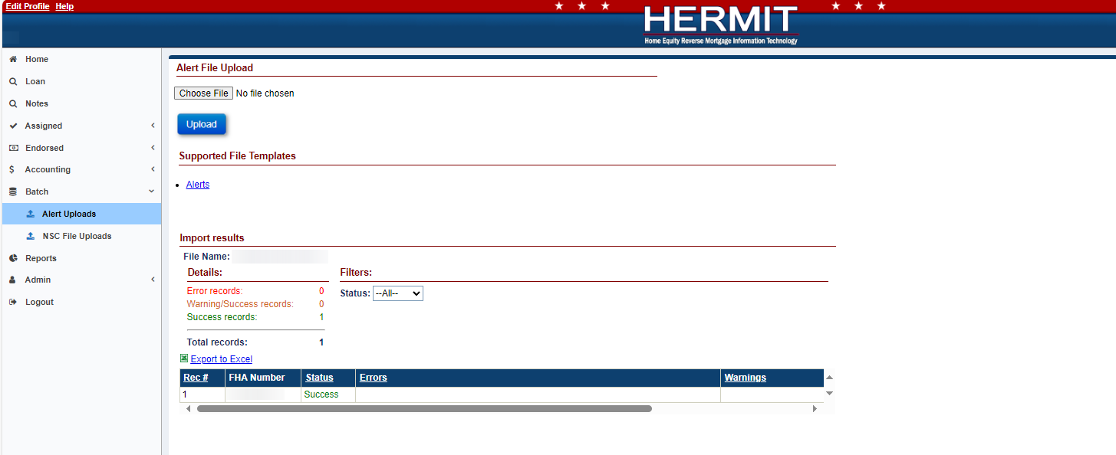
Figure 8: File Processing In HERMIT
File name and type:
- Any file name may be used, there are no naming requirements.
- A flat Text (Tab delimited) file is required. The valid file extension is .txt
- Each row must contain only one record.
Frequency of upload file:
There is no restriction on the number of files uploaded on a given day. File layout examples can be found in each section.
The Servicing Module provides a feature to allow HUD/HUD Contractors to upload a volume of transactions for the following activities in Table 4.
Table 12: HECM File Upload Types
File Upload Type | Description
Alerts | Is used to inform HERMIT of all Endorsed and Assigned Alerts

Data formatting:
Dashes (-) and decimal points (.) are permitted within the upload file; no other special characters or symbols should be present.
File Header Description:
The first row of each file must contain the file type identifier. No other header row or header information is permitted. The presence of any other header information will result in file upload failure.
The valid file type identifier is as follows:
- “AlertsImport”

Alerts Import – Record Layout
This table describes the required data elements, formats and their sequence within the file.
Table 13: Data Item Descriptions for File AlertsImport
File Type Identifier: AlertsImport
Data Item | Description | Format/Range of Values | Required | Seq. #
FHA Case # | FHA case number | Numeric(10); | Yes | 1
Alert Type Code | Alert Type | String(4);  See Table 7 for Alert Type Codes and Description reference; | Yes | 2
Alert Date | The Date when the Alert was applied to the loan | Date(10);  Format: YYYY-MM-DD; | Yes | 3
Expiration Date | The Date when the Alert will expire | Date(10);  Format: YYYY-MM-DD; | NO | 4
Alert Amount | Informational field | Integer followed by decimal (2);  >= ‘0.00’ | NO | 5
Alert Note | Informational field | String(500) | NO | 6

Alerts Import Transaction Codes and Descriptions

Table 14: Alert Type Codes and Descriptions
Category | Alert Type Code | Alert Type | Alert Severity | Alert Description
Alerts
 | 10 | User Generated | Critical | Loan Balance > 95% of Max Claim Amount
 | 20 | User Generated | General Tracking | Power of Attorney (POA) Received
 | 30 | User Generated | Critical | Insurance Default
 | 40 | User Generated | Critical | Tax Default
 | 60 | User Generated | General Tracking | Death Certificate Received – Borrower
 | 70 | User Generated | General Tracking | Death Certificate Received – Co-Borrower
 | 90 | User Generated | Critical | Loan Setup Issue
 | 120 | User Generated | Critical | HECM Compliant
 | 130 | User Generated | General Tracking | Occupancy Issue/Intent to Return
 | 140 | User Generated | General Tracking | Occupancy Issue/Intent to Unknown
 | 170 | User Generated | General Tracking | Spouse not an Obligor
 | 220 | User Generated | Critical | FEMA Alert
 | 230 | User Generated | Critical | Flood Insurance Required
 | 400 | User Generated | General Tracking | Other (See Notes)
 | 450 | User Generated | General Tracking | Payoff Quoted
 | 500 | User Generated | General Tracking | Property Address Changes sent to Tax Monitoring
 | 540 | User Generated | Critical | Int. Rate Type Discrepancy
 | 580 | User Generated | Critical | Funded Date/Effective Date Issue
 | 730 | User Generated | Critical | Claim Type 20 - Demand Assignment by HUD
 | 740 | User Generated | Critical | Claim Type 24 - HECM Supplemental
 | 760 | User Generated | Critical | Congressional
 | 770 | User Generated | General Tracking | Do Not Release - 2nd Mortgage
 | 790 | User Generated | Critical | Change of Payment Plan Pending
 | 810 | User Generated | General Tracking | Bankruptcy Discharged
 | 820 | User Generated | General Tracking | Bankruptcy Dismissed
 | 821 | User Generated | General Tracking | Loan Balance < 97.5% of claim amt
 | 826 | User Generated | General Tracking | A CAIVRS Block has been added
 | 831 | User Generated | General Tracking | CAIVRS Block has been suppressed
 | 836 | User Generated | General Tracking | Contested Bankruptcy
 | 839 | User Generated | General Tracking | Account has been lender billed
 | 841 | User Generated | General Tracking | Lender billed flag has been removed
 | 850 | User Generated | General Tracking | Conveyance To REO
 | 860 | User Generated | General Tracking | Force Placed Insurance
 | 870 | User Generated | General Tracking | Indemnification Agreement
 | 880 | User Generated | General Tracking | Repayment Plan for Property Charges
 | 900 | User Generated | Critical | Extension - Delay Foreclosure
 | 910 | User Generated | General Tracking | Test Alert
 | 920 | User Generated | General Tracking | Due & Payable - Death
 | 930 | User Generated | General Tracking | Due & Payable - Insurance
 | 940 | User Generated | General Tracking | Due & Payable - Occupancy
 | 950 | User Generated | General Tracking | Due & Payable - Other
 | 960 | User Generated | General Tracking | Due & Payable - Other Property Charges (HOA/Condo Fees, etc.)
 | 970 | User Generated | General Tracking | Due & Payable - Repairs
 | 980 | User Generated | General Tracking | Due & Payable - Sold or Conveyed Title
 | 990 | User Generated | General Tracking | Due & Payable - Taxes
 | 1000 | User Generated | General Tracking | Due & Payable - Taxes & Insurance
 | 1010 | User Generated | Critical | Extension - Claim Filing
 | 1020 | User Generated | Critical | Extension - DIL
 | 1030 | User Generated | Critical | Extension - Repairs
 | 1040 | User Generated | General Tracking | Loan referred to OIG for review
 | 1050 | User Generated | General Tracking | Loan referred to QAD for review
 | 1060 | User Generated | Critical | Other Property Charges (HOA/Condo Fees, Utility Liens, etc.)
 | 1090 | User Generated | General Tracking | 1st Release was sent to REKON
 | 1100 | User Generated | General Tracking | 2nd Release was sent to REKON
 | 1130 | User Generated | Critical | Pending Receipt of Recorded Assignment from Servicer
 | 1140 | User Generated | Critical | Loan Balance is >= 98% MCA
 | 1190 | User Generated | Critical | Scheduled OPL/CPL update failed
 | 1220 | User Generated | Critical | Eviction
 | 1230 | User Generated | General Tracking | Servicer Late Disbursement Charge
 | 1270 | User Generated | General Tracking | Repayment Plan created prior to 9/26/2020 has been inactivated. Please create a new one.
 | 1280 | User Generated | General Tracking | Curr Int Rate will not change on ARM 1st Change Date since Curr Index is < 30 days from Change Date
 | 1290 | User Generated | Critical | PDMDA 4634
 | 1300 | User Generated | Critical | PDMDA 4724
 | 1310 | User Generated | Critical | Suspend All Servicing Actions - See Notes
 | 1320 | User Generated | Critical | Lost in Tax Sale
 | 7778 | User Generated | Critical | MIP Collection Stopped-Foreclosure Sale Date
 | 7790 | User Generated | Critical | Claim Payment returned by payee/investor

NSC Alert Import – B2G File layout
This embedded template can be used as a guide for creating the upload file. It can also be found on the upload screen within HERMIT.
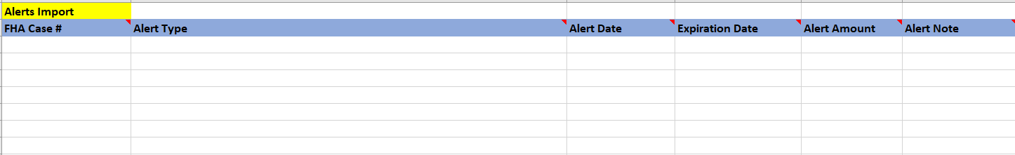
Figure 9:: Alerts Upload File

Alert Upload Errors
This table describes the Error Messages that could occur based on the data condition uploaded by the user.
Table 15: Data conditions for Alert Upload Errors
Error Condition | Error Message
The loan the user is attempting to update through the Alert B2G must have a valid FHA Case Number. | The FHA Case Number is Invalid
The loan the user is attempting to update through the Alert B2G must have an FHA Case Number. | FHA Case Number is required
The loan the user is attempting to update through the Alert B2G cannot have a Case Status of Cancelled. | To Add Alert on this Case, the Case Status cannot be “Cancelled
The user is attempting to upload an invalid Alert Type | The Alert Type is invalid
The loan the user is attempting to update through the Alert B2G must have an Alert Type | Alert Type is required
The loan the user is attempting to update through the Alert B2G must have an Alert Date | Alert Date is required
The user is attempting to upload a File with Alert Note greater than 500 characters. | To Add Alert on this Case, the Alert Note cannot be greater than 500 characters
The user is attempting to upload a duplicate file. | File is Duplicated
The user is attempting to upload a File with invalid data. (Example: The user attempts to upload a file that has an extra column or tab in the file) | Row xxxx has invalid data
The File Format the user is attempting to upload is not a .txt (tab delimited) | File (Name of Document), Error: Invalid

NSC Disbursement Uploads
NSC Disbursement Uploads: There are multiple upload types that can be used to update loan-level data from this page.
- Inspection Disbursements
- Release Fee Disbursements
- State Prohib Legal – Appraisal Disbursements
- State Prohib Legal – Inspection Disbursements

Upload File Requirements
This section documents the record layout requirements used to generate a file that will successfully upload Disbursements to the HERMIT system. Below is a view of the HERMIT NSC Disbursement Uploads Screen. It allows the authorized user to browse their internal sources for HECM data to retrieve the various files to be uploaded for the day. Once a file is selected using the Choose File button, the authorized user clicks the Upload button for immediate processing of the file into HERMIT. The user would repeat this process for each file type as needed.

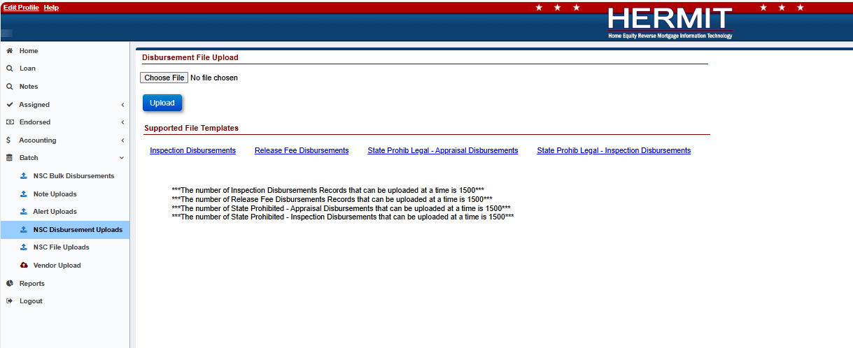
Figure 10: HERMIT Upload Screen

Each file may contain up to 1,500 records. The processing time to upload a file containing up to 1,500 records will normally take a few minutes. If there are any posting errors, the user will be notified during the process. The upload is deemed to be complete when the user is notified via a success or failure message on the screen. The message consists of three types of notifications:
- Error records
- Warnings/success records
- Success records

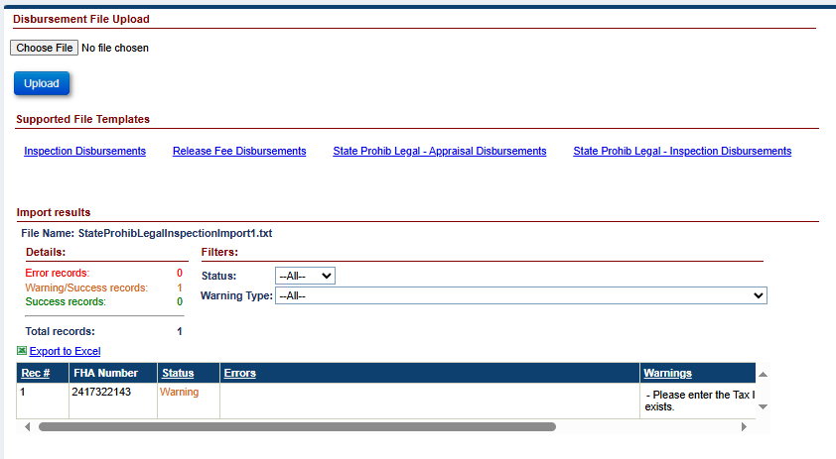
Figure 11: File Processing In HERMIT
File name and type:
- Any file name may be used, there are no naming requirements.
- A flat Text (Tab delimited) file is required. The valid file extension is .txt
- Each row must contain only one record.
Frequency of upload file:
There is no restriction on the number of files uploaded on a given day. File layout examples can be found in each section.
The Servicing Module provides a feature to allow HUD/HUD Contractors to upload a volume of transactions for the following activities in Table 4.
Table 16: HECM File Upload Types
File Upload Type | Description
Inspection Disbursements | Is used to inform HERMIT of all Disb – Unscheduled from LOC Inspection Disbursements
Release Fee Disbursements | Is used to inform HERMIT of all Disb – Unscheduled from LOC Release Fee Disbursements
State Prohib Legal – Appraisal Disbursements | Is used to inform HERMIT of all State Prohibited Legal – Appraisal Disbursements
State Prohib Legal – Inspection Disbursements | Is used to inform HERMIT of all State Prohibited Legal – Inspection Disbursements

Data formatting:
Dashes (-) and decimal points (.) are permitted within the upload file; no other special characters or symbols should be present.
File Header Description:
The first row of each file must contain the file type identifier. No other header row or header information is permitted. The presence of any other header information will result in file upload failure.
The valid file type identifier is as follows:
- “InspectionDisbursementsImport”
- “ReleaseFeeDisbursementsImport”
- “StateProhibLegalAppraisalImport”
- “StateProhibLegalInspectionImport”

Disbursement Import – Record Layout
This table describes the required data elements, formats and their sequence within the file for two types of Disbursement Imports
- InspectionDisbursementsImport
- ReleaseFeeDisburesementsImport
- StateProhibLegalAppraisalImport
- StateProhibLegalInspectionImport
Table 17: Data Item Descriptions for DisbursmentsImport File
File Type Identifier: DisbursementsImport
Data Item | Description | Format/Range of Values | Required | Seq. #
FHA Case # | FHA case number | Numeric(10); | Yes | 1
Transaction Category Code | Transaction Category | String(4);  See Table 7 for Transaction Category Codes and Description reference; | Yes | 2
Transaction Code | Transaction Description | String(4);  See Table 8 for Transaction Codes and Description reference; | Yes | 3
Vendor Code | Vendor Type | String(3);  See Table 9 for Vendor Codes and Description reference; | Yes | 4
Payee/Pay to Code | Payee/Pay to | String(4);  See Table 10 for Payee/Pay to Codes and Description reference; | Yes | 5
Disbursement Amount | The Amount of the Disbursement | Integer followed by decimal (2);  Must be > 0.00 and <= $1,000,000 | Yes | 6
Process Date | Process Date | Date(10);  Format: YYYY-MM-DD; | Yes | 7
Check Stub Note 1 | Note Displayed on Check Stub line 1. Only Applies to Payment Method Check | String(55) | NO | 8
Check Stub Note 2 | Note Displayed on Check Stub line 2. Only Applies to Payment Method Check | String(55) | NO | 9
Check Stub Note 3 | Note Displayed on Check Stub line 3. Only Applies to Payment Method Check | String(55) | NO | 10
Invoice Date | The Date of the Disbursement Invoice | Date(10);  Format: YYYY-MM-DD; | NO | 11
Invoice # | The Number listed on the Invoice | String (25) | Yes | 12
Disb Note | Informational field | String(255) | NO | 13
Special Handling | Checks that will be returned to NSC for further processing. Only Applies to Payment Method Check. | Integer followed by decimal (2);  Must be > 0.00; | NO | 14

Disbursement Transaction Codes and Descriptions
InspectionDisbursementsImport
Table 18: Transaction Category Codes and Descriptions
Category | Transaction Category Code | Transaction Category | Transaction Description
Disbursement
 | 1300 | Disb - Unscheduled from LOC | This Transaction Category is initiated by HUD to create an Unscheduled from LOC Disbursement.

Table 19: Transaction Codes and Descriptions
Category | Transaction Code | Transaction Category | Transaction Description Name | Transaction Description
Disbursement
 | 1352 | Disb – Unscheduled from LOC | Disb – Unscheduled from LOC Inspections | This transaction is initiated by HUD to add a Disbursement for Unscheduled from LOC Inspections.

Table 20: Vendor Codes and Descriptions
Category | Vendor Code | Vendor Name Description
Vendor
 | 90 | Inspector

Table 21: Payee/Pay to Codes and Descriptions
Category | Payee/Pay to Code | Payee/Pay to Name Description
Payee/Pay to
 | 5204 | Office of Tiger Global Real Estate Services, Inc.
 | 5206 | Spectrum Field Servicers, Incorp
 | 5208 | Single Source Property Solutions
 | 5228 | Tag Mississippi Enterprises, Inc
 | 5230 | The Metis Group, LLC
 | 5232 | iMortgage Services
 | 5264 | Concourse Federal Group, L.L.C.
 | 5318 | Network Asset Services, LLC
 | 5328 | ZVN Properties, INC
 | 5356 | Five Brothers Mortgage Servicing and Securing, INC
 | 5549 | Service 1^{st,} LLC
 | 26080 | MCS Five Brothers LLC

ReleaseFeeDisbursementImport
Table 22: Transaction Category Codes and Descriptions
Category | Transaction Category Code | Transaction Category | Transaction Description
Disbursement
 | 1300 | Disb - Unscheduled from LOC | This Transaction Category is initiated by HUD to create an Unscheduled from LOC Disbursement.

Table 23: Transaction Codes and Descriptions
Category | Transaction Code | Transaction Category | Transaction Description Name | Transaction Description
Disbursement
 | 1351 | Disb – Unscheduled from LOC | Disb – Unscheduled from LOC Release Fee | This transaction is initiated by HUD to add a Disbursement for Unscheduled from LOC Release Fee.

Table 24: Vendor Codes and Descriptions
Category | Vendor Code | Vendor Name Description
Vendor
 | 140 | Release Fee

Table 25: Payee/Pay to Codes and Descriptions
Category | Payee/Pay to Code | Payee/Pay to Name Description
Payee/Pay to
 | 5828 | The City of New York Office of the City Register
 | 6243 | CUMBERLAND REGISTRY OF DEEDS
 | 6244 | SARASOTA RECORDING
 | 6245 | SACRAMENTO CLERK-RECORDER
 | 7951 | LENAWEE COUNTY REGISTER OF DEEDS
 | 15382 | LENDERS ESCROW & TITLE
 | 21455 | First American Mortgage Solutions, LLC
 | 21526 | Hamilton County Auditor
 | 21527 | Lake County Auditor
 | 21528 | Porter County Auditor
 | 21584 | BRISTOL FALL RIVER REGISTRY OF DEEDS
 | 21621 | CLINTON COUNTY RECORDER OF DEEDS
 | 21741 | KLAMATH COUNTY CLERK
 | 22531 | Town of Bethel
 | 22532 | DONA ANA COUNTY CLERK
 | 22533 | Teneshia Hudspeth, Harris County Clerk
 | 24529 | Compu-Link Corporation

StateProhibAppraisalsImport
Table 26: Transaction Category Codes and Descriptions
Category | Transaction Category Code | Transaction Category | Transaction Description
Disbursement
 | 2120 | Corp Advance – Section 305 Disbursements | This Transaction Category is initiated by HUD to create a Corporate Advance Disbursement.

Table 27: Transaction Codes and Descriptions
Category | Transaction Code | Transaction Category | Transaction Description Name | Transaction Description
Disbursement
 | 4342 | Corp Advance – Section 305 Disbursements | Corp Adv – S305 – State Prohibited Legal - Appraisals | This transaction is initiated by HUD to add a Disbursement for Corporate Advance – State Prohibited Legal - Appraisals

Table 28: Vendor Codes and Descriptions
Category | Vendor Code | Vendor Name Description
Vendor
 | 10 | Appraiser

Table 29: Payee/Pay to Codes and Descriptions
Category | Payee/Pay to Code | Payee/Pay to Name Description
Payee/Pay to
 | 9060 | ALL PHASE ROOFING INC
 | 5576 | APPRAISAL EXPRESS OF CENTRAL FLORIDA, INC
 | 20285 | ATLAS ROOFING & EXTERIORS
 | 16192 | BACHMANS
 | 8035 | CAROLINE HALL, AS TRUSTEE OF THE CAROLINE HALL REVOCABLE TRUST
 | 17215 | CHICAGO TITLE COMPANY, LLC – GILBERT
 | 5263 | CONCOURSE FEDERAL GROUP, LLC
 | 14418 | DAVID MICHAEL HEIM, ATTORNEY AND COUNSELOR AT LAW
 | 20129 | ELITE TITLE COMPANY INC
 | 11926 | ESTATE OF JUANITY DOWDY & H DRYWALL CONSTRUCTION
 | 20002 | FIDELITY NATIONAL TITLE(PHOENIX)AGUA
 | 18553 | FIRST AMERICAN TITLE-GLENDALE(GOODE)
 | 24743 | GREEN TREE VILLAGE HOA, INC
 | 13984 | H&M Unlimited INC – WINTER GARDEN
 | 20151 | HOLDEN ROOFING INC – SAN MARCOS
 | 5231 | iMortgage Services
 | 15120 | INDEPENDENCE TITLE – AUSTIN - -
 | 17069 | INFINITY TITLE LLC – ST GEORGE
 | 9757 | KALAMAZOO VALLEY APPRAISALS INC
 | 17589 | LANDS END ABSTRACT
 | 5405 | MARK FOUGHT
 | 9249 | MARSOLF CONSTRUCTION_
 | 5573 | MIDTOWN VALUATION INC.
 | 7780 | MONTANA TITLE & ESCROW
 | 17254 | O’DONNELL, PA
 | 7721 | REGINA M. BRIGGS, TRSUTEE- THE PATRICIA MACKEY 2010 REVOC. TRUST DATED 08/30/2010
 | 5205 | SERVICER 1ST VALUATION AND SETTLEMENT SERVICES, INC.
 | 5301 | SERVICELINK VALUATION SOLUTIONS, LLC
 | 5226 | Spectrum Field Services, Inc.
 | 5227 | Tag Mississippi Enterprises, Incorporated
 | 21464 | TALLULAH CONSTRUCTION INC
 | 11180 | THE ESTATE OF LENA LUCIANO AND MICHEAL LUCIANO
 | 8620 | THE HUBBLE TRUST C/O LARRY HUBBLE
 | 5229 | The Metis Group, LLC
 | 5409 | VICTOR LEBRON JIMENEZ
 | 7421 | VIRGINIA L OTTO
 | 20282 | WAYNE WOOD
 | 16180 | WILDWOOD ROOFING & CONSTRUCTION

StateProhibInspectionsImport
Table 30: Transaction Category Codes and Descriptions
Category | Transaction Category Code | Transaction Category | Transaction Description
Disbursement
 | 2120 | Corp Advance – Section 305 Disbursements | This Transaction Category is initiated by HUD to create a Corporate Advance Disbursement.

Table 31: Transaction Codes and Descriptions
Category | Transaction Code | Transaction Category | Transaction Description Name | Transaction Description
Disbursement
 | 4344 | Corp Advance – Section 305 Disbursements | Corp Adv – S305 – State Prohibited Legal - Inspections | This transaction is initiated by HUD to add a Disbursement for Corporate Advance – State Prohibited Legal - Inspections

Table 32: Vendor Codes and Descriptions
Category | Vendor Code | Vendor Name Description
Vendor
 | 90 | Inspector

Table 33: Payee/Pay to Codes and Descriptions
Category | Payee/Pay to Code | Payee/Pay to Name Description
Payee/Pay to
 | 5264 | Concourse Federal Group, L.L.C
 | 5356 | Five Brothers Mortgage Servicing and Securing, INC
 | 5232 | iMortgage Services
 | 26080 | MCS Five Brothers LLC
 | 5318 | Network Asset Services, LLC
 | 2045 | Office of Tiger Global Real Estate Services, Inc.
 | 5549 | Service 1^{st,} LLC
 | 5208 | Single Source Property Solutions
 | 5206 | Spectrum Field Servicers, Incorp
 | 5228 | Tag Mississippi Enterprises, Inc
 | 5230 | The Metis Group, LLC
 | 5328 | ZVN Properties, INC

Disbursement Import – B2G File layout
The templates can be used as a guide for creating the upload file for InspectionDisbursementsImport, ReleaseFeeDisbursementsImport, StateProhibAppraisalsImport, and StateProhibInspectionsImport. It can also be found on the upload screen within HERMIT.

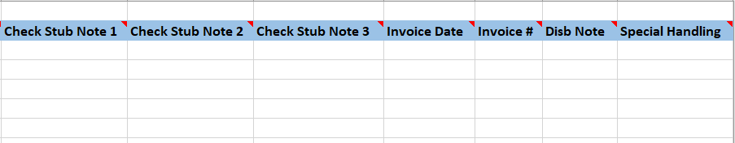
Figure 12: Inspection Disbursement Upload File

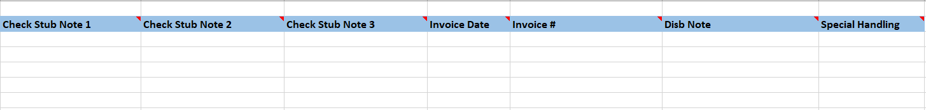
Figure 13: Release Fee Disbursement Upload File

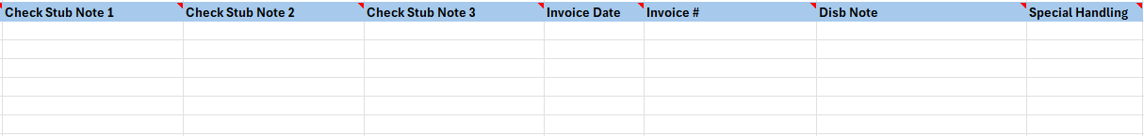
Figure 14: State Prohib Legal Appraisal Disbursements Upload File

Figure 15: State Prohib Legal Inspection Disbursements Upload File

NSC Disbursement Upload Errors
This table describes the Error Messages that could occur based on the data condition uploaded by the user.
Table 34: Data conditions for NSC Disbursement Upload Errors
Error Condition | Error Message
The loan the user is attempting to update through the NSC Disbursement Transaction B2G must have a valid FHA Case Number. | The FHA Case Number is Invalid
The loan the user is attempting to update through the NSC Disbursement Transaction B2G must have an FHA Case # | FHA Case # is required
The loan the user is attempting to update through the NSC Disbursement Transaction B2G cannot have a Case Status of Cancelled | To add the Disbursement Transaction to this Case, the Case Status cannot be “Cancelled
The loan the user is attempting to update through the NSC Disbursement Transaction B2G the Servicer must be the HUD NSC Contractor | To Add the Disbursement to this Case, the Servicer must be the HUD NSC Contractor
The user is attempting to upload an Invalid Disbursement Transaction Category through the NSC Disbursement Transaction B2G | The Disbursement Transaction Category is invalid
The user is attempting to upload a file without a Disbursement Transaction Category through the NSC Disbursement Transaction B2G | Disbursement Transaction Category is required
The user is attempting to upload an Invalid Disbursement Transaction Description through the NSC Disbursement Transaction B2G | The Disbursement Transaction Description is invalid
The user is attempting to upload a file without a Disbursement Transaction Description through the NSC Disbursement Transaction B2G. | Disbursement Transaction Description is required
The user is attempting to upload an Invalid Vendor Type through the NSC Disbursement Transaction B2G | The Vendor Type is invalid
The user is attempting to upload a file without a Vendor Type through the NSC Disbursement Transaction B2G | Vendor Type is required
The user is attempting to upload an Invalid Payee/Pay to through the NSC Disbursement Transaction B2G | The Payee/Pay to is Invalid
The user is attempting to upload a file without a Payee/Pay to through the NSC Disbursement Transaction B2G. | Payee/Pay to is required
The user is attempting to upload a Disbursement Amount <= $0.00 through the NSC Disbursement Transaction B2G. | The Disbursement Transaction Amount must be > $0.00 and <= $1,000,000.00
The user is attempting to upload a file without a Disbursement Amount through the NSC Disbursement Transaction B2G. | Disbursement Amount is required
The user is attempting to upload a Disbursement Amount of $0.00 through the NSC Disbursement Transaction B2G | Zero value is not allowed to create Disbursement. Please enter valid Disbursement Amount
The user is attempting to upload a Negative Disbursement Amount through the NSC Disbursement Transaction B2G | Amount entered is below the minimum value of $0.00
The user is attempting to upload a file with an Invalid Process Date through the NSC Disbursement Transaction B2G. | Invalid Process Date
The user is attempting to upload a file without a Process Date through the NSC Disbursement Transaction B2G. | Process Date is required
The user is attempting to upload a file with an Invalid Invoice Date through the NSC Disbursement Transaction B2G. | Invalid Invoice Date
The user is attempting to upload an Invoice # that is greater than 25 characters through the NSC Disbursement Transaction B2G. | Invoice # exceeds 25 characters
The user is attempting to upload a file without an Invoice # through the NSC Disbursement Transaction B2G. | Invoice # is required
The user is attempting to upload a Disbursement Note greater than 255 characters through the NSC Disbursement Transaction B2G | Disbursement Note exceeds 255 characters
The user is attempting to upload a Vendor Disbursement that does not have the City, State, and/or Zip Code listed for that Vendor Payee through the NSC Disbursement Transaction B2G. | City, State, and Zip are required fields for the Vendor. Please update in the Admin > Vendor area for the chosen Vendor Payee selected
The user is attempting to upload a Vendor Disbursement that does not have a 9-digit Tax ID | Tax ID of 9 digits is required. Please update in the appropriate area.
The user is attempting to upload a Vendor Disbursement that has more than 55 characters for Check Stub Note 1 when the Payment Method is Check. | Check Stub Note 1 exceeds 55 characters
The user is attempting to upload a Vendor Disbursement that has more than 55 characters for Check Stub Note 2 when the Payment Method is Check. | Check Stub Note 2 exceeds 55 characters
The user is attempting to upload a Vendor Disbursement that has more than 55 characters for Check Stub Note 3 when the Payment Method is Check. | Check Stub Note 3 exceeds 55 characters
The user is attempting to upload a Vendor Disbursement where the Special Handling is not Y or N when the Payment Method is Check. | The Special Handling is invalid
The user is attempting to upload a Corp Adv – S305 - State Prohibited Legal – Appraisals or Corp Adv – S305 – State Prohibited Legal – Inspections Disbursement for a loan that is not in the state of Maryland or New York through the NSC Disbursement Transaction B2G. | The State must be Maryland or New York for the selected Transaction Description
The user is attempting to upload a duplicate file. | File is Duplicated
The user is attempting to upload a File with invalid data. (Example: The user attempts to upload a file that has an extra column in the file) | Row xxxx has invalid data
The File Format the user is attempting to upload is not a .txt (tab delimited) | File (Name of Document), Error: Invalid

NSC File Uploads
NSC File Uploads: There are three upload types that can be used to update loan-level data from this page. They are:
- NSC Transactions
- Asset Sale Reports
- Loan Details/Transactions PDFs

Upload File Requirements
This section documents the record layout requirements used to generate a file that will successfully upload records to the HERMIT system, as well as direct HERMIT to generate reports for a certain population of loans. Below is a view of the HERMIT Upload Screen. It allows the authorized user to browse their internal sources for HECM data to retrieve the various files to be uploaded for the day. Once a file is selected using the Choose File button, the authorized user clicks the Upload button for immediate processing of the file into HERMIT. The user would repeat this process for each file type as needed.

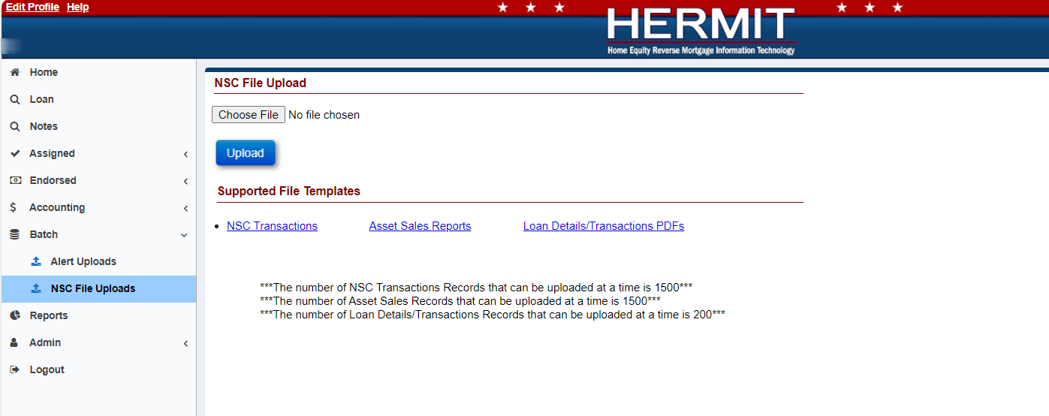
Figure 16: HERMIT Upload Screen

Each file may contain up to 1,500 records for NSC Transactions and Asset Sale Reports. The Loan Details/Transactions PDFs file may contain up to 200 records. The processing time to upload a file containing up to 1,500 records will normally take a few minutes. If there are any posting errors, the user will be notified during the process. The upload is deemed to be complete when the user is notified via a success or failure message on the screen. The message consists of three types of notifications:
- Error records
- Warnings/success records
- Success records

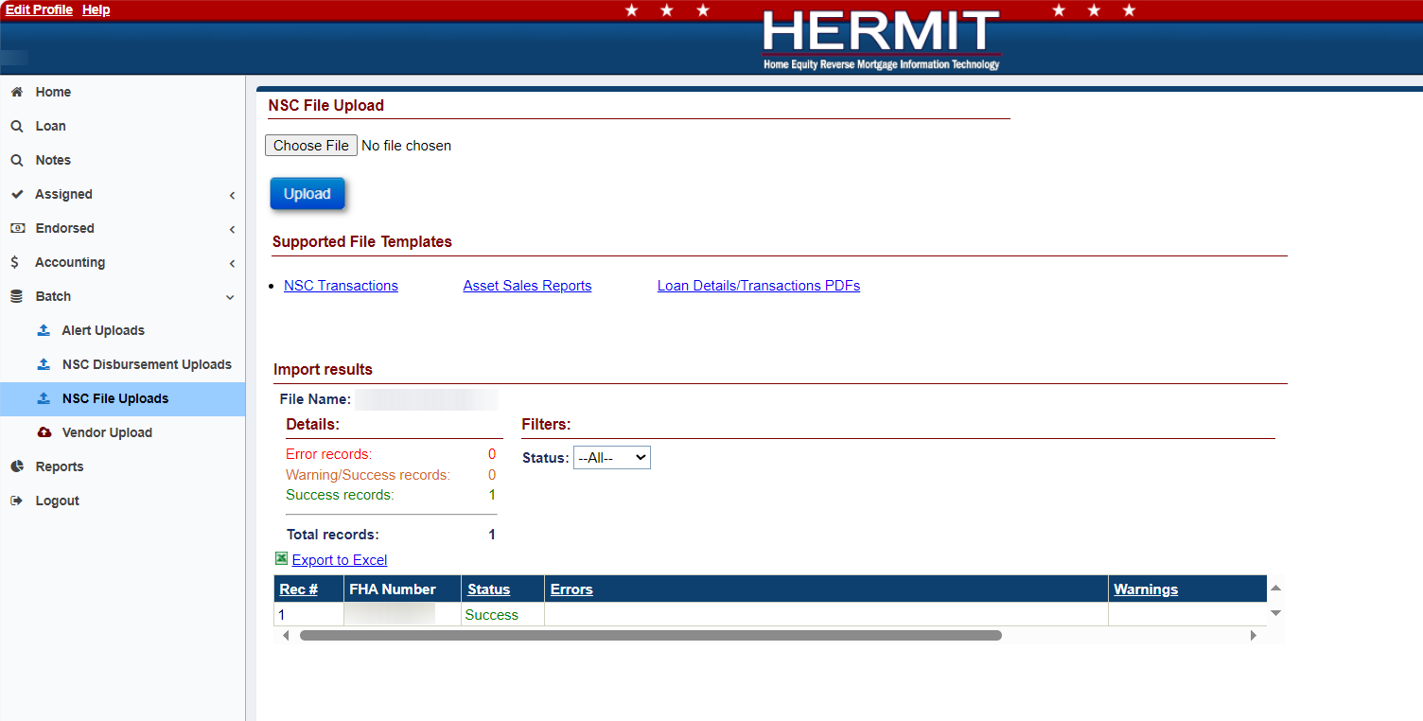
Figure 17: File Processing In HERMIT
File name and type:
- Any file name may be used, there are no naming requirements.
- A flat Text (Tab delimited) file is required. The valid file extension is .txt
- Each row must contain only one record.
Frequency of upload file:
There is no restriction on the number of files uploaded on a given day. File layout examples can be found in each section.
The Servicing Module provides a feature to allow HUD/HUD Contractors to upload a volume of transactions for the following activities in Table 4.
Table 35: HECM File Upload Types
File Upload Type | Description
NSC Transactions | Is used to inform HERMIT of all Asset Sale Payoff transactions
Asset Sale Reports | Is used to generate four Reports (Contact Extract, Loan Extract, Loan Level Balance, and Loan Transaction Details) from HERMIT. These Reports are in a download queue which is in the top right corner of HERMIT.
Loan Details/Transactions PDFs | Is used to generate three PDFs (Loan Details, Loan Transaction, and Loan Historical Transaction) from HERMIT. These PDFs are in a download queue which is in the top right corner of HERMIT.

Data formatting:
Dashes (-) and decimal points (.) are permitted within the upload file; no other special characters or symbols should be present.
File Header Description:
The first row of each file must contain the file type identifier. No other header row or header information is permitted. The presence of any other header information will result in file upload failure.
The valid file type identifier is as follows:
- “NSCImport”
- “B2GAssetSalesReport”
- “LoanDetailsAndTransactionsPDF”

NSC Transaction Import – Record Layout
This table describes the required data elements, formats and their sequence within the file.
Table 36: Data Item Descriptions for File NSCImport
File Type Identifier: NSCImport
Data Item | Description | Format/Range of Values | Required | Seq. #
FHA Case # | FHA case number | Numeric(10); | Yes | 1
Transaction Code | Transaction Type | String(4);  See Table 7 for Transaction Codes and Description reference; | Yes | 2
Effective Date | The Date when the payment was applied to the loan balance | Date(10);  Format: YYYY-MM-DD; | Yes | 3
Amount | Transaction amount | Integer followed by decimal (2);  Must be > 0.00; | NO | 4

NSC Transaction Import - Transaction Codes and Descriptions

Table 37: Transaction Codes and Descriptions
Category | Transaction Code | Transaction Category | Transaction Name | Transaction Description
Termination
 | 2883 | Terminate | Terminate – Asset Sale | This transaction is initiated by the HUD to terminate the loan due to an Asset Sale.

NSC Transaction Import – B2G File layout
This embedded template can be used as a guide for creating the upload file. It can also be found on the upload screen within HERMIT.

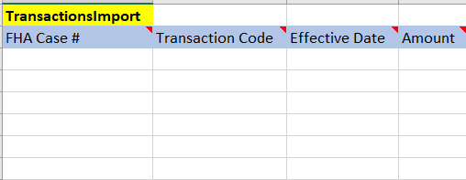
Figure 18: NSC Transactions Upload File

Asset Sale Reports - Record Layout
This table describes the required data elements, formats and their sequence within the file.
Table 38: Data Item Description for File B2GAssetSaleReports
File Type Identifier: B2GAssetSaleReports
Data Item | Description | Format/Range of Values | Required | Seq. #
FHA Case # | FHA Case Number | Numeric(10) or Numeric(9) | Yes | 1

Asset Sale Reports – B2G File Layout
This embedded template can be used as a guide for creating the upload file. It can also be found on the upload screen within HERMIT.
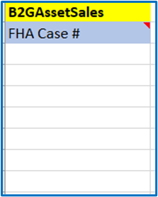
Figure 19: B2G Asset Sales Upload File

Loan Details/Transactions PDFs - Record Layout
This table describes the required data elements, formats, and their sequence within the file.
Table 39: Data Item Description for File LoanDeatilsAndTransactionsPDF
File Type Identifier: LoanDeatilsAndTransactionsPDF
Data Item | Description | Format/Range of Values | Required | Seq. #
FHA Case # | FHA Case Number | Numeric(10); | Yes | 1

Loan Details & Transactions PDFs – B2G File Layout
This embedded template can be used as a guide for creating the upload file. It can also be found on the upload screen within HERMIT.
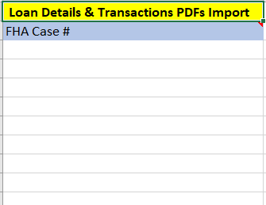
Figure 20: Loan Details & Transactions PDFs Upload File

NSC File Upload Errors
This table describes the Error Messages that could occur based on the data condition uploaded by the user.
Table 40: Data conditions for NSC File Upload Errors

Error Condition | Error Message
The loan the user is attempting to update through the NSC File Uploads page must have a valid FHA Case Number. | The FHA Case Number is Invalid
The loan the user is attempting to upload through the NSC File Uploads page does not have an FHA Case Number | FHA Case # is required
The loan the user is attempting to upload the Loan Details/Transactions PDFs Template through the Loan Details/Transactions B2G must be serviced by the HUD NSC Contractor | The servicer on this loan is not the HUD NSC Contractor
The loan the user is attempting to update through the Assigned Transaction B2G cannot have a Case Status of Terminated | To Terminate this Case, the Case Status cannot be “Terminated
The loan the user is attempting to update through the Assigned Transaction B2G cannot have a Case Status of Cancelled | To Terminate this Case, the Case Status cannot be “Cancelled
The loan the user is attempting to update through the Assigned Transaction B2G must be in a Case Status of Assigned | To Terminate this Case, the Servicer must be the HUD NSC Contractor
The loan the user is attempting to update through the Assigned Transaction B2G has an Effective payoff date earlier then the Effective date of either a payoff, partial repay, loan setup balance, or write-off transaction for the given loan entered for the B2G Transaction | Payoff cannot be processed. The entered payoff Effective Date cannot be earlier than the Effective Date of the payoff, partial repay, loan setup balance or write-off transaction(s) in the system
The loan the user is attempting to update through the Assigned Transaction B2G must have an Active Due and Payable Timeline | To Terminate this Case with an Asset Sale Termination Type, the Case must have an active “Due and Payable” Timeline
The loan the user is attempting to update through the Assigned Transaction B2G cannot have Pending Disbursements that affects loan balance | To Terminate this Case, there can be no Pending Disbursements
The loan the user is attempting to update through the Assigned Transaction B2G cannot have a Payoff Effective Date greater than a year from the latest Transaction’s Effective Date that affects loan balance | Payoff cannot be processed. The entered payoff Effective Date cannot be greater than 365 days from the latest Effective Date of certain transactions which affect loan balance in the system
The loan the user is attempting to update through the Assigned Transaction B2G cannot have an Auto Write-Off >= $3,000 when entering a payoff effective date that is prior to the latest transaction’s effective date for certain transaction that affect loan balance | The loan is unable to be Terminated due to the remaining balance being >= $3,000 after the Termination Amount is applied. The Step “Approval of Write-Off by HUD” will need to be completed on the Assigned Write-Off Review Timeline to Terminate the loan. If this loan does not have an Assigned Write-Off Review Timeline this will need to be setup for this loan.” The import results will be captured on the screen (as indicated below) once the transactions are uploaded
The user is attempting to upload a duplicate Assigned Transaction file | File is Duplicated
The user is attempting to upload a File with invalid data. (Example: The user attempts to upload a file that has an extra row or tab in the file) | Row xxxx has invalid data

Quality Control and Verification

File Verification
HECM files uploaded to HERMIT must pass multiple levels of validation to ensure the following:
- File extension
- Record layout aligns to file type identifier.
- Data contained in the file is valid and formatted correctly for each expected data item.
- A value is provided for every data item defined.
In case of error due to file format validation, the upload process will be stopped, and an error message generated indicating the cause. If validation determines that individual records do not comply with business rules, data processing may continue, and a report will be generated listing those records. This report will detail:
- Warnings – An unexpected value is present, but record uploaded successfully.
- Errors – Record was found to be out of compliance with business rules and record was not uploaded.
All uploads will be immediately integrated and visible in HERMIT upon completion of a successful B2G upload. Any issues you encounter during the file upload process should be directed to HECM SP Help Desk – servicingsupport@hermitsp.com

