Home Equity Reverse Mortgage Information Technology
(HERMIT)

HERMIT System Changes – Release 8.1

Release Date: 9/27/2025
Document Date: 9/27/2025
Version 1.0

September 2025

INTRODUCTION
The Home Equity Reverse Mortgage Information Technology (HERMIT) software release version 8.1 consists of the following system changes:
Table of Contents
Servicer Related Changes 4
1. Loan > Transactions > Loan page (594883, 592093) 4
2. Corporate Advance: “Borrower Recoverable” indicator, Interest & MIP Accrual changes, and Loan Balance updates (592093) 4
3. Corporate Advance: Loan > Payoff page (592093) 11
4. Claims: Block 17 and Borrower Recoverable Corporate Advances (592093) 11
5. Timeline Steps: Allow Servicers to update additional Step Complete Dates (582598) 12
6. Timeline: Loss Mitigation - Cash for Keys – Schedule Dates (595896) 12
Servicer and NSC / HUD Related Changes: 13
7. Timeline: Updates to certain Letters to include a Mini Miranda and/or Privacy Policy (594691) 13
8. Timelines: Unique Timeline Identifier (595018) 16
9. Claims: Form HUD 27011 Updates (595535) 17
10. Reports: Claims Detail (596145) 17
NSC / HUD Related Changes: 18
11. Payment Files without Tax ID Numbers (TIN’s) (595825) 18
12. Timelines: Updates to the Assigned Loss Mitigation - Short Sale Timeline (595004) 20
13. Timeline: Updates to the Assigned > Insurance/Loss Draft Administration Timeline (595770) 24
14. Timeline: Updates to the Assigned > Request for Unscheduled Advance and Assigned > Request for Payment Timelines. (595082) 26
15. Reports: Timeline Identifier to Timeline Activity Report (595018) 26
16. Reports: Bulk Printing Letters Report (50934) 27
17. Dashboard Landing: Export to Excel 27

If you have any questions regarding the functionality of the software release, please contact the HERMIT Help Desk at 561-899-2610 or at servicingsupport@hermitsp.com. If you have any policy related questions, please send an email to HUD at answers@hud.gov.

Servicer Related Changes

Loan > Transactions > Loan page (594883, 592093)
The following changes were made to Loan > Transactions > Loan: “Loan Transaction Results” and “Export Transactions” grids:
- Removed column “% Recoverable”
- Removed column “Recoverable Amt”
- Renamed column from “Loan Bal Trans Amt” to “Trans Amt”
- Existing column “Loan Bal on Trans Dt”. Field was updated to include Borrower Recoverable Corp Advance transaction amounts. Excludes Corporate Advance transactions that are Non-Borrower Recoverable.
- Added new column “Corp Adv Borr Recov” See topic #2 for further details.
- Added new column “Int Rate”. Populates only for “Monthly Int, MIP Accrual & SF” (Trans Code 1160) and “Auto-Adjust Int Mip SF” (1190) transactions, for transactions added on or after the Release Date. The Interest Rate displayed for each transaction reflects the rate effective on the date the transaction was posted.

Corporate Advance: “Borrower Recoverable” indicator, Interest & MIP Accrual changes, and Loan Balance updates (592093)
Several significant changes were made to the system related to Corporate Advance transaction reporting, accrual calculations, and loan balance / Unpaid Principal Balance (UPB). These updates will result in an increased Loan Balance for loans with any Borrower Recoverable Corporate Advance transactions.
The following is a summary of changes:
- New checkbox “Borr Recoverable” on the New Loan Transaction modal for User Interface (UI), Servicer Transactions, and Batch > B2G transactions
- List of Transaction Codes where “Borr Recoverable” applies
- Accrual Start Date
- Update Accruals to calculate Note Interest and MIP on Borrower Recoverable Corporate Advances
- Existing / Legacy Borrower Recoverable Corporate Advance transactions
- Loan Balance page

- New “Borr Recoverable” checkbox and column “Corp Adv Borr Recov”
User Interface: A new checkbox “Borr Recoverable” was added to the New Loan Transaction modal for corporate advance transactions on Endorsed loans. This feature allows users to identify transactions that are recoverable from the borrower. This checkbox will default as selected when creating a new corporate advance transaction for the applicable transaction codes listed below. The box should only be unchecked if the transaction is prohibited from being recovered by the borrower due to state or local jurisdiction rules.
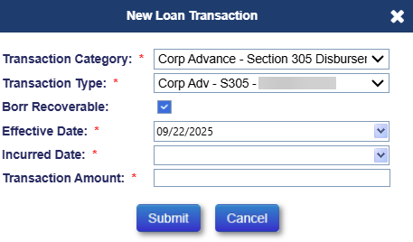
The corresponding column “Corp Adv Borr Recov” was added to the Loan > Transaction grid between the “Corp. Adv. Amt” and “Late Charge” fields. This column will display a checkmark when the “Borr Recoverable” box is selected on a corporate advance transaction. The checkbox cannot be edited on an existing transaction. If a correction is needed, the transaction must be adjusted off and reentered with the proper checkbox value.
IMPORTANT: Transactions with the “Corp Adv Borr Recov” checkbox marked will accrue Interest and MIP and will be included in the Loan Balance. All areas of the system where the Loan Balance is displayed were updated to reflect the new total loan balance including the Borrower Recoverable Corporate Advances.
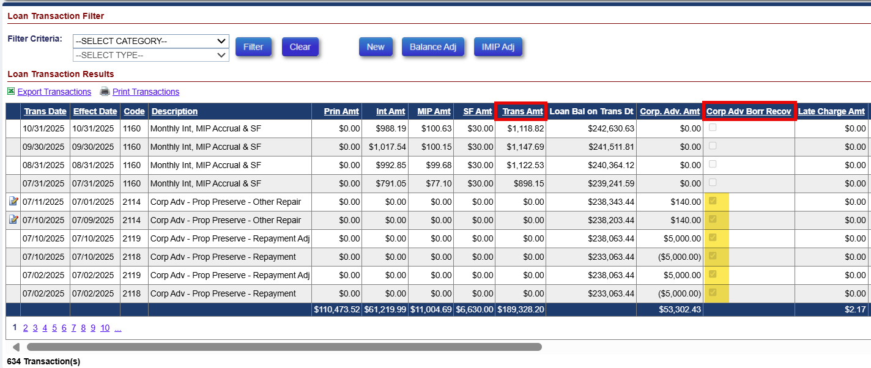
Batch > Servicer Transactions: The Batch > Servicer Transactions screen includes the “Borr Recoverable” checkbox. The “Borr Recoverable” checkbox is only enabled for corporate advance transactions that are eligible to be marked as borrower recoverable (for the applicable transaction codes listed below). The checkbox should be selected except when there is a state, local, or other jurisdictional restriction on collecting this Corporate Advance from the Borrower.
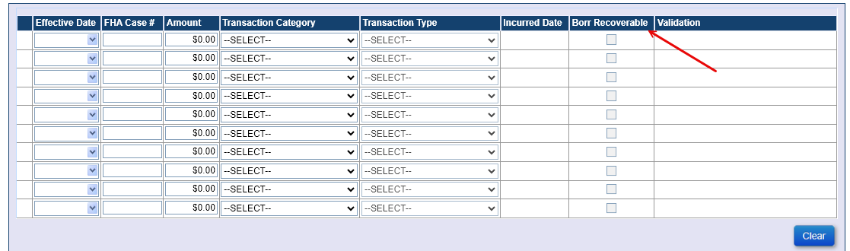

Batch > B2G Transactions: A new column titled “Borr Recoverable” was added to the B2G upload template file, which can be accessed from the Batch > Servicer File Upload screen by clicking “Transactions” link and downloading the file.
For transaction codes that are eligible to be Borrower Recoverable (see Topic 2.b.), populate the field in the upload file as necessary: Select dropdown value “No” if there is a state, local, or other jurisdictional restriction on collecting this Corporate Advance from the Borrower. Select dropdown value “Yes” if there is no such restriction. If the field is left blank in the upload file, the system automatically sets the transaction to “Yes”.
For transaction codes that are never eligible to be Borrower Recoverable, the system automatically sets the field to “No” regardless of what is populated in the upload file.

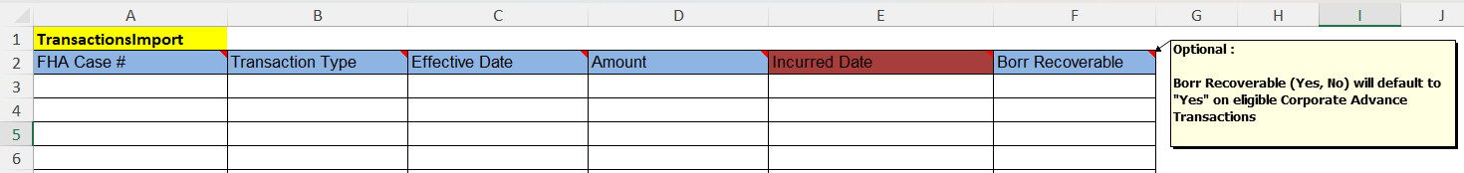

- List of Transaction Codes eligible to be marked as “Borr Recoverable”
The following transactions are considered eligible to be labeled as Borrower Recoverable. The “Borr Recoverable” checkbox is available only on the following corporate advance transactions:
Transaction Code | Transaction Description | Trans Category
2441 | Corp Adv - Misc Claim - Rental Expense | Corp Advance - Misc Claim
2448 | Corp Adv - Misc Claim - Rental Income | Corp Advance - Misc Claim
2101 | Corp Adv - Prop Preserve - Boarding | Corp Advance - Property Preservation
2102 | Corp Adv - Prop Preserve - Remove Debris | Corp Advance - Property Preservation
2103 | Corp Adv - Prop Preserve - Hazard Abate | Corp Advance - Property Preservation
2104 | Corp Adv - Prop Preserve - Utilities | Corp Advance - Property Preservation
2111 | Corp Adv - Prop Preserve - Prop Inspect | Corp Advance - Property Preservation
2112 | Corp Adv - Prop Preserve - Landscape | Corp Advance - Property Preservation
2113 | Corp Adv - Prop Preserve - Roof Repair | Corp Advance - Property Preservation
2114 | Corp Adv - Prop Preserve - Other Repair | Corp Advance - Property Preservation
2115 | Corp Adv - Prop Preserve - Winterizing | Corp Advance - Property Preservation
2116 | Corp Adv - Prop Preserve - Securing | Corp Advance - Property Preservation
2117 | Corp Adv - Prop Preserve - Other | Corp Advance - Property Preservation
2118 | Corp Adv - Prop Preserve - Repayment | Corp Advance - Property Preservation
2221 | Corp Adv - Release Fee | Corp Advance - Release Fee
2120 | Corp Adv - S305 - Flood Insurance | Corp Advance - Section 305 Disbursements
2121 | Corp Adv - S305 - Hazard Insurance | Corp Advance - Section 305 Disbursements
2122 | Corp Adv - S305 - Taxes | Corp Advance - Section 305 Disbursements
2123 | Corp Adv - S305 - Utilities | Corp Advance - Section 305 Disbursements
2124 | Corp Adv - S305 - Eviction Fees | Corp Advance - Section 305 Disbursements
2125 | Corp Adv - S305 - Other | Corp Advance - Section 305 Disbursements
2126 | Corp Adv - S305 - Ground Rent | Corp Advance - Section 305 Disbursements
2127 | Corp Adv - S305 - Condominium Dues | Corp Advance - Section 305 Disbursements
2135 | Corp Adv - S305 - Utilities - Liens | Corp Advance - Section 305 Disbursements
2137 | Corp Adv - S305 - HOA Dues | Corp Advance - Section 305 Disbursements
4120 | Corp Adv - S305 - Flood Insurance - Repay | Corp Advance - Section 305 Disbursements
4121 | Corp Adv - S305 - Hazard Insurance - Repay | Corp Advance - Section 305 Disbursements
4122 | Corp Adv - S305 - Taxes - Repay | Corp Advance - Section 305 Disbursements
4123 | Corp Adv - S305 - Utilities - Repay | Corp Advance - Section 305 Disbursements
4124 | Corp Adv - S305 - Eviction Fees - Repay | Corp Advance - Section 305 Disbursements
4125 | Corp Adv - S305 - Other - Repay | Corp Advance - Section 305 Disbursements
4126 | Corp Adv - S305 - Ground Rent - Repay | Corp Advance - Section 305 Disbursements
4127 | Corp Adv - S305 - Condominium Dues - Repay | Corp Advance - Section 305 Disbursements
4135 | Corp Adv - S305 - Utilities - Liens - Repay | Corp Advance - Section 305 Disbursements
4137 | Corp Adv - S305 - HOA Dues - Repay | Corp Advance - Section 305 Disbursements
2128 | Corp Adv - S305 - Repayment | Corp Advance - Section 305 Disbursements
2131 | Corp Adv - S306 - Attorney Fees | Corp Advance - Section 306 Disbursements
2132 | Corp Adv - S306 - Trustee Fees | Corp Advance - Section 306 Disbursements
2133 | Corp Adv - S306 - Other | Corp Advance - Section 306 Disbursements
2138 | Corp Adv - S306 - Repayment | Corp Advance - Section 306 Disbursements
2141 | Corp Adv - S307 - Sheriff Fees | Corp Advance - Section 307 Disbursements
2142 | Corp Adv - S307 - Title Examination Fees | Corp Advance - Section 307 Disbursements
2143 | Corp Adv - S307 - Recording Fees | Corp Advance - Section 307 Disbursements
2144 | Corp Adv - S307 - Other | Corp Advance - Section 307 Disbursements
2148 | Corp Adv - S307 - Repayment | Corp Advance - Section 307 Disbursements
2151 | Corp Adv - S308 - State - Taxes on Deed | Corp Advance - Section 308 Disbursements
2152 | Corp Adv - S308 - Other - Taxes on Deed | Corp Advance - Section 308 Disbursements
2158 | Corp Adv - S308 - Repayment | Corp Advance - Section 308 Disbursements
2161 | Corp Adv - S309 - Liens Paid | Corp Advance - Section 309 Disbursements
2162 | Corp Adv - S309 - Other | Corp Advance - Section 309 Disbursements
2168 | Corp Adv - S309 - Repayment | Corp Advance - Section 309 Disbursements
2171 | Corp Adv - S310 - Bnk Attorney Fees | Corp Advance - Section 310 Disbursements
2172 | Corp Adv - S310 - Other | Corp Advance - Section 310 Disbursements
2178 | Corp Adv - S310 - Repayment | Corp Advance - Section 310 Disbursements
2231 | Corp Adv - S405 - Overhead Costs | Corp Advance - Section 405 Disbursements
2238 | Corp Adv - S405 - Repayment | Corp Advance - Section 405 Disbursements
2181 | Corp Adv - S409 - Appraisal Fees | Corp Advance - Section 409 Disbursements
2182 | Corp Adv - S409 - Other | Corp Advance - Section 409 Disbursements
2188 | Corp Adv - S409 - Repayment | Corp Advance - Section 409 Disbursements
2271 | Corp Adv - S410 - Deficiency Judgement | Corp Advance - Section 410 Disbursements
2278 | Corp Adv - S410 - Repayment | Corp Advance - Section 410 Disbursements

- Accrual Start Date: 09/01/2025
The Accrual Start Date is the date on which Interest and MIP begins accruing on Borrower Recoverable Corporate Advance Transactions and is set to September 1, 2025. The Interest and MIP Accruals are not retro-active prior to the Accrual Start Date but occur starting on the Accrual Start Date going forward.
Example Populations of Corporate Advances:
- New Borrower Recoverable Corp Advances: Transactions, Repayments, or Adjustments entered into HERMIT on or after the Release Date with Transaction Effective Date on or after the Accrual Start Date (09/01/2025) calculates Interest and MIP starting on the Transaction Effective Date.
- Legacy Borrower Recoverable Corp Advances: Transactions, Repayments, or Adjustments entered into HERMIT prior to the Release Date with Transaction Effective Dates prior to the Accrual Start Date calculates Interest and MIP starting on the Accrual Start Date of 09/01/2025.
- Crossover Borrower Recoverable Corp Advances: Loan Transactions, Repayments, or Adjustments entered into HERMIT on or after the Release Date with Transaction Effective Date prior to the Accrual Start Date calculates Interest and MIP starting on the Accrual Start Date of 09/01/2025.

- Update Accruals to calculate Note Interest and MIP on Borrower Recoverable Corporate Advances
Accrual transactions now calculate Interest and MIP on Borrower Recoverable Corporate Advances in addition to Interest and MIP on traditional Loan Balance:
- Month End accrual 1160 “Monthly Int, MIP Accrual & SF” includes Interest and MIP calculated on Borrower Recoverable Corp Advances starting on the later of the Accrual Start Date or the Transaction’s Effective Date, in addition to the Interest and MIP calculated on traditional loan balance. The system will post one combined 1160 accrual during month end which includes all applicable Interest and MIP.
- Auto Adjustment accrual 1190 “Auto-Adjust Int Mip SF”, which is automatically posted upon loan Recalc or adding / adjusting transactions with a backdated Effective Date, includes Interest and MIP calculated on Borrower Recoverable Corp Advances starting on the later of the Accrual Start Date or the Transaction’s Effective Date. This is in addition to the Interest and MIP calculated on traditional loan balance. The system will post one combined 1190 accrual per Effective Date which includes all applicable Interest and MIP.
IMPORTANT: Borrower Recoverable Corporate Advances are subject to Late Charges and Penalty Interest according to the same rules in place for traditional Loan Balance transactions. MIP posted under transactions 1160, 1190, and 1191 will continue to require necessary approvals and collected via the Accounting Module.
- Existing / Legacy Borrower Recoverable Corporate Advance transactions
Existing / Legacy Borrower Recoverable Corporate Advance transactions are subject to Interest and MIP accruals starting on the later of Accrual Start Date or transaction Effective Date. The “Corp Adv Borr Recov” checkbox cannot be edited on an existing transaction, therefore if a correction is needed the transaction must be adjusted off and reentered with the proper checkbox value.

- Loan Balance page
The Loan Balance page on the left menu was updated with the following under the Principal Limit Calculation section:
  - Existing field “Interest Balance” displays all interest calculated including the Interest on Borrower Recoverable Corporate Advances
  - Existing field “MIP Balance” displays all MIP calculated including the MIP on Borrower Recoverable Corporate Advances
  - New field “Borr Recov Corp Adv Balance:” displays the total of Borrower Recoverable Corporate Advances on the loan as of today’s date
  - Existing field “Loan Balance” displays new total Loan Balance including Borrower Recoverable Corporate Advance transactions, in addition to traditional Loan Balance components.
  - Existing field “Net Principal Limit” displays new amount based on Borrower Recoverable Corporate Advance transactions being included in the Loan Balance: the result will typically be a reduced NPL.
Under the Loan Balance Information section, the Pie Chart now displays a new category in orange labeled “Borr Recov Corp Adv”. Screen shot of Loan Balance page:
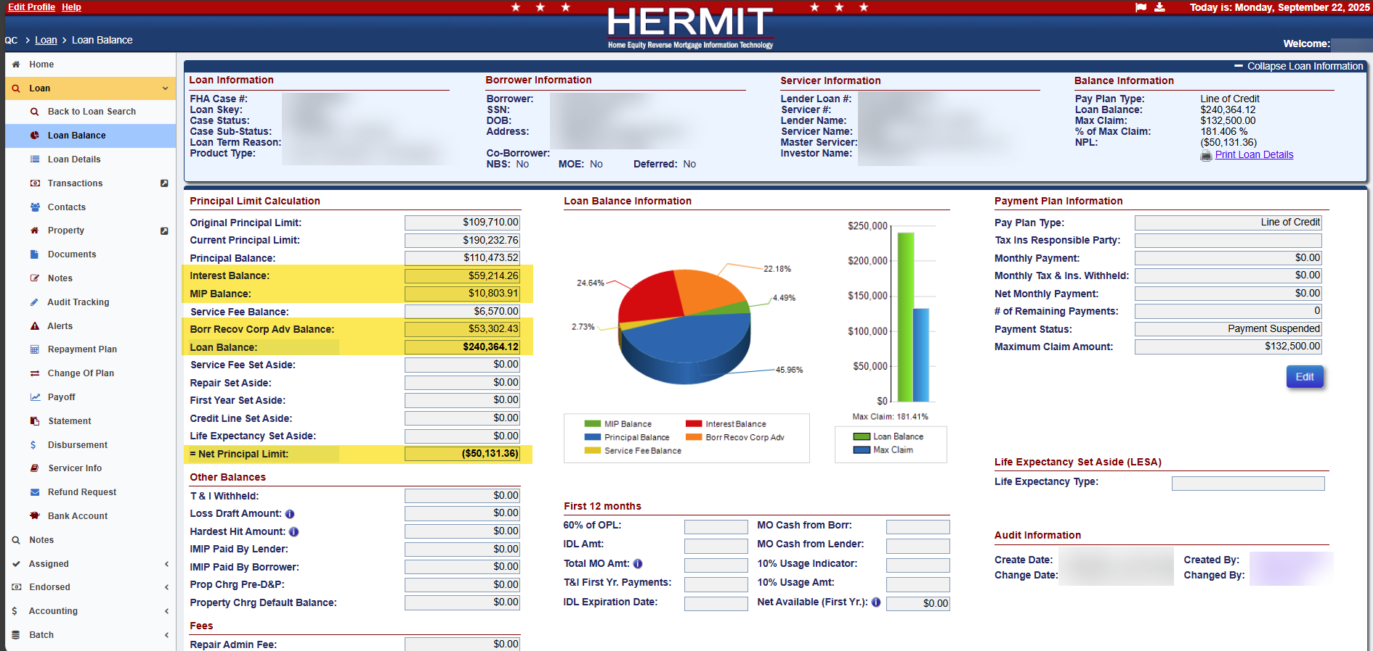

Corporate Advance: Loan > Payoff page (592093)
Updates were made to the Loan > Payoff page. The payoff includes Interest and MIP for all Borrower Recoverable Corporate Advance Transactions and excludes all Non-Borrower Recoverable Corporate Advance Transactions. The Loan Balance row on the Payoff page includes the Borrower Recoverable Corporate Advance Transactions, along with Interest and MIP. When Borrower Recoverable Corporate Transactions have Effective Dates within the current month, those transactions will be displayed on separate rows from the Loan Balance in the payoff page.

Claims: Block 17 and Borrower Recoverable Corporate Advances (592093)
The following changes were made related to Claims and the Borrower Recoverable Corporate Advances:
- Claim Types 21 and 23: Update Block 17 to include Pre-D&P Borrower Recoverable Corporate advances.
- Claim Types 21 and 23: Restrict Adjusting transactions after Claim Paid date
- Claim Type 23 Non-Final Rule: prevent double-payment of Interest

- Claim Types 21 and 23: Update Block 17 to include Pre-D&P Borrower Recoverable Corporate advances.
Updates were made to Claim Types 21 and 23 to include Pre-Due & Payable Borrower Recoverable Corporate Advance amounts to Block 17 on the Claim form if the transaction has an Effective Date and Incurred Date prior to the Due & Payable date, and the transaction is not itemized on the Claim Form. As a result of this change, Borrower Recoverable Corporate Advances added to HERMIT with Effective and Incurred dates prior to the D&P Date will not need to be reclassified to a Pre D&P Advance or LOC Draw in order to be included on the Claim.

- Claim Types 21 and 23: Restrict Adjusting transactions after Claim Paid date
An update was made to restrict transactions from being adjusted after a Claim is paid. The Adjustment icon is disabled for these transactions under Loan > Transactions > Loan.
Servicers can still add transactions after the Parent Claim Paid date and Supplemental Claim Paid dates but can only adjust new transactions that were created after the latest claim paid date.

- Claim Type 23 Non-Final Rule: prevent double-payment of Interest
A change was made to Block 17 on Claim Type 23 Non-Final Rule with Borrower Recoverable Corporate Advance transactions itemized on the claim form: the system automatically reduces Block 17 by the compounded amount of Interest from the later of the Accrual Start Date of 09/01/2025 or the transaction Effective Date through the Block 10 Date. The purpose of this reduction is to prevent double-payment of Interest as Note Interest is itemized on the claim up to Block 10.

No changes were made to the following areas:
  - Claim Types 21 and 23: Rules for including Corporate Advances as itemized expenses remain as previously in place, regardless of whether the Corporate Advance is Borrower Recoverable or not.
  - Claim Type 22: Restriction to filing the claim when the loan has Corporate Advances remains as previously in place.

Timeline Steps: Allow Servicers to update additional Step Complete Dates (582598)
Servicer Manager user role can now edit already completed step Completion Dates for many more Servicer Group steps. Edits are still subject to existing restrictions such as disallowing future dates and preventing edits to steps that are locked at initial completion. Once a claim is submitted for review, editing is prohibited to maintain alignment with curtailment-related controls.
The Admin > Editable Timeline Steps screen was updated to display these changes for authorized users, including HUD NSC Managers.
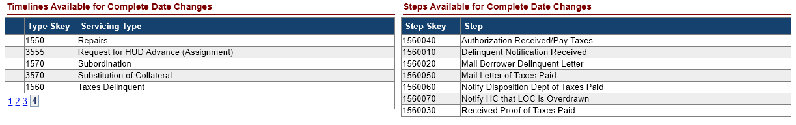

Timeline: Loss Mitigation - Cash for Keys – Schedule Dates (595896)
An update was made to the Loss Mitigation – Cash for Keys Timeline scheduled dates, to vary based on the “Reason for Request” selected and only apply to the following steps:

Step | Reason for Request | Estimated Scheduled Days
Occupant Received Funds | Post Foreclosure Eviction Avoidance | 130
Occupant Received Funds | Deed in Lieu | 270
Occupant Received Funds | Short Sale | 120
Upload Cash for Keys Package | Post Foreclosure Eviction Avoidance | 130
Upload Cash for Keys Package | Deed in Lieu | 270
Upload Cash for Keys Package | Short Sale | 120
Vacated Prop built in appliances and fixes | Post Foreclosure Eviction Avoidance | 100
Vacated Prop built in appliances and fixes | Deed in Lieu | 240
Vacated Prop confirmed Broom Swept | Post Foreclosure Eviction Avoidance | 100
Vacated Prop confirmed Broom Swept | Deed in Lieu | 240
Verified Occupant has vacated/Inspected | Post Foreclosure Eviction Avoidance | 100
Verified Occupant has vacated/Inspected | Deed in Lieu | 240

Servicer and NSC / HUD Related Changes:

Timeline: Updates to certain Letters to include a Mini Miranda and/or Privacy Policy (594691)
The footer on multiple Letters in HERMIT was updated to include a Mini Miranda and to exclude the debt collector reference that was previously stated (if applicable). Additionally, there were four letters updated to include a new Privacy Policy page.
- The prior Debt Collector Reference which states “Compu-Link Corporation as Contractor for The Department of Housing and Urban Development is a debt collector and is attempting to collect on a debt. Any Information obtained shall be used for that purpose.” This debt collector reference was removed from the following Letters:
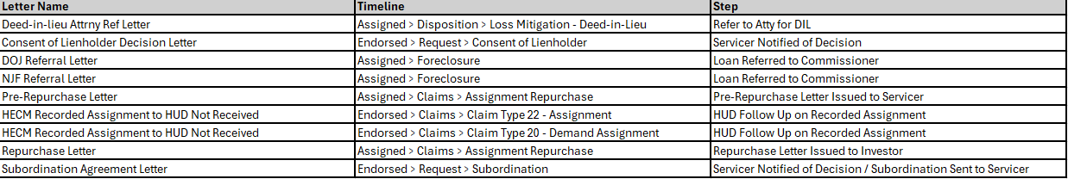

- The Mini Miranda states “This communication is from a debt collector. This is an attempt to collect a debt, and any information obtained will be used for that purpose. Notwithstanding the foregoing, if you are currently in a bankruptcy proceeding or have received a discharge in bankruptcy, this communication is for informational purposes only and is not an attempt to collect a debt. If you are represented by an attorney, please provide this notice to your attorney.” This Mini Miranda was added to the following Letters:

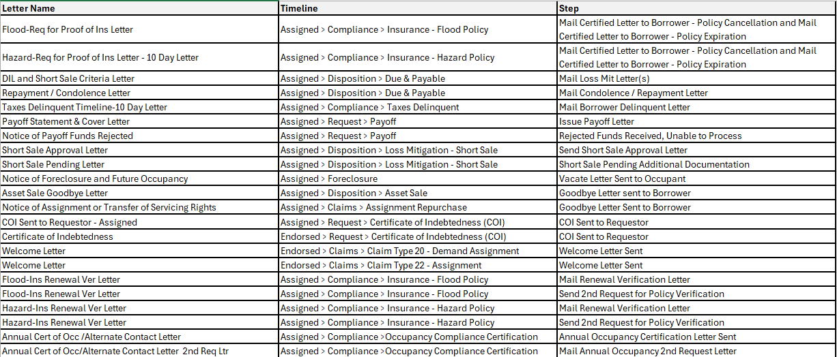

- The Privacy Policy page was added to the Step “Goodbye Letter Sent to Borrower” on the Assigned > Disposition > Asset Sale Timeline and Assigned > Claims > Assignment Repurchase Timeline. This Privacy Policy page was added to the Step “Welcome Letter Sent” on the Endorsed > Claims > Claim Type 20 – Demand Assignment Timeline and Endorsed > Claims > Claim Type 22 –Assignment Timeline.

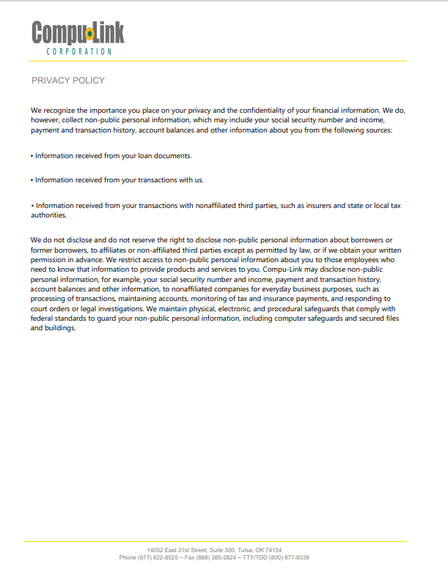

Timelines: Unique Timeline Identifier (595018)
Updates were made to display and search by unique timeline identifier (TL Mgmt Skey) to reduce confusion and create efficiency across multiple timelines.
The Servicing Management Criteria section search functionality, the search results grid, and the results export were updated to include the unique Timeline Management Skey for Timeline Category screens:
- Timeline groups Endorsed and Assigned:
  - Compliance
  - Disposition
  - Requests
  - Foreclosure
  - Bankruptcy
  - Release
  - Claims
- Timeline group Assigned:
  - REO
Servicing Management Criteria search functionality:
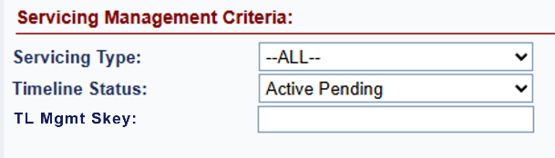
Search results grid:
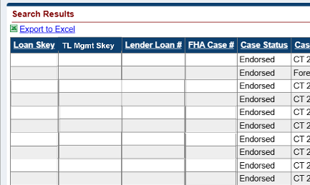

Search results export:
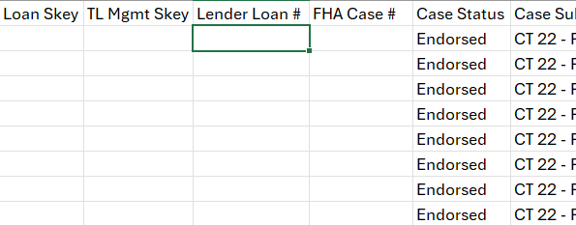

Claims: Form HUD 27011 Updates (595535)
Updates were made in both the document PDF and system stored forms of the Single-Family Application for Benefits Claim Form HUD-27011 following the 2023 version release. When applicable, the updates were applied uniformly to Claim Types 21, 22, 23, and 24.

Reports: Claims Detail (596145)
Updates were made to the Claims Detail report within the Reports module, located under Servicer Reports > Daily Reports, to exclude any loans where the claim payment was adjusted/removed from the loan.

NSC / HUD Related Changes:

Payment Files without Tax ID Numbers (TIN’s) (595825)
Updates were made to administrative and operational screens to require and validate Tax ID. All screens and files require a 9-digit Tax ID.
- An error message is displayed if validations fail in the following areas:
  - Admin > Vendors screen. Required fields:
    - Tax ID
    - City
    - State
    - Zip
  - Bulk Vendor File. Required fields:
    - Tax ID
    - City
    - State
    - Zip
  - Admin > Tax Authority screen. Required fields:
    - Tax ID
    - Auth Payee
    - City
    - State
    - Zip
  - Admin > County Clerks screen. Required fields:
    - Tax ID (Under County Clerk Name)
    - Pay To Name
    - City
    - State
    - Zip
  - Assigned > Compliance > Ins – Hazard Policy Timeline (Edit Servicing Mgmt screen). Conditionally required when Company Name is displayed:
    - Agent Name
    - Tax ID
    - Address 1
    - City
    - State
    - Zip
  - Assigned > Compliance > Ins – Flood Policy Timeline (Edit Servicing Mgmt screen). Conditionally required when Company Name is displayed:
    - Agent Name
    - Tax ID
    - Address 1
    - City
    - State
    - Zip
  - Assigned > Requests > Payoff Request Timeline (Edit Servicing Mgmt screen). Conditionally required when Payee is displayed:
    - Tax ID
    - Address 1
    - City
    - State
    - Zip

- Disbursements
The Loan > Disbursements screen was updated when the user attempts to add a Disbursement and selects Payee Type of “Vendor,” “Tax Authority,” “County Clerk,” “Insurance Agent (For Loan)” or “Payoff Refund” and the Tax ID is missing. New error message states “Tax ID is a required field. Please update in the appropriate area” and previous warning message was removed.
Note: This applies for Disbursements created after Release 8.1
The Batch > NSC Bulk Disbursements screen was updated when the user attempts to add a Disbursement and selects Payee Type of “Vendor,” “Tax Authority,” or “Payoff Refund” and the Tax ID is missing. New error message states “Tax ID is a required field. Please update in the appropriate area” and previous warning message was removed.
The Batch > NSC Disbursement Uploads screen was updated when the user attempts to add a Disbursement B2G file (Inspection, Release Fee, State Prohib Legal – Appraisal and State Prohib Legal – Inspection) where the Payee is missing a Tax ID in the uploaded file. New error message states “Tax ID is a required field. Please update in the appropriate area” and previous warning message was removed.

Timelines: Updates to the Assigned Loss Mitigation - Short Sale Timeline (595004)
The Assigned > Disposition > Loss Mitigation – Short Sale Timeline was updated to include new steps, step types were updated on existing steps, step descriptions were revised, new Error messages were added, existing steps were inactivated, and new triggers were introduced.
- List of Step Changes and New Steps on Loss Mitigation – Short Sale Timeline:
Update | Step Description | Servicing Step Type | Scheduled Date | Rule
Servicing Step Type & Scheduled Date Change | Received Required Documents | Trigger | Timeline Initiation Date plus 20 Days | Triggered by completion of Step “Initiate Short Sale Process”
 |  |  |  | Scheduled Date is set to the Step “Initiate Short Sale Process” Complete Date + 20 Calendar Day
Servicing Step Type & Scheduled Date Change | Prepare Short Sale Calculation Worksheet | Trigger | Complete Date of Step “Received Required Documents” plus 1 Business Day | Triggered by completion by completion of Step “Received Required Documents”
 |  |  |  | Scheduled Date is set to the Complete Date of Step “Received Required Documents” + 1 Business Day
 |  |  |  | Step can only be completed by clicking the “Print” icon tied to the Step
Servicing Step Type & Scheduled Date Change | Send Short Sale Approval request to HUD | Trigger | Complete Date of Step “Prepare Short Sale Calculation Worksheet” plus 1 Business Day | Triggered by completion of Step “Prepare Short Sale Calculation Worksheet”
 |  |  |  | Scheduled Date is set to the Complete Date of Step “Prepare Short Sale Calculation Worksheet” + 1 Business Day
New | Short Sale Decision Issued | Trigger | Complete Date of Step “Send Short Sale Approval request to HUD” or Step “Additional Documentation Sent to HUD” plus 5 Business Days | Triggered by completion of Step “Send Short Sale Approval request to HUD” or “Additional Documentation Sent to HUD”
 |  |  |  | Step automatically completes upon completion of Step “Short Sale Approved by HUD”, “Short Sale Denied by HUD”, or “Short Sale Pending Additional Information”
 |  |  |  | Scheduled Date is set to the Complete Date of Step “Send Short Sale Approval request to HUD” or “Additional Documentation Sent to HUD” + 5 Business Days
Step Condition | Short Sale Approved by HUD | Optional | Step Creation Date | Step “Short Sale Decision Issued” must be Pending Completion to add Step “Short Sale Approved by HUD”
 |  |  |  | Completion of Step “Short Sale Approved by HUD” automatically completes Step “Short Sale Decision Issued”
 |  |  |  | Only one Step can be Pending Completion
Step Condition | Short Sale Denied by HUD | Optional | Step Creation Date | Step “Short Sale Decision Issued” must be Pending Completion to add Step “Short Sale Denied by HUD”
 |  |  |  | Completion of Step “Short Sale Denied by HUD” automatically completes Step “Short Sale Decision Issued”
 |  |  |  | Only one Step can be Pending Completion
Step Group & Step Condition | Short Sale Pending Additional Documentation | Optional | Step Creation Date | Step Group updated from HUD Contractor to HUD
 |  |  |  | Step “Short Sale Decision Issued” must be Pending Completion to add Step “Short Sale Pending Additional Documentation”
 |  |  |  | Completion of Step “Short Sale Pending Additional Documentation” automatically completes Step “Short Sale Decision Issued”
 |  |  |  | Only one Step can be Pending Completion
Servicing Step Type | Send Short Sale Approval Letter | Trigger | Complete Date of Step “Short Sale Approved by HUD” plus 5 Business Days | Triggered by completion of Step “Short Sale Approved by HUD”
 |  |  |  | Scheduled Date is set to the Complete Date of Step “Short Sale Approved by HUD” + 5 Business Days
 |  |  |  | Step can only be completed by clicking the “Print” icon tied to the Step
New | Scheduled Short Sale Closing Date | Trigger | Complete Date of Step “Send Short Sale Approval Letter” plus 5 Business Days | Triggered by completion of Step “Send Short Sale Approval Letter”
 |  |  |  | Step “Scheduled Short Sale Closing Date” Complete Date can be a future date, but cannot be later than the Complete Date of Step “Send Short Sale Approval Letter” + 45 Calendar Days
 |  |  |  | Step “Scheduled Short Sale Closing Date” Complete Date must be on or after Step “Send Short Sale Approval Letter” Complete Date
 |  |  |  | Scheduled Date is set to the Complete Date of Step “Send Short Sale Approval Letter” + 5 Business Days
New | Short Sale Closing Extension Approved | Optional | Step Creation Date | Step “Scheduled Short Sale Closing Date” must be Complete and Step “Short Sale Closing Date” must be Pending Completion to add
 |  |  |  | Step “Short Sale Closing Extension Approved” Complete Date must be after Step “Scheduled Short Sale Closing Date” Complete Date and the latest Step “Short Sale Closing Extension Approved” Complete Date
 |  |  |  | Step “Short Sale Closing Extension Approved” cannot be added if an active completed Step “Short Sale Approval Expired” exists
 |  |  |  | Only one Step can be Pending Completion
Servicing Step Type & Renamed Step | Short Sale Closing Date | Trigger | Step “Scheduled Short Sale Closing Date” Complete Date | Step renamed from “Sale Closing Date” to “Short Sale Closing Date”
 |  |  |  | Triggered by completion of Step “Scheduled Short Sale Closing Date”
 |  |  |  | Scheduled Date is set to the Complete Date of Step “Scheduled Short Sale Closing Date”
Servicing Step Type | Received Closing Proceeds | Trigger | Step “Short Sale Closing Date” Complete Date plus 1 Business Day | Triggered by completion of Step “Short Sale Closing Date”
 |  |  |  | Scheduled Date is set to the Complete Date of Step “Received Closing Proceeds” + 1 Business Day
New | Short Sale Expired | Automated | Step Creation Date | Step will automatically be added to the timeline when Today’s Date is after the Complete Date of Step “Scheduled Short Sale Closing Date” and the latest Complete Date of Step “Short Sale Closing Extension Approved” (if applicable)
New | Additional Documentation Requested | Trigger | Step “Short Sale Pending Additional Documentation” Complete Date plus 2 Business Days | Triggered by completion of Step “Short Sale Pending Additional Documentation”
 |  |  |  | Scheduled Date is set to the Complete Date of Step “Short Sale Pending Additional Documentation” + 2 Business Days
New | Additional Documentation Received | Trigger | Step “Additional Documentation Requested” Complete Date plus 5 Business Days | Triggered by completion of Step “Additional Documentation Requested”
 |  |  |  | Scheduled Date is set to the Complete Date of Step “Additional Documentation Requested” + 5 Business Days
New | Revise Short Sale Calculation Worksheet | Trigger | Step “Additional Documentation Received” Complete Date plus 1 Business Day | Triggered by completion of Step “Additional Documentation Received”
 |  |  |  | Scheduled Date is set to the Complete Date of Step “Additional Documentation Received” + 1 Business Day
New | Additional Documentation Sent to HUD | Trigger | Step “Revise Short Sale Calculation Worksheet” Complete Date plus 1 Business Day | Triggered by completion of Step “Revise Short Sale Calculation Worksheet”
 |  |  |  | Scheduled Date is set to the Complete Date of Step “Revise Short Sale Calculation Worksheet” + 1 Business Day
New | Borrower Notified of Short Sale Denial | Trigger | Step “Short Sale Denied by HUD” Complete Date plus 2 Business Days | Triggered by completion of Step “Short Sale Denied by HUD”
 |  |  |  | Scheduled Date is set to the Complete Date of Step “Short Sale Denied by HUD” + 2 Business Days
New | Referred for Additional Loss Mitigation Review | Trigger | Step “Borrower Notified of Short Sale Denial” Complete Date plus 5 Business Days | Triggered by completion of Step “Borrower Notified of Short Sale Denial”
 |  |  |  | Scheduled Date is set to the Complete Date of Step “Borrower Notified of Short Sale Denial” + 5 Business Days
 |  |  |  | Timeline will inactivate upon completion of Step “Referred for Additional Loss Mitigation Review”
New | Short Sale Cancelled | Optional | Step Creation Date | Only one Step can be Pending Completion
 |  |  |  | Timeline will inactivate upon completion of Step “Short Sale Cancelled”
New | Supplemental Short Sale Calculation Worksheet | Optional | Step Creation Date | Only one Step can be Pending Completion
 |  |  |  | Step “Prepare Short Sale Calculation Worksheet” must be completed to add Step “Supplemental Short Sale Calculation Worksheet”
New | Missing Required Documents | Optional | Step Creation Date | Only one Step can be Pending Completion
 |  |  |  | Step “Received Required Documents” must be Pending Completion to add step “Missing Required Documents”
New | Follow Up | Optional | Step Creation Date | Only one Step can be Pending Completion

- The following step was Inactivated from the Loss Mitigation – Short sale Timeline and will no longer be Active after the Implementation of Release 8.1
    - Deed Recorded Date
- New Error messages were added to prevent duplication of certain steps and prevent steps from being completed out of sequence
    - An Error message will now display if a new step is being added when a pending step already exists.
    - An Error message will now display if a new step is being added out of sequence.
      - For Example, a user will not be able to add a new Optional Step “Short Sale Closing Extension Approved” if there is not an active completed Step “Scheduled Short Sale Closing Date”.

Timeline: Updates to the Assigned > Insurance/Loss Draft Administration Timeline (595770)
The Assigned > Compliance > Insurance/Loss Draft Administration Timeline was updated to include new Error Messages, modify existing Error Messages, update Scheduled Dates from Calendar days to Business days, introduce new system inactivation functionality, and update user role permissions for editing Loss Draft Set Aside Setup Balances.
- A new Error Message will display when the user tries to add one of the following steps when one of the following steps is pending completion:
  - “Issue Initial Disbursement of Repair Funds”
  - “Issue Subsequent Disbursement of Repair Funds”
  - “Issue Final Disbursement of Repair Funds”
  - “Repairs will not be Completed – Review for D&P”
- The Error Message will state “The selected step cannot be added if one of the steps below is pending completion:
  - “Issue Initial Disbursement of Repair Funds”
  - “Issue Subsequent Disbursement of Repair Funds”
  - “Issue Final Disbursement of Repair Funds”
  - “Repairs will not be Completed – Review for D&P”
Inactivate the existing pending step to add the new step or click cancel from the New Step Modal.”
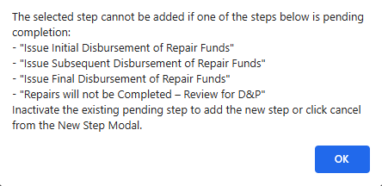

- A new Error Message will display when there is an active pending “Send Lien Waiver” or “Lien Wavier Received” and the user adds the step “Issue Final Disbursement of Repair Funds.”
- The Error Message will state “All Lien Waiver steps must be completed before completing Step “Issue Final Disbursement of Repair Funds.””
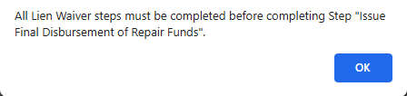

- The Error message “The selected step cannot be added since the “Contract/Adjuster’s Report” has already been received” was modified to state “There must be an active pending “Verify Contract/Adjuster’s Report Received” step in order to add the selected step.”
- When the following steps are added to the Timeline the Scheduled Date was updated from Calendar days to Business days:
- “Repair Inspection Received”
- “Subsequent Repair Inspection Received”
- “Send Lien Waiver”
- “Lien Waiver Received”
- “Supplemental Inspection Received”
- “Transfer of Repair Funds to Loan Balance”
- The system will automatically Inactivate the Assigned > Compliance > Insurance/Loss Draft timeline when the “Remaining Balance” field on the Servicing Mgmt tab is $0.00 and the Step “Transfer of Repair Funds to Loan Balance” or “Issue Final Disbursement of Repair Funds” is completed.
- The Role “HUD Contractor Cash” can now edit the “Loss Draft – Setup” on the Loan > Transaction > Set Aside page along with the Roles “HUD Contractor Cash Supervisor” and “HUD NSC Manager.”

Timeline: Updates to the Assigned > Request for Unscheduled Advance and Assigned > Request for Payment Timelines. (595082)
The Timelines Assigned > Compliance > Request for Unscheduled Advance and Assigned > Compliance > Request for Payment were updated to have a Step auto completed with the Initiation Date at Timeline Setup.
- The Step “Request for funds Received” will auto-complete with the Initiation Date entered at Timeline Setup on the Assigned > Compliance > Request for Unscheduled Advance Timeline.
- The Step “Payment Requested” will auto-complete with the Initiation Date entered at Timeline Setup on the Assigned > Compliance > Request for Payment Timeline.

Reports: Timeline Identifier to Timeline Activity Report (595018)
Updates were made to the Timeline Activity report within the Reports module, located under Reports > Assigned Notes Reports > Daily Reports, to display and search by unique timeline identifier or Timeline Mgmt Skey.
Timeline Activity Report:

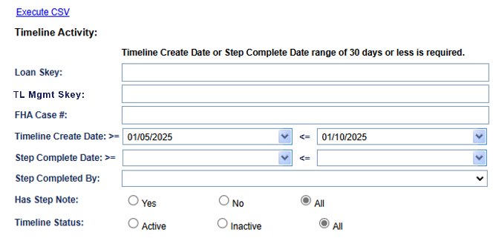

Reports: Bulk Printing Letters Report (50934)
An update was made to the Bulk Printing Letters report within the Reports module, located under Reports > Assigned Notes Reports > Daily Reports, to remove text from the page which previously stated “* * * Report is only looking at Servicer = ‘Compu-Link Corporation’ and Case Status = ‘Assigned’ or ‘Endorsed’ * * *”. The text was removed because the Welcome Letter Sent letter may be generated by the NSC contractor for cases not yet showing Servicer as HUD.

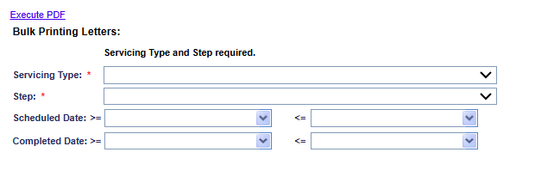

Dashboard Landing: Export to Excel
An update was made to the Dashboard Summary page to add an “Export to Excel” link to the Timeline Summary results.
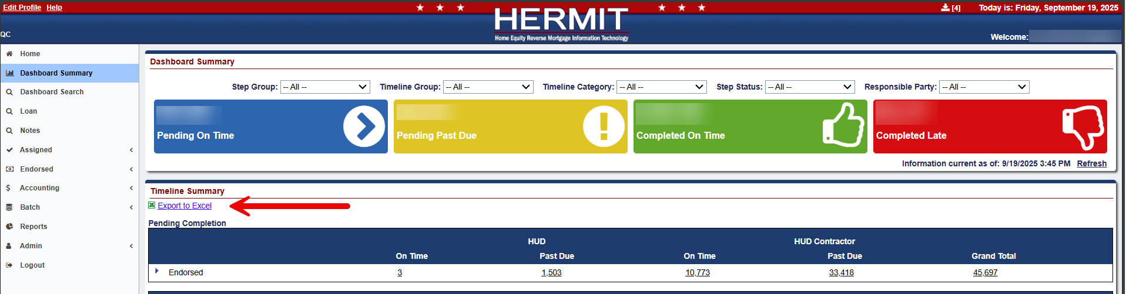

Clicking the “Export to Excel” link will generate up to 4 reports in the Download Queue at the top right of the page for the criteria selected:
- DashboardCompletedEndorsed
- DashboardCompletedAssigned
- DashboardPendingEndorsed
- DashboardPendingAssigned
Download Queue Link:
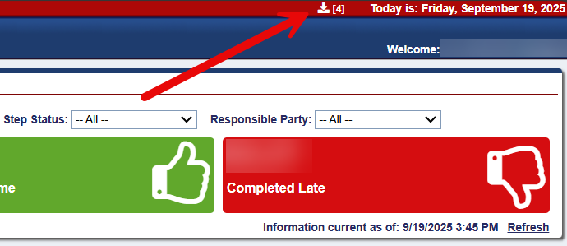
Download Queue Results:
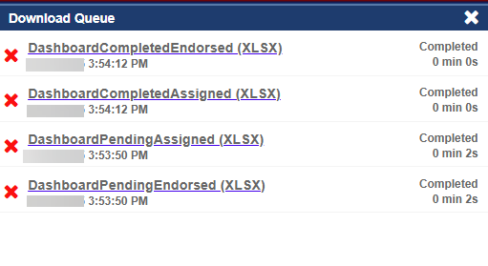

------ End of Document -----

