Home Equity Reverse Mortgage Information Technology
(HERMIT)

HERMIT System Changes – Release 7.91

Release Date: 03/29/25
Document Date: 03/29/25
Version 1.0

March 2025

INTRODUCTION
The Home Equity Reverse Mortgage Information Technology (HERMIT) software release version 7.9 consists of the following system changes:
Table of Contents
NSC / HUD Related Changes: 3
1. New Dashboard Summary page 3
2. New Dashboard Search page 7

If you have any questions regarding the functionality of the software release, please contact the HERMIT Help Desk at 561-899-2610 or at servicingsupport@hermitsp.com. If you have any policy related questions, please send an email to HUD at answers@hud.gov.

NSC / HUD Related Changes:

New Dashboard Summary page
Two new pages were added to HERMIT for all HUD NSC and HUD NSC Contractor User Roles: Dashboard Summary and Dashboard Search. HUD NSC and HUD NSC Contractor User Roles will be directed to the Dashboard Summary page upon logging in, as the Landing page for these users. Search filters are available on both pages allowing the user to further drill down the summary and grid detail.
HUD NSC Manager and Contractor Supervisor/ Mgmt user roles can view the Dashboard data for all Responsible Parties. However, individual users will only see Timeline Steps where they are the user listed as the Resonsible Party on that timeline.
The Dashboard excludes counts for Terminated Loans and Timelines that are Inactive. In addition, the initial implementation of the Dashboard pages includes the following specific Timelines. Additional timelines will be added at a later date.
  - Endorsed > Claims > Claim Type 22 – Assignment
  - Endorsed > Requests > Due & Payable w/ HUD Approval
  - Assigned > Compliance > Insurance – Flood Policy
  - Assigned > Compliance > Insurance – Hazard Policy
  - Assigned > Compliance > Insurance/Hardest Hit Funds Administration
  - Assigned > Compliance > Insurance/Loss Draft Administration
  - Assigned > Compliance > Occupancy Compliance Certification
  - Assigned > Disposition > Loss Mitigation – Short Sale

The Dashboard Summary page has two sections:
  - Dashboard Summary
  - Timeline Summary

- The Dashboard Summary section includes dropdown filters that can be selected to limit search results, as well as summary boxes with counts of Timeline Steps, by category.
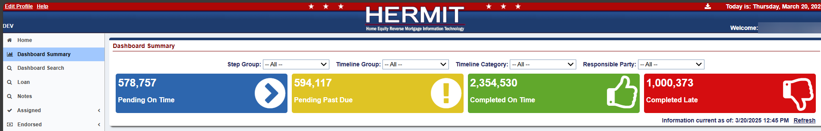
- Dashboard Summary dropdown filter options are:
  - Step Group
    - HUD
    - HUD Contractor
  - Timeline Group
    - Assigned
    - Endorsed
  - Timeline Category
    - Claims – Endorsed
    - Compliance – Assigned
    - Disposition – Assigned
    - Requests – Endorsed
  - Responsible Party
    - List of all users who are assigned a Responsible Party on at least one of the Timelines in the Dashboard

- Dashboard Summary boxes: Blue, Yellow, Green, and Red boxes are displayed with counts of Timeline Steps, by category are dependent on the filter criteria selected on the page. These boxes show the counts for the following:
  - Pending On Time (color blue)
  - Pending Past Due (color yellow)
  - Completed On Time (color green)
  - Completed Late (color red)

Clicking on a box under the Dashboard Summary page automatically opens a new Dashboard Search window that displays the results for that population. See Topic #2 for information on the Dashboard Search page.

- The Timeline Summary section on the Dashboard Summary page displays detailed results based on the Dashboard Filters and if applicable, individual User Roles.
- Timeline Summary is organized into Step status Pending Completion and Steps Completed. The first 2 boxes are for Pending Completion steps and are separated by what Timeline Group the timeline is listed under: Endorsed or Assigned. Under each Step Status and Timeline Group, information can be further drilled down by clicking on the arrow on the left of the row to expand the grid.
There are five columns displayed: two columns for HUD steps, two columns for HUD Contractor steps, and one Grand Total. Columns displayed:
  - HUD Steps On Time
  - HUD Steps Past Due
  - HUD Contractor Steps On Time
  - HUD Contractor Steps Past Due
  - Grand Total

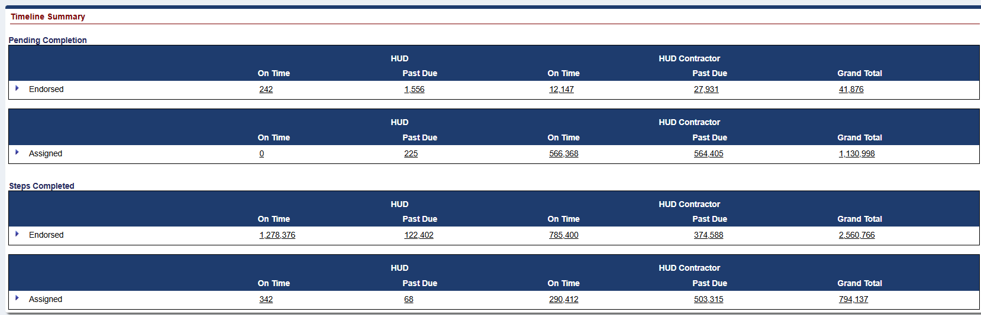
- Drilling down in the Timeline Summary grid. By clicking the blue arrow to the left of the row, the data can be drilled into. Clicking on a numerical count in the Timeline Summary grid automatically opens a new Dashboard Search window that displays the results for that population.
  - The drill order is Timeline Group > Responsible Party > Timeline Category > Timeline Name/Servicing Type > Step Name.
  - *For User Roles HUD NSC-Mgr and Contractor-Supervisor/Management, information is displayed for all Responsible Parties, including timelines with Responsible Party not yet assigned: listed in the results as “Unassigned”. For other user roles, the users will see only steps for timelines where they are assigned Responsible Party.
    - HUD NSC-Mgr*
    - HUD NSC-Staff
    - Contractor-Supervisor/Management*
    - Contractor-Cash
    - Contractor-Cash Supervisor
    - Contractor-Customer Service
    - Contractor-Default
    - Contractor-Documentation
    - Contractor-First Mortgage
    - Contractor-Release
    - Contractor-Release Supervisor
    - HUD Read Only
  - Example of drilling down / expanding grid results for user that can view multiple Responsible parties.
    - Expand Endorsed
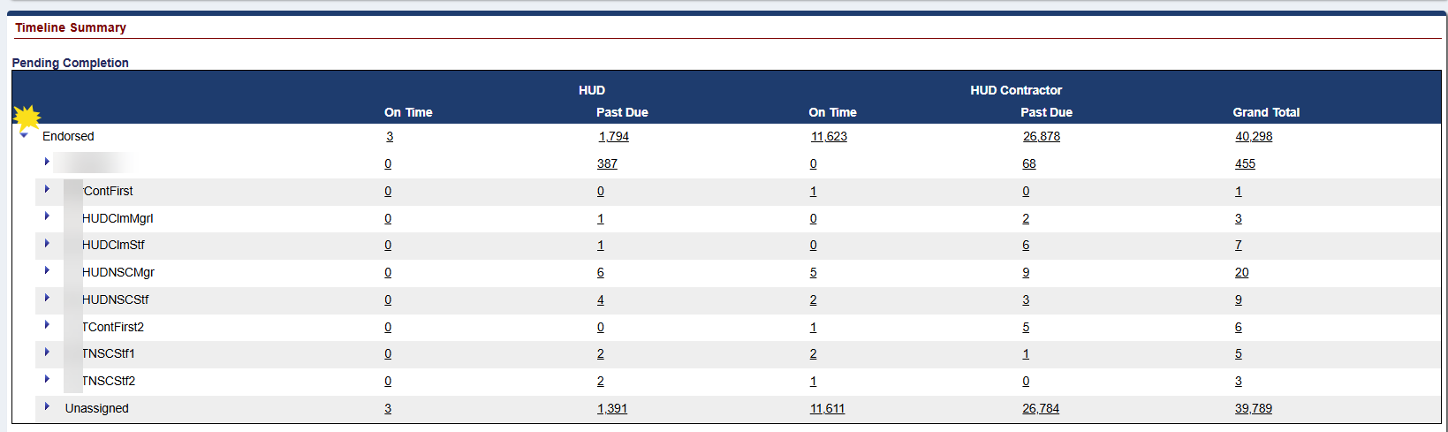
    - Expand Unassigned
    - Expand Requests – Endorsed
    - Expand Due & Payable w/HUD Approval
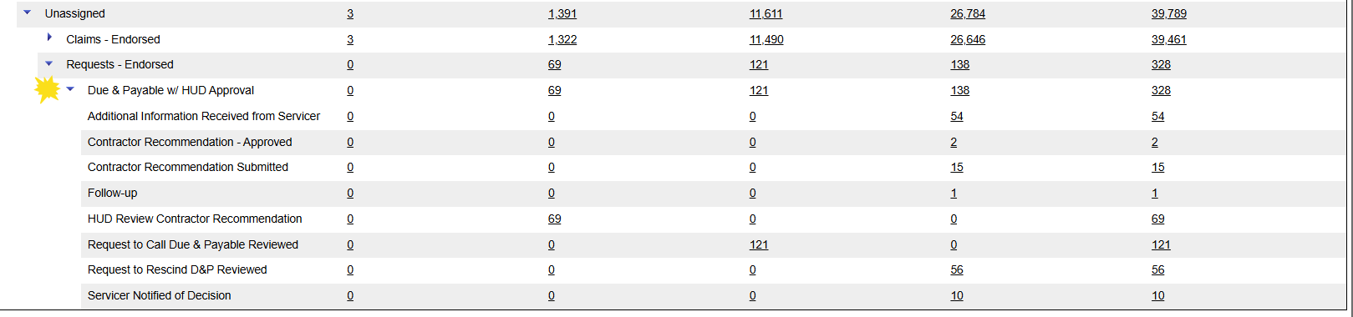
    - The counts will be displayed for each row in each category corresponding to the Step Group selected.

New Dashboard Search page
The second of two new pages added to HERMIT for all HUD NSC and HUD NSC Contractor User Roles is the Dashboard Search page.
Both Dashboard pages exclude counts for Terminated Loans and Timelines that are Inactive. In addition, the initial implementation of the Dashboard pages includes the following specific Timelines. Additional timelines will be added at a later date.
  - Endorsed > Claims > Claim Type 22 – Assignment
  - Endorsed > Requests > Due & Payable w/ HUD Approval
  - Assigned > Compliance > Insurance – Flood Policy
  - Assigned > Compliance > Insurance – Hazard Policy
  - Assigned > Compliance > Insurance/Hardest Hit Funds Administration
  - Assigned > Compliance > Insurance/Loss Draft Administration
  - Assigned > Compliance > Occupancy Compliance Certification
  - Assigned > Disposition > Loss Mitigation – Short Sale

- The Dashboard Search page displays search criteria and detailed results based on the Dashboard Filters. A user navigates to this page either by clicking on a numerical step count in the Timeline Summary section of the Dashboard Summary page or clicking on Dashboard Search on the Left Menu.
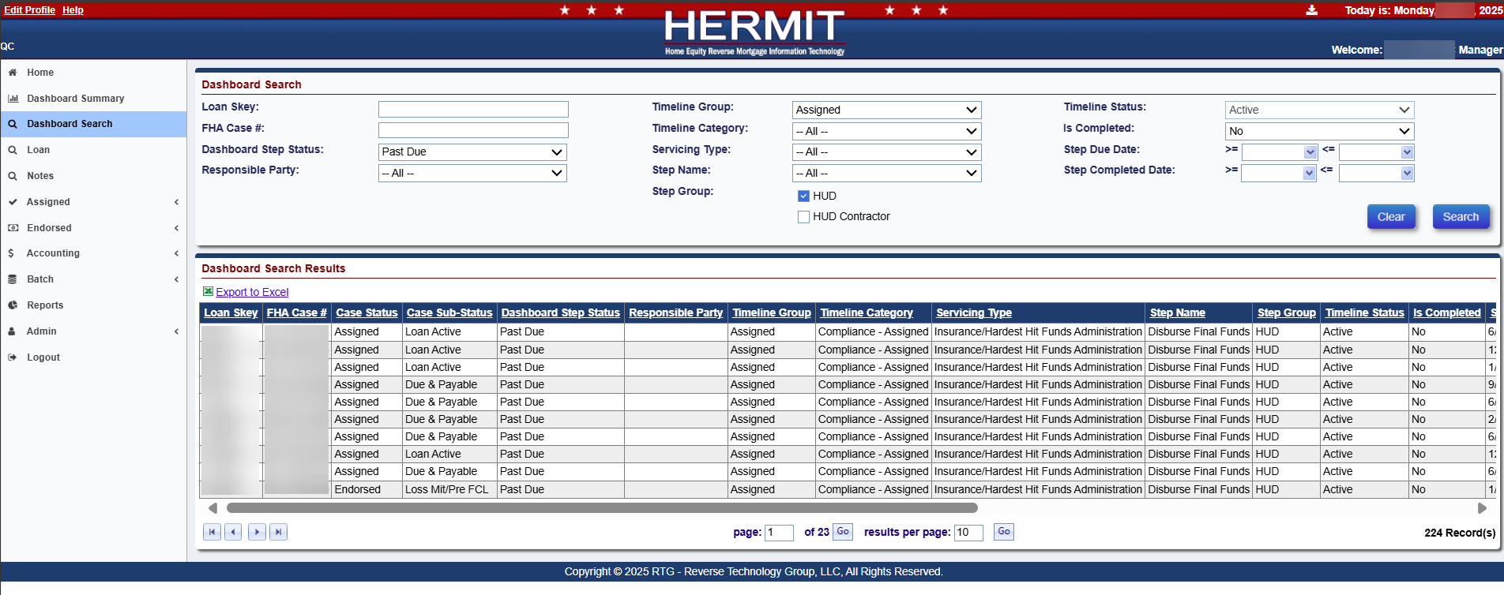
- Dashboard Search screen allows a user to enter customized search parameters and click Search. The results for the corresponding population will be displayed under the Dashboard Search Results section of the screen. The results may be exported using the Export to Excel feature or users can jump directly to the timeline which houses that step by clicking the desired loan displayed in the result grid.
------ End of Document -----

