Home Equity Reverse Mortgage Information Technology
(HERMIT)

HERMIT System Changes – Release 8.0

Release Date: 06/21/25
Document Date: 06/20/25
Version 1.0

June 2025

INTRODUCTION
The Home Equity Reverse Mortgage Information Technology (HERMIT) software release version 8.0 consists of the following system changes:
Table of Contents
Servicer Related Changes 4
1. Loan: Update to Initial MIP and Monthly MIP Late Charges and Penalty Interest (589990) 4
2. New Report: Prop Pres Detail (594812) 4
3. Updated Report: Loan Principal Limit Detail Report updated to require Case Sub-Status to pull the report (50199) 6
4. New Endorsed Timeline: Loss Mitigation - Cash for Keys (590396) 7
5. Claims: Hard Stop Validation: Loss Mitigation - Cash for Keys (590396) 7
6. Claims: Timeframes and permitted dollar amounts: Loss Mitigation - Cash for Keys (590396) 8
Servicer and NSC / HUD Related Changes: 10
7. Claims: Timeframes and permitted dollar amounts: Loss Mitigation - Cash for Keys (590396) 10
8. General: Password Reset (590927) 11
9. Notes: Search Screen (594495) 11
10. Servicing: Identifying Primary Servicer ID (594496) 12
11. Loan: Contacts (594754) 12
12. Accounting Transmittal: Screen (594494) 13
13. Disbursements: New Export Disbursements link on Loan - Disbursement Page 13
14. Disbursements & Transactions: Automatically Populate Transaction Type when only one option is available (593657) 14
15. Transactions: Add Unique Transaction Codes for Existing Termination Transactions (591343) 15
16. Transactions: Update Loan Bal on Trans Dt Column on the Loan Transactions Page (50336) 15
17. Timeline: All Endorsed and Assigned Timeline Search results were updated to include three new columns (594405) 15
18. Timeline: New Letter Step added to Assigned and Endorsed – Bankruptcy Ch. 7, Bankruptcy Ch.13, and Foreclosure Timelines (539291) 16
19. Timelines: Extension Timelines (566144) 19
20. Timelines: Updates to the Assigned & Endorsed Occupancy Compliance Certification Timeline (594764) 20
21. Timelines: Updates to Insurance – Hazard Policy and Insurance – Flood Policy Timelines and New Alerts (590751) 22
NSC / HUD Related Changes 29
22. New Alerts on Assigned > Compliance: Insurance – Hazard and Flood Policy Timelines (590751) 29
23. New Alerts on Other Assigned > Compliance Timelines 32
24. Timelines: Updates to the Assigned > Insurance/Loss Draft Administration Timeline (593367) 34
25. Report Updates: Property Charge Default Reporting (50521) 39
NSC / HUD Dashboard 39
26. New Dashboard Summary page (589639 / 50479) 39
27. New Dashboard Search page 43

If you have any questions regarding the functionality of the software release, please contact the HERMIT Help Desk at 561-899-2610 or at servicingsupport@hermitsp.com. If you have any policy related questions, please send an email to HUD at answers@hud.gov.

Servicer Related Changes

Loan: Update to Initial MIP and Monthly MIP Late Charges and Penalty Interest (589990)
The Late Charges and Penalty Interest on Initial MIP (IMIP) and Monthly MIP (MMIP) have been updated to separate the timeframes based on Non-Final Rule Loans (FHA Case Number Assignment < 09/19/2017) and Final Rule Loans (FHA Case Numbers Assigned on or after 09/19/2017). Changes in this Release are to the grace period / # of days for Non-Final Rule loans. The logic for Final Rule loans is unchanged but stated in the below table below for convenience. These are the timeframes for Late Charge and Penalty Interest:
 | Type | FHA Case Numbers Assigned prior to 09/19/2017 | FHA Case Numbers assigned on or after 09/19/2017
Initial MIP | Late Charge | Late Charges will be assessed to the loan if payment is not received within 15 days of the Closing Date | Late Charges will be assessed to the loan if payment is not received within 20 days of the Closing Date
Initial MIP | Penalty Interest (Interest Charge) | Penalty Interest will be assessed to the loan if payment is not received within 30 days of the Closing Date | Penalty Interest will be assessed to the loan if payment is not received within 20 days of the Closing Date
Monthly MIP | Late Charge | Late Charges will be assessed to the loan if payment is not received within 10 days of the 1st Business Day of the Month. | Late Charges will be assessed to the loan if payment is not received within 5 days of the 1st Business Day of the Month.
Monthly MIP | Penalty Interest (Interest Charge) | Penalty Interest will be assessed to the loan if payment is not received within 30 days of the 1st Business Day of the Month | Penalty Interest will be assessed to the loan if payment is not received within 5 days of the 1st Business Day of the Month

New Report: Prop Pres Detail (594812)
A new report called “Prop Pres Detail” was added in the Reports module under Servicer Reports > Daily Reports. Servicers initiate the Preservation and Protection timeline for each over-allowable (OA) request when the Preservation and Protection expenses exceed the HUD allowable limits. Since multiple active P&P timelines can be initiated on a loan, this report provides better visibility of what has been sent to HUD for a decision, when the Servicer is notified of the decision, the outcome of the request, as well as a full history of OA requests for a selected loan.
Servicer Reports area:
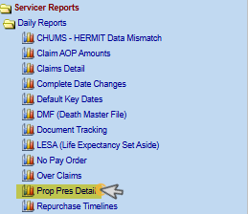
Prop Pres Detail Report Search Criteria:
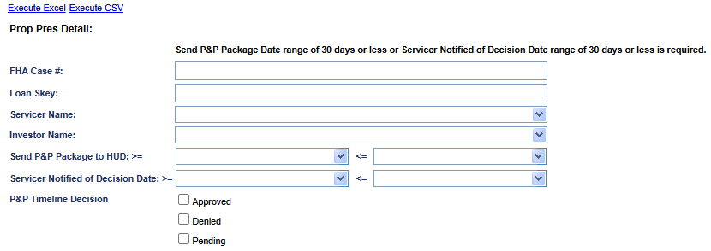
- Search Criteria includes:
- FHA Case #
- Loan Skey
- Servicer Name
- Investor Name
- Send P&P Package to HUD (date range of 30 days or less)
- Servicer Notified of Decision Date (date range of 30 days or less)
- Selectable filter criteria for P&P Timeline Decision:
- Approved
- Denied
- Pending
- The output is available in CSV and Excel formats and includes the following fields:
- Skey
- FHA Case #
- Case Status
- Case Sub Status
- Servicer Name
- Investor Name
- Request ID
- Specific Timeline Number
- Sequence Number
- Transaction Code
- Transaction Type
- HUD Bid Decision (Approved, Denied, Pending)
- Bid Requested Amt
- Bid Approved Amt
- Bid 1 Amt
- Bid 2 Amt
- Specific Transaction Number
- Linked (Y/N)
- Linked Transaction amount
- Linked Transaction - Trans Date
- Linked Transaction - Effective Date
- Linked Transaction - Incurred Date
- Servicer remarks
- HUD remarks
- Created user id
- Created date
- HUD Decision User ID
- HUD Decision Date
- HUD Decision - Approved Step Date (for this timeline)
- HUD Decision - Denied Step Date (for this timeline)
- HUD Decision - Pended Step Date (for this timeline)
- Line-Item User ID
- Line-Item Change Date

Updated Report: Loan Principal Limit Detail Report updated to require Case Sub-Status to pull the report (50199)
The Loan Principal Limit Detail Report was updated to require Case Sub-Status when the user Executes the report as CSV or Excel. The Error message “Case Sub-Status is required” will be displayed when a user tries to execute the Report without selecting a Case Sub-Status. The user will not receive the Error if a Loan Skey is entered at the time the report is executed.
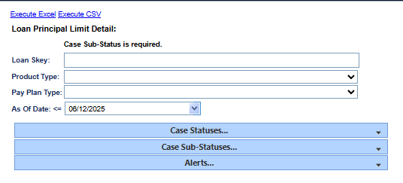

New Endorsed Timeline: Loss Mitigation - Cash for Keys (590396)
A new Timeline was created under Endorsed > Disposition: Loss Mitigation - Cash for Keys Timelines. In addition to standard fields required to set up the timeline, a “Reason for Request” must be selected from the following options:
- Deed in Lieu
- Post-Foreclosure Eviction Avoidance
- Short Sale
The following template timeline steps are created upon timeline initiation and then based on the user-reported “Reason for Request” as follows:
Servicing Step Description | Reason for Request
Cash for Keys Offer Letter Sent | All
Cash for Keys Offer Letter Received (Confirmation) | All
DIL was executed | Reason: Deed In Lieu (Only)
DIL returned to the Mortgagee | Reason: Deed In Lieu (Only)
DIL was filed for recording | Reason: Deed In Lieu (Only)
Recorded DIL received | Reason: Deed In Lieu (Only)
Date and amount of the relocation offer | Reason: Post FCL Eviction (Only)
Short sale closing date | Reason: Short Sale (Only)
Date and amount of the Cash for Keys offer | Reason: Short Sale (Only)
Verified Occupant has vacated /Inspected | Reason: Post FCL Eviction & DIL (Only)
Vacated Prop confirmed Broom Swept | Reason: Post FCL Eviction & DIL (Only)
Vacated Prop built in appliances and fixes | Reason: Post FCL Eviction & DIL (Only)
Occupant received funds | All
Upload Cash for Keys Package | All

Claims: Hard Stop Validation: Loss Mitigation - Cash for Keys (590396)
A new hard stop validation was added in the submission of Claim Types 21, and 23. If there is a Cash for Keys transaction on the claim form (Transaction Code 2136) then step “Upload Cash for Keys Package” on the Loss Mitigation – Cash for Keys timeline must have a step completion date to pass validation. If the transaction exists but the step is not completed, the hard stop validation message will show:
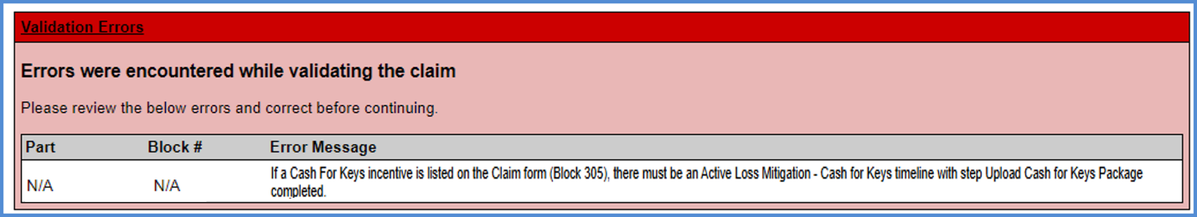

Claims: Timeframes and permitted dollar amounts: Loss Mitigation - Cash for Keys (590396)
Updates were made on the 1st popup modal displayed after the Servicer User clicks “Finalize and Submit Claim” for each condition to display additional text related to the Cash for Keys transaction.
- For Claim Type 21 and “Deed In Lieu Obtained” checked on the Disposition Information page: if Transaction “Corp Adv - S305 - Cash For Keys” TC 2136 is itemized in Part D: Support Document of the claim form: with Effective Date of the transaction:
Is within 365 Days from Block 29 (Due and Payable Date): Display message:
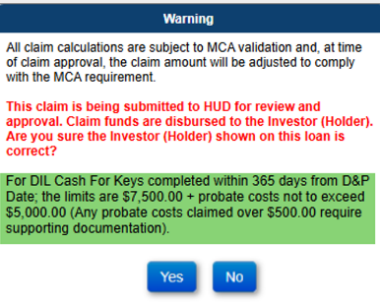
Is between 366 days and 547 days from Block 29 (Due and Payable Date): Display message:
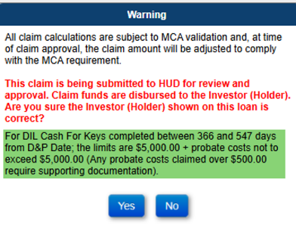
- For Claim Type 21 and “Foreclosure” checked on the Disposition Information page, if Transaction “Corp Adv - S305 - Cash For Keys” TC 2136 is itemized in Part D: Support Document of the claim form; AND Cash For Keys timeline with Reason for Request “Post Foreclosure Eviction Avoidance”: with Effective Date of the transaction:
Is within 60 days of the step completion date for “Date and Amount of the Relocation Offer” on the Cash for Keys timeline: Display message:
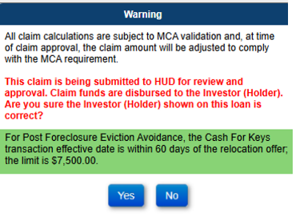
Is between 61 days and 90 days from the step completion date for “Date and Amount of the Relocation Offer” on the Cash for Keys timeline: Display message:
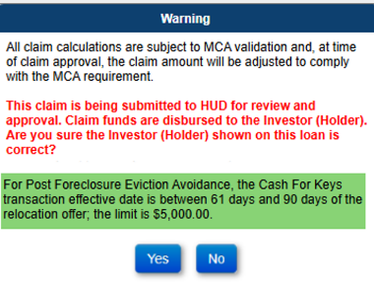
Is greater than 90 days from the step completion date for “Date and Amount of the Relocation Offer” on the Cash for Keys timeline: Display message:
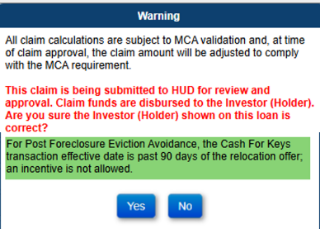
- For Claim Type 23 Short Sale: if Transaction “Corp Adv - S305 - Cash For Keys” TC 2136 is itemized in Part D: Support Document of the claim form; with Effective Date of the transaction:
Is within 365 Days from Block 29 (Due and Payable Date), Display message:
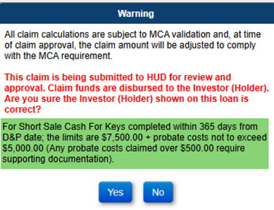
Is between 366 days and 547 days from Block 29 (Due and Payable Date), Display message:
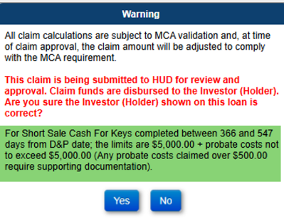

Servicer and NSC / HUD Related Changes:

Claims: Timeframes and permitted dollar amounts: Loss Mitigation - Cash for Keys (590396)
Updates were made to display additional text related to the Cash for Keys transaction on the Claims HUD Decision window when the HUD user clicks the magnifying glass icon on step the Ready for Review or Re Review.
- For Claim Type 21 and “Deed In Lieu Obtained” checked on the Disposition Information page: if Transaction “Corp Adv - S305 - Cash For Keys” TC 2136 is itemized in Part D: Support Document of the claim form: with Effective Date of the transaction:
Is within 365 Days from Block 29 (Due and Payable Date): Display message:
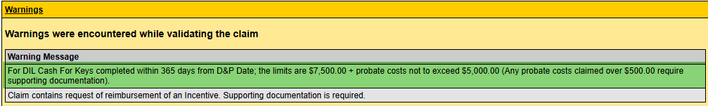
Is between 366 days and 547 days from Block 29 (Due and Payable Date): Display message:
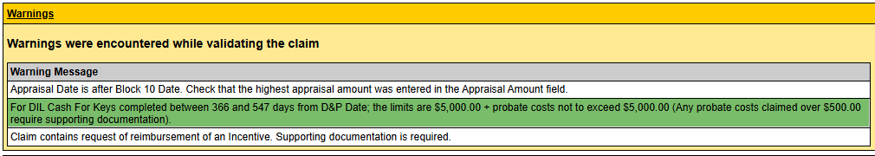
- For Claim Type 21 and “Foreclosure” checked on the Disposition Information page, if Transaction “Corp Adv - S305 - Cash For Keys” TC 2136 is itemized in Part D: Support Document of the claim form; AND Cash For Keys timeline with Reason for Request “Post Foreclosure Eviction Avoidance”: with Effective Date of the transaction:
Is within 60 days of the step completion date for “Date and Amount of the Relocation Offer” on the Cash for Keys timeline: Display message:
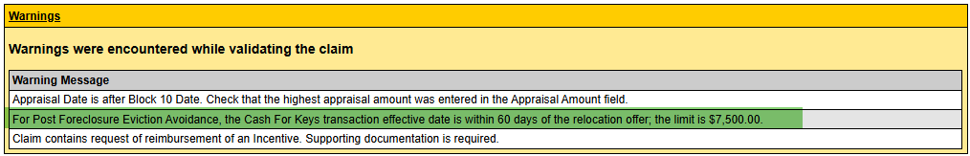
Is between 61 days and 90 days from the step completion date for “Date and Amount of the Relocation Offer” on the Cash for Keys timeline: Display message:
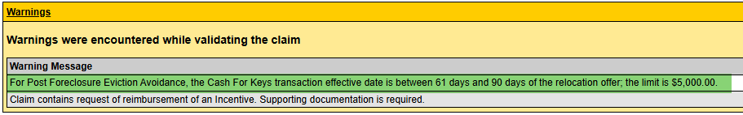
Is greater than 90 days from the step completion date for “Date and Amount of the Relocation Offer” on the Cash for Keys timeline: Display message:
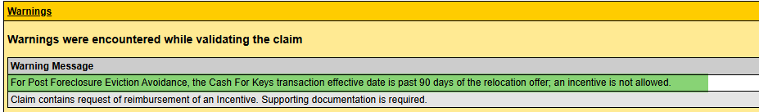
- For Claim Type 23 Short Sale: if Transaction “Corp Adv - S305 - Cash For Keys” TC 2136 is itemized in Part D: Support Document of the claim form; with Effective Date of the transaction:
Is within 365 Days from Block 29 (Due and Payable Date), Display message:
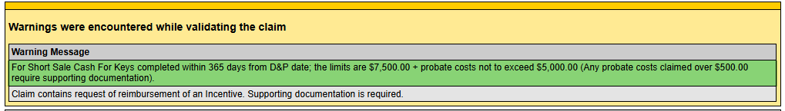
Is between 366 days and 547 days from Block 29 (Due and Payable Date), Display message:
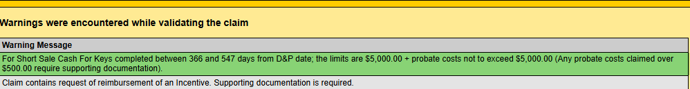

General: Password Reset (590927)
Updates were made to the current password reset functionality once the users account has been locked due to three unsuccessful login attempts, with updated instructions.

Notes: Search Screen (594495)
An update was made on the Notes search screen to add an additional searchability feature. Case Status in the dropdown search was updated to include “ALL” case statuses:
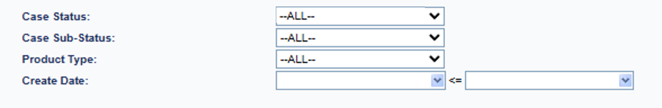

Servicing: Identifying Primary Servicer ID (594496)
Updates were made to better identify the primary or main Servicer ID when there are multiple Mortgagee ID’s with the same Servicer Name. All search boxes which include “Servicer Name” have been updated to sort, showing the primary servicer name first/top results. Additionally, changes to the font color on the search results, allowing the alternate results to show a clear distinction from the primary servicer. With this change, Mortgagee ID’s which do not have bank routing and/or account numbers stored within the system, are changed to show a clear distinction, however, continuing to allow selection by the user.
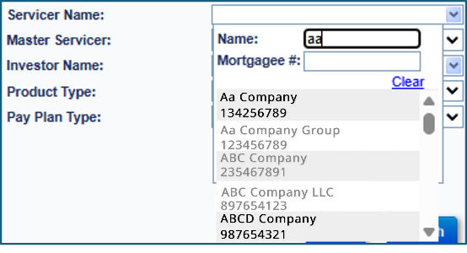

Loan: Contacts (594754)
Updates were made to the Loan > Contacts Information screen to display the last four digits of the Social Security Numbers (SSN#) for additional Borrowers.
Contact Information:
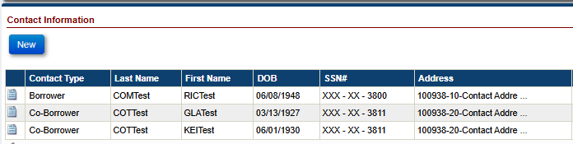
Other Information:
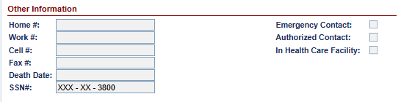

Accounting Transmittal: Screen (594494)
Updates were made on the Accounting > Transmittal search page to add additional searchability features, changes to the search results and the output search results.
Changes to the search parameters to add searchability of:
- Batch Status
- Batch Amount
- GL Sent Date
- Sent Confirmation Date
- Posted Date
Changes to add an Information bubble to the Transmittal Search screen to inform the user:
Investor Name is only searchable for Claims Payable, Claims Receivable and Monthly MIP Due
Changes to the Transmittal search results and the Transmittal search results export:
- Investor Name to display the Investor associated with the transmittal batch
- Servicer # to display the Servicer Mortgagee ID associated with the transmittal batch
- Investor # to display the Investor Mortgagee ID associated with the transmittal batch

Disbursements: New Export Disbursements link on Loan - Disbursement Page
An export link called “Export Disbursements” was added to the Loan > Disbursements screen for all Assigned loans to allow the users to export disbursements to excel.
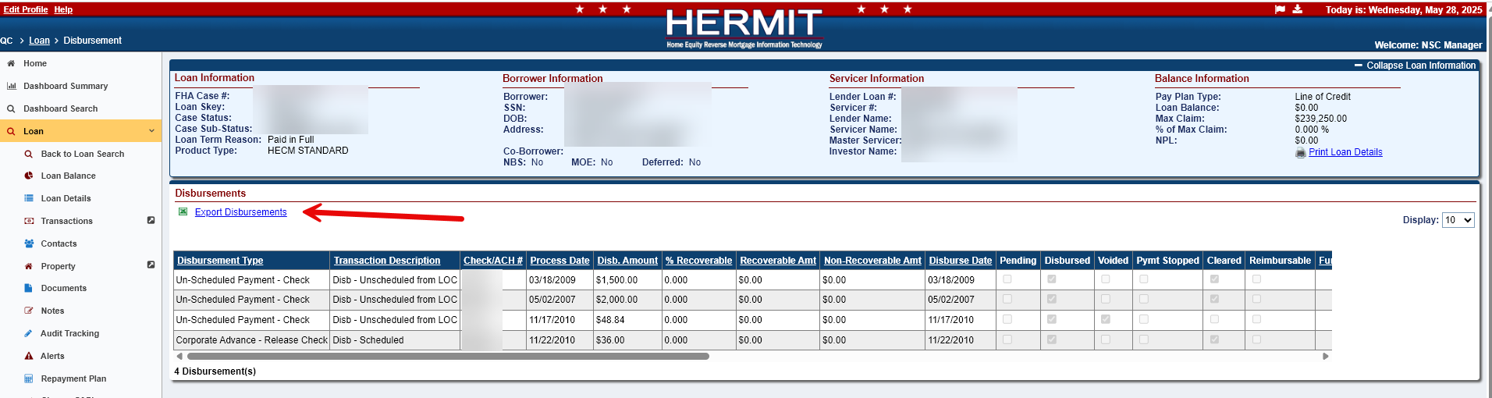

Disbursements & Transactions: Automatically Populate Transaction Type when only one option is available (593657)
An update was made when processing transactions or disbursements with one Transaction Type (Endorsed) or Transaction Description (Assigned) for the applicable Transaction Category. The system will automatically populate the dropdown selection Transaction Type/Transaction Description for options with only one selection once the Transaction Category has been selected.
Loan > Transactions (Endorsed)
- “Disb – Refund/Payment Remittance Overage,” the Transaction Type automatically populates “Disb – Refund/Payment Remittance Overage” (Trans Code = 2550)
Loan > Disbursements (Assigned)
- “Corp Advance - Penalty,” the Transaction Type automatically populates “Corp Advance – Penalty” (Trans Code = 2211)
- “Disb – Scheduled” automatically populates “Disb – Scheduled” (TC = 1250)
- “Disb – Refund/Payment Remittance Overage,” the Transaction Type automatically populates “Disb – Refund/Payment Remittance Overage” (Trans Code = 2550)
Batch > Servicer Transactions (Endorsed)
- “Disb – Scheduled” automatically populates “Disb – Scheduled” (TC = 1250)
- “Disb – Taxes & Insurance Withheld” automatically populates “Disb – Taxes & Ins Withheld” (TC = 1550)
- “Refunds/Payments” automatically populates “Disb – Refund/Payment Remittance Overage” (TC = 2550)
- “Corp Advance – Penalty” automatically populates “Corp Advance – Penalty” (TC = 2211)
- “Corp Advance - Release Fee” automatically populates “Corp Adv - Release Fee” (TC = 2221)
- “Partial Repay - LESA” automatically populates “Partial Repay – LESA” (TC = 2731)
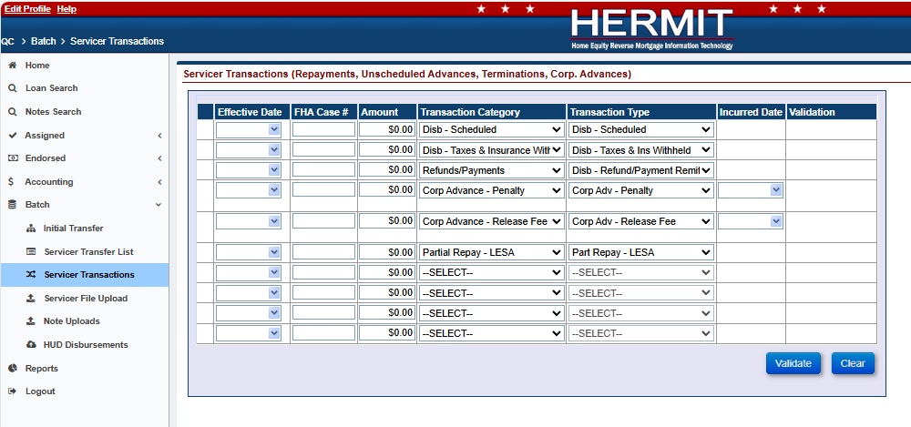

Batch > NSC Bulk Disbursements (Assigned)
- “Disb – Refund/Payment Remittance Overage,” the Transaction Type automatically populates “Disb – Refund/Payment Remittance Overage” (Trans Code = 2550)
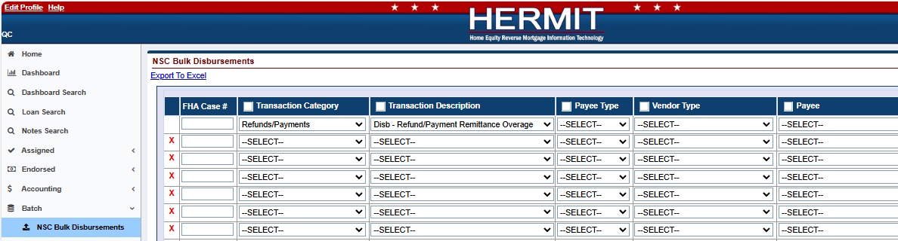

Transactions: Add Unique Transaction Codes for Existing Termination Transactions (591343)
New unique transaction codes have been added to replace the generic transaction code that was used for multiple adjustment transactions. The following new transaction codes are listed below:
- Terminate - Refinance Adj- Transaction Code (2843)
- Terminate - 3rd Party FCL Sale(PIF) Adj – Transaction Code TBD (2844)
- Terminate - Asset Sale Adj – Transaction Code TBD (2845)
- Terminate - Short Sale (PIF W/Write-Off) Adj – Transaction Code TBD (2846)
- Terminate - 3rd Pty FCL Sale(PIF w/WOff) Adj – Transaction Code TBD (2847)

Transactions: Update Loan Bal on Trans Dt Column on the Loan Transactions Page (50336)
Column Loan Bal on Trans Dt on the Loan Transaction Result area on Transaction screen has been updated to remove Corporate Advances from this total.

Timeline: All Endorsed and Assigned Timeline Search results were updated to include three new columns (594405)
All Endorsed and Assigned Timeline Search results grids were updated to include the columns “Step Completed By,” “Step Completed By Date,” and “Timeline Step Status.”
- Once the user selects a Step in the drop down on the Timeline Search page and click search the following columns will appear in the results grid:
- Step Completed By
- Step Completed By Date
- Timeline Step Status
- The column name “Step Completion Date” was renamed to “Complete Date” on the Timeline Search results grid.
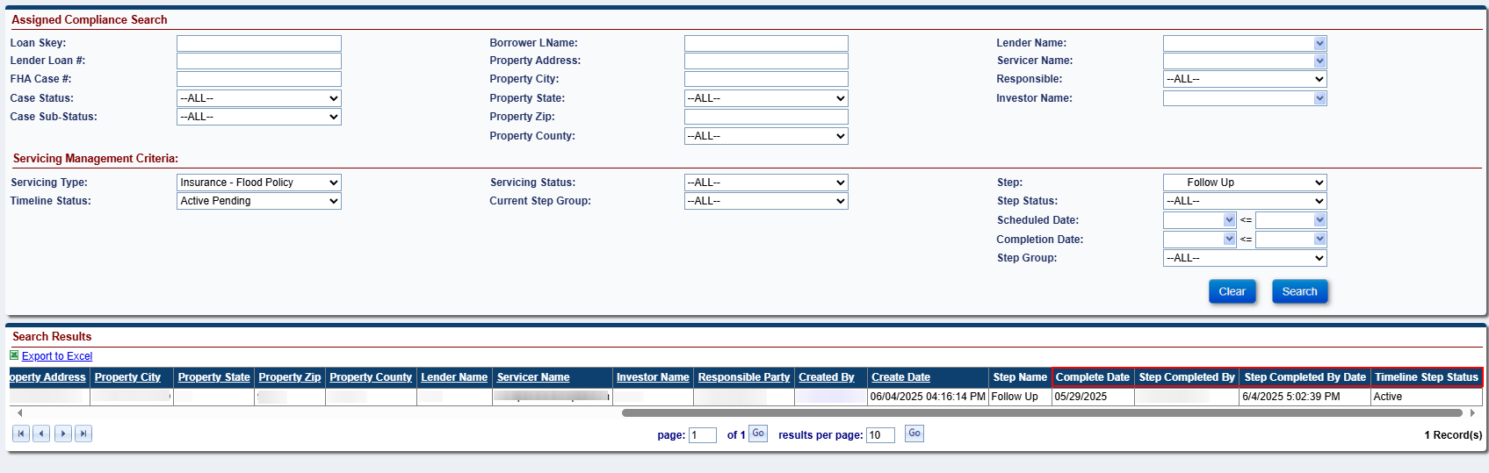
- Once the user clicks Export to Excel with the search results including the three new columns then those columns will also appear in the Excel file.

Timeline: New Letter Step added to Assigned and Endorsed – Bankruptcy Ch. 7, Bankruptcy Ch.13, and Foreclosure Timelines (539291)
A new Optional Letter Step called “Statement of Account” was added to Assigned > Bankruptcy Ch. 7, Assigned > Bankruptcy Ch.13, Assigned > Foreclosure, Endorsed > Bankruptcy Ch. 7, Endorsed > Bankruptcy Ch. 13, and Endorsed > Foreclosure Timelines.
- The New Step “Statement of Account” is a HUD Optional Step that has the Letter “Statement of Account” tied to the Step.
- The “Statement of Account” step will display the magnifying glass and printer icon next to the step. The user will only be able to complete the step when clicking on the printer icon. The user will not be able to complete the step by clicking on the step or when the step is added on the new window modal.
- Multiple new HUD Optional Letter Steps “Statement of Account” may be added to an active Timeline.
- The “Statement of Account” Letter will populate with current HERMIT Data as of the date the letter is printed.
- “Statement of Account” Mapping Data for populated fields:
Statement of Account Field Name | HERMIT Mapping
To | Borrower's Name, Co-Borrower's Name (if applicable), and Mailing Address
FHA Case Number | FHA Case Number
Mortgagor/Owner | Borrower's Name
Co-Mortgagor | Co-Borrower's Name (if applicable)
Property Address | Property Address
Part 1. General Account Information
Original Mortgage Amount | Sum of All Loan Setup Transactions
Unpaid Principal Balance | Loan Balance
Interest Rate | Current Int Rate
Type of Mortgage | Default to "HECM"
Last Paid Amount | Most Recent Repayment Transaction Amount that does not have an Adjustment
Date | Most Recent Repayment Transaction Date that does not have an Adjustment
Date of Oldest Unpaid Interest Installment | Date is populated from the Active Due & Payable Timeline for either Endorsed or Assigned Loans as followed:
Date of Oldest Unpaid Interest Installment | -If there is an Active Endorsed > Requests > Due & Payable w/ HUD Approval Timeline, the field should populate with the Completed Date of HUD Step "HUD Decision - Approved" (Applies to Endorsed Loans)
Date of Oldest Unpaid Interest Installment | -If there is an Active Endorsed > Due & Payable w/o HUD Approval Timeline, the field should populate with the "Create Date" of the Due & Payable w/o HUD Approval Timeline (Applies to Endorsed Loans)
Date of Oldest Unpaid Interest Installment | -If there is an Active Assigned > Disposition > Due & Payable Timeline, the field should populate with the Completed Date of HUD Contractor Step "Disposition Event Occurred" (Applies to Assigned Loans)
Part 2. Assumption Information / Bring Information Current
Part 3. Payoff Information
Principal Balance | Principal Balance
Interest Due | Interest Balance plus Interest Accrued
Service Charge | Service Balance Fee
Other (Specify) | MIP Balance
Total Payoff Amount as of: | Date form is Printed and Total Payoff Amount is the Sum of the fields “Principal Balance,” “Interest Due,” “Service Charge,” “Late Charge,” “Returned Check Charge,” “Advance Amount,” “Tax Escrow Applied,” “Other (Specify),” and “Interest on Advances” on the form
Per Diem Interest | Per Diem Interest Amount

- The “Statement of Account” step in included in the Dashboard.
- Once the Letter is printed the “Statement of Account” Letter will be archived on the Documents page.
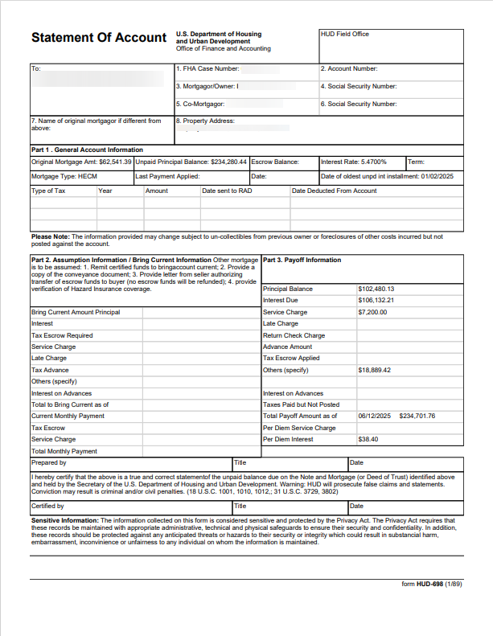
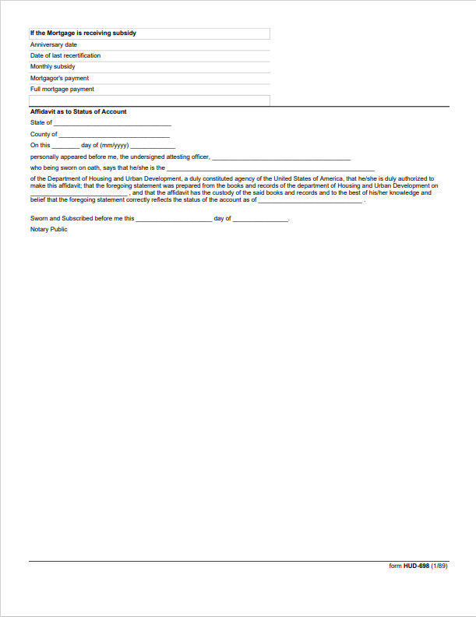

Timelines: Extension Timelines (566144)
The following timelines were updated to include new hard stops, updates to certain triggered steps, and the auto-completion of certain steps.
- Endorsed Extension - At-Risk
- Endorsed Extension - Property Charge Loss Mitigation
- Endorsed Extension - Claims Deadlines
- Endorsed Extension - Repairs
- Endorsed Extension - Deed-in-Lieu
- Endorsed Extension - Late Notification of Death
- Endorsed Extension - Hardest Hit Fund (HHF)
- Endorsed Extension - Appraisal
- Endorsed Extension - Other
- Endorsed Extension - Delay Due & Payable
- Assigned Extension - Extension - At-Risk
- Assigned Extension - Property Charge Loss Mitigation
The existing Step “Submit Extension Request for Time” will now require completion prior to a HUD Decision being made. A new error message preventing steps from being completed out of sequence have been added. The message will be displayed when an attempt is made to add either a “HUD Decision – Approved” or “HUD Decision – Denied” before Step “Submit Extension Request for Time” is completed.
The following Servicing Step Types have been updated from Template Steps to Triggered Steps. These Steps will now be auto-completed when either Optional Step “HUD Decision – Approved” or “HUD Decision – Denied” is completed:
- Step “Request for Extension of Time Recd”
- Step “Extension of Time Reviewed”
- Step “Servicer Notified of Decision”
- Step “Borrower Notified of Decision” (Extension – Property Charge Loss Mitigation Timeline ONLY)

Timelines: Updates to the Assigned & Endorsed Occupancy Compliance Certification Timeline (594764)
Multiple changes were made to the Assigned & Endorsed Occupancy Compliance Certification Timelines.
- New Optional Steps were added for Assigned and Endorsed timelines:
  - “Re-send Annual Occupancy Certification Letter”
  - “Follow Up”
  - “Order Supplemental Occupancy Inspection”
  - “Supplemental Occupancy Inspection Received”
- Step Descriptions were renamed, Servicing Step Types updated, and Steps inactivated going forward:
  - For Assigned Loans:
    - The Step Description has been renamed from “Setup Servicing Disposition Screen” to “Review for Due & Payable” and the Step Type was updated from Optional to Automated.
    - The Step Type on step “Received Property Inspection” has been updated from Automated to triggered.
    - The Step “Mortgagor’s Certification of Ineligible NBS” was Inactivated and will no longer be Active after the Release.
  - For Endorsed Loans:
    - The Step Type has been updated for steps “Telephone/Verbal Confirmation of Occupancy Made” and “Received Property Inspection” from Automated to Optional.
- Certain steps have been updated to auto-complete for both Assigned and Endorsed Loans. The following steps will now be completed automatically based on the following criteria:
  - Step “Re-start Annual Occupancy Certification”:
    - If Step “Annual Occupancy Cert Letter Received” is completed before the “Re-start Annual Occupancy Certification” Scheduled Date, then Step “Re-start Annual Occupancy Certification” will auto-complete when today’s date is equal to the Scheduled Date.
    - If Step “Annual Occupancy Cert Letter Received” is completed on or after the “Re-start Annual Occupancy Certification” Scheduled Date, then Step “Re-start Annual Occupancy Certification” will auto-complete when Step “Annual Occupancy Cert Letter Received” is completed.
  - Step “Annual Occupancy Cert Letter Received”:
    - Step “Annual Occupancy Cert Letter Received” will auto-complete when step “Telephone/Verbal Confirmation of Occupancy Made” is completed. NOTE: Step “Annual Occupancy Cert Letter Received” may still be manually completed, however the new auto-completion logic was added in cases where a verbal verification of occupancy is completed in lieu of receiving a physical or electronic certificate.
- A new timeline will automatically be initiated/created based on updated criteria for both Assigned and Endorsed Loans:
  - The system will automatically initiate a new Occupancy Compliance Certification timeline when the step “Re-start Annual Occupancy Certification” is completed. The previous timeline is automatically inactivated once a new timeline is created by the system.
  - The Scheduled Date for Step “Signed Anniversary Date” for the newly initiated timeline will be driven by the completion date of Step “Annual Occupancy Cert Letter Received”.
    - If Step “Annual Occupancy Cert Letter Received” was completed more than 12 months from the Scheduled Date of the “Signed Anniversary Date”, then the Scheduled Date of “Signed Anniversary Date” will be pre-populated in the new timeline with the 1st day of the month after the closing date in the calendar year following the “Annual Occupancy Cert Letter Received” complete date.
      - For Example, if the Scheduled Date for “Signed Anniversary Date” is 03/01/2024 and step “Annual Occupancy Cert Letter Received” is completed on 05/01/2025, then the Schedule Date of “Signed Anniversary Date” will be pre-populated as 03/01/2026 in the new timeline.
    - If Step “Annual Occupancy Cert Letter Received” was completed less than or equal to 12 months from the Scheduled Date of the “Signed Anniversary Date”, then the Scheduled Date of the “Signed Anniversary Date” will be pre-populated in the new timeline with the 1st day of the month after the closing date in the next calendar year.
      - For Example, if the Scheduled Date for “Signed Anniversary Date” is 03/01/2024 and step “Annual Occupancy Cert Letter Received” is completed on 06/01/2024, then the Scheduled Date of “Signed Anniversary Date” will be pre-populated as 03/01/2025 in the new timeline.
- Calculations setting Scheduled Dates on Automated and Triggered Steps were updated from calendar days to business days.
- New error messages were added to prevent duplication of certain steps and prevent steps from being completed out of sequence.
  - An error message will now display for steps that only allow one active step to exist on a timeline
  - An error message will now display if a new step is being added when a pending step already exists
  - An error message will now display if a new step is being added out of sequence.
    - For Example, a user will not be permitted to add Step “Order Supplemental Occupancy Inspection” if Step “Order Property Inspection and SSI Search” or “Received Property Inspection” is pending completion

Timelines: Updates to Insurance – Hazard Policy and Insurance – Flood Policy Timelines and New Alerts (590751)
The Assigned > Compliance > Insurance – Hazard Policy and Assigned > Compliance > Insurance - Flood Policy Timelines were updated to include new steps, step types were updated on existing steps, step descriptions were revised, new Error messages were added, existing steps were inactivated, and new triggers were introduced. New critical Alerts were added to display when the Assigned Insurance Timelines are Out of Compliance or do not exist.
The same changes were made to the Endorsed > Compliance > Insurance – Hazard Policy and Endorsed > Compliance > Insurance - Flood Policy Timelines, with the exception of the Alerts and Dashboard impacts, which only apply to Assigned timelines.
- List of Step Changes on Insurance – Hazard Policy and Insurance – Flood Policy Timelines:
Update | Step Description | Servicing Step Type | Scheduled Date | Rule
Scheduled Date Change | Policy Expires | Template | Timeline Initiation Date plus 12 Months | The Scheduled Date is editable, however it cannot be prior to Step "Policy Effective" Scheduled Date
 |  |  |  | Step will automatically complete when Today's Date is after the Scheduled Date
Renamed | Generate Mortgagee Clause Letter | Optional | Step Creation Date | Step previously named "Insurance Declaration Received" was updated to "Generate Mortgagee Clause Letter" and changed from a Template Step to an Optional Step
Servicing Step Type Change | Returned Receipt Received from Borrower | Optional | Step Creation Date | Servicing Step Type changed from a Template Step to an Optional Step
 |  |  |  | Step will inactivate upon completion of Step "Renewal Insurance Declaration Received" or completion of Step "Received Notification of Policy Reinstatement"
Servicing Type Change | Mail Renewal Verification Letter | Automated | Creation Date of Step "Mail Renewal Verification Letter" plus 3 days | Servicing Step Type changed from a Template Step to an Automated Step
 |  |  |  | Step will be automatically added to the timeline when Today's Date is 45 days from Step "Policy Expires" Scheduled Date and a renewal insurance declaration has not yet been received, as indicated by Step "Renewal Insurance Declaration Received" not existing or pending completion
 |  |  |  | Step can only Completed when the user clicks on the Printer Icon
Step Condition | Received Notification of Policy Cancellation | Optional | Step Creation Date | Step can only be added if the current policy has never been cancelled or if the current policy has been reinstated after a cancellation, as indicated by the completion of "Received Notification of Policy Reinstatement".
 |  |  |  | Step completion date must be after the latest completion date of Step "Received Notification of Policy Reinstatement" unless the policy has never been cancelled
 |  |  |  | Step cannot be added if the current policy has expired, as indicated by the Scheduled Date of Step "Policy Expires"
 |  |  |  | Pending Step(s) will inactivate upon completion of Step "Policy Expires"
Automation logic changed | Send 2nd Request for Policy Verification | Automated | Step Creation Date plus 3 Days | Step will be automatically added to the timeline when Today's Date is 20 days from Step "Policy Expires" Scheduled Date, Step "Mail Renewal Verification Letter" is Completed, Step "Renewal Insurance Declaration Received" has not been completed, and the Policy has not expired, as indicated by the Scheduled Date of Step "Policy Expires"
 |  |  |  | Pending Step(s) will inactivate upon completion of Step "Renewal Insurance Declaration Received"
 |  |  |  | Note: this is a Dashboard step
Renamed | Mail Certified Letter to Borrower – Policy Expiration | Trigger | Complete Date of Step "Policy Expires" plus 3 Days | Step Description was updated from "Mail Certified Letter to Borrower" to "Mail Certified Letter to Borrower - Policy Expiration"
 |  |  |  | Servicing Step Type changed from Template Step to Trigger Step
 |  |  |  | Triggered by completion of Step "Policy Expires"
 |  |  |  | Step will inactivate upon completion of Step "Renewal Insurance Declaration Received"

- List of New Steps on Insurance – Hazard Policy and Insurance – Flood Policy Timelines:
Update | Step Description | Servicing Step Type | Scheduled Date | Rule
New | Insurance Declaration Received | Template | Timeline Initiation Date plus 5 days | This is a separate step from the one that was renamed
 |  |  |  | Note: this is a Dashboard step
New | Mail Certified Letter to Borrower - Policy Cancellation | Trigger | Complete Date of the Step "Received Notification of Policy Cancellation" plus 3 Days | Triggered by completion of Step "Received Notification of Policy Cancellation"
 |  |  |  | Step can only Completed when the user clicks on the Printer Icon
New | Renewal Insurance Declaration Received | Optional | Step Creation | Note: this is a Dashboard step
New | Renewal Insurance Declaration Effective | Trigger | Complete Date of the Step "Renewal Insurance Declaration Received" plus 3 days | Triggered by completion of Step "Renewal Insurance Declaration Received"
 |  |  |  | Step Completion Date represents the Policy Effective (Start) Date of the renewal policy and will permit future completion dates.
 |  |  |  | Note: this is a Dashboard step
New | Received Notification of Policy Reinstatement | Optional | Step Creation | Step can only be added after the current policy has been cancelled, as indicated by the completion of Step "Received Notification of Policy Cancellation".
 |  |  |  | Step completion date cannot be prior to the completion date of Step "Received Notification of Policy Cancellation"
 |  |  |  | Step cannot be added if the current policy has expired, as indicated by the Scheduled Date of Step "Policy Expires"
 |  |  |  | Pending Step(s) will inactivate upon completion of "Policy Expires"
 |  |  |  | Note: this is a Dashboard step
New | Follow Up | Optional | Step Creation | Note: this is a Dashboard step
New | Review for Due & Payable | Trigger | Complete Date of the Step "Mail Certified Letter to Borrower – Policy Expiration" or Step "Mail Certified Letter to Borrower – Policy Cancellation" plus 10 days | Triggered by completion of Step "Mail Certified Letter to Borrower - Policy Cancellation" or completion of Step "Mail Certified Letter to Borrower - Policy Expiration"
 |  |  |  | Step will inactivate upon completion of Step "Renewal Insurance Declaration Received" or completion of Step "Received Notification of Policy Reinstatement"
 |  |  |  | Note: this is a Dashboard step
- The following steps were Inactivated from the Insurance – Hazard and Flood Policy Timelines and will no longer be Active after the Implementation of Release 8.0.
- Notify Loan Counselor
- Policy Cancellation
- New Error messages were added to prevent duplication of certain steps and prevent steps from being completed out of sequence.
- An Error message will now display for steps that only allow one active step to exist on a timeline.
- An Error message will now display if a new step is being added when a pending step already exists.
- An Error message will now display if a new step is being added out of sequence.
  - For Example, a user will not be able to add a new Optional Step “Received Notification of Policy Reinstatement” if a “Received Notification of Policy Cancellation” step has never been completed.
- Two new read-only fields were added to the Servicing Management Information tab for the Insurance – Hazard and Flood Policy Timelines.
- Effective Start Date: The value for this field is set to the “Policy Effective” step Scheduled Date from the Compliance Steps tab
- Effective End Date: The value for this field is set to the “Policy Expires” step Scheduled Date from the Compliance Steps tab.
NOTE: The value for this field will update if the “Policy Expires” step Scheduled Date is edited.
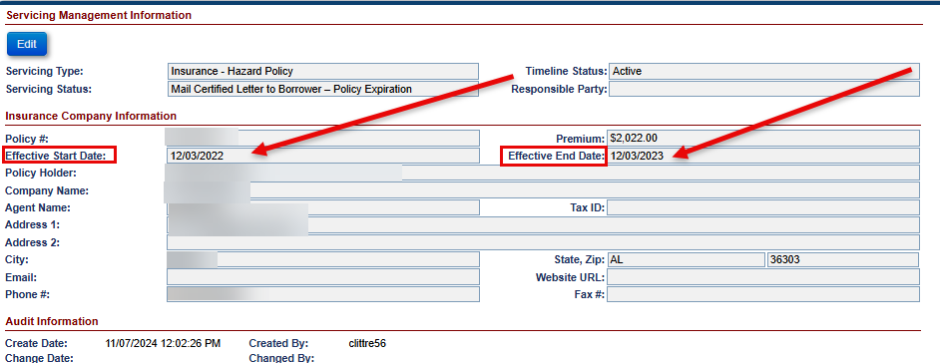
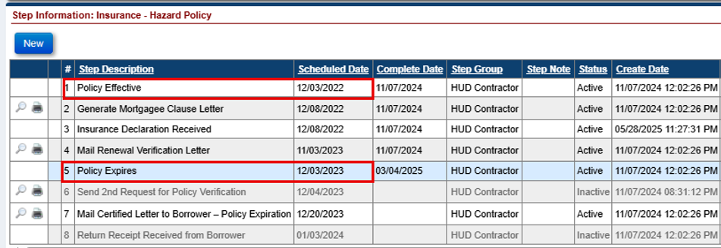
- System triggers for the creation of a new timeline have been updated for Insurance – Hazard and Flood Policy Timelines.
- The system will trigger a new Insurance – Hazard and Flood Policy Timeline when the Step “Renewal Insurance Declaration Effective” is completed
  - The Policy Effective Scheduled Date for the newly created system timeline will be set to the “Renewal Insurance Declaration Effective” Complete Date
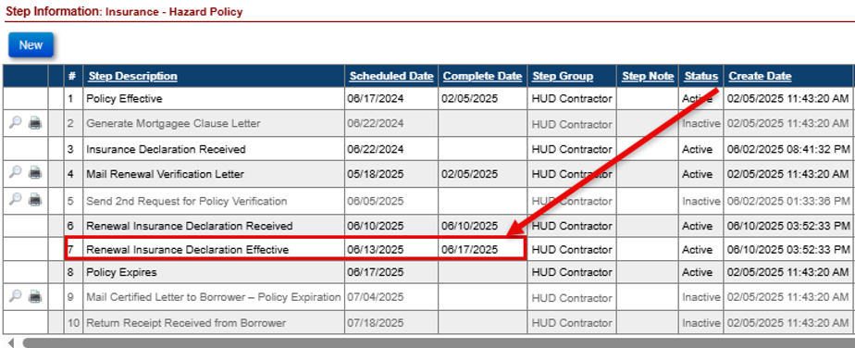
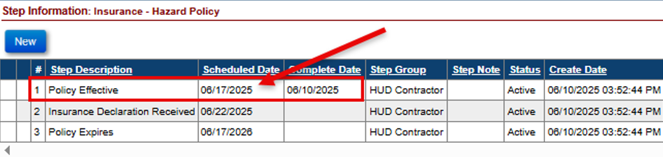
- Multiple timelines will only be permitted when created by the system. Users will be restricted from manually setting up a new Insurance – Hazard or Flood Policy Timeline if an active timeline exists. The user will need to inactivate the existing timeline before setting up a new timeline manually.
- The user will not be able to Activate an Inactive Insurance – Hazard or Flood Policy Timeline.

NSC / HUD Related Changes

New Alerts on Assigned > Compliance: Insurance – Hazard and Flood Policy Timelines (590751)
This topic is a continuation of “ Timelines: Updates to Insurance – Hazard Policy and Insurance – Flood Policy Timelines and New Alerts”
- Assigned timelines only: New Critical Alerts were created and added to Reports > Daily Reports > Alert Details to identify Assigned Loans that do not have an active Insurance – Hazard or Flood Policy Timeline when required and to identify once a Hazard or Flood Policy has expired or has cancelled.
- If an Assigned > Insurance – Hazard Policy Timeline is inactivated on an Assigned Loan that has not been Terminated, the system will automatically generate a new “Hazard Insurance Required” alert. This alert will appear in the Critical Alerts popup when the loan is opened.
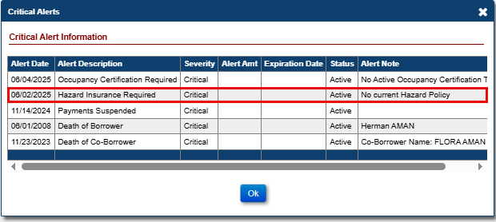
- The “Hazard Insurance Required” alert will inactivate when an active Assigned > Insurance – Hazard Policy Timeline exists, the Case Status is set to “Terminated”, or the loan is no longer serviced by HUD.

- If a HUD Assignment Servicing Transfer (when CT22 Step “Assignment to HUD sent for recording/Servicer Files Claim Type 22 – Form 27011” is completed) is completed and there is no Active or Inactive Assigned > Insurance – Hazard Policy Timeline that exists, then the system will automatically generate a new “Hazard Insurance Timeline Required after Assignment to HUD” alert. This alert will appear in the Critical Alerts popup when the loan is opened.
  - The “Hazard Insurance Required after Assignment to HUD” alert will inactivate when an active Assigned > Insurance – Hazard Policy Timeline exists, the Case Status is set to “Terminated”, or the loan is no longer serviced by HUD.
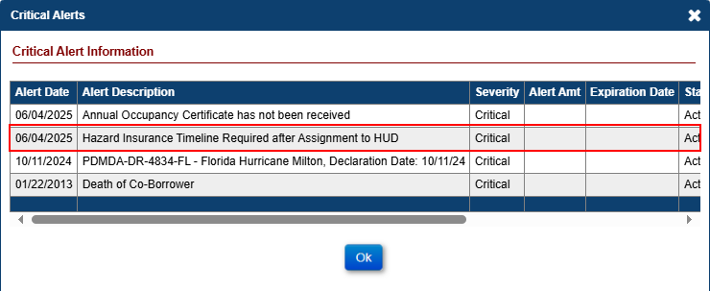

- If a Policy Cancellation or Policy Expiration event occurs an active Assigned > Insurance – Hazard Policy Timeline on an Assigned Loan that has not been Terminated, the system will automatically generate a new “Hazard Insurance is Out of Compliance” alert. This alert will appear in the Critical Alerts popup when the loan is opened.
- A Policy Cancellation event is triggered when Step “Received Notification of Policy Cancellation” is completed, and Step “Received Notification of Policy Reinstatement” does not exist or the last step completed is before the “Received Notification of Policy Cancellation” complete date.
- A Policy Expiration event is triggered when Step “Policy Expires” is Completed
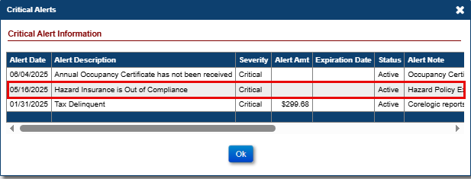
  - The “Hazard Insurance is Out of Compliance” alert added due to a Policy Cancellation event will inactivate when the Assigned > Insurance – Hazard Policy is reinstated (as indicated by Step “Received Notification of Policy Reinstatement” after the last “Received Notification of Policy Cancellation” step completion date), the timeline is inactivated, the Case Status is set to “Terminated”, or the loan is no longer serviced by HUD.
  - The “Hazard Insurance is Out of Compliance” alert added due to a Policy Expiration event will inactivate when the timeline is inactivated, the Case Status is set to “Terminated”, or the loan is no longer serviced by HUD.

- If an Insurance – Flood Policy Timeline is inactivated on an Assigned Loan that has not been Terminated and the “Flood Ins. Required” field in the Property > Property Info screen is checked, then the system will automatically generate a new “Flood Insurance Required” alert. This alert will appear in the Critical Alerts popup when the loan is opened.
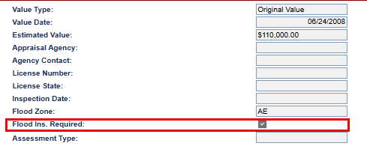
  - The “Flood Insurance Required” alert will inactivate when an active Insurance – Flood Policy Timeline exists, the “Flood Ins. Required” field in the Property > Property Info screen is no longer checked, the Case Status is set to “Terminated”, or the loan is no longer serviced by HUD.

- If a HUD Assignment Servicing Transfer (when CT22 Step “Assignment to HUD sent for recording/Servicer Files Claim Type 22 – Form 27011” is completed) is completed and there is no Active or Inactive Assigned Insurance – Flood Policy Timeline that exists and the “Flood Ins. Required” field from the Property > Property Info screen is checked, then the system will automatically generate a new “Flood Insurance Timeline Required after Assignment to HUD” alert. This alert will appear in the Critical Alerts popup when the loan is opened.
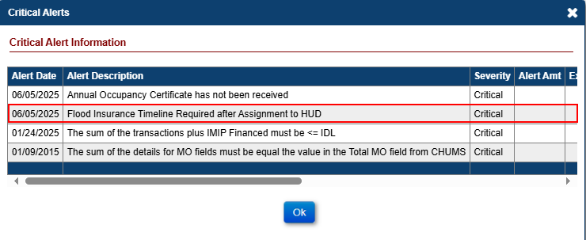
  - The “Flood Insurance Required after Assignment to HUD” alert will inactivate when an active Insurance – Flood Policy Timeline exists, the “Flood Ins. Required” field from the Property > Property Info screen is no longer checked, the Case Status is set to “Terminated”, or the loan is no longer serviced by HUD

- If a Policy Cancellation or Policy Expiration event occurs an active Insurance – Flood Policy Timeline on an Assigned Loan that has not been Terminated and the “Flood Ins. Required” field from the Property > Property Info screen is checked, then the system will automatically generate a new “Flood Insurance is Out of Compliance” alert. This alert will appear in the Critical Alerts popup when the loan is opened.
  - A Policy Cancellation event is triggered when Step “Received Notification of Policy Cancellation” is completed, and Step “Received Notification of Policy Reinstatement” does not exist or the last step completed is before the “Received Notification of Policy Cancellation” complete date.
  - A Policy Expiration event is triggered when Step “Policy Expires” is Completed
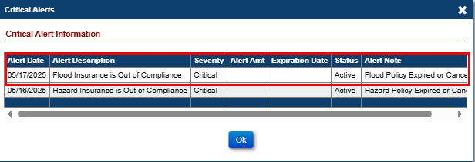
  - The “Flood Insurance is Out of Compliance” alert added due to a Policy Cancellation event will inactivate when the Insurance – Flood Policy is reinstated (as indicated by Step “Received Notification of Policy Reinstatement” after the last “Received Notification of Policy Cancellation” step completion date), the “Flood Ins. Required” field from the Property > Property Info screen is no longer checked, the timeline is inactivated, the Case Status is set to “Terminated”, or the loan is no longer serviced by HUD.
  - The “Flood Insurance is Out of Compliance” alert added due to a Policy Expiration event will inactivate when the “Flood Ins. Required” field from the Property > Property Info screen is no longer checked, the timeline is inactivated, the Case Status is set to “Terminated”, or the loan is no longer serviced by HUD.

New Alerts on Other Assigned > Compliance Timelines
New Alerts have been added for Other Assigned > Compliance Timelines when there is no Active timeline found and one is expected, or when action is required on an Active timeline. The Alerts will be automatically Added and Inactivated by the system when the criteria are met. All of the new Alerts are available in the existing “Alerts Detail” report found under Assigned Notes Reports > Daily Reports. The report can be run on Active, Inactive, or All Alert Statuses as needed.
The new alerts are:
Timeline | Alert | Displayed when:
Insurance/Hardest Hit Funds Administration | Hardest Hit Funds Administration Required | Active Timeline is Expected but does not exist
Insurance/Hardest Hit Funds Administration | Insurance/Hardest Hit Funds Final Disbursement Required | Step "Disburse Final Funds" is Past Due and not completed
Insurance/Loss Draft Administration | Loss Draft Administration Required | Active Timeline is Expected but does not exist
Insurance/Loss Draft Administration | Review for Disbursement of Repair Funds | Step "Review for Disbursement of Repair Funds" is Past Due and not completed
Occupancy Compliance Certification | Occupancy Certification Required | Active Timeline is Expected but does not exist
Occupancy Compliance Certification | Annual Occupancy Certificate has not been received | Step "Annual Occupancy Cert Letter Received" is Past Due and not completed
Request for Payment | Payment Processing by Cash Management Pending | Step "Cash Management Processed Payment" is Past Due and not completed
Request for Unscheduled Advance | Cash Management Approval Required | Step "Cash Management Approved Unscheduled Request for Funds" is Past Due and not completed
Taxes Delinquent | Authorization to Pay Taxes Required | Step "Authorization Received/Pay Taxes" is Past Due and not completed

The Alerts will become Inactive when the condition that caused them no longer applies, including: upon Termination of the loan, Inactivation of the timeline, or completion of the step that caused the alert to be added.

Timelines: Updates to the Assigned > Insurance/Loss Draft Administration Timeline (593367)
The Assigned > Compliance > Insurance/Loss Draft Administration Timeline was updated to include new steps, step types were updated on existing steps, step descriptions were revised, new Error messages were added, existing steps were inactivated, and new triggers were introduced.
- List of Step Changes to the Assigned > Insurance/Loss Draft Administration Timeline:
Update | Step Description | Servicing Step Type | Scheduled Date | Rule
Servicing Step Type Change | Verify Contract/Adjuster's Report Received | Trigger | Complete Date of Step "Initiate Insurance/Loss Draft Administration" plus 30 days | Servicing Step Type changed from Template Step to Trigger Step  Triggered by completion of the Step "Initiate Insurance/Loss Draft Administration"
Renamed | Issue Initial Disbursement of Repair Funds | Optional | Step Creation | Renamed from Step "Issue First Third of Repair Funds" to "Issue Initial Disbursement of Repair Funds"  Servicing Step Type changed from Template Step to Optional Step  Cannot be added to the Timeline unless the Step "Review for Disbursement of Repair Funds" is Pending Completion
Renamed | Order Repair Inspection | Trigger | Complete Date of Step "Issue Initial Disbursement of Repair Funds" plus 30 days | Renamed from Step "Order 50% Inspection" to "Order Repair Inspection"  Servicing Step Type changed from Template Step to Trigger Step  Triggered by completion of the Step "Issue Initial Disbursement of Repair Funds"
Renamed | Issue Subsequent of Disbursement of Repair Funds | Optional | Step Creation | Renamed from Step "Issue Second Third of Repair Funds" to "Issue Subsequent of Disbursement of Repair Funds"  Servicing Step Type changed from Template Step to Optional Step  Cannot be added to the Timeline unless the Step "Review for Disbursement of Repair Funds" is Pending Completion and the Step "Issue Initial Disbursement of Repair Funds" is Completed.
Renamed | Issue Final Disbursement of Repair Funds | Optional | Step Creation | Renamed Step from "Disburse Final Funds / Send Lien Waiver" to "Issue Final Disbursement of Repair Funds"  Servicing Step Type changed from Template Step to Optional Step  Cannot be added to the Timeline unless the Step "Review for Disbursement of Repair Funds" is Pending Completion and the Step "Prepare for Final Disbursement of Repair Funds" is Completed.  The Step will Inactivate once the user changes the Step Status to Inactive
Renamed | Order Supplemental Repair Inspection | Optional | Step Creation | Renamed Step from "Order Supplemental Inspection" to "Order Supplemental Repair Inspection"  Cannot be added to the Timeline when one of the following steps are pending completion: "Order Repair Inspection," "Order Subsequent Repair Inspection," "Repair Inspection Received," "Subsequent Repair Inspection Received," "Order Supplemental Repair Inspection," or "Supplemental Repair Inspection Received"
Servicing Type Change | Lien Waiver Received | Trigger | Complete Date of Step "Send Lien Waiver" plus 7 days | Servicing Step Type changed from Template Step to Trigger Step  Triggered by completion of the Step "Send Lien Waiver"  The Step will Inactivate once the Step "Issue Final Disbursement of Repair Funds" is set to Inactive

- List of New Steps on Assigned > Insurance/Loss Draft Administration Timeline:
Update | Step Description | Servicing Step Type | Scheduled Date | Rule
New | Repair Inspection Received | Trigger | Complete Date of Step "Order Repair Inspection" plus 7 days | Triggered by completion of the Step "Order Repair Inspection"
 |  |  |  | Note: this is a Dashboard step
New | Order Subsequent Repair Inspection | Trigger | Complete Date of Step "Issue Subsequent Disbursement of Repair Funds" plus 30 days | Triggered by completion of the Step "Issue Subsequent Disbursement of Repair Funds"
New | Subsequent Repair Inspection Received | Trigger | Complete Date of Step "Order Subsequent Repair Inspection" plus 7 days | Triggered by completion of the Step "Order Subsequent Repair Inspection"
New | Follow Up | Optional | Step Creation | Note: this is a Dashboard step
New | Missing Lien Waiver | Optional | Step Creation | Cannot be added to the Timeline unless the Step "Send Lien Waiver" is Completed
New | Missing Adjuster's Report | Optional | Step Creation | Cannot be added to the Timeline unless the Step "Verify Contract / Adjuster's Report Received" is Pending Completion
New | Missing Contract | Optional | Step Creation | Cannot be added to the Timeline unless the Step "Verify Contract / Adjuster's Report Received" is Pending Completion
New | Prepare for Final Disbursement of Repair Funds | Optional | Step Creation | Cannot be added to the Timeline unless the Step "Review for Disbursement of Repair Funds" is Pending Completion
 |  |  |  | The Step will Inactivate once the Step "Issue Final Disbursement of Repair Funds" is set to Inactive
New | Repairs will not be Completed – Review for D&P | Optional | Step Creation | Cannot be added to the Timeline unless the Step "Review for Disbursement of Repair Funds" or "Verify Contract / Adjuster's Report Received" is Pending Completion
 |  |  |  | The Step will Inactivate once the user changes the Step Status to Inactive
New | Review for Disbursement of Repair Funds | Trigger | Max Complete Date of the one of the following Steps "Verify Contract / Adjuster's Report Received," "Repair Inspection Received," or "Subsequent Repair Inspection Received" plus 30 days | Triggered by completion of one of the following Steps "Verify Contract / Adjuster's Report Received," "Repair Inspection Received," or "Subsequent Repair Inspection Received"
 |  |  |  | Auto Completed upon the Completion of one of the following Steps "Issue Initial Disbursement of Repair Funds," "Issue Subsequent Disbursement of Repair Funds," "Issue Final Disbursement of Repair Funds" or "Repairs will not be Completed - Review for D&P"
 |  |  |  | Note: this is a Dashboard step
New | Transfer of Repair Funds to Loan Balance | Automated | Complete Date of Step "Repairs will not be Completed – Review for D&P" plus 5 days | Automatically added when the Step "Repairs will not be Completed – Review for D&P" is Completed, and the Remaining Balance is greater than $0.00
 |  |  |  | Note: this is a Dashboard step
New | Send Lien Waiver | Automated | Complete Date of Step "Prepare for Final Disbursement of Repair Funds" plus 5 days | Automatically added when the Step "Prepare for Final Disbursement of Repair Funds" is Completed and the Loss Draft Funds Balance is equal to or greater than $5,000.00
 |  |  |  | The Step will Inactivate once the Step "Issue Final Disbursement of Repair Funds" is set to Inactive
 |  |  |  | Note: this is a Dashboard step
New | Supplemental Repair Inspection Received | Trigger | Complete Date of Step "Order Supplemental Repair Inspection" plus 7 days | Triggered by completion of the Step "Order Supplemental Repair Inspection"

- The Step “Order Final Inspection” was Inactivated from the Assigned > Insurance/Loss Draft Administration Timeline and will no longer be Active after the Implementation of Release 8.0.

- New Error messages were added to prevent duplication of certain steps and prevent steps from being completed out of sequence.
- An Error message will now display for steps that only allow one active step to exist on a timeline.
- An Error message will now display if a new step is being added when a pending step already exists.
- An Error message will now display if a step is being added out of sequence.
  - For Example, a user will not be able to add Optional Step “Issue Initial Disbursement of Repair Funds” if a “Review for Disbursement of Repair Funds” step is pending completion.

Report Updates: Property Charge Default Reporting (50521)
Updates were made to the “Property Charge Default” report located under Assigned Notes Reports > Daily Reports to require a date range of 60 days or less for field “Property Charge Date” to improve the execution time for the report.
All other aspects of the report remain as is from the initial implementation in Release 7.9.

NSC / HUD Dashboard

New Dashboard Summary page (589639 / 50479)
In Release 7.91, two new pages were added to HERMIT for all HUD NSC and HUD NSC Contractor User Roles: Dashboard Summary and Dashboard Search. HUD NSC and HUD NSC Contractor User Roles will be directed to the Dashboard Summary page upon logging in, as the Landing page for these users. Search filters are available on both pages allowing the user to further drill down the summary and grid detail. Additional changes were made to the Dashboard Summary page in Release 8.0.
HUD NSC Manager and Contractor Supervisor/ Mgmt user roles can view the Dashboard data for all Responsible Parties. However, individual users will only see Timeline Steps where they are the user listed as the Responsible Party on that timeline.
The Dashboard excludes counts for Terminated Loans and Timelines that are Inactive. In addition, the initial implementation of the Dashboard pages includes the following specific Timelines. Additional timelines will be added at a later date.
  - Endorsed > Claims > Claim Type 22 – Assignment
  - Endorsed > Requests > Due & Payable w/ HUD Approval
  - Assigned > Compliance > Insurance – Flood Policy
  - Assigned > Compliance > Insurance – Hazard Policy
  - Assigned > Compliance > Insurance/Hardest Hit Funds Administration
  - Assigned > Compliance > Insurance/Loss Draft Administration
  - Assigned > Compliance > Occupancy Compliance Certification
  - Assigned > Disposition > Loss Mitigation – Short Sale

The Dashboard Summary page has two sections:
  - Dashboard Summary
  - Timeline Summary

- The Dashboard Summary section includes dropdown filters that can be selected to limit search results, as well as summary boxes with counts of Timeline Steps, by category.

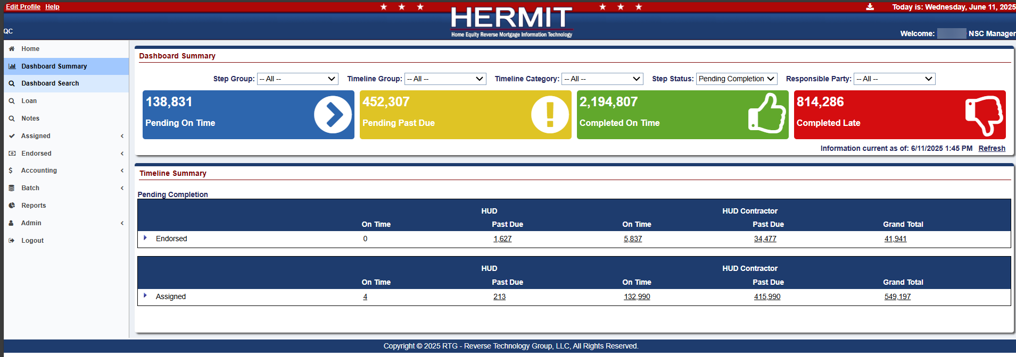
- Dashboard Summary dropdown filter options are:
  - Step Group
    - HUD
    - HUD Contractor
  - Timeline Group
    - Assigned
    - Endorsed
  - Timeline Category
    - Claims – Endorsed
    - Compliance – Assigned
    - Disposition – Assigned
    - Requests – Endorsed
  - Step Status (added in Release 8.0)
    - Pending Completion
    - Steps Completed
  - Responsible Party
    - List of all users who are assigned a Responsible Party on at least one of the Timelines in the Dashboard

- Dashboard Summary boxes: Blue, Yellow, Green, and Red boxes are displayed with counts of Timeline Steps, by category are dependent on the filter criteria selected on the page. These boxes show the counts for the following:
  - Pending On Time (color blue)
  - Pending Past Due (color yellow)
  - Completed On Time (color green)
  - Completed Late (color red)

Clicking on a box under the Dashboard Summary page automatically opens a new Dashboard Search window that displays the results for that population. See Topic #2 for information on the Dashboard Search page.
- The Timeline Summary section on the Dashboard Summary page displays detailed results based on the Dashboard Filters and if applicable, individual User Roles.
- Timeline Summary is organized into Step status Pending Completion and Steps Completed. The page defaults to showing only Pending Completion data but can be adjusted by utilizing filter “Step Status” When filtering by “All”: the first 2 boxes are for Pending Completion steps and are separated by what Timeline Group the timeline is listed under: Endorsed or Assigned. Under each Step Status and Timeline Group, information can be further drilled down by clicking on the arrow on the left of the row to expand the grid.
There are five columns displayed: two columns for HUD steps, two columns for HUD Contractor steps, and one Grand Total. Columns displayed:
  - HUD Steps On Time
  - HUD Steps Past Due
  - HUD Contractor Steps On Time
  - HUD Contractor Steps Past Due
  - Grand Total

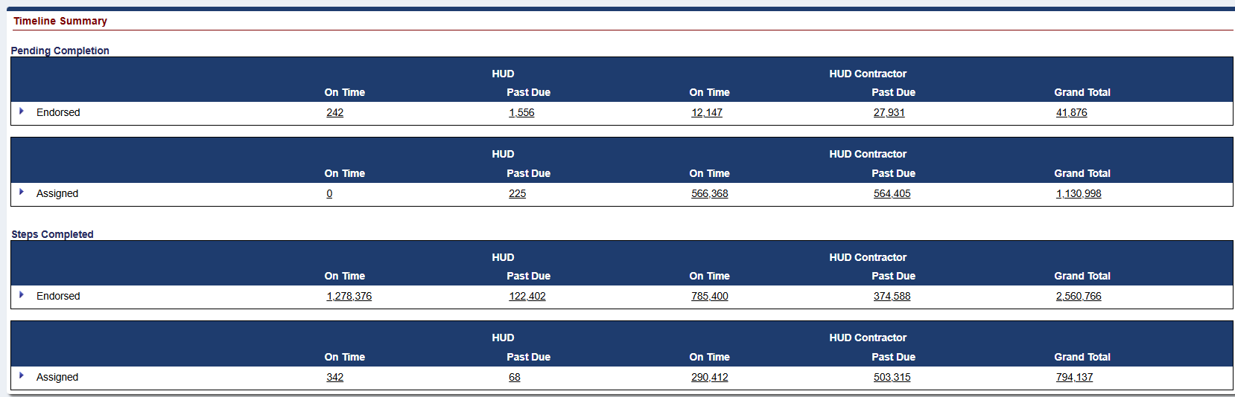
- Drilling down in the Timeline Summary grid. By clicking the blue arrow to the left of the row, the data can be drilled into. Clicking on a numerical count in the Timeline Summary grid automatically opens a new Dashboard Search window that displays the results for that population.
  - The drill order is Timeline Group > Responsible Party > Timeline Category > Timeline Name/Servicing Type > Step Name.
  - *For User Roles HUD NSC-Mgr and Contractor-Supervisor/Management, information is displayed for all Responsible Parties, including timelines with Responsible Party not yet assigned: listed in the results as “Unassigned”. For other user roles, the users will see only steps for timelines where they are assigned Responsible Party.
    - HUD NSC-Mgr*
    - HUD NSC-Staff
    - Contractor-Supervisor/Management*
    - Contractor-Cash
    - Contractor-Cash Supervisor
    - Contractor-Customer Service
    - Contractor-Default
    - Contractor-Documentation
    - Contractor-First Mortgage
    - Contractor-Release
    - Contractor-Release Supervisor
    - HUD Read Only
  - Example of drilling down / expanding grid results for user that can view multiple Responsible parties.
    - Expand Endorsed
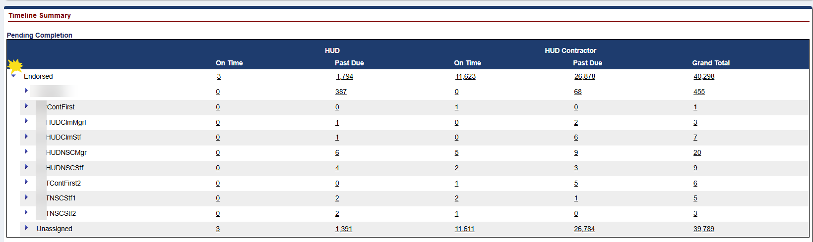
    - Expand Unassigned
    - Expand Requests – Endorsed
    - Expand Due & Payable w/HUD Approval
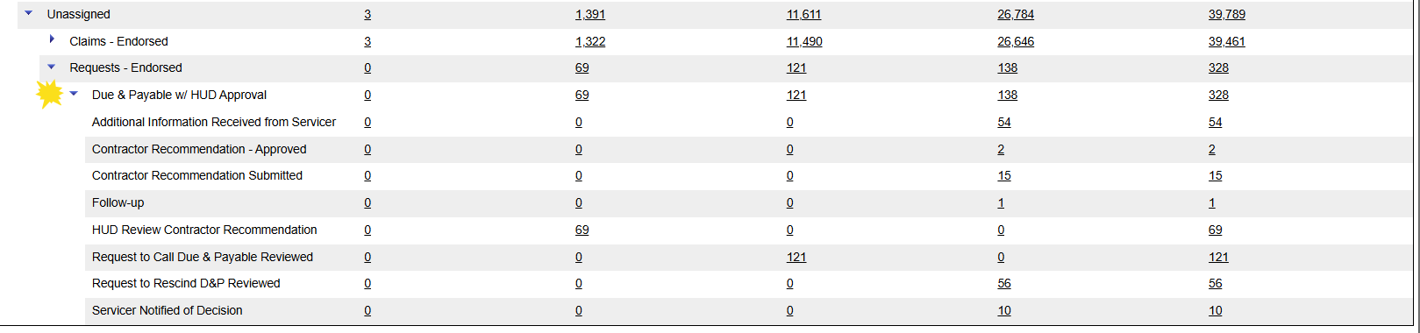
    - The counts will be displayed for each row in each category corresponding to the Step Group selected.

New Dashboard Search page
The second of two new pages added to HERMIT for all HUD NSC and HUD NSC Contractor User Roles is the Dashboard Search page.
Both Dashboard pages exclude counts for Terminated Loans and Timelines that are Inactive. In addition, the initial implementation of the Dashboard pages includes the following specific Timelines. Additional timelines will be added at a later date.
  - Endorsed > Claims > Claim Type 22 – Assignment
  - Endorsed > Requests > Due & Payable w/ HUD Approval
  - Assigned > Compliance > Insurance – Flood Policy
  - Assigned > Compliance > Insurance – Hazard Policy
  - Assigned > Compliance > Insurance/Hardest Hit Funds Administration
  - Assigned > Compliance > Insurance/Loss Draft Administration
  - Assigned > Compliance > Occupancy Compliance Certification
  - Assigned > Disposition > Loss Mitigation – Short Sale

- The Dashboard Search page displays search criteria and detailed results based on the Dashboard Filters. A user navigates to this page either by clicking on a numerical step count in the Timeline Summary section of the Dashboard Summary page or clicking on Dashboard Search on the Left Menu.
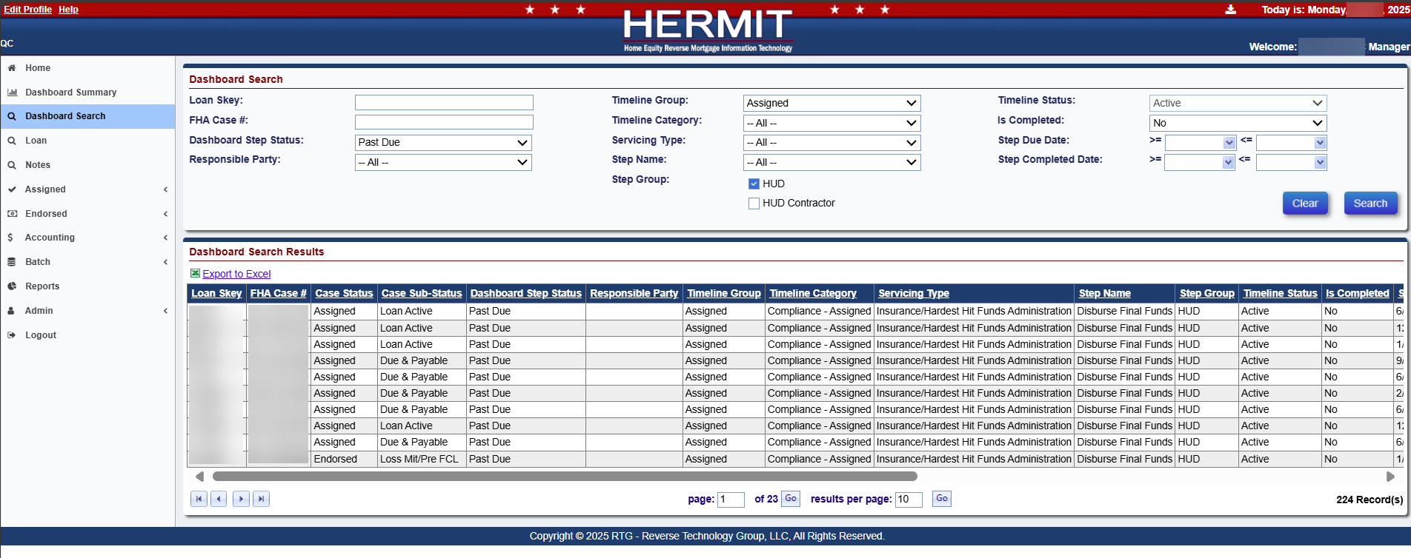
- Dashboard Search screen allows a user to enter customized search parameters and click Search. The results for the corresponding population will be displayed under the Dashboard Search Results section of the screen. The results may be exported using the Export to Excel feature or users can jump directly to the timeline which houses that step by clicking the desired loan displayed in the result grid.

------ End of Document -----

