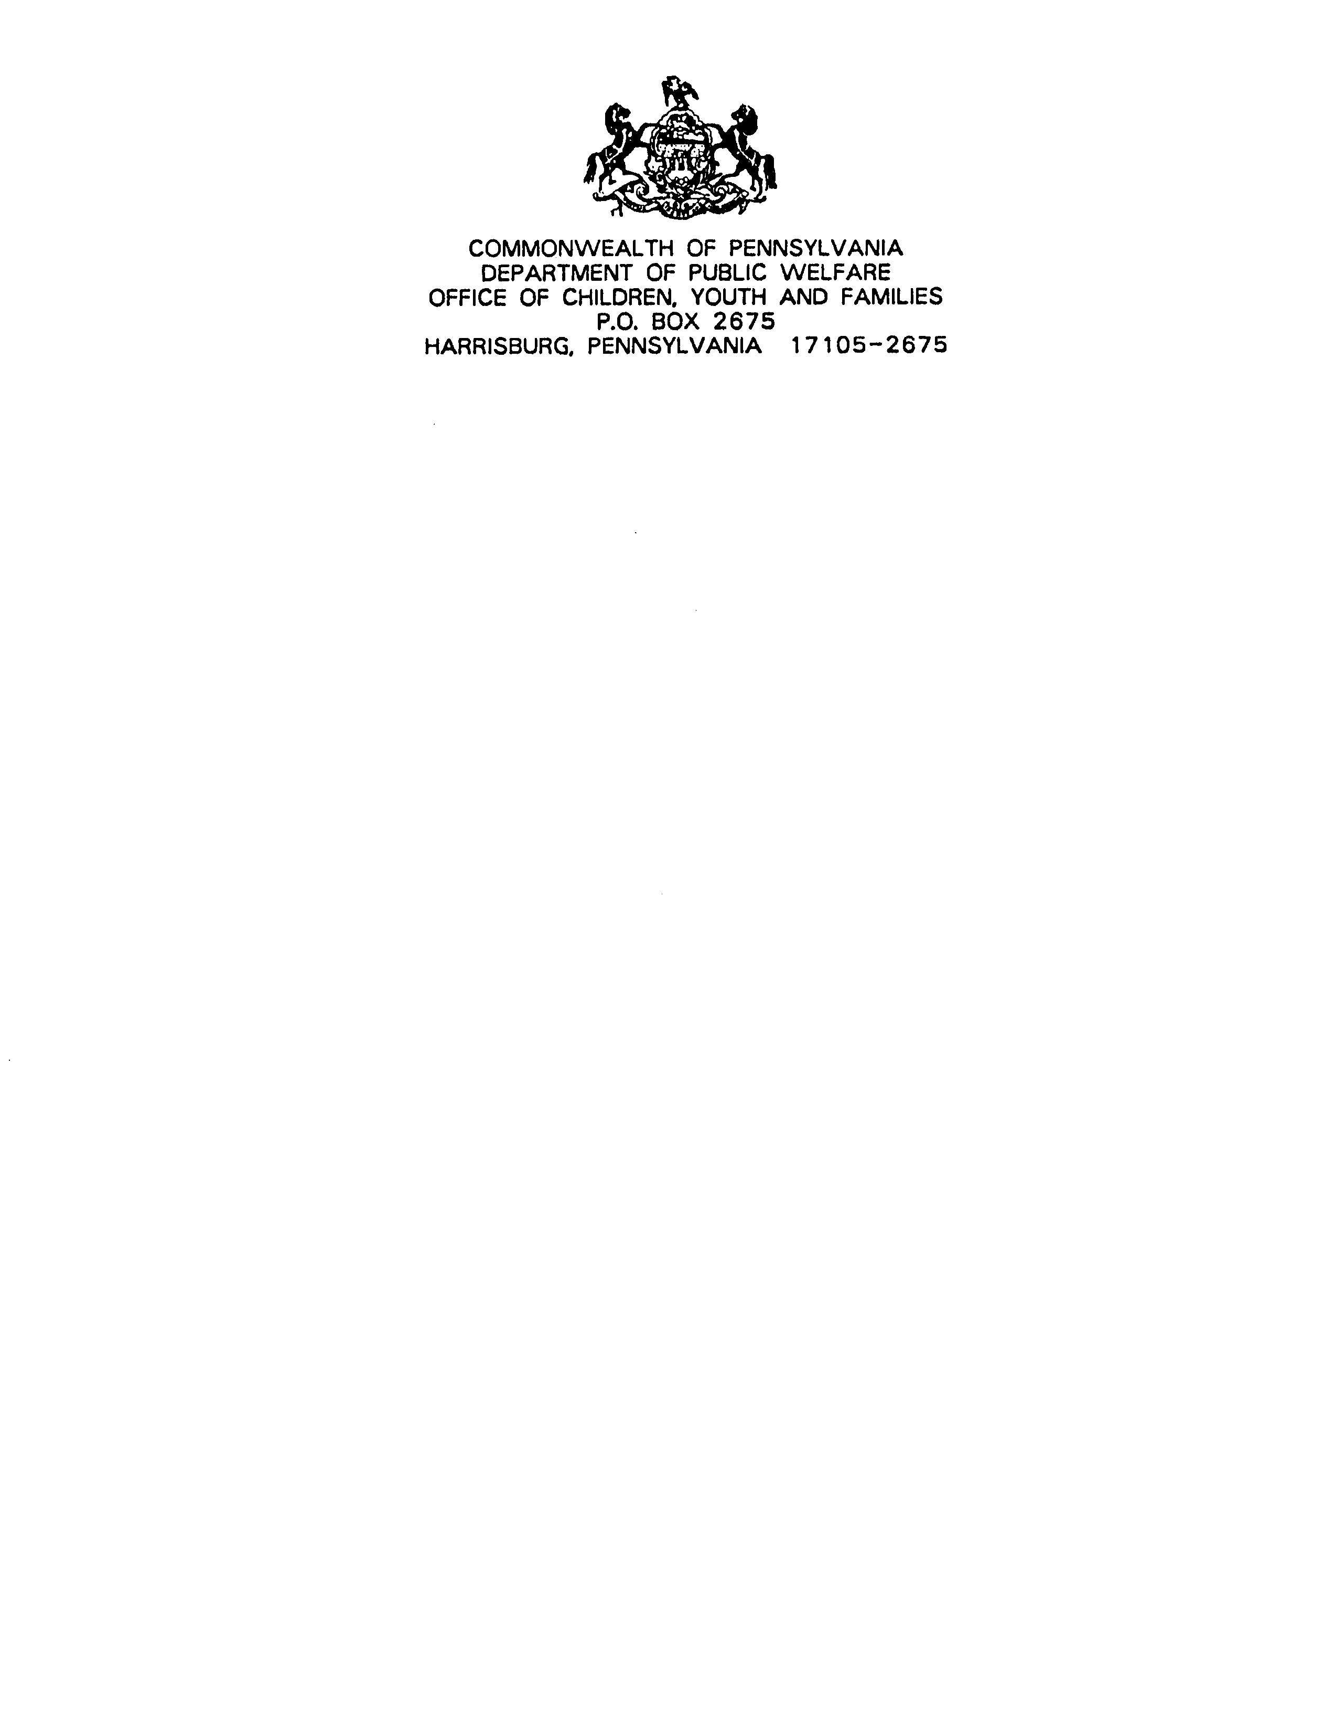
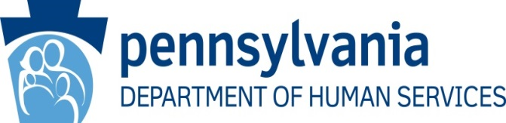

December 24, 2020

Bureau of Human Services Licensing TEL: (717) 705-0383
Licensing Administration FAX: (717) 705-6955

Scott Logan
Social Security Administration
Office of Income Security Programs
Keys Section
2518 Robert M. Ball Building
6401 Security Boulevard
Baltimore, MD 21235

Dear Mr. Logan:

I have been assigned the responsibility for implementing the Keys Amendment requirements and the Keys Amendment Certification for the Commonwealth of Pennsylvania. Enclosed is Pennsylvania’s certification under the Keys Amendment, Section 1616(e) of the Social Security Act, 42 U.S.C §§ 1382e and 45 CFR Part 1397, for Federal Fiscal Year 2021.

There were no new licensing regulations which would affect residential settings where Supplemental Security Income (SSI) recipients reside proposed or promulgated during this past year.

If you have any questions about this submission, please contact me at this office at 717-705-0382.

Sincerely,

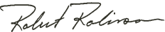

Robert Robinson
Director

Enclosures

STATE CERTIFICATION

The Commonwealth of Pennsylvania submits the following certification, as required by 45 CFR, Section1397.10(e) and (f) for Federal Fiscal Year 2021.

- Two State Agencies in the Commonwealth of Pennsylvania are responsible for establishing, maintaining, and ensuring the enforcement of standards for residential facilities in which significant numbers of SSI recipients are likely to reside in accordance with 45 CFR, Section 1397.10. These agencies are:

The Department of Human Services
The Department of Labor and Industry

The Department of Labor and Industry is responsible for standards relating to life safety. The Department of Human Services is responsible for the program standards governing the facilities listed below:

Domiciliary Care Program of Adults
Child Residential and Day Treatment Facilities
Community Residential Rehabilitation Facilities
Community Homes for Individuals with Mental Retardation
Personal Care Homes for Adults
Family Living Homes
Long Term Structured Residences

- The Department of Human Services has been identified as the single state agency responsible for the certification by the laws and regulations related to the Keys Amendment.

- The Commonwealth assures that information about standards, enforcement procedures, waivers of standards, and violations of standards by specific facilities has been made available for public review, as required by 45 CFR, Section 1397.109(c) and 1397.20(d)(2).

- The names and addresses of facilities that are in violation of the above standards and regulations are reported to the relevant Social Security Administration Regional Office in accordance with 45 CFR, Section 1397.20(c).

___________________________________________
Robert Robinson, Director
Human Services Licensing Administration
Department of Human Services
Commonwealth of Pennsylvania

