 of

December 22, 2021
Social Security Administration Office of Income Security Programs
Keys Section
2518 Robert M. Ball Building
6401 Security Boulevard
Baltimore, Maryland 21235
RE: 2022 Keys Amendment Certification
Dear Mr. Logan:
Pursuant to the provisions of Section 1616(e) of the Social Security Act, I certify that the Tennessee Department of Health (TDH), as the designated State Agency for coordinating compliance with the Keys Amendment; the Tennessee Department of Mental Health and Substance Abuse Services (TDMHSAS), based upon the information provided by Alex R. King, J.D., Director of Licensure at TDMHSAS; and the Tennessee Department of Intellectual and Developmental Disabilities (TDIDD), based upon the information provided by Daven N. Harrell, Director of Risk Management and Licensure at (TDIDD), are in compliance with the statutory and regulatory provisions of the Keys Amendments for the federal fiscal year of 2022.
The Office of Health Care Facilities at TDH is the regulatory agency for nursing homes, assisted care living facilities, as well as other types of health care facilities. TDMHSAS is the regulatory agency for Tennessee agencies providing mental health and alcohol and drug abuse services. TDIDD is the regulatory agency for Tennessee agencies providing services to those with developmental and intellectual disabilities. A complete copy of rules may be viewed as follows:
TDH http ://publications.tnsosfiles.com/rules/1200/1200-08/1200-08.htm
TDMHSAS https://publications.tnsosfiles.com/rules/0940/0940.htm
TDIDD http://(publications.tnsosflles.com/rules/0465/0465. htm
I certify that the standards promulgated through TDH, TDMHSAS, and TDIDD are made available annually to the public for review. In addition, any interested individual may obtain a copy of the standards along with a list of waivers of the standards, enforcement procedures, and any violations, upon request.

 of
Enclosed is a summary of revised standards and enforcement procedures for 2020. If you should need further assistance, please do not hesitate to contact me at (615) 741-6257.
Respectfully
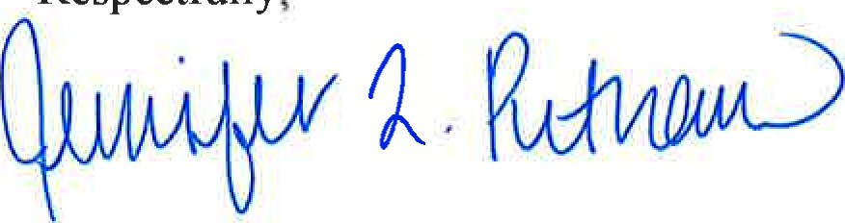
Jennifer L. Putnam, Esq.
Assistant Commissioner, Health Licensure and Regulation
Valerie Nagoshiner, Chief of' Staff, Department of Health
Ann R. Reed, Director of Licensure, Office of Health Care Facilities, Department of Health
Alex R. King, J.D., Director of Licensure, Department of Mental Health and Substance Abuse Services
Daven N. Harrell, Director of Risk Management and Licensure, Department of Intellectual and Developmental Disabilities
Enclosure

