Home Equity Reverse Mortgage Information Technology
(HERMIT)

HERMIT System Changes – Release 7.9

Release Date: 02/22/25
Document Date: 02/07/25
Version 1.0

February 2025

INTRODUCTION
The Home Equity Reverse Mortgage Information Technology (HERMIT) software release version 7.9 consists of the following system changes:
Table of Contents
Servicer Related Changes 4
1. MIP Batches in Unapproved status: CHUMS Cancellation Updates (591439 & 591937 & 578096) 4
2. MIP Batches in Unapproved status: Preventing Termination of a Loan (591439 & 591937 & 578096) 6
3. MIP Batches in Unapproved status: Preventing Approval of a Claim (591439 & 591937 & 578096) 6
4. Transactions: Four Endorsed Transactions Renamed (590196 & 590510) 7
NSC / HUD Related Changes 8
5. Letter: Welcome Letter to include Unscheduled Advance Request Forms Only for Loans with a Positive NPL (592799) 8
6. Letter: Repurchase Demand Letter to be Auto-Populated w/ Repurchase Reason (592144) 9
7. Disbursements: New “Corp Adv – S305 – State Prohibited Legal - Appraisals” and “Corp Adv – S305 – State Prohibited Legal – Inspections” Transaction (591162) 9
8. Batch: NSC Disbursement Uploads: Two New links added (591162) 10
9. Batch: “Corp Adv – S305 – State Prohibited Legal” Disbursement added to the Bulk NSC Disbursements page (591162) 11
10. Disbursements: Updates to Unscheduled Property Charge Disbursements and Viewing Property Charge Default Balances for Assigned Loans. 11
11. New Report: CT-22 Denial Reason (593060) 17
12. New Report: Property Charge Default Reporting (593219) 19
13. New Report: HUD Monthly Management Report (539367) 21
14. Report Changes: Timeline Activity Report to include Step Group Servicer (589845) 22
15. Report Changes: Timeline Activity Report add New Columns (591243 & 591967) 22
Servicer and NSC / HUD Related Changes: 23
16. Transaction Permissions: Separate permissions for Endorsed & Assigned transactions (563429) 23
17. Transactions: Prevent Incurred Date from being a Future Date (593245) 23
18. Transactions: Removed “Disb – Delinquent Taxes” Transaction from Assigned and Endorsed loans (590196 & 590510) 24
19. Loan: Payoff page was updated to exclude “Corp Adv – S305 – State Prohibited Legal” Transactions (591464) 24
20. Timelines: New Columns on Timeline Step > Step Information grid (591243) 25

If you have any questions regarding the functionality of the software release, please contact the HERMIT Help Desk at 561-899-2610 or at servicingsupport@hermitsp.com. If you have any policy related questions, please send an email to HUD at answers@hud.gov.

Servicer Related Changes

MIP Batches in Unapproved status: CHUMS Cancellation Updates (591439 & 591937 & 578096)
Existing functionality: When HERMIT receives a Case Cancellation record from CHUMS/ FHA Connection, a Cancellation Refund is sent to the Accounting Module to refund eligible Mortgage Insurance Premiums (MIP) which generally includes both Initial MIP (IMIP) and Monthly MIP (MMIP). The Cancellation Refund Amount is viewable under Accounting > Transmittals > Batch Type = Refunds and is displayed in the Loan > Transactions > Loan page as Transaction Code: 1090 “Loan Setup – Adj”.
An update was made to the Cancellation Refund Amount to only include amounts from MIP Batches that were successfully collected. Uncollected MIP Batches with the following Batch Statuses will not be included in the Cancellation Refund amount:
  - Ready for Approval: (MMIP*)
  - Failure – Technical Issues: (IMIP or MMIP)
  - Failed (Retired): (IMIP or MMIP). This is referred to as a Debit Voucher.

*Batch Status “Ready for Approval” only applies to Monthly MIP batches as individual batch approvals are not applicable for Initial MIP.

Upon processing a Case Cancellation, the amount of Uncollected MIP that was not included in the Cancellation Refund Amount is now displayed on the Loan > Transactions > Loan page as Transaction Code 2910 “Write-Off – Auto”. The Total Loan balance will continue to zero out, as it does today.

In addition, the original Uncollected MIP Batches are updated as follows:
- If the original MIP batch included one loan: The original Uncollected MIP Batch will be set to No Pay Order and a Batch Note added stating “{Date} - Case was Cancelled by CHUMS, and the Batch was not Approved for Processing so it was set to “No Pay Order”.”
- If the original MIP batch included more than one loan, then the Uncollected MIP Amounts will be removed from the original MIP Batch and placed into a new batch only for the Uncollected MIP. The following will also occur:
  - Original MIP Batch Trans Count and Batch Amount will be reduced by the Uncollected MIP Counts and Amounts, respectively
  - New MIP Batch for Uncollected MIP will be created and updated as follows:
    - New Batch set to “No Pay Order”. The Trans Count and Batch Amount includes only what was removed from the original MIP Batch due to the Cancellation.
    - New Batch Note added stating “{Date} - Case was Cancelled by CHUMS, and the Batch was not Approved for Processing so it was set to “No Pay Order”.”

Loan > Transactions > Loan:
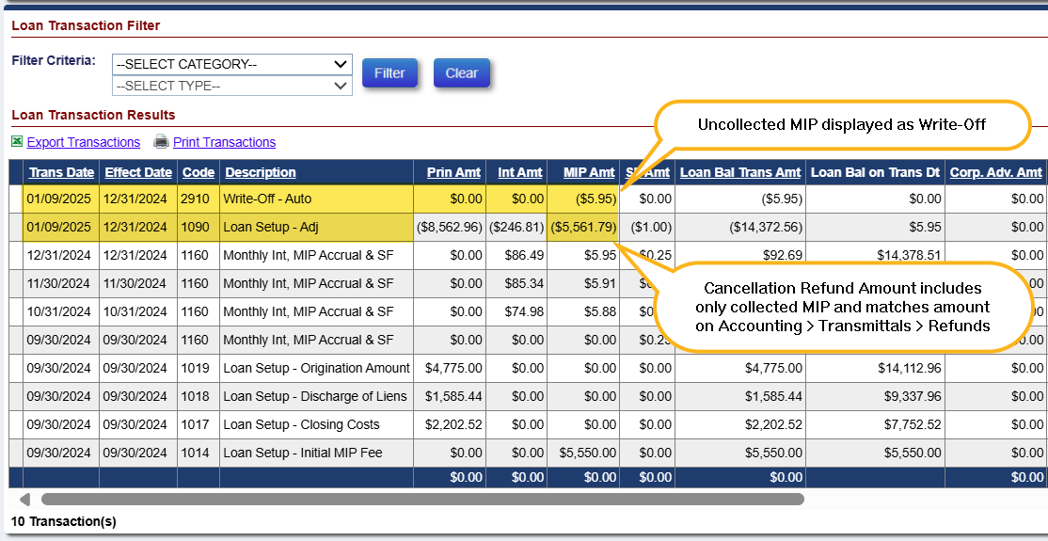

Accounting > Transmittals > Batch Type: Refunds
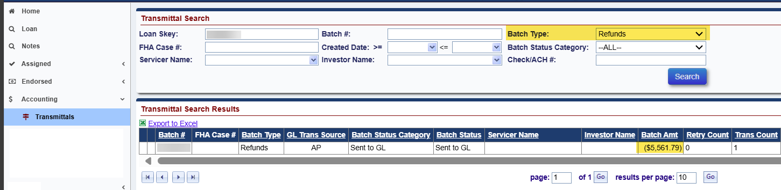

Accounting > Transmittals > Batch Type: Monthly MIP Due (to view uncollected MIP)
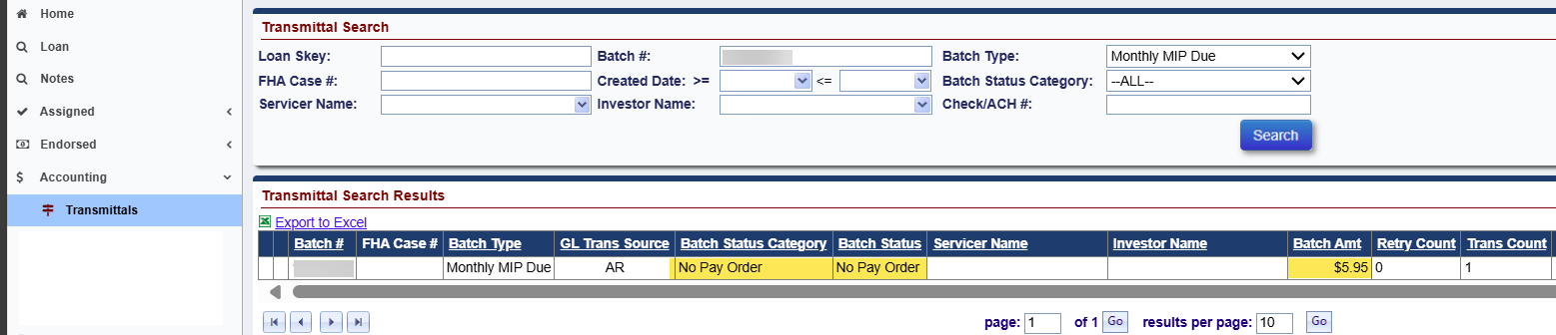

MIP Batches in Unapproved status: Preventing Termination of a Loan (591439 & 591937 & 578096)
An update was made to prevent Termination of an Endorsed loan if there is an Uncollected MIP Batch on the loan. Uncollected MIP Batches with the following Batch Statuses cannot be Terminated until the MIP Batch is Approved or otherwise resolved:
  - Ready for Approval: (MMIP)
  - Failure – Technical Issues: (IMIP or MMIP)
  - Failed (Retired): (IMIP or MMIP). This is referred to as a Debit Voucher.
The following error message will be displayed when the user tries to Terminate the loan and there is an Uncollected MIP Batch: “This loan cannot be terminated due to having a MIP Batch in Ready for Approval, Failure – Technical Issues or Failed Retired status.”
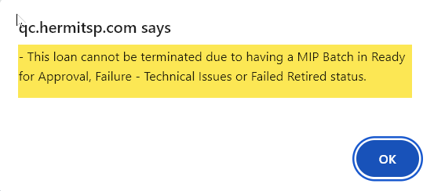

MIP Batches in Unapproved status: Preventing Approval of a Claim (591439 & 591937 & 578096)
An update was made to the claims hard stop validation on Claim Types 21, 23, and 24 to prevent a claim from being approved by HUD if there is an Uncollected MIP Batch. Prior to this enhancement, the hard stop validation only applied to Batch Status Category “Failed” (Retired). Following these updates, the hard stop validation now applies to any type of Uncollected MIP Batch and cannot be Approved by HUD until the MIP Batch is Approved or is otherwise resolved:
  - Ready for Approval: (MMIP)
  - Failure – Technical Issues: (IMIP or MMIP)
  - Failed (Retired): (IMIP or MMIP). This is referred to as a Debit Voucher.

For both Servicer Users and HUD users, the claims worksheet will display an informational yellow User Alert when there is an Uncollected MIP Batch on the loan. The Servicer may still file or resubmit the claim if there is an Unapproved MIP Batch on the loan, but HUD will not be able to Approve the Claim.
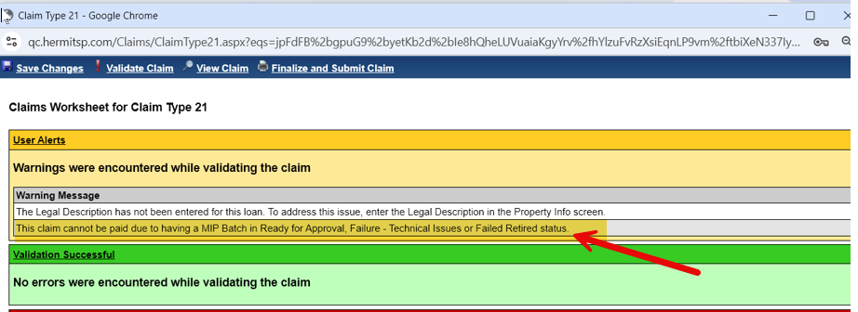

If a HUD user attempts to Approve the claim and there is an Unapproved MIP Batch on the loan, a claims hard stop validation message will be displayed preventing Approval of the Claim.
The hard stop validation language was revised to state “This claim cannot be paid due to having a MIP Batch in Ready for Approval, Failure - Technical Issues or Failed Retired status.”

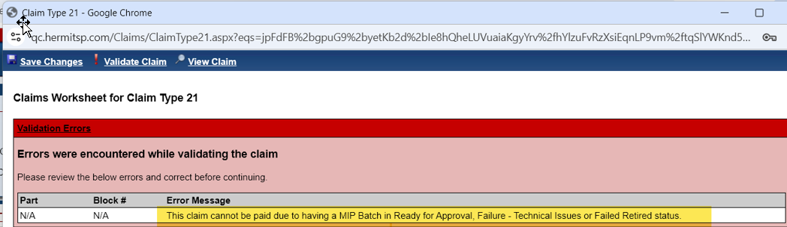
When there is an Unapproved MIP Batch, the authorized HUD user may still Pend the claim.
This hard stop validation does not apply to Claim Types 20 and 22 since these claims are auto-approved.

Transactions: Four Endorsed Transactions Renamed (590196 & 590510)
An update was made to rename four Endorsed Transactions to clarify the Transaction purpose as a Property Charge Transaction.
Transaction Code | Former Transaction Description | Updated Transaction Description
2450 | Disb - Unscheduled from LOC Insurance | Disb - Property Charge - Insurance
2350 | Disb - Unscheduled from LOC Taxes | Disb - Property Charge - Taxes
2490 | Disb - Unscheduled from LOC Insur Adj | Disb - Property Charge - Insurance Adj
2390 | Disb - Unscheduled from LOC Taxes Adj | Disb - Property Charge - Taxes Adj

NSC / HUD Related Changes

Letter: Welcome Letter to include Unscheduled Advance Request Forms Only for Loans with a Positive NPL (592799)
An update was made to add copies of the “Unscheduled Advance Request Form – Funds from Line of Credit” to the Welcome Letter printed from a Claim Type 22 – Assignment or Claim Type 20 – Demand Assignment when funds are available to be drawn by a borrower. Available funds can be drawn by a borrower for loans with Payment Plan types Line of Credit, Modified Term, or Modified Tenure and the Net Principal Limit is greater than $0.00. For these loans, Unscheduled Advance Request Forms are included when the Welcome Letter is printed.
Unscheduled Advance Request Forms will be excluded from printed Welcome Letters when funds are not available to be drawn by a borrower.
Welcome letters can be printed/viewed under:
- HUD Contractor Step “Welcome Letter Sent” on the Endorsed > Claims > Claim Type 22 – Assignment Timeline
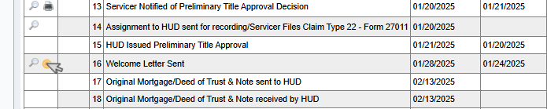
- HUD Contractor Step) “Welcome Letter Sent” on the Endorsed > Claims > Claim Type 20 – Demand Assignment Timeline
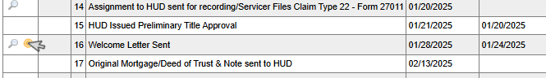
Reports module > Assigned Notes Reports > Bulk Printing Letters
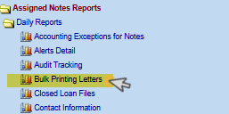
In addition, the Print Welcome Letter link on the Loan > Transactions > Loan page was removed and is no longer available for any users. The Welcome Letters must be printed form the corresponding Assignment Timeline.

Letter: Repurchase Demand Letter to be Auto-Populated w/ Repurchase Reason (592144)
An update was made to the Assignment Repurchase timeline HUD Contractor Letter Step “Repurchase Letter Issued to Investor” to pre-populate the “Comments” field in the Modify Letter Fields modal. The Modify Letter Fields modal is displayed after clicking the magnifying glass or printer icon on the step. Screen shot of the Comments box on the Modify Letter Fields modal:
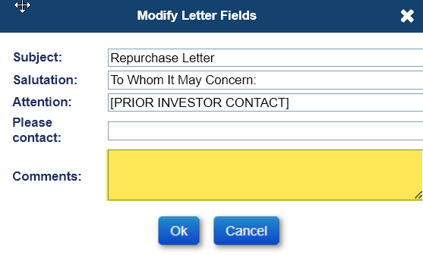
If the “Pre-Repurchase Letter” was already generated and the magnifying glass or print icon is clicked on Letter step “Repurchase Letter Issued to Investor”, the Comments box will be populated with text from the “HUD Comments” field on the Servicing Mgmt page (entered at timeline initiation).
If this is considered a Direct Repurchase where the “Pre-Repurchase Letter” was not generated and the magnifying glass or print icon is clicked on Letter step “Repurchase Letter Issued to Investor”, no pre-populated text will be displayed in the Comments box.
Regardless of whether the “Pre-Repurchase Letter” was printed or not, the Comments from the Modify Letter Fields modal will be printed on the Repurchase Letter. The character limit for the Comments box was updated to 1,000 characters to match the “Pre-Repurchase Letter”. Users are still able to modify, edit, or delete the text pre-populated in the Comments filed of the Modify Letter Fields modal.

Disbursements: New “Corp Adv – S305 – State Prohibited Legal - Appraisals” and “Corp Adv – S305 – State Prohibited Legal – Inspections” Transaction (591162)
Two new Disbursements called “Corp Adv – S305 – State Prohibited Legal - Appraisals” and “Corp Adv – S305 – State Prohibited Legal – Inspections” will be available for Loans only in the state of Maryland and New York in HUD’s portfolio and will be entered through the New Disbursement window on the Loan > Disbursement page.
- The following below will show in the New Disbursement window:
- The Transaction Category will be “Disb – Unscheduled from LOC”
- The Transaction Description will display “Corp Adv – S305 – State Prohibited Legal - Appraisals” and “Corp Adv – S305 – State Prohibited Legal – Inspections”
- The Payee Type will default to “Vendor”
- The “Corp Adv – S305 – State Prohibited Legal – Appraisals” and “Corp Adv – S305 – State Prohibited Legal – Inspections” will both have a corresponding Adjustment Transaction code if the disbursement is voided.
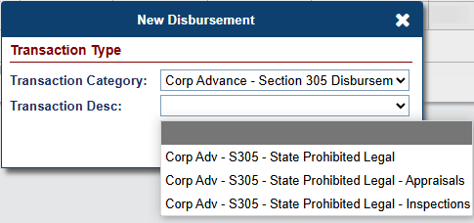

Batch: NSC Disbursement Uploads: Two New links added (591162)
An update was made to the Batch > NSC Disbursement Uploads page to add two new links called “State Prohib Legal – Appraisal Disbursements” and “State Prohib Legal – Inspection Disbursements” . The new links provide a Template file for users to upload multiple “Corp Adv – S305 - State Prohibited – Legal – Appraisals” and “Corp Adv – S305 - State Prohibited Legal – Inspections” Disbursements for Loans in HUD’s portfolio only for the state of Maryland and/or New York. Once the user uploads the Template successfully, the system will display the Pending Disbursements on the Loan > Disbursements page.
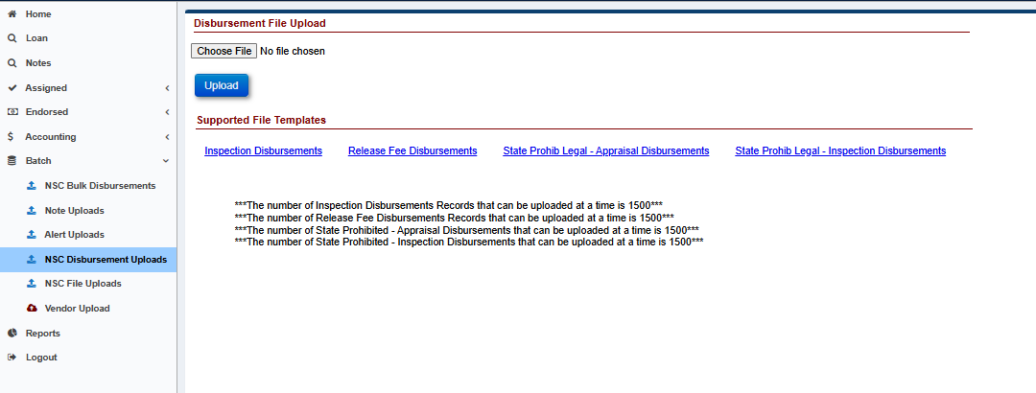

Batch: “Corp Adv – S305 – State Prohibited Legal” Disbursement added to the Bulk NSC Disbursements page (591162)
An update was made to the Batch > NSC Bulk Disbursements page to add the “Corp Adv – S305 – State Prohibited Legal” Disbursement . This page allows multiple transactions to be added at a time without having to manually add them to each loan. Only Authorized users can use and view this page.
- The Transaction Category “Corp Advance – Section 305 Disbursements” was added to the Transaction Category drop-down list.
- The Transaction Description “Corp Adv – S305 – State Prohibited Legal” was added to the Transaction Description drop-down list.
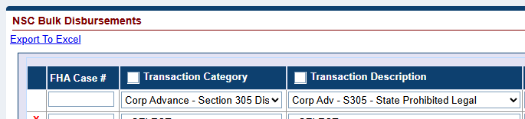

Disbursements: Updates to Unscheduled Property Charge Disbursements and Viewing Property Charge Default Balances for Assigned Loans.
Multiple changes were made to Disbursements for Unscheduled Property Charges affecting loans in HUD’s portfolio, generally referred to as Assigned loans. Changes include renamed and updated field on the Loan Balance page from “Unscheduled Prop Chrg” to “Property Chrg Default Balance”; New and renamed Disbursement Types to be used on Non-Default vs. Default Property Charges; and new popups displayed during Disbursement entry, including errors and warning/ certify modals which guide the user if certain Disbursement types are permitted or not.
Disbursements considered to be “Non-Default Property Charges” must be used when there are sufficient Available Funds in the Credit Line Set Aside (CLSA) and/or Net Principal Limit (NPL). This will be referred to throughout the remainder of the Release Notes as Non-Default Prop Chrg.
Disbursements considered to be “Default Property Charge” Disbursements must be used when there are insufficient Available Funds. This will be referred to throughout the remainder of the Release Notes as Default Prop Chrg.

- Renamed & Updated Field on Loan Balance page: The field “Unscheduled Prop Chrg” on the Loan Balance page was renamed to “Property Chrg Default Balance” and includes all Default Prop Chrg Disbursements. Non-Default Prop Chrg Disbursements are not included.
The “Property Chrg Default Balance” can be less than $0.00. NOTE: If the “Property Chrg Default Balance” field is less than $0.00, this indicates an issue that will need to be researched further.
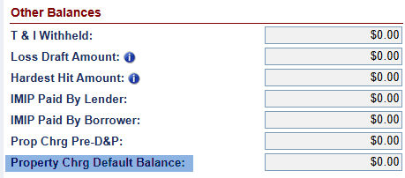

- Disbursement Changes to separate Non-Default Prop Chrg and Default Prop Chrg Disbursements:
Changes were made under Transaction Category “Disb – Unscheduled from LOC” for Assigned loans, to the list of Disbursements available in the Transaction Desc dropdown. These changes apply to all methods of Disbursement entry. On Assigned loans, a user will only be able to create a Non-Default Prop Chrg Disbursement when there are sufficient Available Funds in the Credit Line Set Aside (CLSA) and/or Net Principal Limit (NPL). When there are insufficient Available Funds, the user will be directed to create a Default Prop Chrg Disbursement.
Example of Disbursement options available: including New and Renamed transactions:
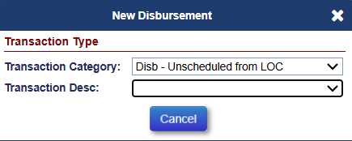
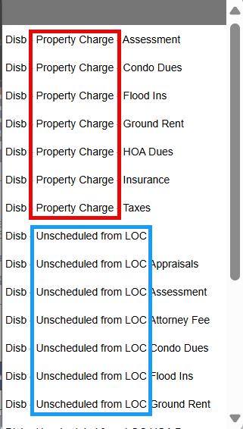
Default Prop Chrg Disbursements are listed with Descriptions: “Disb - Property Charge” displayed in red box above and Non-Default Prop Chrg Disbursements are listed with Descriptions: “Disb – Unscheduled from LOC” displayed in blue box above.

- Renamed Disbursements, not related to either Non-Default or Default Prop Chrg:
Two Disbursement codes were renamed since these are not considered Property Charges.
Transaction Code | Former Disbursement Description | Updated Disbursement Description
1359 | Disb – LOC – Property Charge – Attorney Fee | Disb - Unscheduled from LOC Attorney Fee
1399 | Disb – LOC – Property Charge – Attorney Fee Adj | Disb - Unscheduled from LOC Attorney Fee Adj

- New Disbursement Codes for Non-Default Prop Chrg:
New “Unscheduled from LOC” Disbursement codes were added for Assigned loans. The new transactions are intended to report Non-Default Prop Chrg. These must be used when there are sufficient funds available in the Credit Line Set Aside (CLSA) field and/or the Net Principal Limit (NPL) field.
Non-Default Prop Chrg - New Disbursements
Transaction Code | Disbursement Description
1370 | Disb - Unscheduled from LOC Assessment
1368 | Disb - Unscheduled from LOC Condo Dues
1364 | Disb - Unscheduled from LOC Flood Ins
1362 | Disb - Unscheduled from LOC Ground Rent
1366 | Disb - Unscheduled from LOC HOA Dues
1360 | Disb - Unscheduled from LOC Insurance
1372 | Disb – Unscheduled from LOC Taxes
1371 | Disb - Unscheduled from LOC Assessment Adj
1369 | Disb - Unscheduled from LOC Condo Dues Adj
1365 | Disb - Unscheduled from LOC Flood Ins Adj
1363 | Disb - Unscheduled from LOC Ground Rent Adj
1367 | Disb - Unscheduled from LOC HOA Dues Adj
1361 | Disb - Unscheduled from LOC Insurance Adj
1373 | Disb – Unscheduled from LOC Taxes Adj
- Renamed Disbursement Codes for Default Prop Chrg:
Existing Disbursements were renamed to clarify reporting of Default Prop Chrg Disbursements for Assigned loans. These must be used when there are insufficient funds available in the CLSA field and/or the NPL field.

Default Prop Chrg – Renamed Disbursements
Transaction Code | Former Disbursement Description | Updated Disbursement Description
2351 | Disb - LOC - Property Charge - Assessment | Disb - Property Charge - Assessment
1358 | Disb - LOC - Property Charge - Condo Dues | Disb - Property Charge - Condo Dues
1356 | Disb - LOC - Property Charge - Flood Ins | Disb - Property Charge - Flood Ins
1355 | Disb - LOC - Property Charge Ground Rent | Disb - Property Charge - Ground Rent
1357 | Disb - LOC - Property Charge - HOA Dues | Disb - Property Charge - HOA Dues
2450 | Disb - Unscheduled from LOC Insurance | Disb - Property Charge - Insurance
2350 | Disb - Unscheduled from LOC Taxes | Disb - Property Charge - Taxes
2391 | Disb - LOC - Prop Charge - Assessment Adj | Disb - Property Charge - Assessment Adj
1398 | Disb - LOC - Prop Charge-Condo Due Adj | Disb - Property Charge - Condo Due Adj
1396 | Disb - LOC - Prop Charge - Flood Ins Adj | Disb - Property Charge - Flood Ins Adj
1395 | Disb - LOC - Property Charge - Ground Rent Adj | Disb - Property Charge - Ground Rent Adj
1397 | Disb - LOC - Prop Charge-HOA Dues Adj | Disb - Property Charge - HOA Dues Adj
2490 | Disb - Unscheduled from LOC Insur Adj | Disb - Property Charge - Insurance Adj
2390 | Disb - Unscheduled from LOC Taxes Adj | Disb - Property Charge - Taxes Adj

- Multiple Disbursements: If the loan has Available Funds in the CLSA field and/or the NPL field but does not have sufficient funds to cover the whole disbursement transaction amount, then the user will need to create two disbursements. First create a Non-Default Prop Chrg Disbursement using the remaining Available Funds from the CLSA field and/or NPL field (see the “Non-Default Prop Chrg - New Disbursements” table above). Next, create a Default Prop Chrg Disbursement for the remaining transaction amount (see the “Default Prop Chrg – Renamed Disbursements” table above). Splitting the disbursement into two separate transactions may require the user to flag the disbursements as “Special Handling”.

- Popup modals: Certify and Error messages
Two new Certify warning Messages and a new Hard Stop Error were added. Each of these messages relies on an Available funds calculation. Available funds are calculated as follows:
- If the NPL Balance is greater than $0.00, then the NPL Balance = NPL Balance
- If the NPL Balance is less than $0.00, then the NPL Balance = $0.00
- Available Funds = Credit Line Set Aside Balance + NPL Balance - Pending Disbursements (that impact NPL).
- NOTE: Pending Disbursements (that impact NPL) do not reduce the NPL Balance or Credit Line Set Aside Balance until the transaction is disbursed and reflected in the Loan Transactions grid.
- Examples:
- Example 1: The loan’s CLSA field has an amount of $50.00 and the NPL field has an amount of $20.00. The Pending Disbursements that impact the CLSA and/or NPL total $35.00. The Available funds equal $35.00 ($50.00 + $ 20.00 - $35.00 = $35.00)
- Example 2: The loan’s CLSA field has an amount of $60.00 and the NPL field has an amount of ($35.00). The Pending Disbursements that impact the CLSA and/or NPL total $20.00. The Available funds equal $40.00 ($60.00 + $0.00 - $20.00 = $40.00).

- Error message: The user will receive a Hard Stop Error when the Available Funds are less than the Non-Default Property Charge Disbursement Amount
- Message: “The Unscheduled from LOC Disbursement Amount cannot exceed the combined amount available from the NPL and or Credit Line Set Aside in the amount of “$x.xx.”

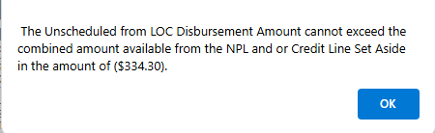

- Certify / warning message on Non-Default Prop Chrg: The user will receive a Certify or warning Message when processing a Non-Default Prop Chrg Disbursement if the Available Funds are sufficient, but a portion of the transaction will reduce the NPL. The user may continue with processing the disbursement by clicking “Yes” to the Message.
- The Certify or warning Message will display for Term and Tenure plans if the “Available Funds” are greater than or equal to the Non-Default Prop Chrg Disbursement Amount.
- The Certify or warning Message will display for Modified Term and Modified Tenure plans if the “Available Funds” are greater than or equal to the Non-Default Prop Chrg Disbursement Amount, but the CLSA is less than the Non-Default Prop Chrg Disbursement Amount.
- Message: “This disbursement will cause the NPL to be insufficient to support future Scheduled Payments. Are you sure you want to continue?”
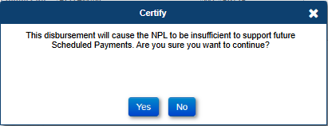

- Certify / warning message on Default Prop Chrg: The user will receive a Certify or warning Message when processing a Default Prop Chrg Disbursement when there are Available funds. The user may continue with processing the disbursement by clicking "Yes” to the Message.
- Message: “Available funds from the Credit Line Set Aside and/or NPL should be used before disbursing a Default Property Charge. Are you sure you want to continue?”
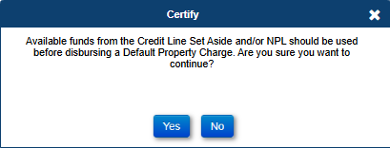

New Report: CT-22 Denial Reason (593060)
A new report called “CT-22 Denial Reason” was added in the Reports module under Management /Budgetary > Daily Reports. This report includes the denial reasons selected on the HECM Assignment Acceptance Checklist from the HUD Decision Denial Letter.
HUD and HUD Contractor Reports area:
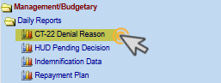
CT-22 Denial Reason Report Search Criteria:
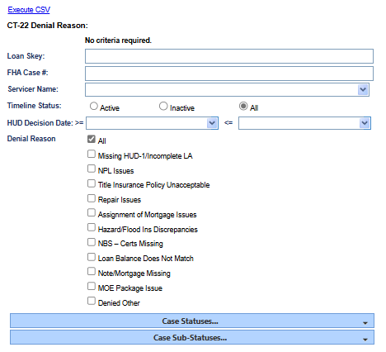
- Search Criteria includes:
- Loan Skey
- FHA Case #
- Servicer Name
- Timeline Status (Active, Inactive, All)
- HUD Decision Date (Date Range)

- Selectable filter criteria:
- Denial Reason:
  - Missing HUD-1/Incomplete LA
  - NPL Issues
  - Title Insurance Policy Unacceptable
  - Repair Issues
  - Assignment of Mortgage Issues
  - Hazard/Flood Ins Discrepancies
  - NBS – Certs Missing
  - Loan Balance Does Not Match
  - Note/Mortgage Missing
  - MOE Package Issue
  - Denied Other
- Case Statuses
- Case Sub-Statuses

- The output is available in CSV format and includes the following fields:
  - Loan Skey
  - FHA Case Number
  - Case Status
  - Case Sub-Status
  - Timeline Status
  - HUD Decision Date (Step Completion Date)
  - Missing HUD-1/Incomplete LA
  - NPL Issues
  - Title Insurance Policy Unacceptable
  - Repair Issues
  - Assignment of Mortgage Issues
  - Hazard/Flood Ins Discrepancies
  - NBS - Certs Missing
  - Loan Balance Does Not Match
  - Note/Mortgage Missing
  - MOE Package Issue
  - Denied Other
  - Servicer

New Report: Property Charge Default Reporting (593219)
A new Report called “Property Charge Default” was added in the Reports module under Assigned Notes Reports > Daily Reports for HUD and HUD Contractors. This report includes Assigned Loans (loans in HUD’s portfolio) with Property Charge Default Amounts (due to insufficient funds available).
HUD and HUD Contractor reports area:
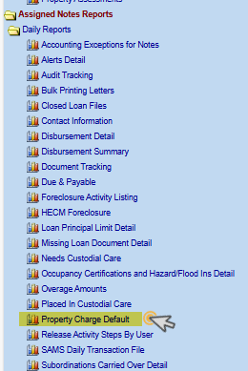
Loans will be added to this report when the “Property Chrg Default Balance” field is greater than $0.00. This field was renamed from “Unscheduled Prop Chrg.”
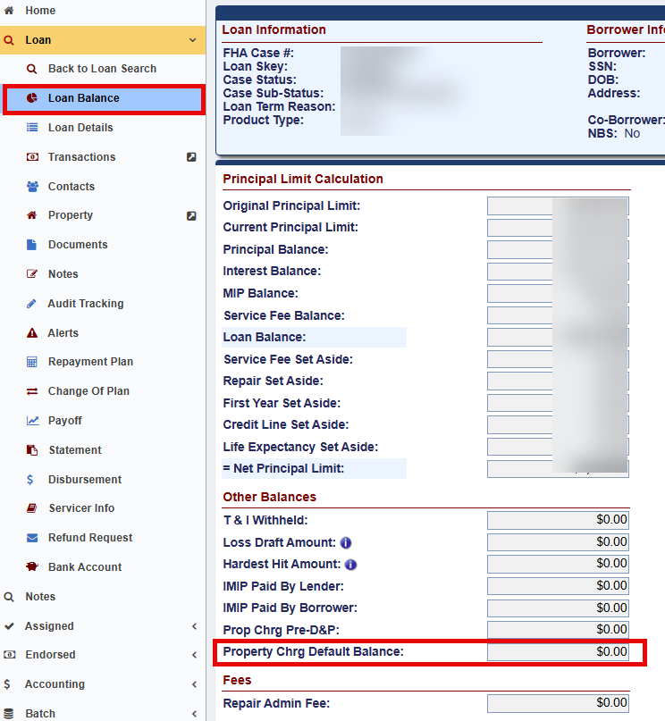
“Total Funds Available” will be determined by assessing the Credit Line Set Aside (If Modified payment type) and the Net Principal Limit availability independently. If the Credit Line Set Aside is less than $0.00, the report will display the CLSA as $0.00. Likewise, if the Net Principal Limit is less than $0.00, the report will display the NPL as $0.00. “Total Funds Available” for Modified payment types will display as $0.00 or greater and is calculated by adding the Credit Line Set Aside and the Net Principal Limit.
“Last Default Property Charge Transaction Date” field will display the latest transaction date of the following disbursement transactions:
Trans Code | Disbursement Description
1355 | Disb - Default Property Charge- Ground Rent
1356 | Disb - Default Property Charge- Flood Ins
1357 | Disb - Default Property Charge-HOA Dues
1358 | Disb - Default Property Charge-Condo Dues
2350 | Disb - Default Property Charge - Taxes
2351 | Disb - Default Property Charge- Assessment
2450 | Disb - Default Property Charge - Insurance

Property Charge Default Report Search Criteria:
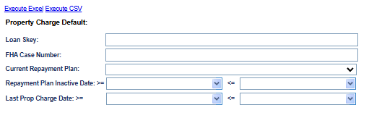
- Search Criteria includes:
- Loan Skey
- FHA Case Number
- Current Repayment Plan (Yes/No)
- Repayment Plan Inactive Date (Date Range)
- Last Property Charge Date (Date Range)

- The output will be in EXCEL and CSV format and have the following fields:
  - Loan Skey
  - FHA Case Number
  - Case status
  - Case Sub-status
  - Property Charge Balance
  - Payment Plan Type
  - Net Principal Limit (NPL)
  - Credit Line Set Aside (CLSA)
  - Total Funds Available
  - Property Charge Less Available Funds
  - Current Repayment Plan (Active/Inactive)
  - Repayment Plan Inactive Date
  - Last Property Charge Transaction Date

New Report: HUD Monthly Management Report (539367)
A new Report called “HUD Monthly Management” was added in the Reports module under Assigned Notes Reports > Monthly Reports for HUD and HUD Contractors. This report includes the Monthly Management Report data from Fiscal Year 2015-2016 onward. The report includes data from October 1 through September 30, broken down by Fiscal Year. The report data will automatically be populated each month for the current fiscal year.
If running the report prior to the end of a Fiscal Year, the report only includes data through the most recent month end date. After the Fiscal Year has ended, all 12 months in the report will be populated.
HUD and HUD Contractor reports area:
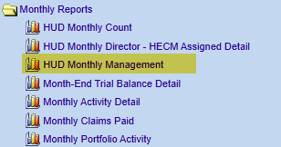
HUD Monthly Management Report Search:
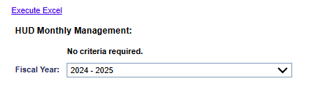

Report Changes: Timeline Activity Report to include Step Group Servicer (589845)
Changes were made to the “Timeline Activity” Report under Assigned Notes Reports > Daily Reports for HUD and HUD Contractors. Endorsed timelines that include at least one Step Group HUD or HUD Contractor step will be included in the results of the Timeline Activity Report. Endorsed timelines that have only Servicer Steps without any HUD or HUD Contractor steps in the timeline will continue to be excluded from this report. The following Endorsed timelines have only Servicer steps and are not included in the report:
  - 1510 Occupancy Compliance Certification
  - 1520 Insurance - Hazard Policy
  - 1530 Insurance - Flood Policy
  - 1540 Insurance - Forced Place
  - 1550 Repairs
  - 1560 Taxes Delinquent
  - 2520 Due & Payable w/o HUD Approval
  - 2530 Loss Mitigation - Deed-in-Lieu
  - 2540 Loss Mitigation - Family Sale Pending
  - 2550 Loss Mitigation - Pre-Foreclosure
  - 2560 Loss Mitigation - Short Sale
  - 3535 Payoff Request
  - 4510 Foreclosure
  - 5510 Bankruptcy - Chapter 7
  - 5520 Bankruptcy - Chapter 13
All other Endorsed timelines are included in the report, if the necessary criteria to display them is met.

Report Changes: Timeline Activity Report add New Columns (591243 & 591967)
The following columns were added to the “Timeline Activity” Report Results under Assigned Notes Reports > Daily Reports for HUD and HUD Contractors:
- Timeline Inactive Date – The Date the Timeline was inactivated
- Timeline Inactivated By – The user who inactivated the Timeline
- Step Inactive Date – The Date the Step was inactivated
- Step Inactivated By – The user who inactivated the Step
- Timeline Servicing Mgmt Skey – The Skey associated with the specific Timeline
- Timeline Servicing Step Skey (Servicing Activity Skey) – The Skey related to the specific Step in the Timeline
- Request For Payment Amount – From the Assigned > Request for Payment timeline Servicing Mgmt page

Servicer and NSC / HUD Related Changes:

Transaction Permissions: Separate permissions for Endorsed & Assigned transactions (563429)
Updates were made to user role permissions to only permit certain roles to Create and Edit Assigned Transactions and Endorsed Transactions.
The following roles can CREATE and EDIT Endorsed Transactions:
  - Investor-GNMA-FNMA
  - Lender-Mgr
  - Lender-Staff
  - Servicer-Mgr
  - Servicer-Staff
The following roles can CREATE and EDIT Assigned Transactions:
  - Contractor Cash
  - Contractor Cash Supervisor
  - HUD NSC Manager

Transactions: Prevent Incurred Date from being a Future Date (593245)
A new restriction was implemented to prevent users from adding a transaction with a future Incurred Date for transactions that require an Incurred Date. A new Hard Stop Error Message will appear when an authorized user attempts to input a future Incurred Date when entering a new loan transaction from the New Loan Transaction Modal.

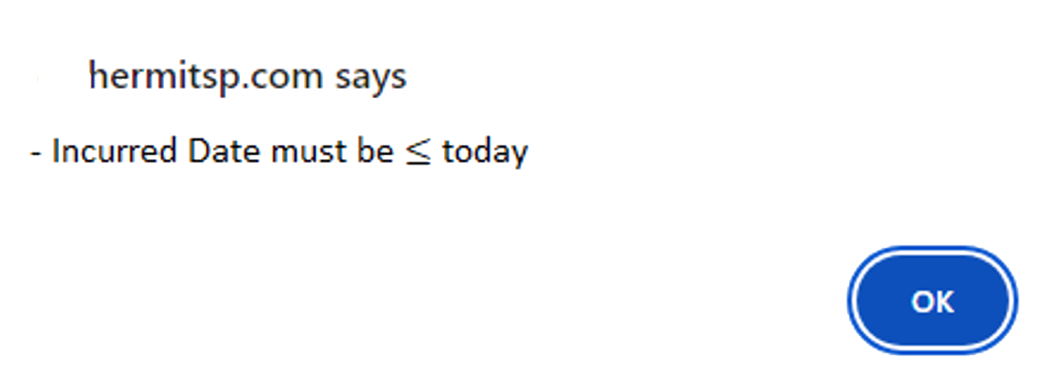

Transactions: Removed “Disb – Delinquent Taxes” Transaction from Assigned and Endorsed loans (590196 & 590510)
An update was made to no longer display the Transaction “Disb – Delinquent Taxes” (Trans Code 1450) for Assigned and Endorsed Loans.
- The Transaction “Disb – Delinquent Taxes” will no longer appear in the Transaction Category drop down list and will no longer appear on the Transaction Type drop down list on the Transaction > Loan page. The user will be able to adjust off “Disb – Delinquent Taxes” Transactions that were added prior to the release.
- The Transaction “Disb - Delinquent Taxes” will no longer appear in the Transaction Category drop down list and will no longer appear on the Transaction Type drop down list on Batch > Servicer Transactions page.
- The user will no longer be able to upload the Transaction Code 1450 (Disb – Delinquent Taxes) or the Transaction Code 1490 (Disb - Delinquent Taxes Adj) on the Batch > Servicer File Upload page. The user will receive the Error “Transaction Code is invalid. Please see a list of valid Transaction Codes.”
- The “Pay” Taxes button is no longer visible on the Assigned > Compliance > Taxes Delinquent Timeline when the user completes the step “Authorization Received/Pay Taxes.”

Loan: Payoff page was updated to exclude “Corp Adv – S305 – State Prohibited Legal” Transactions (591464)
An update was made to the Loan > Payoff page to exclude all “Corp Adv – S305 – State Prohibited Legal” Transactions from the Total Payoff Amount on the Loan > Payoff page for both Assigned and Endorsed loans as these represent charges that are not recoverable from the Borrower.

Timelines: New Columns on Timeline Step > Step Information grid (591243)
On all Endorsed and Assigned Timelines, four new columns were added to the step information grid found under the timeline steps. The four new columns are:
  - “Timeline Inactive Date”
  - “Timeline Inactivated By”
  - “Step Inactive Date”
  - “Step Inactivated By”

The “Timeline Inactive Date”, “Timeline Inactivated By”, “Step Inactive Date”, and “Step Inactivated By” will be populated with the latest date the timeline or step was inactivated, for timelines or steps inactivated on or after the Release Date. All four fields will be recorded on the Audit tracking page.

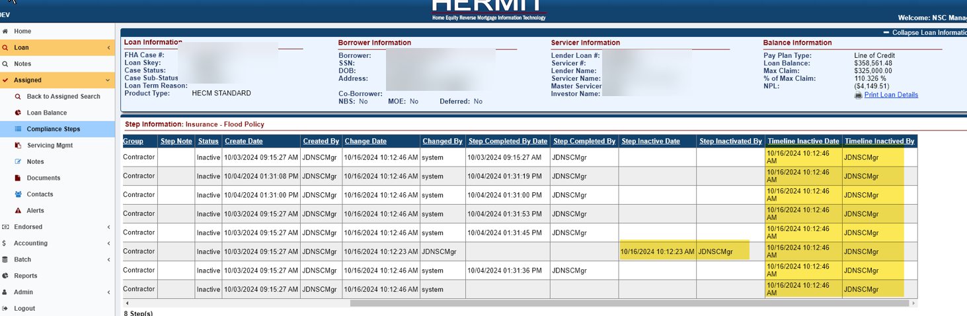

------ End of Document -----

