

United States Department of Housing and Urban Development

Home Equity Conversion Mortgage Business Service Provider (HECM BSP)

File Format and Layout
For Vendor Upload

Version 1.0

November 19, 2022
Revision History

COPIES CONTROLLED BY: Configuration Management

Version | Date | Revision Description | Author
1.0 | 11/19/2022 | Initial release | HECM BSP

Table of Contents

1 General Information 2
1.1 Purpose and Scope 2
1.2 Contents 2
1.3 Points of Contact 2
1.4 Acronyms 3
2 Technical specifications 5
2.1 Upload File Requirements 5
2.2 Vendor Upload – Record Layout 7
3 Quality Control and Verification 9
3.1 File Verification 9
3.2 Vendor Upload File layout 10

List of Tables

Table 1: HERMIT System Support Points of Contact 3
Table 2: HERMIT Program Organization Points of Contact 3
Table 3: Acronyms, Abbreviations, System Names/Codes 3
Table 4: HECM File Upload Types 6
Table 5: Data Item Descriptions for File VendorUpload 7

List of Figures
Figure 1: Vendor Upload Screen 5
Figure 2: File Processing In HERMIT 6
Figure 3: Vendor Upload File 10

General Information
This document serves as a reference for technical analysts who are responsible for enabling the functionality to add vendors in bulk to the Home Equity Reverse Mortgage Information Technology (HERMIT) system.

1.1 Purpose and Scope
The function of this document is to define and describe the data upload process in the HERMIT system. This document specifies the file record layout required for the upload of Vendors data to the HERMIT system.

Contents
The data upload process described in this document comprises the method and data elements involved in the HERMIT system. The specifications presented are:
- Define the requirements, design, procedures, and other relevant characteristics required for data uploads to HERMIT.
- Provide the syntax rules (file formats) and the semantic conventions (names, meanings, and physical units) used to generate and handle data products and data structures in the HERMIT system.
Note: Please be advised that this is the current up-to-date B2G File Layout document. It is imminent that changes will be made to the B2G File Layout document in the future when system changes are made. When those system changes are prioritized for release by HUD, this document will be updated and distributed per direction from HUD.

Points of Contact
Questions about specifications within this document should be directed to the servicingsupport@hermitsp.com email address. The key points of contact for the HERMIT system are displayed below for escalation purposes.
Table 1: HERMIT System Support Points of Contact
Function | Name | Phone | E-mail Address
HERMIT Help Desk | HERMIT Help Desk | 561-899-2610 | servicingsupport@hermitsp.com
Program Manager | Mark Lusk | 561-283-8428 | Mark.Lusk@reversetg.com
Alternate Project Manager | Paul D’Aulisa | 561-283-8394 | PDaulisa@reversetg.com

Table 2: HERMIT Program Organization Points of Contact

Function | Name | Phone | E-mail Address
HERMIT System Owner | Tracene Davis | 202-402-5748 | Tracene.L.Davis@hud.gov
HERMIT COR | Roscoe Brunson | 240-422-2695 | roscoe.d.brunson@hud.gov
HERMIT SCOR | Arthur Harris | 202-402-2325 | Arthur.X.Harris@hud.gov
HERMIT SCOR | Juanita Johnson | 202-402-5348 | Juanita.L.Johnson@hud.gov
HERMIT ISSO | Elaine Nguyen | 202-402-3221 | Elaine.C.Nguyen@hud.gov
NSC SME | Theresa Coffman | 918-292-8965 | Theresa.J.Coffman@hud.gov

Acronyms
Table 3: Acronyms, Abbreviations, System Names/Codes
Acronym/Abbreviation/System Name | Definition
FHA | Federal Housing Administration
B2G | Business To Government
HECM | Home Equity Conversion Mortgage
HERMIT | Home Equity Reverse Mortgage Information Technology
HUD | U.S. Department of Housing and Urban Development
HECM SP | Home Equity Conversion Mortgage Service Provider
MIP | Mortgage Insurance Premium
.csv | Comma Separated Values File extension
.tsv | Tab Separated Values File extension
.txt | Flat Text File extension
Seq. # | Sequence Number

Technical specifications
This following upload type can be used to upload Vendors in bulk in HERMIT.
- Vendor Upload

Upload File Requirements
This section documents the record layout requirements used to generate a file that will successfully upload records to the HERMIT system. Below is a view of the Vendor Upload Screen. It allows the authorized user to browse their internal sources for HECM data to retrieve the various files to be uploaded for the day. Once a file is selected, the authorized user pushes the Upload button for immediate processing of the file into HERMIT. The user would repeat this process as needed.
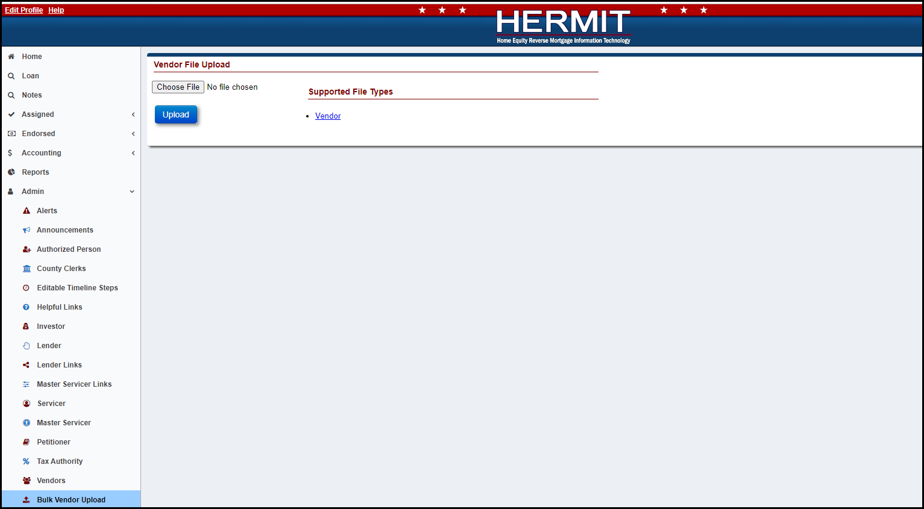
Figure 1: Vendor Upload Screen

Each file may contain up to 500 records. The processing time to upload a file, containing up to 500 records will normally take a few minutes. If there are any posting errors, the user will be notified during the process. The upload is deemed to be complete when the user is notified via a success or failure message on the screen. The message consists of three types of notifications:
- Error records
- Warnings/success records
- Success records
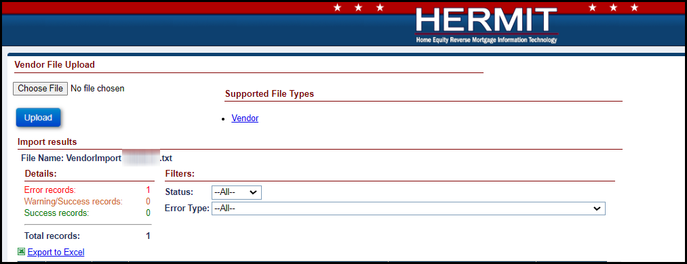
Figure 2: File Processing In HERMIT
- File name and type:
- Any file name may be used, there are no naming requirements
- A flat tab delimited file is expected. The valid file extensions are .txt, .csv or .tsv
- Each row must contain only one record
- Each data element is expected to be separated by a ‘Tab’
- Frequency of upload file:
Uploading at least one file daily versus monthly is recommended. There is no restriction on the number of files uploaded on a given day. File layout examples can be found in the Appendix.
Table 4: HECM File Upload Types
File Upload Type | Description
Vendor Upload | Is used to bulk upload vendors in the system.
- Data formatting:
Dashes (-) and decimal points (.) are permitted within the upload file; no other special characters or symbols should be present.
- File Header Description:
The first row of each file must contain the file type identifier. No other header row or header information is permitted. The presence of any other header information will result in file upload failure.
The valid file type identifier is as follows:
- “VendorUpload”

Vendor Upload – Record Layout
This table describes the required data elements, formats, and their sequence within the file.
Table 5: Data Item Descriptions for File VendorUpload
File Type Identifier: VendorUpload
Data Item | Description | Format/Range of Values | Required | Seq. #
Vendor Name | Vendor Name | String (80);  Vendor Name must be unique; | Yes | 1
Servicer | HUD assigned mortgagee number of assigned servicer | Integer;  FHA Mortgagee Number;  HUD Contractor FHA Mortgagee Number is 9999909990 | Yes | 2
Vendor Type | Type of Vendor | Integer;  ‘10’ = Appraiser  ‘11’ = Other  ‘30’ = HOA  ‘40’ = Hazard Insurance Carrier  ‘50’ = Force-Placed Insurance Carrier  ‘60’ = Flood Insurance Carrier  ‘70’ = Contractor  ‘80’ = Property Preservation  ‘90’ = Inspector  ‘100’ = Broker/Realtor  ‘110’ = MIP  ‘120’ = Attorney  ‘130’ = Utility  ‘140’ = Release Fee  ‘150’ = M&M Contractor  ‘160’ = Asset Sale Purchaser  ‘170’ = Refund | Yes | 3
Department | Department | String(30); | No | 4
Contact Name | Contact Name | String(60); | No | 5
Tax ID | Tax ID | Integer;  If entered, must be 9 digits. | No | 6
Address 1 | Address | String(60); | Yes | 7
Address 2 | Address | String(60); | No | 8
City | City | String(50); | No | 9
State | State | String(2); | No | 10
Zip | Zip Code | String(9); | No | 11
Payment Address 1 | Payment Address 1 | String(60); | No | 12
Payment Address 2 | Payment Address 2 | String(60); | No | 13
Payment City | Payment City | String(50); | No | 14
State | State | String(2); | No | 15
Zip | Zip Code | String(9); | No | 16
Days of Operation | Days of Operation | String(50); If not entered, default “Monday – Friday” | No | 17
Hour of Operation | Hour of Operation | String(50); If not entered, default “7:00 A.M. – 7:00 P.M. Central Time” | No | 18
Phone # | Phone # | String(15); | No | 19
Fax # | Fax # | String(10); | No | 20
Email | Email | String(40); | No | 21
Website Url | Website Url | String(50); | No | 22
License # | License # | String(20); | No | 23
License State | License State | String(2); | No | 24
ABA Routing # | Bank Routing # | String(9);  Must be 9 digits. | Conditional;  if Payment Method is ACH | 25
Account # | Bank Account # | String(30); | Conditional;  if Payment Method is ACH | 26
Confirm Account # | Confirm Bank Account # by entering same as Bank Account # | String(30);  Must match Account # | Conditional;  if Payment Method is ACH;  if Account # is added | 27
Payment Method | Payment Method | String(1);  ‘A’ = ACH  ‘C’ = Check | No | 28

Quality Control and Verification

File Verification
HECM files uploaded to HERMIT must pass multiple levels of validation to ensure the following:
- File extension
- Record layout aligns to file type identifier
- Data contained in the file is valid and formatted correctly for each expected data item
- A value is provided for every data item defined
- Every data element is separated with a tab
In case of error due to file format validation, the upload process will be stopped, and an error message generated indicating the cause. If validation determines that individual records do not comply with business rules, data processing may continue, and a report will be generated listing those records. This report will detail:
- Warnings – An unexpected value is present, but record uploaded successfully.
- Errors – Record was found to be out of compliance with business rules and record was not uploaded.
All uploads will be immediately integrated and visible in HERMIT upon completion of a successful upload. Any issues you encounter during the file upload process should be directed to HECM SP help desk – servicingsupport@hermitsp.com.

Vendor Upload File layout
Screenshots below can be used as a guide for creating the Vendor upload file. It can also be found on the upload screen within HERMIT.
Vendor Upload File displayed below:
Note - The Vendor Upload file is just one file, which is split into three screenshots for readability purposes.
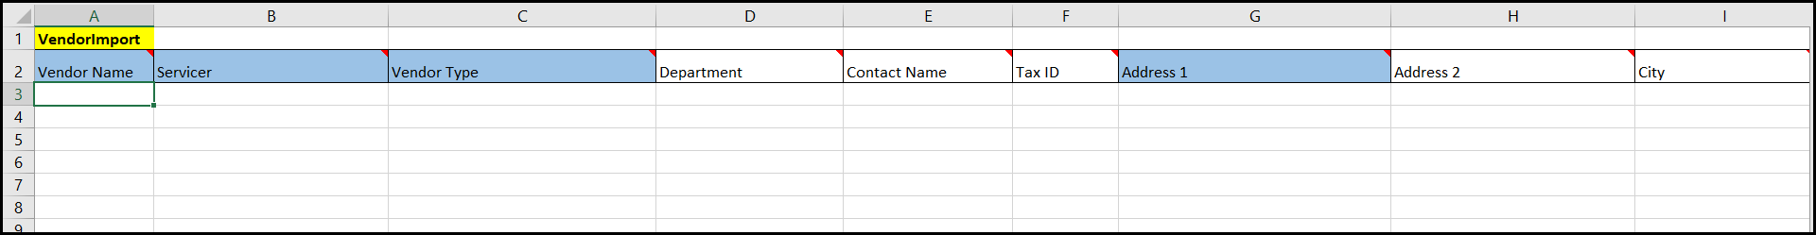
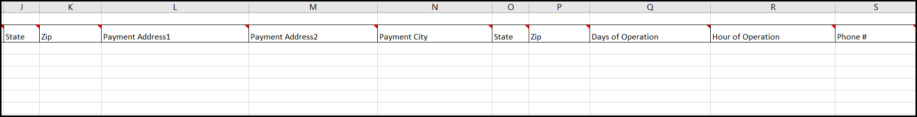
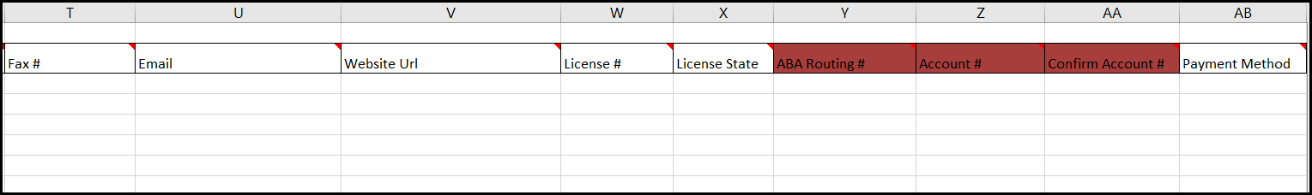
Figure 3: Vendor Upload File

