Home Equity Reverse Mortgage Information Technology
(HERMIT)

HERMIT System Changes – Release 7.6

Release Date: 03/23/24
Document Date: 03/29/24
Version 1.1

March 2024

INTRODUCTION
The Home Equity Reverse Mortgage Information Technology (HERMIT) software release version 7.6 consists of the following system changes:
Table of Contents
Servicer Related Changes 4
1. MIP Batches grouped by Investor and MIP Batch Approvals required by Servicers (588175, 589117) 4
2. B2G for adding Notes – Available for Servicer/Lender and NSC users (539356) 4
3. Move fields Note Doc Exists/Mtg Doc Exists under 2nd Mortgage/DOT on Loan Details (539492) 6
4. Add New Document Types in the HERMIT System (589001) 6
5. Transaction: Changes to “Relocation Incentive” Transaction Code 2134 in Section 305 (569190) 7
6. Transaction: Changes to “Cash for Keys” Transaction Code 2136 in Section 305, ML 2023-23 (589186) 8
7. Transaction: New “Mortgagee Incentive” Transaction Code 4338 in Section 305, ML 2023-23 (589186) 8
8. Transaction: New “Probate Cost” Transaction Code 4340 in Section 305, ML 2023-23 (589186) 9
9. Statutory Maximum Claim Amount field ML 2023-23 (589186) 10
10. Timeline Changes to Endorsed > Foreclosure Timeline (589186) 10
11. Claims Curtailment: Inactivate the Default Appraisal Curtailment Event, ML 2023-23 (589186) 11
12. Claims Curtailment: Updates to Foreclosure Appraisal Curtailment Event, ML 2023-23 (589186) 12
13. Claims: Cash for Keys 2136 & Relocation Incentive 2134 Transactions cause a Claim Hard Stop Validation for CT21 3rd party sale or CT24 after a CT21 3rd Party Sale (560065) 13
14. Claims Updates to Hard Stop Validations (589186) 14
15. Claims User Alerts and Warnings (589186) 15
16. Claims – Capping a Claim for exceeding Maximum Claim Amount (MCA) (589186, 588929) 15
17. Claims – Capping a Claim for exceeding Statutory Maximum Claim Amount (589186) 16
NSC / HUD Related Changes 18
18. B2G for Bulk Disbursement Upload-Release Fees (587266) 18
19. Update FCL Vacate Letter Sent to Occupant & Disposition Loss Mitigation Short Sale Worksheet (587288) 19
20. Report to show the History and Future payments of all tax Payments for Assigned (589163) 20
21. Claim Type 22 – Assignment and Request for HUD Advance (Assignment): Remove Unpaid Authorization when CT22 is filed (550171) 23
22. Updates to the Tax Services Interface and User Interface 23

If you have any questions regarding the functionality of the software release, please contact the HERMIT Help Desk at 561-899-2610 or at servicingsupport@hermitsp.com. If you have any policy related questions, please send an email to HUD at answers@hud.gov.

Servicer Related Changes

MIP Batches grouped by Investor and MIP Batch Approvals required by Servicers (588175, 589117)
See attached document for procedures for how to Approve Monthly MIP batches split out by Investor.

B2G for adding Notes – Available for Servicer/Lender and NSC users (539356)
A new category was added under Batch called Note Uploads. This page is available for Authorized Users. When the user uploads a file on the Notes Uploads page the Import Results will appear once the file has been uploaded. The number of Records that can be uploaded at a time is 1,500.
See “HERMIT B2G File Format and Layout” document on the HERMIT Resources webpage for full details.
For HUD Users
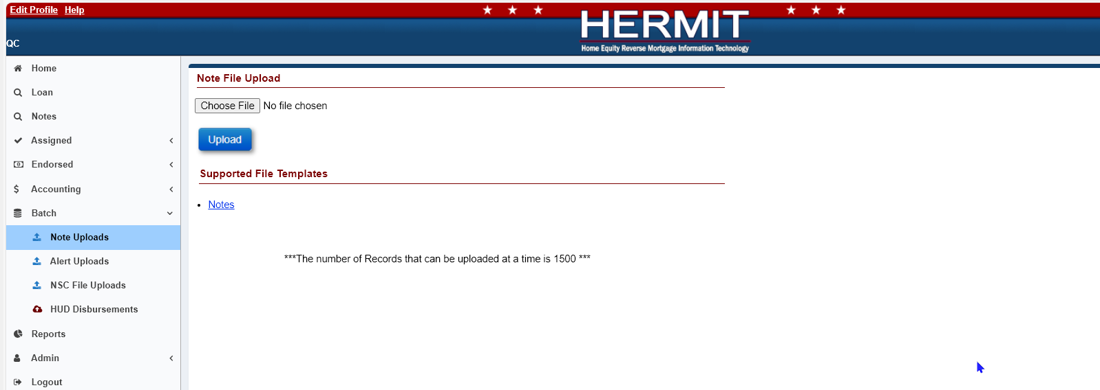

For Servicers & Lenders
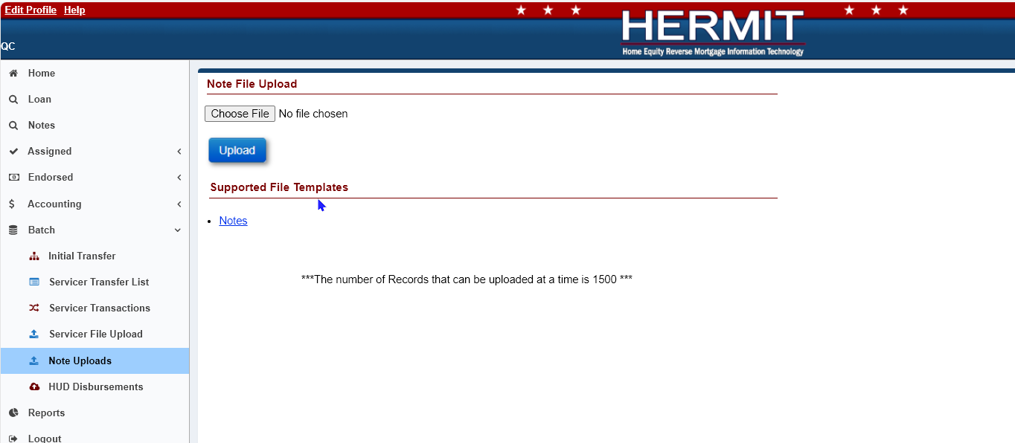

- The Note Uploads page is available under Batch on the left menu for the following Authorized users:
- CLS-Cash
- CLS-Cash Supervisor
- CLS-Customer Service
- CLS-Default
- CLS-Documentation
- CLS-First Mortgage
- CLS-Release
- CLS-Release Supervisor
- CLS-Supervisor/Management
- HUD Claims-Mgr I
- HUD Claims-Mgr II
- HUD Claims-Staff
- HUD NSC-Mgr
- HUD NSC-Staff
- HUD SF Premium Mgr
- HUD SF-Staff
- Lender-Mgr
- Lender-Staff
- Servicer-Mgr
- Servicer-Staff
- On the Note Uploads page there is a “Notes” link that provides a Template File.
- When the user uploads a file on the Note Uploads page the Import Results will appear once the file has been uploaded. The Import Results will display as either a Success, Error, or Warning after the upload process. The user can click Export to Excel to display these Import Results in an Excel File. Once the user clicks outside of this page or tries to perform a different action on this page, the Import Results will no longer be displayed, and you will not be able to obtain these results again.

Move fields Note Doc Exists/Mtg Doc Exists under 2nd Mortgage/DOT on Loan Details (539492)
Fields and checkboxes “Mortgage Doc Exists:” and “Note Doc Exists:” were moved from Loan Identifiers at the top right of Loan Details to the bottom right under the 2nd Mortgage/DOT section.
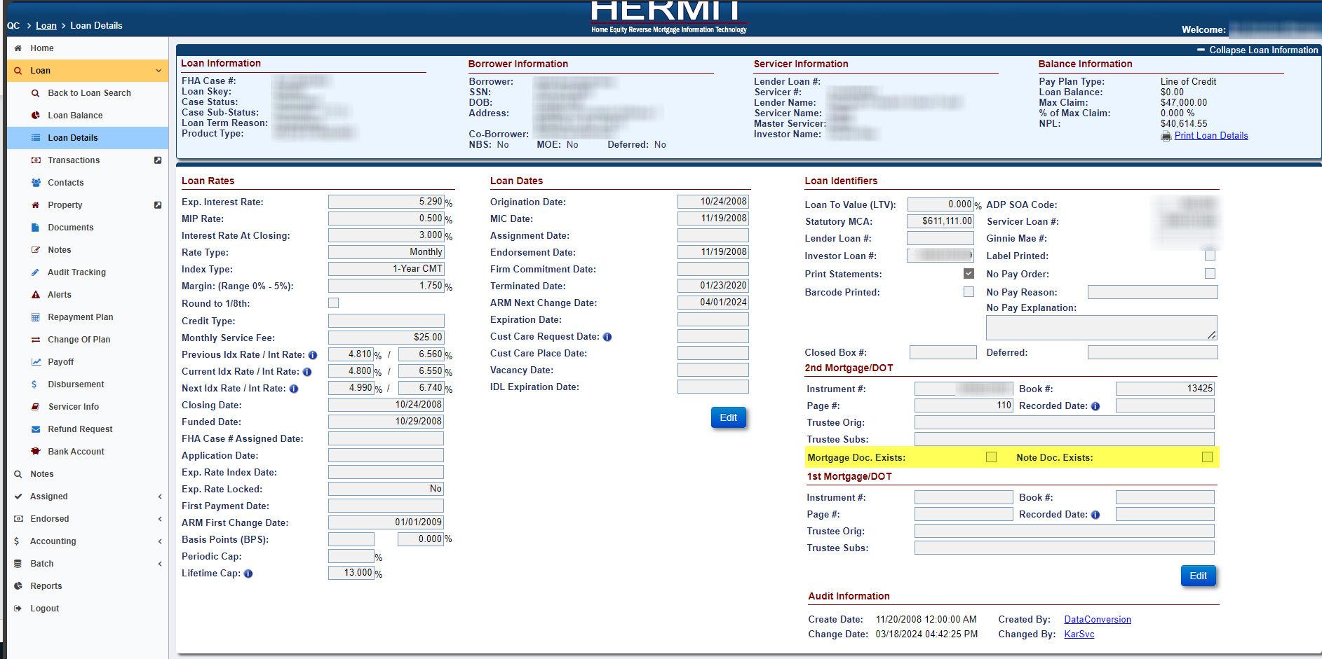

Add New Document Types in the HERMIT System (589001)
New Document Types have been added to HERMIT System. See “HERMIT Document Upload File Format” on the HERMIT Resources webpage for full details.
The following document types were added:
- 3rd Party Authorization (TPA)
- Cash Mgmt Correspondence
- Marriage Certificate
- Notice of Intent to Foreclose
- Point of Contact Change
- Probate Documents
- Property Citations/Violations
- Release Dept Correspondence
- Release Requests
- Release: 1st Mortgage (AH)
- Release: 2nd Mortgage (BH)
- Returned Mail
- Title Search
- Utility Bills
- Will
- Certified Return Receipts

Transaction: Changes to “Relocation Incentive” Transaction Code 2134 in Section 305 (569190)
Updates have been made to the existing Relocation Incentive Transaction Code 2134 originally implemented in Release 5.5. Changes include: removing the FHA Case # Assigned Date restriction to permit the transaction on all loans regardless of FHA Case # Assigned Date and increasing the Transaction Amount Cap from $3,000 to $10,600.
The Transaction is available under Transaction Category “Corp Advance – Section 305 Disbursements”, and Transaction Type “Corp Adv – S305 – Relocation Incentive”.
When adding Transaction “Relocation Incentive” to a loan via User Interface (UI) or B2G, the following apply:
- Transaction Cap is $10,600.00.
- Transaction is permitted on all loans regardless of FHA Case # Assigned Date
- Transaction Incurred Date is not entered by the user but set behind the scenes to the same date reported in the Effective Date field
- Transaction will be restricted if a “Cash For Keys” transaction code 2136 already exists on the same loan.
- Transaction is only pulled into the Claim form for a CT21 or a CT24 after a Parent CT21 and will not be pulled into a CT23.

Claims Eligible Expense Rules: Relocation Incentive transaction 2134 will be pulled into the claim form ALWAYS for Claim Type 21 or CT24 after CT21, regardless of Effective Date or Incurred Date. This transaction is NOT permitted to be paid beyond MCA.

If claiming this transaction as a reimbursable expense, servicers shall upload all documentation, including but not limited to: Executed agreements, copy of the local jurisdiction codes or ordinance requiring such payment, proof of payment to the party (date and amount) and other information as required for claim consideration.

Transaction: Changes to “Cash for Keys” Transaction Code 2136 in Section 305, ML 2023-23 (589186)
As a result of updates published in Mortgagee Letter 2023-23, the Cash for Keys Transaction has been updated. The Cash for Keys transaction in Section 305 is an Incentive payable to the Borrower, Heir, or party vacating the property if eligible to receive the payment based on HUD’s requirements.
The Transaction is available under Transaction Category “Corp Advance – Section 305 Disbursements”, and Transaction Type “Corp Adv – S305 – Cash for Keys”.
When adding Transaction “Cash for Keys” to a loan via User Interface (UI) or B2G, the following apply:
- Transaction Cap is $10,600.00.
- Transaction is permitted on all loans regardless of FHA Case # Assigned Date
- Transaction Incurred Date is not entered by the user but set behind the scenes to the same date reported in the Effective Date field
- Transaction will be restricted if a “Relocation Incentive” transaction already exists on the same loan.
- Transaction is permitted only for loans with an Active Due and Payable timeline.
- Transaction Effective Date must be within 547 days of the loan’s Due and Payable Date.
- Multiple Transactions of this type are not permitted.

Claims Eligible Expense Rules: Cash for Keys transaction 2136 will be pulled into the claim form ALWAYS for all Claim types CT21, CT23, and CT24, regardless of Effective Date or Incurred Date. This transaction IS permitted to be paid beyond MCA.

If claiming this transaction as a reimbursable expense, servicers shall upload all documentation, including but not limited to: Executed agreements, proof of payment to the party (date and amount) and other information as required. Please refer to ML2023-23 for additional information.

Transaction: New “Mortgagee Incentive” Transaction Code 4338 in Section 305, ML 2023-23 (589186)
As a result of updates published in Mortgagee Letter 2023-23, a new transaction code for “Mortgagee Incentive” has been added to Section 305. The purpose of this transaction is to report Incentives paid to the Mortgagee/ Servicer when completing a "Deed in Lieu of Foreclosure" or "Sale of the acquired property".
The Transaction is available under Transaction Category “Corp Advance – Section 305 Disbursements”, and Transaction Type “Corp Adv – S305 – Mortgagee Incentive”.
When adding Transaction “Mortgagee Incentive” to a loan via User Interface (UI) or B2G, the following apply:
- Transaction Cap is $1,500.00.
- Transaction is permitted on all loans regardless of FHA Case # Assigned Date
- Transaction Incurred Date is not entered by the user but set behind the scenes to the same date reported in the Effective Date field
- Multiple Transactions of this type are not permitted.

Claims Eligible Expense Rules: Mortgagee Incentive transaction code 4338 will be pulled into the claim form ALWAYS for all Claim types CT21, CT23, and CT24, regardless of Effective Date or Incurred Date. This transaction IS permitted to be paid beyond MCA.

Multiple requests for a Mortgagee incentive are prohibited. Only one (1) mortgagee incentive shall be considered & reimbursed per FHA Case when filing for claim benefits.

Transaction: New “Probate Cost” Transaction Code 4340 in Section 305, ML 2023-23 (589186)
As a result of updates published in Mortgagee Letter 2023-23, a new transaction code for “Probate Cost” has been added to Section 305. The purpose of this transaction is to report costs of Probate incurred related to the $5,000 cap as associated with Cash for Keys Incentive.
The Transaction is available under Transaction Category “Corp Advance – Section 305 Disbursements”, and Transaction Type “Corp Adv – S305 – Probate Cost”.
When adding Transaction “Probate Cost” to a loan via User Interface (UI) or B2G, the following apply:
- Transaction Category Cap is $5,000.00.
- Transaction is permitted on all loans regardless of FHA Case # Assigned Date
- Transaction Incurred Date is not entered by the user but set behind the scenes to the same date reported in the Effective Date field
- Multiple Transactions of this type are permitted as long as the total of all transactions does not exceed $5,000.00.

Claims Eligible Expense Rules: Probate Cost transaction code 4340 will be pulled into the claim form ALWAYS for all Claim types CT21, CT23, and CT24, regardless of Effective Date or Incurred Date. This transaction IS permitted to be paid beyond MCA.

If claiming this transaction as a reimbursable expense, servicers shall upload all documentation. Please refer to ML2023-23 for additional information

Statutory Maximum Claim Amount field ML 2023-23 (589186)
As a result of updates published in Mortgagee Letter 2023-23, a new field entitled “Statutory Maximum Claim Amount” has been added to the system. The field is displayed on the Loan Details page in HERMIT, under the Loan Identifiers section as “Statutory MCA”.
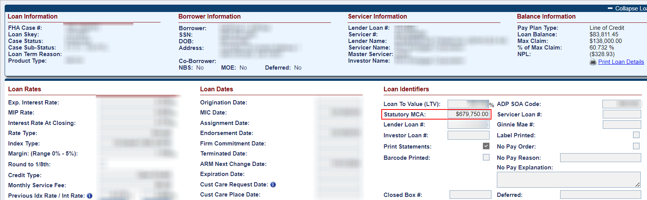
The Statutory Maximum Claim Amount is identified by HUD as stated in the published Mortgagee Letters defining HECM Mortgage Limits. For new loans where Loan Setup is completed after the 7.6 Release Date, the amount is populated automatically during Loan Setup. For loans already in HERMIT prior to the 7.6 Release Date, the amount has been populated with the statutory Limit provided by HUD.
Claims impact: In no case shall any claim amount for insurance benefits exceed the Statutory Maximum Claim Amount. In other words, Total Claim Amounts may be paid in excess of the loan’s Maximum Claim Amount (MCA) but may NEVER be paid in excess of the loan’s Statutory Maximum Claim Amount.
DBI shall be permitted in excess of MCA for HECM loans with a case assignment date prior to the Final Rule (09/19/2017) however, DBI shall be capped at Statutory MCA for all loans, regardless of case assignment date.”

If a change is needed to the amount stated on a particular loan, HUD will need to approve the request to change the amount.

Timeline Changes to Endorsed > Foreclosure Timeline (589186)
As a result of updates published in Mortgagee Letter 2023-23, changes have been made to the Endorsed > Foreclosure Timeline. These changes apply to Endorsed > Foreclosure timelines for ALL states. Multiple Foreclosure timelines exist based on state.
Former Optional timeline step “Foreclosure Sale Appraisal Date” has been renamed to “Foreclosure Sale Appraisal Date Optional” and updated to Inactive. This step will not be available going forward.
A new Template timeline “Foreclosure Sale Appraisal Date” step has been added to each state’s Foreclosure timeline. Any Endorsed > Foreclosure Timeline created after the Release Date will display this step on the timeline. The former Optional Step is no longer available.
The following step completion dates are editable by user roles Servicer Manager and HUD NSC Manager after the step has already been completed.
Important: The step completion dates should always reflect the most accurate dates prior to a claim being filed.
- Foreclosure Sale Date
- Foreclosure Sale Appraisal Date
- Foreclosure Sale Postponed/Restarted
Servicers are responsible for uploading all Property Appraisals into the Loan > Property > Property Values page to be reviewed by HUD during Claims Review.
Important Claims Impact: For Claim Type 21 with Foreclosure Instituted checkbox selected on the Claims Worksheet, both “Foreclosure Sale Date” and “Foreclosure Sale Appraisal Date” steps on the Endorsed > Foreclosure timeline must be completed in order to file the claim.
A new Optional timeline step “Foreclosure Sale Postponed/Restarted” has been added to the Endorsed > Foreclosure Timelines. Multiple “Foreclosure Sale Postponed/Restarted” steps are allowed on the same loan. When this step is completed, a Note will be saved to the Notes page with sample Note Text “The Step Foreclosure Sale Postponed/Restarted was completed on <STEP COMPLETE DATE> by <USER_ID>.”.
Former Optional timeline step “Sale Postponed” has been Inactivated and is not available going forward.
Data changes: The following Data Changes are being completed to add necessary steps to existing Endorsed > Foreclosure Timelines:
- A one-time Data Change/ DCR to add step and populate the step completion date for new step “Foreclosure Sale Appraisal Date” with the step completion date of former step “Foreclosure Sale Appraisal Date Optional” if the former step was present on the same Active Foreclosure timeline.
- A one-time Data Change/ DCR to add new step “Foreclosure Sale Appraisal Date” to Active Endorsed > Foreclosure timelines on loans that did not have former step “Foreclosure Sale Appraisal Date Optional” completed.
- A one-time Data Change/ DCR to add new optional step and populate the step completion date “Foreclosure Sale Postponed/Restarted” with the step completion date of former step “Sale Postponed” if the former step was present on the same Active Foreclosure timeline.

Claims Curtailment: Inactivate the Default Appraisal Curtailment Event, ML 2023-23 (589186)
As a result of updates published in Mortgagee Letter 2023-23, the Default Appraisal Curtailment Event has been removed from HERMIT’s Auto-Curtailment logic for loans with claims submitted after the 7.6 Release Date.

Claims Curtailment: Updates to Foreclosure Appraisal Curtailment Event, ML 2023-23 (589186)
As a result of updates published in Mortgagee Letter 2023-23, the Foreclosure Appraisal Curtailment Event has been updated. Changes include: expanding this Curtailment Event to apply to all loans regardless of FHA Case # Assigned date and implementing separate logic when “Foreclosure Sale Postponed/Restarted” step is completed on the Endorsed > Foreclosure timeline.
The Foreclosure Appraisal Curtailment event applies to loans with a Foreclosure Sale Date on or after 04/24/2024 that are Claim Type 21 with “Foreclosure Instituted” box selected on the Claims Worksheet.
Important: Servicers are responsible for uploading all Property Appraisals into the Loan > Property > Property Values page to be reviewed by HUD during Claims Review.
Effective Date: Only applies to loans with “Foreclosure Sale Date” step completion date on the Foreclosure timeline which is on or after 04/24/2024.
Note – In cases where the servicer initiated a foreclosure then converted the action to a DIL, the servicer must select the DIL box to confirm the DIL was completed. When the completion of a DIL is reported, the Foreclosure Appraisal Curtailment will no longer apply.

Curtailment Rule – Condition A Foreclosure Sale Postponed/Restarted date is NOT completed and Foreclosure Appraisal is before Foreclosure Sale Date.
Foreclosure timeline does not have a completed step “Foreclosure Sale Postponed/Restarted” AND step completion date of “Foreclosure Sale Appraisal Date” is before step completion date of step “Foreclosure Sale Appraisal”:
Condition A Curtailment Rule: “Foreclosure Sale Appraisal Date” step completion date must occur and indicate an appraisal effective date that is no more than 30 days before Foreclosure Sale Date” step completion date to avoid curtailment. If “Foreclosure Sale Appraisal Date” is 31 days or more before the “Foreclosure Sale Date” then the Claim will be curtailed.
  - A - Curtailment Deadline: “Foreclosure Sale Appraisal Date” step completion date + 30 days
  - A - Accomplished Date: “Foreclosure Sale Date” step completion date.
  - A - Curtailment Date: “Foreclosure Sale Date” step completion date.
Condition A Curtailment Message: “Auto Curtailed on MM/DD/YYYY. Foreclosure Appraisal must be completed no earlier than 30 days prior to Foreclosure Sale and cannot be after Foreclosure Sale.”

Curtailment Rule – Condition B Foreclosure Sale Postponed/Restarted date is completed.
Foreclosure timeline does have a completed step “Foreclosure Sale Postponed/Restarted”
Condition B Curtailment Rule: the “Foreclosure Sale Date” step completion date must occur on or before “Foreclosure Sale Appraisal Date” step completion date + 180 days to avoid curtailment. If “Foreclosure Sale Appraisal Date” is 180 days or more before the “Foreclosure Sale Date” then the Claim will be curtailed.
- B - Curtailment Deadline: “Foreclosure Sale Appraisal Date” step completion date + 180 days
- B - Accomplished Date: “Foreclosure Sale Date” step completion date
- B - Curtailment Date: “Foreclosure Sale Date” step completion date.
Condition B Curtailment Message: “Auto Curtailed on MM/DD/YYYY. When a Foreclosure Sale is Rescheduled, the Foreclosure Sale Date must be completed no later than 180 days after the Foreclosure Sale Appraisal Date and the Appraisal Date cannot be after Foreclosure Sale.”

Curtailment Rule – Condition C. Foreclosure Appraisal Date is after the Foreclosure Sale Date.
Foreclosure timeline “Foreclosure Sale Appraisal Date” step completion date is after “Foreclosure Sale Date” step completion date.
Condition C - Curtailment Rule: the Claim will be curtailed when “Foreclosure Sale Appraisal Date” step completion date is after the “Foreclosure Sale Appraisal” step completion date.
- C - Curtailment Date: “Foreclosure Sale Date” step completion date.
Condition C Curtailment Message: “Auto Curtailed on MM/DD/YYYY. Foreclosure Appraisal must be completed no earlier than 30 days prior to Foreclosure Sale and cannot be after Foreclosure Sale.”

Claims: Cash for Keys 2136 & Relocation Incentive 2134 Transactions cause a Claim Hard Stop Validation for CT21 3rd party sale or CT24 after a CT21 3rd Party Sale (560065)
A hard stop validation has been implemented to restrict a CT21 3rd Party Sale claim or CT-24 claim following a Parent CT21 3rd Party Sale claim from being filed when either Transaction Code 2136 Cash For Keys or Transaction Code 2134 Relocation Incentive is requested for reimbursement on the claim form.
The Hard Stop Validation is displayed as “Third Party Sale Claims are ineligible for Cash for Keys or Relocation Incentive transactions. Please make the proper adjustments to continue.”
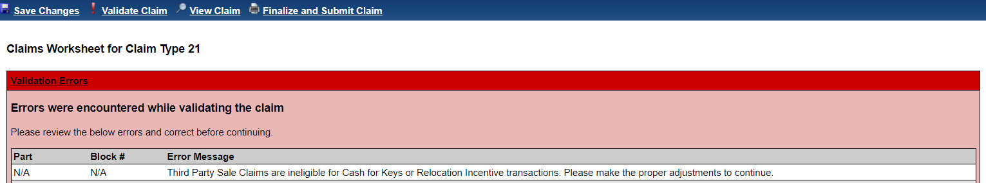
This hard stop is displayed when a user clicks Validate Claim or Finalize and Submit Claim for the following scenarios:
- Claim Type 21 and the ‘Is this a Third Party Sale?’ radio button = ‘Yes’, AND either Transaction Code 2134 ‘Relocation Incentive’ or Transaction Code 2136 ‘Cash for Keys’ is included in the Claim Form.
- Claim Type 24 if the Parent Claim was a CT21 with ‘Is this a Third Party Sale” radio button = ‘Yes’, AND either Transaction Code 2134 ‘Relocation Incentive’ or Transaction Code 2136 ‘Cash for Keys’ is included in the Claim Form.
If the Transaction causing the hard stop validation is adjusted off and nets $0.00, then the claim can be filed.

Claims Updates to Hard Stop Validations (589186)
As a result of updates published in Mortgagee Letter 2023-23, multiple claims hard stop validation errors have been added and appear when user clicks on Validate Claim, or Finalize and Submit Claim on the Claims Worksheet. New claims hard stop validation errors have been added to the claim and are displayed upon clicking either Validate Claim or Finalize and Submit Claim on the Claims Worksheet.
- “Statutory Maximum Claim Amount is required”: displayed when the loan is missing an amount in new field Statutory MCA on the Loan Details page.
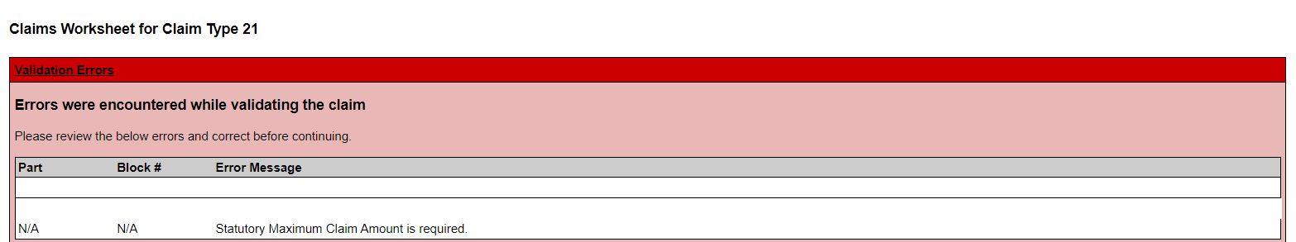
- “Foreclosure Sale Date cannot be blank for Foreclosure Instituted, unless DIL is obtained. Please go to the Foreclosure timeline and enter the Foreclosure Sale Date step completion date.”: displayed when the Foreclosure Sale Date is not completed and Foreclosure Instituted checkbox on the CT21 Claim Worksheet is selected, when DIL Obtained is not selected.
- “Foreclosure Sale Appraisal Date cannot be blank for Foreclosure Instituted, unless DIL is obtained. Please go to the Foreclosure timeline and enter the Foreclosure Sale Appraisal Date step completion date.”: displayed when the Foreclosure Sale Appraisal Date is not completed and Foreclosure Instituted checkbox on the CT21 Claim Worksheet is selected, when DIL Obtained is not selected.
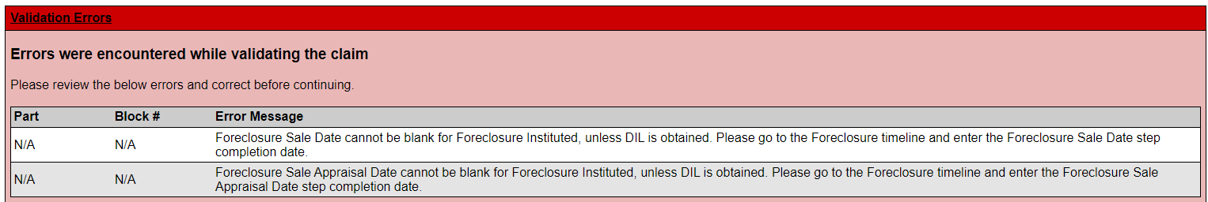
- See topic “Cash for Keys & Relocation Incentive” Topic for an additional Hard Stop Validation message added in this release.

Claims User Alerts and Warnings (589186)
A yellow banner User Alert or Warning will be displayed on the Claims Worksheet when either Transaction “Relocation Incentive” 2134 or “Cash for Keys” 2136 is present in the Claims Worksheet. The text states “Claim contains request of reimbursement of an Incentive. Supporting documentation is required.”
The message is displayed for Servicer users and HUD users with access to view the Claims Worksheet.
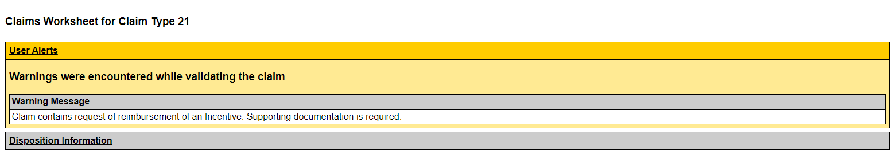

Claims – Capping a Claim for exceeding Maximum Claim Amount (MCA) (589186, 588929)
Note: This section refers to the loan’s Maximum Claim Amount and NOT the loan’s Statutory MCA. See release notes topic “Claims - Capping a Claim for exceeding Statutory Maximum Claim Amount” for details about the Statutory MCA cap.
As a result of updates published in Mortgagee Letter 2023-23, the existing logic for capping a claim due to exceeding Maximum Claim Amount have been revised.
The following transactions identified by HUD will be paid on a claim in excess of the loan’s MCA. In other words, these expenses will still be paid on the claim if the claim has already been capped for exceeding MCA:
- Corp Adv - S305 - Cash For Keys. Transaction Code 2136
- Corp Adv - S305 - Mortgagee Incentive. Transaction Code 4338
- Corp Adv - S305 - Probate Cost. Transaction Code 4340
Important: Only transactions entered with the proper Transaction Code in HERMIT will be paid on the claim in excess of MCA. Transactions entered using a different transaction code and later renamed in the claim form to appear to be one of the above transactions will not be subject to payment beyond the loan’s MCA.
When the Claim is capped for exceeding the loan’s MCA, a message is displayed at the end of the text in Part A, “HUD Comments, if Any” on the Claims Worksheet / Claim Form, stating the following message: “Your claim has been adjusted for exceeding the Max Claim Amount.”
After the claim has been approved, the same message will be displayed on the AOP document in the AOP Comments field and as a Note on the Notes page in the system.
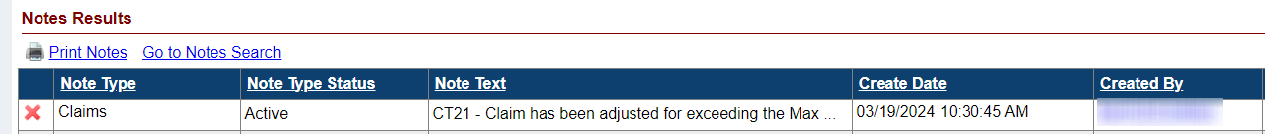
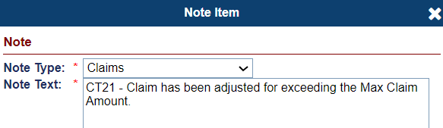
Existing rules for capping the claim at Debenture Interest (DBI), based on the loan’s FHA Case # Assigned Date remain in place. For non-Final Rule loans with FHA Case # Assigned Date before 09/19/17; DBI can be paid in excess of the MCA, if applicable. For Final Rule loans with FHA Case # Assigned Date before 09/19/17; DBI cannot be paid in excess of the MCA.

Claims – Capping a Claim for exceeding Statutory Maximum Claim Amount (589186)
Note: This section refers to the loan’s Statutory Maximum Claim Amount and NOT the loan’s MCA. See release notes topic “Claims - Capping a Claim for exceeding Maximum Claim Amount” for changes related to the MCA cap.
As a result of updates published in Mortgagee Letter 2023-23, new functionality has been added to cap a claim when it exceeds the Statutory MCA amount of the loan. In no case shall any claim amount for insurance benefits exceed the Statutory Maximum Claim Amount. In other words, Total Claim Amounts may NEVER be paid in excess of the loan’s Statutory Maximum Claim Amount.
DBI will still be permitted in excess of MCA for HECM loans with a case assignment date prior to the Final Rule (09/19/2017) however, DBI shall be capped at Statutory MCA for all loans, regardless of case assignment date.”
This affects all Claims regardless of the loan’s FHA Case # Assigned Date.
When the Claim will be capped for exceeding the loan’s Statutory MCA, a message is displayed at the end of the text in Part A, “HUD Comments, if Any” on the Claims Worksheet / Claim Form, stating the following message: “Your claim has been adjusted for exceeding the Statutory Max Claim Amount.”
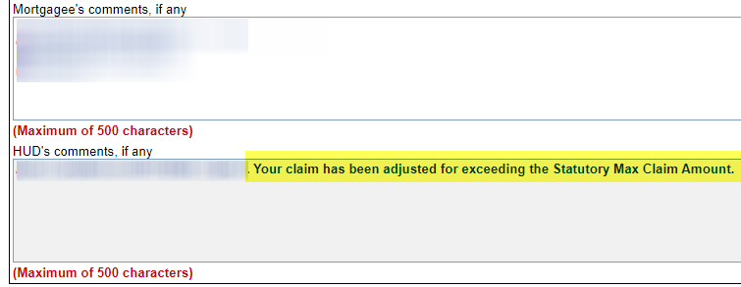
After the claim has been approved, the same message will be displayed on the AOP document in the AOP Comments field and as a Note on the Notes page in the system.

NSC / HUD Related Changes

B2G for Bulk Disbursement Upload-Release Fees (587266)
The Vendor Disbursements link on the Batch > NSC Upload Page was renamed to Inspection Disbursements and a new link called Release Fee Disbursements was added. When the user uploads a file on the NSC Disbursement Uploads page by selecting Release Fee Disbursements link the Import Results will appear once the file has been uploaded. The number of Records that can be uploaded at a time is 1,500.
See “HERMIT NSC B2G File Format and Layout” document on the HERMIT Resources webpage for full details.

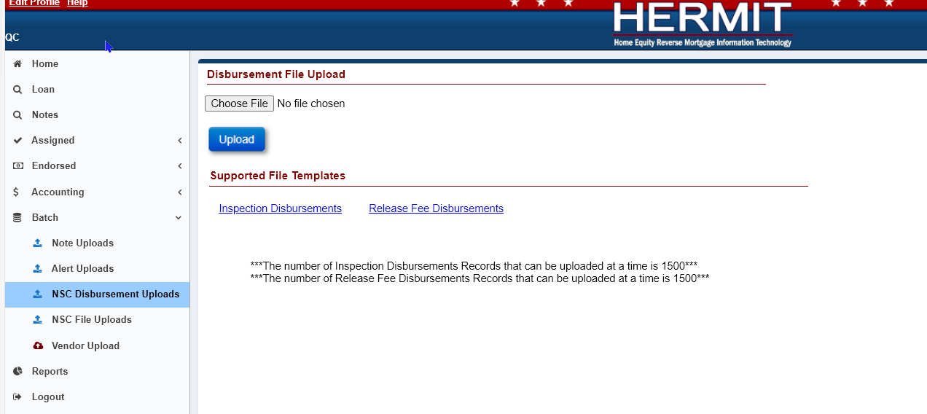
- The NSC Disbursement Uploads page is available under Batch on the left menu for the following Authorized user role: Contractor Cash.
- The Release Fee Disbursements link provides the Release Fee Disbursements Template, this allows multiple Release Fee Disbursements to be uploaded into HERMIT using the NSC Disbursement Uploads page.
- When the user uploads a file on the NSC Disbursement Uploads page the Import Results will appear once the file has been uploaded. The Import Results will display as either a Success, Error, or Warning after the upload process. The user can click Export to Excel to display these Import Results in an Excel File. Once the user clicks outside of this page or tries to perform a different action on this page, the Import Results will no longer be displayed, and you will not be able to obtain these results again.

Update FCL Vacate Letter Sent to Occupant & Disposition Loss Mitigation Short Sale Worksheet (587288)
The Assigned - Foreclosure Vacate Letter Sent to Occupant & Assigned – Disposition Loss Mitigation – Short Sale Denied by HUD Letters have been updated to have generic department information.

Assigned – Foreclosure – “Vacate Letters Sent to Occupant” Letter
In the body of the Assigned – Foreclosure – Vacate Letters Sent to Occupant Letter, the User Name, User Title, User Phone Number and Extension have been updated to Compu-Link Corporation, HECM Servicing Division, 877-622-8525 (Comp-Link Main Phone Number)
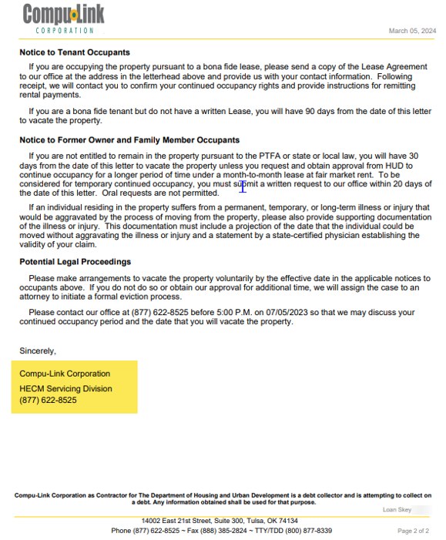

Assigned – Disposition - Loss Mitigation – “Short Sale Denied by HUD” Worksheet
On the top of the Update the Assigned – Disposition - Loss Mitigation – “Short Sale Denied by HUD“ Worksheet, the Counselor <User Name> was changed to Counselor <Responsible Party>. On the next page the “Please Return To: <Username>” was changed to “Please Return To: <Responsible Party>. The “FROM: U.S. Dept of HUD, User Name, Address 1, Address 2, User Phone Number and User Extension, User Fax Number” have been changed to “FROM: U.S. Dept of HUD , Responsible Party, Address 1, Address 2,(877)-622-8525 (Comp-Link Main Phone Number), (888)385-2824 (Compu-Link Fax Number).
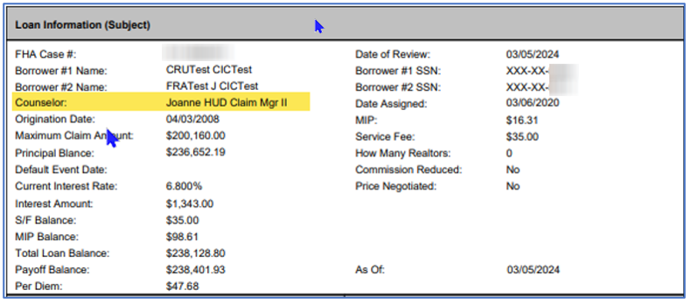
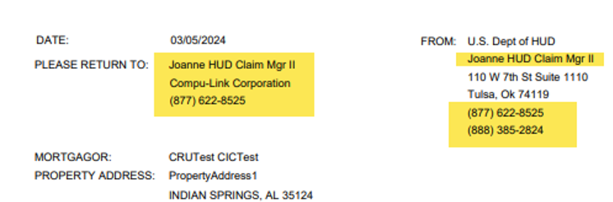

Report to show the History and Future payments of all tax Payments for Assigned (589163)
A new Report called Tax Payment Report has been added to HERMIT reports area under the Assigned Notes Reports/Daily Reports. The report will show the History and Future payments of all tax payments for each Loan in the Assigned Portfolio and that is associated with the Agency Header File. It will include payments made by CoreLogic and Compu-Link and will display Status of Taxes which include “Paid by Servicer”, “Paid by Borrower” “Delinquent”, “Disbursement – Pending”, “Unpaid by Resolved”, “Unpaid but Resolved Pending.”
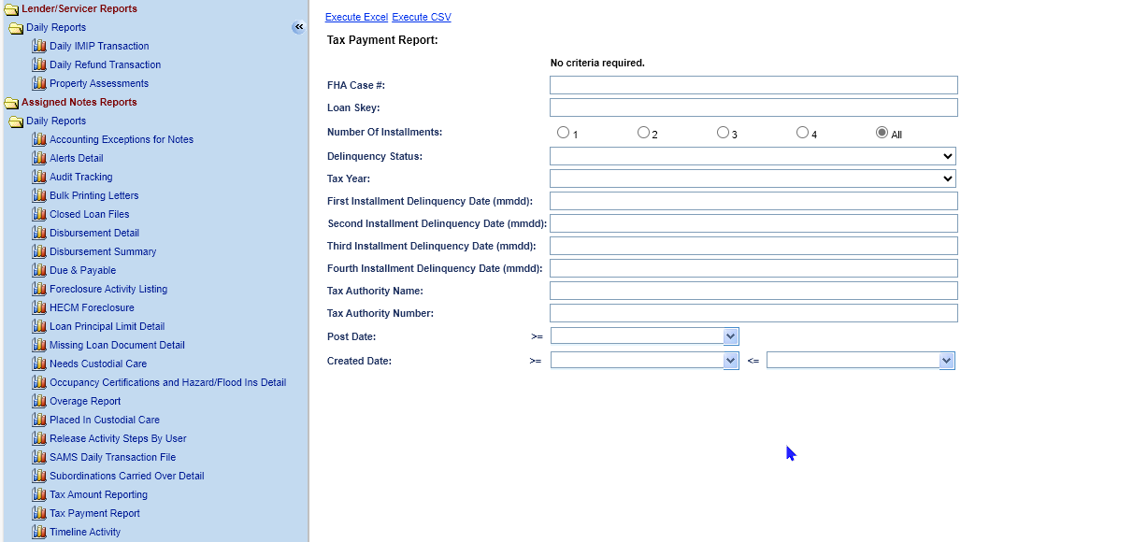

- Search Criteria includes:
- FHA Case #
- Loan Skey
- Delinquency Status (“Paid by Servicer”,“ Paid by Borrower”,” Delinquent”, “Disbursement – Pending”,” Unpaid but Resolved”,“ Unpaid but Resolved – Pending”)
- Tax Year
- 1st Installment Delinquency Date
- 2nd Installment Delinquency Date
- 3rd Installment Delinquency Date
- 4th Installment Delinquency Date
- Number of Installments
- Tax Authority Name
- Tax Authority #
- Post Date
- Create Date

- The output will be in EXCEL and CSV format and have the following fields:
- Status Code (Current Delinquent Year, Prior Delinquent Year)
- Customer Number
- FHA Case #
- Loan Skey
- Area Service Center Code
- Taxing Authority Number
- Taxing Authority Name
- Tax Identification Number
- Pending Apportionment/Hit Code (1 = Tax ID does not cover additional property, 2 Tax ID covers additional property not covered by the legal description)
- Contract/Order Number
- Contract/Order Suffix
- Service Type (C = Escrow, B = Non-Escrow)
- Borrower Name
- Property Street Number/Name
- Property City
- Property State Abbreviated
- Property Zip Code+4
- Legal Description
- Lien Status Code
- Delinquency Status (“Paid by Servicer”,“ Paid by Borrower”,” Delinquent”,“ Disbursement – Pending”,” Unpaid but Resolved”,“ Unpaid but Resolved – Pending”)
- Search Date (Date Core-Logic obtained payment status; MM/DD/YYYY)
- Post Date (The date the taxing authority posted the payment; MM/DD/YYYY)
- Taxable Year
- 1st Installment Delinquency Date
- 2nd Installment Delinquency Date
- 3rd Installment Delinquency Date
- 4th Installment Delinquency Date
- Number of Installments
- Delinquent Age
- Bill Type
- Tax Bill Number
- First Installment Amount
- Second Installment Amount
- Third Installment Amount
- Fourth Installment Amount
- Total Installment Amount
- First Redeem Amount
- First Redeem Thru Date (MM/DD/YYYY)
- Second Redeem Amount
- Second Redeem Thru Date (MM/DD/YYYY)
- Third Redeem Amount
- Third Redeem Thru Date (MM/DD/YYYY)
- Pay Plan

Claim Type 22 – Assignment and Request for HUD Advance (Assignment): Remove Unpaid Authorization when CT22 is filed (550171)
Changes were made for loans that have both a “Claim Type 22 – Assignment” Timeline and a “Request for HUD Advance (Assignment)” Timeline with an Authorization that has not been completed.
Inactivate an Active Timeline “Request for HUD Advance (Assignment)” under Endorsed > Requests area when the CT22 step “Assignment to HUD Sent for Recording / Servicer Files Claim Type 22 – Form 27011” is completed on the Endorsed > Requests > “Claim Type 22 – Assignment” Timeline.
Any “Funds Due HUD Amount” that was on the Accounting > Authorizations page will be REMOVED as a result of inactivating the “Request for HUD Advance (Assignment)” timeline.

A Note will be saved to the Notes page when the “Request for HUD Advance (Assignment)” timeline becomes inactivated due to completion of CT22 step “Assignment to HUD Sent for Recording / Servicer Files Claim Type 22 – Form 27011”. Example Note Text: “A Request for HUD Advance (Assignment) Timeline was inactivated when the Servicer submitted the CT 22 for Payment.”

A Data Change /DCR was completed to Inactivate “Request for HUD Advance (Assignment)” on loans that had the CT22 step “Assignment to HUD Sent for Recording / Servicer Files Claim Type 22 – Form 27011” already completed.

Updates to the Tax Services Interface and User Interface
The following changes were made to HERMIT during the Release 7.6 release cycle with several of the items being implemented mid release on February 10th, 2024. Items below are categorized into two sections by release date.
The following changes were implemented on February 10th, 2024:
- The Total Installment Amount (Field under 4th Installment Amount) is now populated with the Total Installment Amount from the Tax Payment Status (TPS) file and if the Total Installment Amount is zero in the file, the sum of the 1st, 2nd, 3rd and 4th Installment amount is now populated with the Total Installment Amount Field (Field under 4th Installment Amount). The Total Installment Amount field is still editable. Please be aware that if the user edits the Total Installment Amount (Field under 4th Installment Amount), then the edited amount will be summed and pulled into the “Taxes Delinquent – 10 Day Letter”.

Total Installment Field is the total of all 4 Installment Amounts:
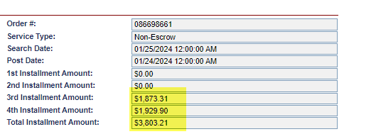
Total Installments Amount edited:
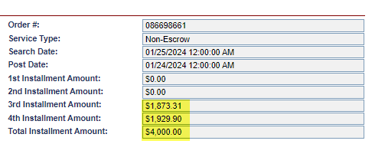

Total Installment Amount pulled into the Borrower Delinquent - 10 Day Letter:
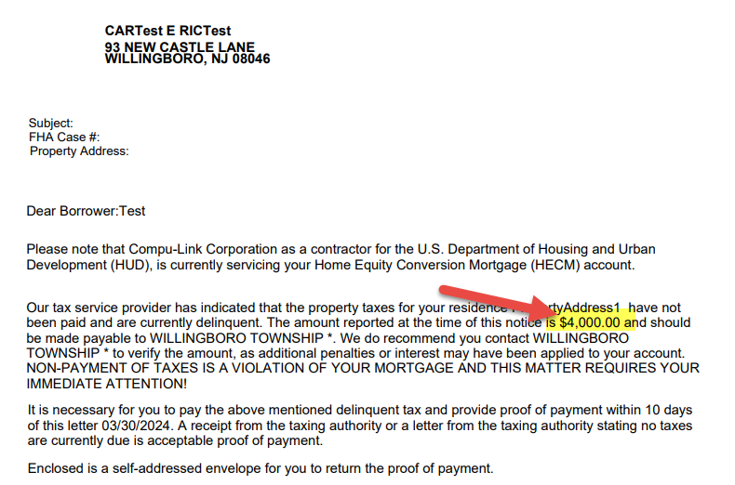
- The Total Installment Amount (Field under 4th Installment Amount) for all Tax Years with a Delinquency Status of “D” is summed together and pulled into the “Taxes Delinquent – 10 Day Letter” on the Assigned Tax Delinquent Timeline. Screen provided above in #1 of this section.
- The step “Received Proof of Taxes Paid” was made an optional step.
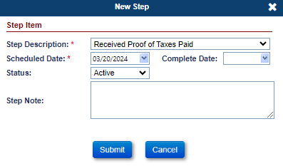
- The Tax Year was updated to display 2022/2023 instead of 20222023.
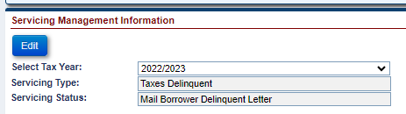
- On the drop down for the Payee on the New Tax Disbursement Window, the Payee will be updated to concatenate the Auth Payee field and the Tax Authority Name field from the Admin -> Tax Authority screen. The Auth Payee will be the first field.
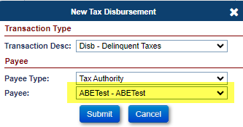
- On the Please Confirm window when paying the taxes in the Edit Disbursement window, there was a message that stated “-The requested Disbursement Amount will exceed the NPL. – Please enter Tax ID for the selected Tax Authority if one exists.” The sentence “- Please enter Tax Id for the selected Tax Authority if one exists”. was removed.
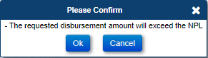
- On the Servicing Management -> Property Tax screen, there is a field called “Delinquency Status”, the same field on the Servicing Management -> Servicing Management Information -> Edit -> Edit Servicing Management screen had a field that is labeled “Tax Payment Status”. Both Fields are now named “Delinquency Status”.
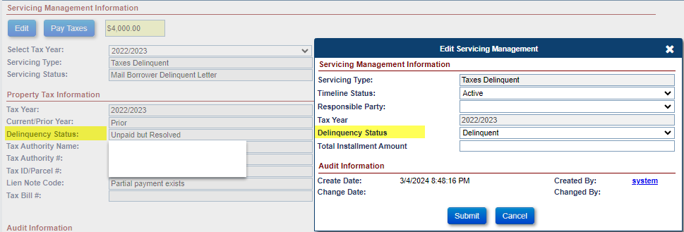
The following changes were implemented on March 23rd:
- The field Tax Authority Number was added to the Admin - > Tax Authority Screen.
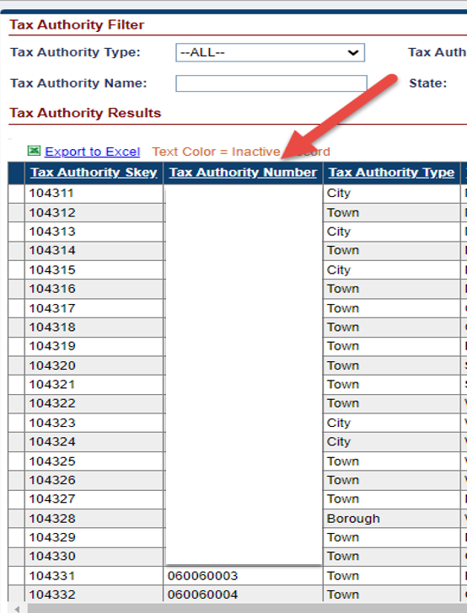
- Records will be overwritten in HERMIT each month if there is a matching Tax Authority ID. If there is a record in HERMIT that does not have a matching Tax Authority ID then the record will not be overwritten. For any New Tax Authorities, a Tax Authority Number will be populated by HERMIT and provided to HUD.
- Alerts related to Taxes will be inactivated when the Taxes Delinquent Timeline is inactivated.
- Update the Audit Record to add the Tax Year to the Tax Audit Items:
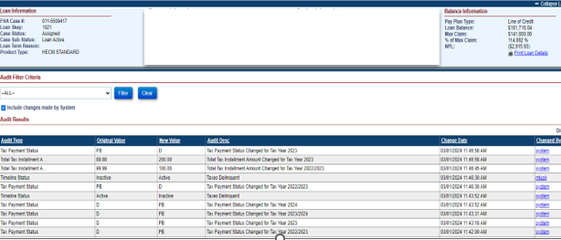
- On the Note, what was changed was added in following Note: "The existing Taxes Delinquent timeline was updated for Authority: <Authority Name> for Parcel No: <Parcel No> for the <Tax Year> tax Year”
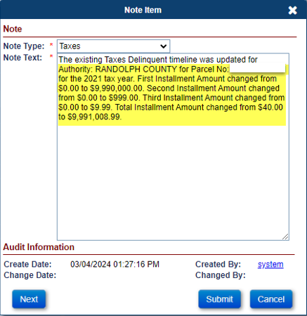
- The word “Void” was changed to Cancelled when creating a disbursement on the same day that it was created.
