Home Equity Reverse Mortgage Information Technology
(HERMIT)

HERMIT System Changes – Release 7.7

Release Date: 06/29/24
Document Date: 06/26/24
Version 1.0

June 2024

INTRODUCTION
The Home Equity Reverse Mortgage Information Technology (HERMIT) software release version 7.7 consists of the following system changes:
Table of Contents
Servicer Related Changes 4
1. Changing Inactive Due & Payable w/ HUD Approval Timeline to Active (589789) 4
2. Timeline: Updates to Due & Payable w/ HUD Approval Timeline (590091) 4
3. Timeline: Update to the Step “Signed Anniversary Date” for both Assigned and Endorsed Occupancy Timelines. (561392) 7
4. Timeline: Updates to Endorsed > Release 2nd Timeline (587324, 539471, 589231, & 590865) 8
5. Updates to Calculated Fields in the Preservation & Protection Info Display Screen (45499) 9
6. Claim Type 24 – Disable 2 Claims Hard Stop validations for CT24 only (591175) 11
7. Claim Type 21 – Appraisal Based Claim – Deed in Lieu: Populate Block 10 with Approved Marketable Title Extension Expiration Date (589282) 12
8. Claim Type 22 – Allow Investor Change until claim form 27011 is submitted (587222) 12
9. Claim Type 22 – MIP for Claims Filed on last day of the month (48044) 12
10. Claim Type 20 – Demand Assignment (544076) 13
11. Report: No Pay Order Report (589942) 14
12. New Document Type: Overclaim/Refund Documentation (591849) 15
NSC / HUD Related Changes 16
13. Assigned Updates to Life Expectancy Set Aside (LESA) Tax Disbursements (590711) 16
14. Assigned Tax Due Dates and Loan Level Tracking (584314) 16
15. Timeline: New Assigned > Request for Payment Timeline (587376) 18
16. Timeline: Added New Steps to Assigned > Release 1st and 2nd Timelines (587324, 539471, 589231, & 590865) 19
17. Timeline: Assigned > Foreclosure Timeline cannot be setup without an Active Due & Payable Timeline (571555) 19
18. Timeline CT 22: Update CT 22 HECM Checklist (591093) 19
19. Timeline CT 22: Update to multiple Letters and Letter Steps on the Endorsed > Claim Type 22 Timeline (539438, 571553 & 590067) 22
20. Timeline CT22: Updated to allow Initiation of Endorsed > Claim Type 22 – Assignment Timeline when the Case Sub-Status is Bankruptcy (591561) 23
21. Timeline CT 22 Claims Worksheet - populate Part A HUD Comments w text (539317) 24
22. Identifying MCA Percentage on the CT 22 (590952) 24
23. Timeline: Estimated Expenses Part of Repurchase (590824) 25
24. Timeline: Repurchase Letter Payoff Date updated to 30 Days from Letter Generation date (584060) 25
25. Report: Assigned > Notes > Reports: Timeline Activity Report was updated to include new Report Results (591156) 27
26. Report: Contact Information Report (589510) 28
27. Report: Indemnification Data Report - Add Field Transaction Date (To & From) (590138) 29
28. Report: Add FHA Case # to the Audit Tracking Report (574120) 30
29. Report: HUD Pending Decision Report (590091) 30
30. Monthly Statements Printing and availability (543086, 589438, 588670) 31
31. Endorsed > Disbursements: Remove ‘Cert of Occupancy’ Date Disbursement Error Message for Endorsed Loans (590037) 33

If you have any questions regarding the functionality of the software release, please contact the HERMIT Help Desk at 561-899-2610 or at servicingsupport@hermitsp.com. If you have any policy related questions, please send an email to HUD at answers@hud.gov.

Servicer Related Changes

Changing Inactive Due & Payable w/ HUD Approval Timeline to Active (589789)
The system was updated for HUD NSC Manager user role to be the only role permitted to change a “Due and Payable w/ HUD Approval” Timeline Status from Inactive to Active from the Endorsed > Requests, Servicing Mgmt page. Other user roles are still permitted to update the Timeline Status from Active to Inactive.

Timeline: Updates to Due & Payable w/ HUD Approval Timeline (590091)
Changes were implemented to the Endorsed > Due & Payable w/ HUD Approval Timeline to improve clarity on timelines requiring actions from HUD and HUD’s Contractor. The “HUD Pending Decision Report” was also updated to incorporate the renamed timeline steps and step triggers.
- Changes to HUD Contractor related Steps:
  - Step “Contractor Reviewed Additional Information” was renamed to “Contractor Recommendation Submitted”.
  - The newly renamed step “Contractor Recommendation Submitted” will be automatically added to the Due & Payable w/ HUD Approval Timeline upon completion of either of the following steps:
    - “Request to Call Due & Payable Reviewed”
    - “Additional Information Received from Servicer”.
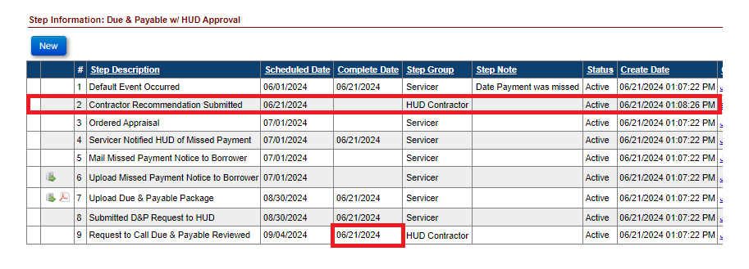

  - Step “Contractor Recommendation Submitted” will auto complete once one of the following HUD Contractor steps are completed with a complete date on or after the scheduled date of the step “Contractor Recommendation Submitted”:
    - “Contractor Recommendation – Approved”
    - “Contractor Recommendation – Denied”
    - “Pending Additional Information from Servicer”
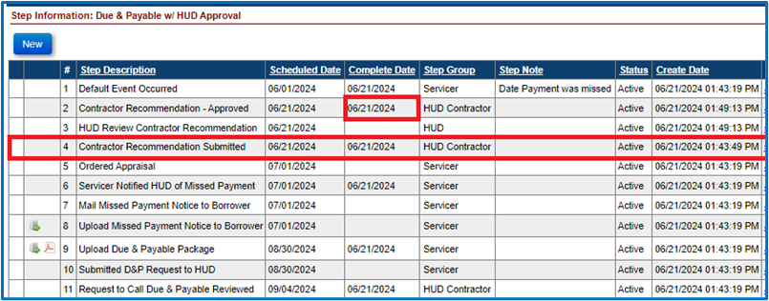

  - Multiple HUD Contractor Step(s) “Contractor Recommendation Submitted” will be allowed, however there will never be more than one step pending completion at any time.
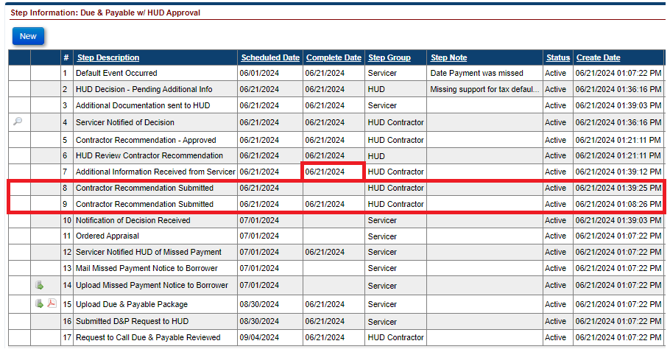

  - Step “Servicer Notified of Decision” will now be automatically added to the Due & Payable w/ HUD Approval Timeline upon completion of Step “Pending Additional Information from Servicer”.
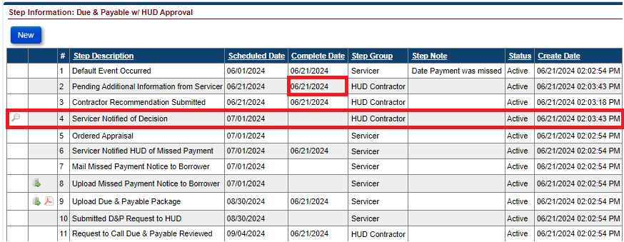

- Changes to HUD related Steps:
  - Step “Request to Call Due & Payable Sent to HUD” will no longer be auto completed when HUD Contractor Step “Contractor Recommendation – Approved” is completed.
  - Step “Request to Call Due & Payable Sent to HUD” was renamed to “HUD Review Contractor Recommendation”
  - The newly renamed step “HUD Review Contractor Recommendation” will be automatically added to the Due & Payable w/ HUD Approval Timeline upon completion of one of the following HUD Contractor steps:
    - “Contractor Recommendation – Approved”
    - “Contractor Recommendation – Denied”
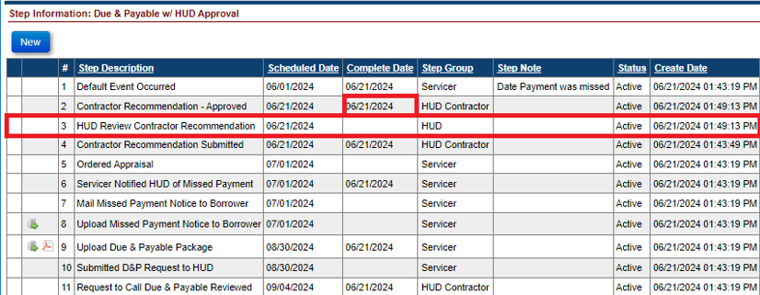
  - Step “HUD Review Contractor Recommendation” will auto complete once one of the following HUD steps are completed with a complete date on or after the scheduled date of the step “HUD Review Contractor Recommendation”:
    - “HUD Decision – Approved”
    - “HUD Decision – Denied”
    - HUD Decision – Pending Additional Info”
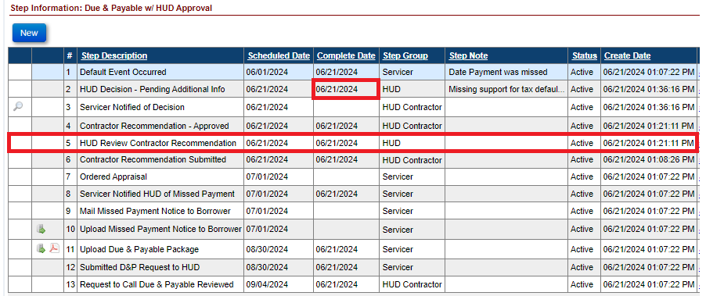
  - Multiple HUD Step(s) “HUD Review Contractor Recommendation” will be allowed, however there will never be more than one step pending completion at any time.
Step “Received Required Additional Information” is an Optional step and will no longer be automatically added to the Due & Payable w/ HUD Approval Timeline upon completion of step “Additional Information Sent to HUD.”

Timeline: Update to the Step “Signed Anniversary Date” for both Assigned and Endorsed Occupancy Timelines. (561392)
In accordance with HUD Handbook 4000.1, the Scheduled Date for the Step “Signed Anniversary Date” on the Endorsed > Occupancy Compliance Certification and Assigned > Occupancy Compliance Certification Timelines in HERMIT has been changed to reflect the 1st day of the month after the Closing date.
For example: If the loan Closing Date is on January 21st, then the Signed Anniversary Date should reflect February 1st. Currently the Signed Anniversary Date reflects the date of Closing.
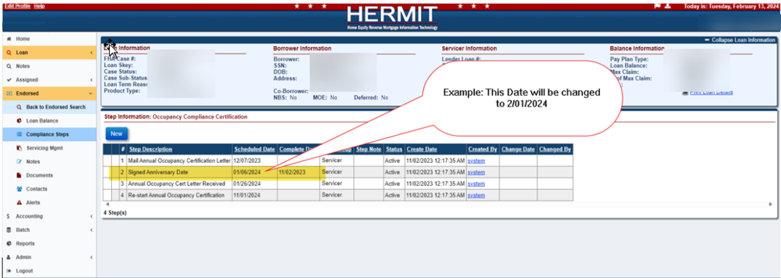

Timeline: Updates to Endorsed > Release 2nd Timeline (587324, 539471, 589231, & 590865)
Multiple changes were made to the Endorsed > Release 2nd timeline including: new validations to initiate an Endorsed > Release 2nd Timeline on a loan with a Case Status Endorsed, addition of four new steps, changes to step triggers, and Auto Notes being added upon completion of steps.
- To Initiate an Endorsed > Release 2nd Timeline with a Case Status of Endorsed, the following validations/conditions must be met:
- If the Case Status is Endorsed and there is an Active Endorsed > Loss Mitigation – Short Sale timeline, the Step “Sale Closing Date” must be completed.
- If the Case Status is Endorsed and there is an Active Endorsed > Loss Mitigation –Deed in Lieu timeline, the Step “Deed Recorded Date” must be completed.
- The Case Status is Endorsed and there is an Active Endorsed > Loss Mitigation – Pre-Foreclosure timeline without either an Active Loss Mitigation – Short Sale or Active Loss Mitigation – Deed in Lieu timeline. If there is an Active Endorsed > Loss Mitigation – Pre-Foreclosure timeline with either an Active Loss Mitigation – Short Sale or Active Loss Mitigation – Deed in Lieu, then the first two conditions (i. & ii) need to be met.
- If a user tries to initiate an Endorsed > Release 2nd Timeline on an Endorsed Loan when the validations/conditions are not met, then the user will receive an Error message.
  - Message: “Case Status must either be “Terminated” or “Endorsed” with the following conditions: an active “Loss Mitigation – Short Sale” timeline with step “Sale Closing Date” completed, OR an active “Loss Mitigation – Deed-in-Lieu” timeline with step “Deed Recorded Date” completed, OR an active “Loss Mitigation Pre-Foreclosure” timeline with no active “Loss Mitigation – Deed-in Lieu” or “Loss Mitigation – Short Sale” timeline.”
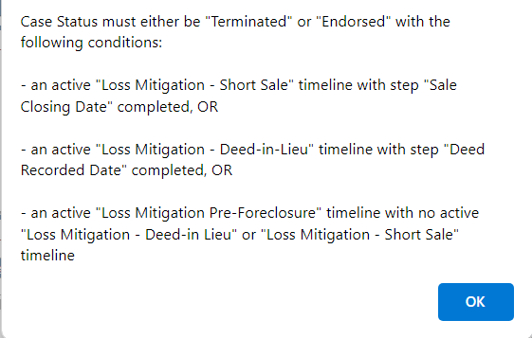

- Four new optional HUD Contractor steps have been added to the Endorsed > Release 2nd timeline.
  - Lien Release Document Follow up
  - Reject/Corrective Release Received
  - Rejected/Corrective Release sent to County for Recording
  - Request for Payment
- The existing Step “Received Missing Mortgage/DOT” is now triggered when the Step “Order Missing Mortgage/DOT” is completed. The Step “Received Missing Mortgage/DOT” is no longer an Optional Step.
- An Auto Note will be added automatically upon completion of any Step within this timeline.
- Message states “{Timeline Group: Endorsed or Assigned} – {Servicing Type}. {Step Name} was completed on MM/DD/YYYY by User ID. Step Note: (Text).”

Updates to Calculated Fields in the Preservation & Protection Info Display Screen (45499)
Changes were made to the Preservation & Protection Info area that is displayed when entering a new P&P transaction to provide more transparency on Property Preservation Allowances available to the servicer. This modal displays two areas of information; the first 3 columns are related to P&P transactions that are not linked to a HUD approved P&P transaction or have Excluded from Max checkbox selected, and the last 4 columns are related to P&P transactions linked to HUD approved P&P transactions.
- The field “Maximum Allowance” in the display was renamed to “P&P Allowance”. The amount reflected in the newly named field “P&P Allowance” still reflects the maximum allowance to preserve the property as designated by HUD in Appendix 7.0 of HUD Handbook 4000.1.
- The calculation in the “Total Allowance Used” field was updated to ensure only Property Preservation Loan Transactions (Corp Adv – Prop Preserve) linked to a “HUD Approved Amount” (amounts approved through a Request > Preservation & Protection Timeline) and Property Preservation Loan Transactions that were “Excluded from Max” at the time of entry were excluded from the “Total Allowance Used” amount.
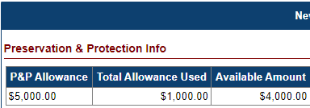

- A cap was introduced to restrict a “Corp Adv – Prop Preserve – Repayment” (transaction code 2118) from exceeding the Transaction Category Total for Transaction Category “Corp Advance – Property Preservation”. A hard stop will display when a “Corp Adv -Prop Preserve – Repayment” transaction exceeding the Category Total.
  - Hard Stop Message: “Transaction Amount must be <= Transaction Category Balance of $xxxx.xx.”
Changes were also made to the right side of the Preservation & Protection Info display related to HUD Approved Property Preservation Amounts.
- A new column was introduced “HUD Approved Minus Used” to capture the difference between the “HUD Approved Amount” and the Property Preservation Loan Transaction Amount (“Corp Adv – Prop Preserve”) for transactions linked under the “Excess Preservation and Protection Allowances” of the New Preservation & Protection Transaction modal. Prior to this change, these differences were reflected in the renamed column “HUD Approved Available” amount, however the excess “HUD Approved Amount” is not available to apply against subsequent Property Preservation Loan Transactions. The calculation for the renamed column “HUD Approved Available” was updated accordingly to (“HUD Approved Amount” – “HUD Approved Used” – “HUD Approved Minus Used”).

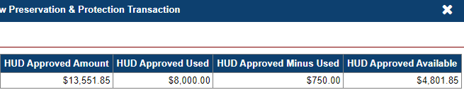

- Example: HUD Approved $8,750.00 for “Remove Debris” under Request ID 8496221561. The Property Preservation Loan Transaction linked to this Request ID was $8,000.00.
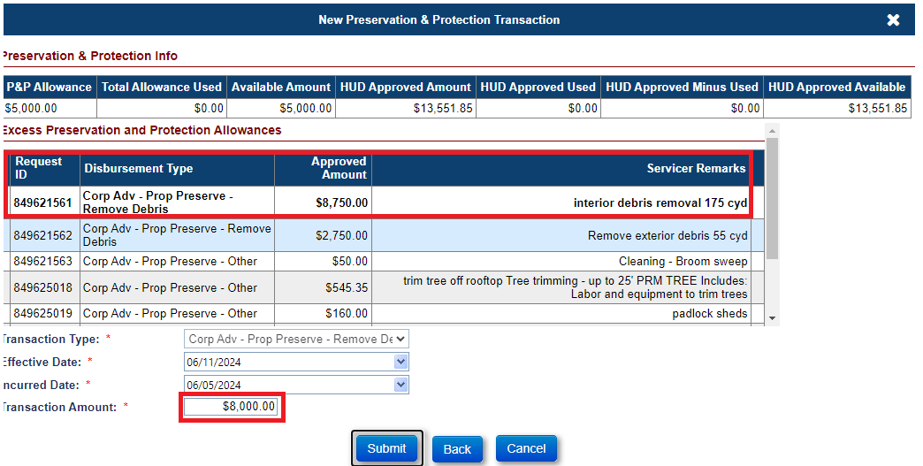

Upon submission of the Property Preservation Loan Transaction (Corp Adv – Prop Preserve – Remove Debris), the “HUD Approved Used” amount increased by $8,000.00, the “HUD Approved Minus Used” amount increased by $750.00 (or the difference between the “HUD Approved Amount” of $8,750.00 and the “HUD Approved Used” amount of $8,000.00), and the “HUD Approved Available” amount reduced by $8,750.00.

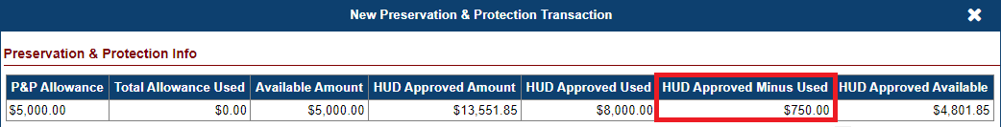

Claim Type 24 – Disable 2 Claims Hard Stop validations for CT24 only (591175)
The following two claims hard stop validations no longer apply to Claim Type 24 Supplemental Claims:
- “Foreclosure Sale Date cannot be blank for Foreclosure Instituted, unless DIL is obtained. Please go to the Foreclosure timeline and enter the Foreclosure Sale Date step completion date.”
- “Foreclosure Sale Appraisal Date cannot be blank for Foreclosure Instituted, unless DIL is obtained. Please go to the Foreclosure timeline and enter the Foreclosure Sale Appraisal Date step completion date.”
Note: Both still apply to Claim Type 21. Implemented on 4/30/24.

Claim Type 21 – Appraisal Based Claim – Deed in Lieu: Populate Block 10 with Approved Marketable Title Extension Expiration Date (589282)
The Marketable Title Extension’s “Extension Expiration Date” populating Block 10 on a Claim Type 21 / Appraisal Based Claim (ABC) has been expanded to apply to Deed In Lieu claims the same as it does for Foreclosure claims. Note: Implemented on 4/17/24.
Block 10 on CT21 / Appraisal Based Claim for both Foreclosure and Deed in Lieu, will be populated with Extension Expiration Date on the Marketable Title extension from either an Extension - COVID-19 Request to Delay Claims Submission timeline, or an Extension - Claims Deadlines timeline, when the reason for request is “CT21 - Marketable Title” and the necessary criteria to apply the extension is met. If the Extension Expiration Date is in the future, the Block 10 date on the Claim Type 21 Appraisal Based Claim will populate with Today / the date the claim is being filed.
See Claims Mapping document for full details on populating Block/ Item 10.

Claim Type 22 – Allow Investor Change until claim form 27011 is submitted (587222)
The system will allow the Investor on a loan to be changed up until the Claim Type 22 – Assignment Timeline step “Assignment to HUD sent for recording/Servicer Files Claim Type 22 - Form 27011” is completed. Previously, investor changes were restricted after the completion of step “HUD Issued Preliminary Title Approval.”

Claim Type 22 – MIP for Claims Filed on last day of the month (48044)
The Total Claim Amount for Claim Type 22 – Assignment was updated to align with the MIP sent and collected via the Accounting Module. This change applies only to CT22 claims with timeline step “Assignment to HUD sent for recording/Servicer Files Claim Type 22 - Form 27011” completed on the last day of the month. MIP on Claims filed mid-month already exclude any current MIP from the Total Claim Amount. For claims that are filed via above step completion date occurring on the last calendar day of the month, the Total Claim Amount now excludes MIP for the current month, since this MIP does not get collected via the Accounting Module and therefore is not payable by HUD on the claim. The Total Claim Amount for CT22 is the amount displayed on Block 137 of the Claim Form.
Example: Last Day of month claim filing.
- Servicer completes Step “Assignment to HUD sent for recording/Servicer Files Claim Type 22 - Form 27011” on 5/31/24
- MIP with accrual date 5/31/24 is not included in the Total Claim Amount/ Block 137 because this MIP does not get collected via Accounting module since the Servicer is now showing the HUD NSC Contractor.
- Last Monthly MIP included in Total Claim Amount is 4/30/24.
- If applicable, MIP Adjustments prior to 5/31/24 will be included.

Claim Type 20 – Demand Assignment (544076)
A new timeline was added to the system for Claim Type 20 – Demand Assignment. This timeline will be used after a HUD Borrower Disbursement (either Scheduled or Unscheduled) has been made on behalf of a servicer or investor who was unable or unwilling to make the payment. The Claim Type 20 timeline tracks all three possible outcomes after a HUD Borrower Disbursement has occurred, which are:
- Servicer reimburses all HUD Borrower Disbursements on the loan and reports the activity in the proper timeline step on the CT20 timeline. No further action on the Demand Assignment timeline will be necessary.
- Servicer does not comply with the Demand. HUD terminates insurance and will not pay a claim (206.133). HUD would support the loan under the 2nd Note only; the 1st Note is still the responsibility of the Servicer.
- Servicer completes the Demand Assignment process and the 1st Note is Assigned to HUD for Servicing.
Important: The Total Claim Amount on the CT20 Demand Assignment is a reduced claim amount as compared to other claim types; CT20 does not pay any Interest accrued on the loan.
Key Points:
- There must be a HUD Borrower Disbursement on the loan to set up a CT20 Demand Assignment timeline
- The Total Claim Amount is viewable on the Claim Form in Block 137 prior to the claim being filed. Block 17 does not reflect the Total Claim Amount.
- The field “Adjustment to Outstanding Balance” on the CT20 displays an amount equal to the current month’s prorated Interest and MIP (from day 1 of the current month through the date the claim is being filed on “Assignment to HUD sent for recording/Servicer Files Claim Type 20 - Form 27011” step completion date). This is to ensure the current month interest and MIP are not included in the total claim paid amount. This differs from how the information is displayed on CT22.

See User Guide for full details on the Claim Type 20 timeline.

Report: No Pay Order Report (589942)
A new report called No Pay Order Report was added to Servicer Reports > Daily Reports. The Report will generate data for all loans with a No Pay Order flag checked/ True.
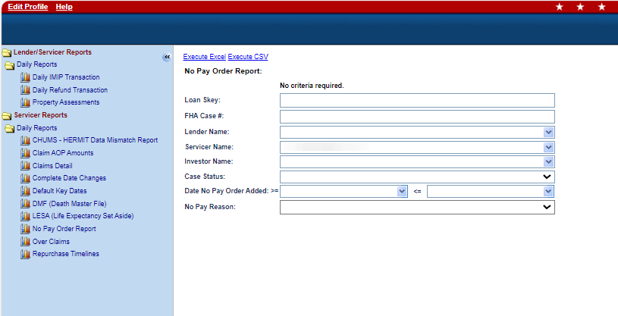

- Search Criteria includes:
- Loan Skey
- FHA Case #
- Lender Name
- Servicer Name
- Investor Name
- Case Status
- Date No Pay Order Added (Date Range)
- No Pay Reason

- Report output will include the following fields:
- Loan Skey
- FHA Case #
- Case Status
- Case Sub Status
- Lender Name
- Servicer Name
- Investor Name
- Date No Pay Order Added
- No Pay Order Added User ID
- No Pay Reason
- No Pay Explanation

New Document Type: Overclaim/Refund Documentation (591849)
A new document type called “Overclaim/Refund Documentation” has been added to allow users to upload documentation when submitting overclaim amounts back to HUD. The new document type called “Overclaim/Refund Documentation” will be available in document type dropdown list on the Upload document window. This new Document type will be available for both Servicers and NSC when uploading bulk document via SFTP. When remitting funds back to HUD, Servicers shall provide supporting documentation as evidence of the remittance to support the overclaim/refunded amount.

NSC / HUD Related Changes

Assigned Updates to Life Expectancy Set Aside (LESA) Tax Disbursements (590711)
For Disbursement “Disb – Life Expectancy Set Aside” on Assigned Loans, the Payee field options have been updated to display Corelogic or Compu-Link and are no longer based on the loan’s Property State. Authorized users can select either Corelogic or Compu-Link when creating this disbursement. The Disbursement Type has also been updated to display “LESA – Tax” instead of “LESA – Tax-Check”.
Note: Implemented on 4/30/24.

Assigned Tax Due Dates and Loan Level Tracking (584314)
A new read only page "Property Tax Info" was added to the Loan > Property area. This page displays loan-level information received from CoreLogic on taxes that were paid along with the tax due dates. This page also includes information on taxes that were paid via the HERMIT application.
The following fields are displayed under Property Tax Information:
- Taxable Year
- Taxing Authority Name
- Taxing Authority Number
- Agency tax Type
- Tax Identification Number
- Parcel Number
- Service Type
- Legal Description
- Delinquency Status
- Bill Type
- Tax Bill Number
- Pay Plan
- Lien Note Code
- Criticality Flag
- Search Date
- Post Date
- Number of Installments
- First Installment Delinquency Date
- Second Installment Delinquency Date
- Third Installment Delinquency Date
- Fourth Installment Delinquency Date
- Delinquent Age
- First Installment Amount
- Second Installment Amount
- Third Installment Amount
- Fourth Installment Amount
- Total Installment Amount
- The last 5 Tax Payments at the Loan Level where the transaction “Disb- Unscheduled from LOC Taxes” was created in the Disbursement area or through the Taxes Delinquent Timeline in HERMIT. There will be no Payment information from the Tax Payment Status File in this area.

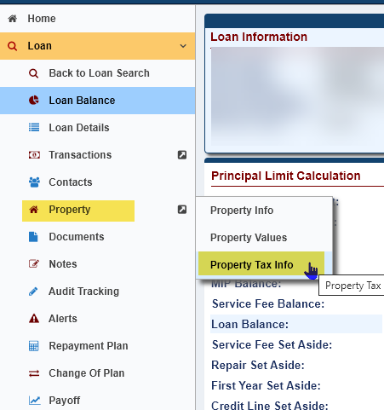

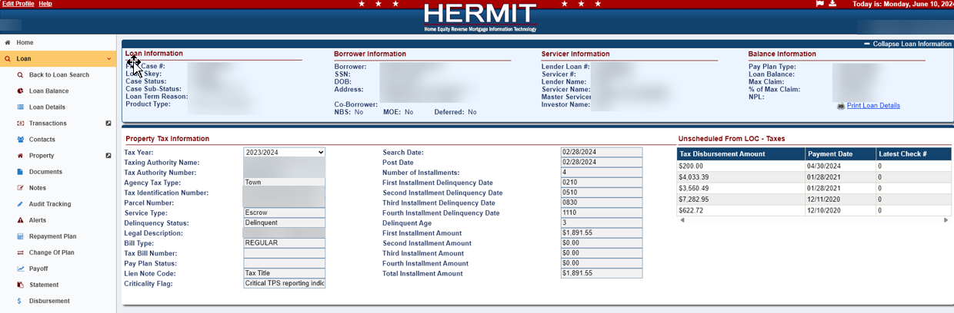

Timeline: New Assigned > Request for Payment Timeline (587376)
A new Timeline named “Request for Payment” was added to the Assigned > Compliance area.
- The following roles can create and edit “Request for Payment” timeline.
- CLS Cash
- CLS Cash Supervisor
- CLS First Mortgage
- CLS Supervisor/Management
- HUD NSC Manager
- Key fields are required when the “Request for Payment” timeline is created.
- Reason for Request: Required field, drop-down menu
- Requested Amount: Required field
- Payee: Required field
- Payee Mailing Address: Required field
- Comments: Conditionally Required when “Other” is select for the Reason for Request
- The following Steps are available on the “Request for Payment” Timeline. Servicing Type column indicates whether the step is Template (T) or Optional (O):
Data Group | Step Description | Servicing Type
HUD Contractor | Payment Requested | T
HUD Contractor | Requested Verified by Specialist | T
HUD Contractor | Cash Management Processed Payment | T
HUD Contractor | Request Revoked for Changes | O
HUD Contractor | Vendor Request Submitted | O
HUD Contractor | Unable to Verify/Cancel Request | O

- The Optional Steps “Request Revoked for Changes” and “Unable to Verify/Cancel Request” will Inactivate the Timeline when either of these Steps are completed.
- On the Edit Servicing Management window, the following fields are displayed
- Servicing Type: Read Only field
- Timeline Status: Editable
- Responsible Party: Editable
- Reason for Request: Read Only field
- Requested Amount: Editable and Required
- Requested By: Editable
- Payee: Editable and Required
- Payee Mailing Address: Editable and Required
- Comments: Editable and Conditionally Required when the Reason for Request is “Other”
- Multiple Timelines can be initiated and multiple timelines with the same Reason for Request are allowed.

Timeline: Added New Steps to Assigned > Release 1st and 2nd Timelines (587324, 539471, 589231, & 590865)
Four new optional HUD Contractor steps were added to the Assigned > Release 1st and Release 2nd timelines:
- Lien Release Document Follow up
- Reject/Corrective Release Received
- Rejected/Corrective Release sent to County for Recording
- Request for Payment
An Auto Note will be added automatically upon completion of any Step within these timelines. Note states “{Timeline Group: Endorsed or Assigned} – {Servicing Type}. {Step Name} was completed on MM/DD/YYYY by User ID. Step Note: (Text).”

Timeline: Assigned > Foreclosure Timeline cannot be setup without an Active Due & Payable Timeline (571555)
The system will not allow the initiation of an Active Assigned > Foreclosure Timeline if there is not an Active Assigned > Due & Payable Timeline after the implementation of Release 7.7. If the user attempts to setup an Assigned > Foreclosure Timeline without an Active > Due & Payable Timeline, the system will produce an Error Message which displays: “An Active Due & Payable Timeline is required to set-up a new Foreclosure Timeline.”
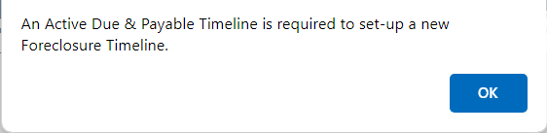

Timeline CT 22: Update CT 22 HECM Checklist (591093)
The HECM Assignment Acceptance Checklist was updated to list standard Denial Reasons underneath the Deny HECM Assignment area.
- Changes to HECM Assignment Checklist
- The “Other” Comment box will no longer allow text to be entered without checking the Acceptable or Unacceptable checkbox located under the MOE Checklist.
- If Text is entered in the “Other” Comments box after the user checks either the Acceptable or Unacceptable Checkbox, then Unchecks the Acceptable or Unacceptable Checkbox the Text will be removed from the “Other” Comments box.
- If No Text is entered in the “Other” Comments box and either the Acceptable or Unacceptable Checkbox is checked, the system will not allow the user to Print the HECM Checklist without Text.

- Changes to “Approve and accept HECM Assignment subject to Acceptance conditions as follows:” Comment box located under “Recommendation” area
- The Comment box will no longer allow text to be entered without checking the Checkbox next to “Approve and accept HECM Assignment subject to Acceptance conditions as follows.”
- If Text is entered in the Comment box after the user clicks the Checkbox, then unchecks the Checkbox the Text will be removed from the Comments box.
- If No Text is entered in the Comment box and the “Approve and accept HECM Assignment subject to Acceptance conditions as follows” Checkbox is checked, the system will not allow the user to Print the HECM Checklist without Text.

- Changes to “Deny HECM Assignment as follows” under “Recommendation” area
- The following Denial Reasons were added:
    - Missing HUD-1/Incomplete LA
    - NPL Issues
    - Title Insurance Policy
    - Repair Issues
    - Assignment of Mortgage Issues
    - Hazard/Flood Ins Discrepancies
    - NSC – Certs Missing
    - Loan Balance Does Not Match
    - Note/Mortgage Missing
    - MOE Package Issue
    - Denied Other (Comment box)

- The “Denied Other” Comment box will no longer allow text to be entered without checking the Checkbox next to “Denied Other.”
- If Text is entered in the “Denied Other” Comment box after the user clicks the Checkbox, then unchecks the Checkbox the Text will be removed from the Comments box.
- If No Text is entered in the “Denied Other” Comment box and the “Denied Other” Checkbox is checked, the system will not allow the user to Print the HECM Checklist without Text.

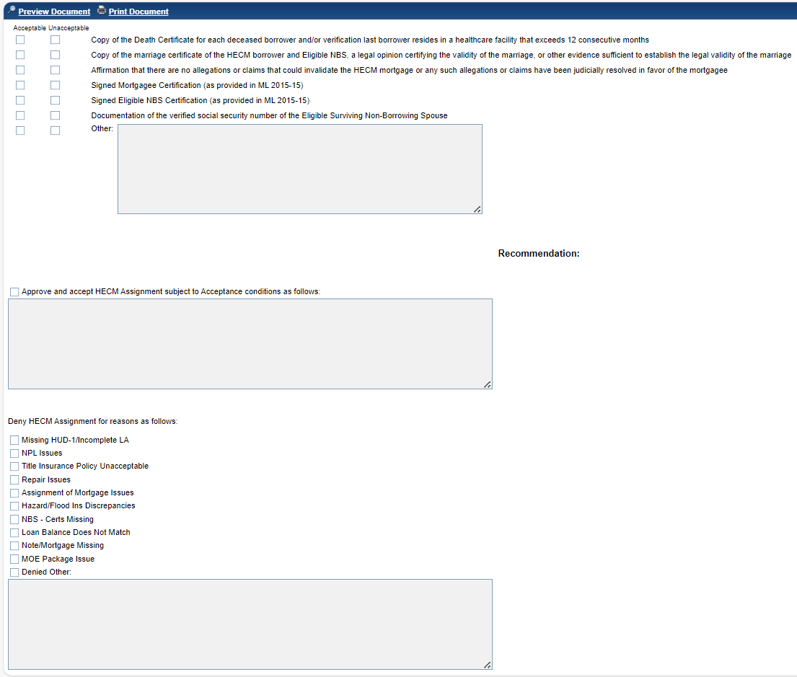

Timeline CT 22: Update to multiple Letters and Letter Steps on the Endorsed > Claim Type 22 Timeline (539438, 571553 & 590067)
Changes to the Endorsed > Claim Type 22 – Assignment Timeline include adding a new step, switching which steps Letters are generated from, and updating content in the letters.

- Changes to the “Denial Request for Assignment Letter”
  - The “Denial Request for Assignment Letter” is no longer tied to the Steps “Assignment Denied – No Funds Due HUD” and “Assignment Denied – Funds Due HUD” on the Claim Type 22 – Assignment Timeline. The printer icon has been removed from these Steps and will no longer display next to the Steps. When the user manually completes the Step “Assignment Denied – No Funds Due HUD” or “Assignment Denied – Funds Due HUD” the system will no longer Inactivate the Timeline.
  - The “Denial Request for Assignment Letter” is now tied to the New Step “HUD Decision Denied Letter.” The Step “HUD Decision Denied Letter” is triggered when either the Step “Assignment Denied – No Funds Due HUD” or “Assignment Denied – Funds Due HUD” is completed.
  - The Step “HUD Decision Denied Letter” will display the magnifying glass and printer icon next to the step. The user will only be able to complete the step when clicking on the printer icon. The user will not be able to complete the step by clicking on the step. Once the user clicks the printer icon next to the step and prints the letter, the step will automatically be completed, and the timeline will automatically Inactivate.
  - On the “Denial Request for Assignment Letter” the Denied Reason(s) pull into the Letter from the printed “HECM Assignment Acceptance Checklist.” The signature in the letter displays “First Mortgage Servicing Department” and the Footer in letter displays the FHA Case #.
- Changes to the “Incomplete Package – Request for Assignment Letter”
  - The “Incomplete Package – Request for Assignment Letter” is no longer tied to the Step “HUD Decision – Pending Incomplete Package” on the Claim Type 22 – Assignment Timeline. The printer icon has been removed from this Step and will no longer display next to the Step. When the user manually completes the Step “HUD Decision – Pending Incomplete Package” the system will trigger the Step “Follow-up on Incomplete Package.”
  - The “Incomplete Package – Request for Assignment Letter” is now tied to the Step “Follow-up on Incomplete Package.” The Step “Follow-up on Incomplete Package” will display the magnifying glass and printer icon next to the step. The user will only be able to complete the step when clicking on the printer icon. The user will not be able to complete the step by clicking on the step. Once the user clicks the printer icon next to the step and prints the letter, the step will automatically be completed.
  - On the “Incomplete Package – Request for Assignment Letter” the signature displays “First Mortgage Servicing Department” and the Footer in letter now displays the FHA Case #.
- Changes to the “Preliminary Title Approval” letter
  - The “Preliminary Title Approval” letter is no longer tied to the Step “HUD Issued Preliminary Title Approval” on the Claim Type 22 – Assignment Timeline. The printer icon has been removed from this Step and will no longer display next to the Step. When the user manually completes the Step “HUD Issued Preliminary Title Approval” the system will trigger the Step “Servicer Notified of Preliminary Title Approval Decision.”
  - The “Preliminary Title Approval” letter is now tied to the Step “Servicer Notified of Preliminary Title Approval Decision” The Step “Servicer Notified of Preliminary Title Approval Decision” will display the magnifying glass and printer icon next to the step. The user will only be able to complete the step when clicking on the printer icon. The user will not be able to complete the step by clicking on the step. Once the user clicks the printer icon next to the step and prints the letter, the step will automatically be completed.
  - On the “Preliminary Title Approval” letter the signature displays “First Mortgage Servicing Department” and the Footer in letter displays the FHA Case #.
- Changes to the “HUD Issued Final Title Approval” letter and “HECM Recorded Assignment to HUD not Received” letter
  - On the “HUD Issued Final Title Approval” letter and “HECM Recorded Assignment to HUD not Received” letter, the signature displays “First Mortgage Servicing Department” and the Footer in letter displays the FHA Case #.
- Changes to the “Checklist for Assigning a Loan to HUD” letter and “Welcome Letter”
- On the “Checklist for Assigning a Loan to HUD” letter and “Welcome Letter” the footer displays the FHA Case #.

Timeline CT22: Updated to allow Initiation of Endorsed > Claim Type 22 – Assignment Timeline when the Case Sub-Status is Bankruptcy (591561)
The system will allow the user to Initiate an Endorsed > Claim Type 22 – Assignment Timeline if the Case Sub-Status is Bankruptcy/Chapter 13 or Bankruptcy/Chapter 7. These two Case Sub-Statuses are permitted in addition to the existing Case Sub Statuses of “Loan Active” and “Payment Suspended” which allow a user to Initiate a Claim Type 22 Timeline.
- If a user tries to Initiate an Endorsed > Claim Type 22 – Assignment Timeline when the Case Sub-Status is not either “Loan Active,” “Payment Suspended” (only if status is Deferred), “Bankruptcy/Chapter 13,” or “Bankruptcy/Chapter 7” then the system will display an Error message which states: "Case Sub-Status must be “Loan Active” or “Bankruptcy” when the loan is not in a deferred status. Case Sub-Status must be “Payment Suspended” when the loan is in a deferred status.”
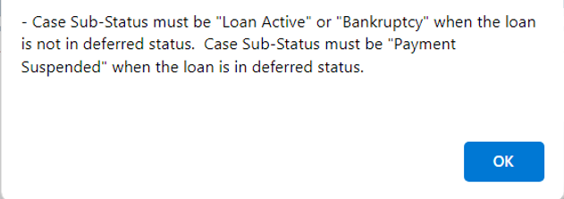

Timeline CT 22 Claims Worksheet - populate Part A HUD Comments w text (539317)
A change was made to Part A of the HUD-27011 in the Claim Type 22 – Assignment Timeline to auto-populate the text “Optional Assignment of a HECM” in the HUD Comments box in lieu of the Mortgagee Comments box. This change was made to ensure this required text is not inadvertently deleted from the claim form prior to claim submission.
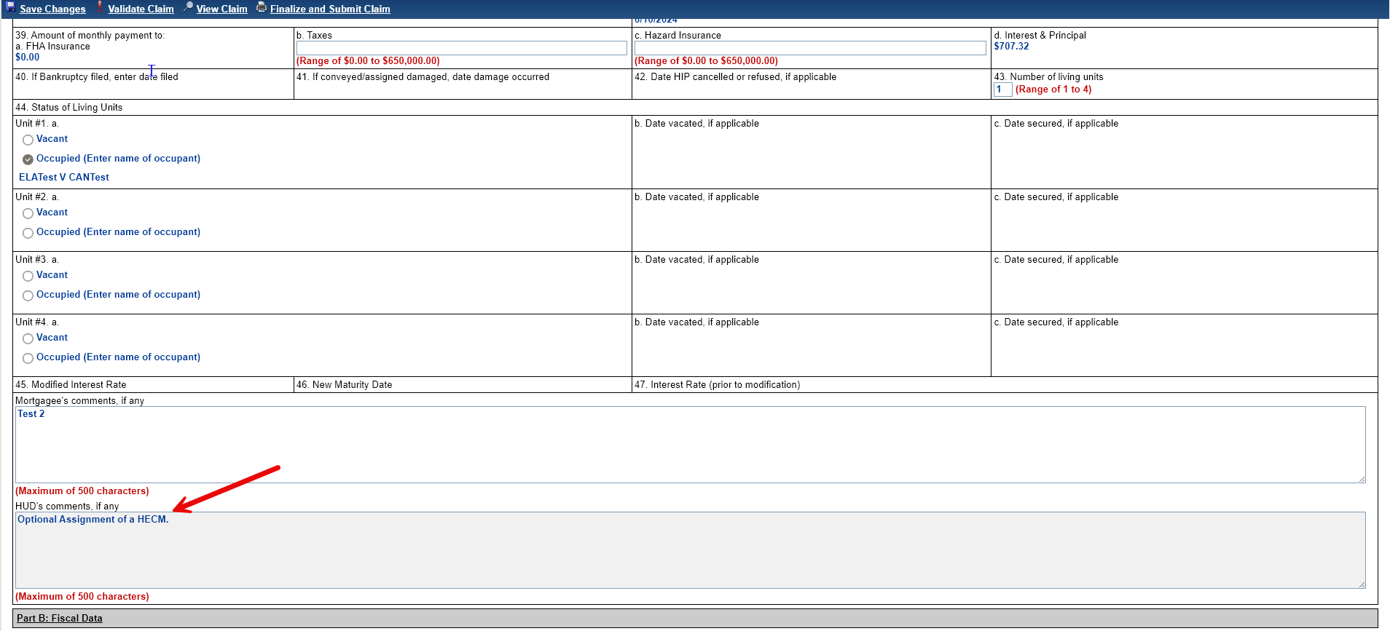

Identifying MCA Percentage on the CT 22 (590952)
A new column called “MCA % at Submission” has been added to the search results grid on the Endorsed > Claims > Search. The “MCA % at Submission” column will be populated with the calculated Maximum Claim percentage only for Claim Type 22 – Assignment Timelines with a completion date for the Step “Submit Assignment Request to HUD.” The new column “MCA % at Submission” will be NULL for all other Claim Types than a Claim Type 22 – Assignment or if there is no active Claim Type 22 – Assignment Timeline with a Step “Submit Assignment Request to HUD” completion date. The Maximum Claim Amount percentage will be captured for each timeline that has a Step “Submit Assignment Request to HUD” completion date whether the timeline is Inactive or Active.
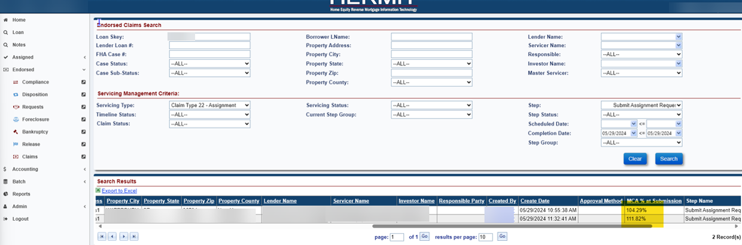

Timeline: Estimated Expenses Part of Repurchase (590824)
A new Hard Stop Validation will be displayed when attempting to complete the Optional HUD Step “HUD Decision – Approved Repurchase” on the Claims > Assignment Repurchase Timeline when there are “Estimated Expenses” present on the Loan > Payoff Screen. The Hard Stop Validation reads, “HUD Decision – Approved Repurchase step cannot be completed until all Estimated Expenses have been removed from the Payoff”. The authorized user will be allowed to complete Optional HUD Step “HUD Decision – Approved Repurchase” once the “Estimated Expenses” have been removed from the Payoff screen. Please contact HUD NSC Contractor to have Estimated Expenses removed, if necessary.

Timeline: Repurchase Letter Payoff Date updated to 30 Days from Letter Generation date (584060)
In the Assigned > Claims > Assignment Repurchase Timeline, the “Payoff Amount” and the “Good Through Date” automatically printed on the Repurchase Letter has been modified to the Repurchase Letter Print Date (Today) + 30 days. The text “with a per diem of (Amount)” has been removed from the Repurchase Letter. These changes to the Repurchase Letter will occur on or after the implementation of Release 7.7.
- When an authorized user reprints the Repurchase Letter by clicking the print icon on the completed step “Repurchase Letter Issued to Investor” on the Assigned > Claims > Assignment Repurchase Timeline, then the “Payoff Amount” and “Payoff Good Through Date” on the Repurchase Letter will now update to “Today’s Date” + 30days
- All printed Letters will now be imaged into the documents tab
- The step “Repurchase Letter Issued to Investor” will be populated with the completion date the first time an authorized user clicks the print icon on the step. Meaning, if the print icon is clicked multiple times to re-print a Repurchase Letter, the step completion date will not change from the initial completion date.
For Example, if an authorized user clicks on the print icon on the Step “Repurchase Letter Issued to Investor” on the Assigned > Claims > Assignment Repurchase Timeline on 01/30/2024, then the Repurchase Letter would display the “Payoff Amount” through 02/29/2024 (01/30/24 + 30 days) (see sample Repurchase Letter below)
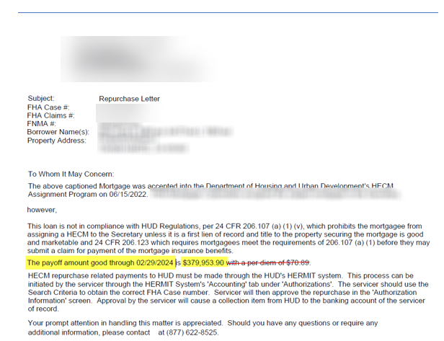

Report: Assigned > Notes > Reports: Timeline Activity Report was updated to include new Report Results (591156)
The Timeline Activity Report was updated to include the columns “Step Completed By Date”, “Changed By”, and “Changed Date.” The existing column “Step Completed By” displays the user who completed the Step.
- Two new columns “Step Completed By” and “Step Completed By Date” were added to the grid on the Timeline Step screen for all timelines (Endorsed and Assigned).
- The column “Step Completed By” has been updated to accurately reflect the original username who completed the Step and the column “Step Completed By Date” displays the original date and time the Step was completed.
- If the complete date for the step is editable and a user updates the completed date, the new fields will not show the user who edited the complete date and will only display the original user who completed the step.
  - Example: Username “Test1” completed a step on 04/18/2024 at 12:00pm then username “Test3” goes in and edit the complete date of that step on 04/19/2024 at 8:00am, the field “Step Completed By” will display username “Test1” and the field “Step Completed By Date” will display 04/18/2024 12:00pm. The “Changed By” will display user “Test3” and the “Changed Date” will reflect 8:00am.
- System will only display in the “Step Completed By” when the system auto completes a step.
- The “Step Completed By”, “Step Completed By Date”, “Changed By”, and “Changed Date” will populate the Timeline Activity Report from the grid on the Timeline Steps screen.
- A Data Change Request (DCR) was processed for Legacy timelines for the columns “Step Completed By” and “Step Completed By Date”, these will display the “Changed By” and “Changed Date” of the last user who updated the timeline prior to a system change and not display system.

Report: Contact Information Report (589510)
A new report called “Contact Information Report” has been added to HERMIT reports area under Assigned Notes Reports > Daily Reports. The report will pull any phone numbers and mailing addresses from every available contact on the loans Serviced by the HUD Contractor (Servicer Skey 900000).
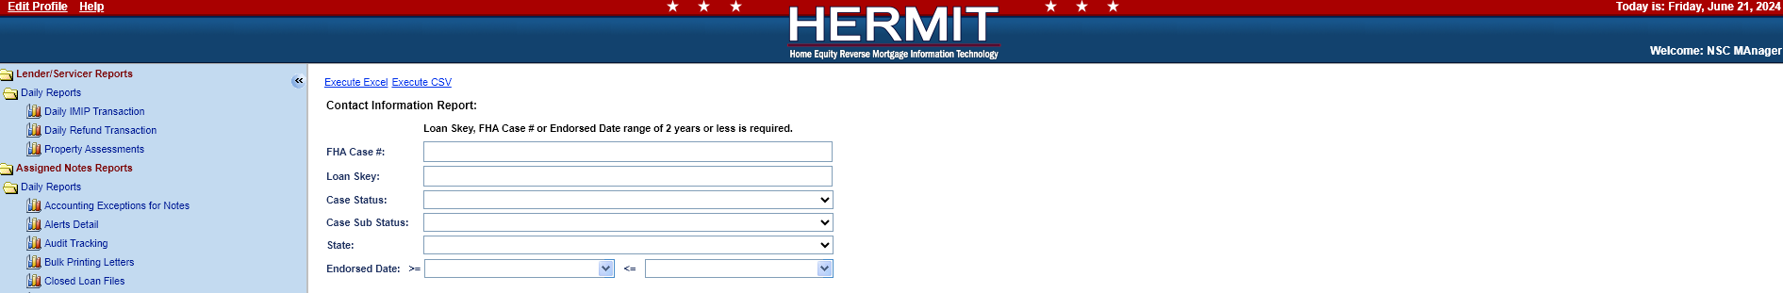
- Search Criteria includes:
- Loan Skey
- FHA Case #
- Case Status
- Case Sub Status
- Endorsed Date
- State

- The output will have the following fields:
- Loan Skey
- FHA Case #
- Case Status
- Case Sub-Status
- Servicer Name
- Closing Date
- Origination Date (if applicable)
- Borrower Last Name
- Borrower First Name
- Property Address
- Property City
- Property State
- Property Zip
- Property County
- Contact Type
- Contact Type Description (if applicable)
- Contact First Name
- Contact Last Name
- Contact Address 1
- Contact Address 2
- Contact City
- Contact State
- Contact Zip
- Contact SSN (if applicable)
- Contact Language
- Contact Death Date
- Contact Email
- Is Authorized Contact Checked (Y/N)
- Contact Home #
- Contact Work #
- Contact Cell #
- Contact Mailing Information Address 1
- Contact Mailing Information Address 2
- Contact Mailing Information City
- Contact Mailing Information State
- Contact Mailing Information Zip

Report: Indemnification Data Report - Add Field Transaction Date (To & From) (590138)
A new search filter was added under Reports > Management/Budgetary > Daily Reports > Indemnification Data. The optional new filter will allow an authorized user to input a “Transaction Date” range before executing an Excel or CSV output of the results. The “Transaction Date” range will not be pre-populated with any values.
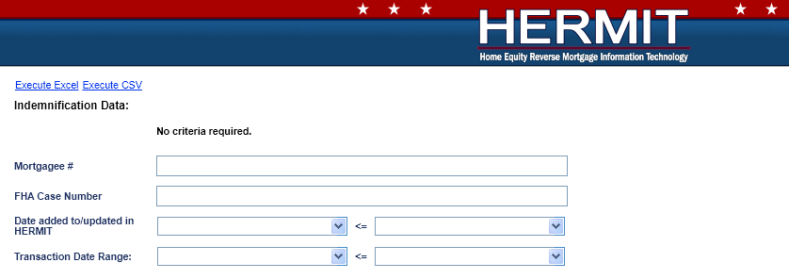

Report: Add FHA Case # to the Audit Tracking Report (574120)
A new column called “FHA Case #” was added to the Report results for the Audit Tracking Report located under Assigned Notes Reports > Daily Reports.
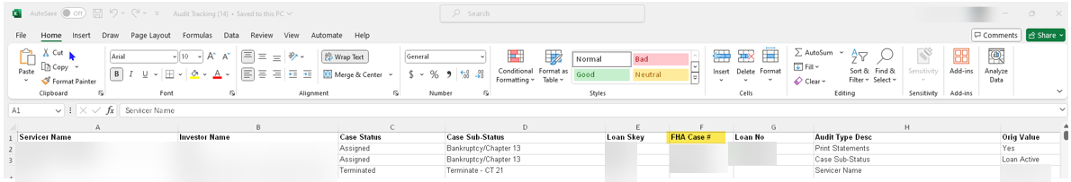

Report: HUD Pending Decision Report (590091)
Revisions were made to the “HUD Pending Decision Report” for the Due & Payable w/ HUD Approval Timeline:
- Loans will be included in the “HUD Pending Decision Report” if all the following are true:
- There is an “Active” Due and Payable w/ HUD Approval Timeline Status
- Case Status is Endorsed
- The newly renamed HUD Step “HUD to Review Contractor Recommendation” is in a “Pending” (not completed) Step Status
- The “Servicing Step” displayed from Reports > Management/Budgetary > Daily Reports > HUD Pending Decision will now default to the renamed HUD Step “HUD to Review Contractor Recommendation” in the dropdown.
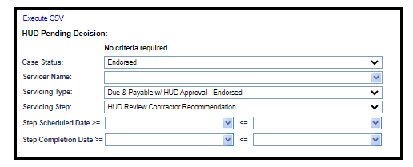

Monthly Statements Printing and availability (543086, 589438, 588670)
- Restrict the Printing of Monthly Statements for Reporting Periods HUD was not Servicing the Loan (543086)
- Enhancement to the Print Statements check box in the Loan Details screen (589438 & 588670)
Monthly Statements are now only available for viewing and printing for the Reporting Periods HUD was servicing the loan following an optional assignment or demand assignment, except for the HUD NSC Manager role who will have permission to view/print statements for any reporting period. Prior to this change, statements from any servicing period could be viewed and printed.
Changes were also made to the “Print Statements” checkbox in Loan Details. The “Print Statements” checkbox will now be checked unless the loan is not being serviced by HUD, the Case Status = “Terminated”, or the Case Sub-Status = Bankruptcy”. The checkbox will be un-checked when an Assigned loan changes to a Terminated Case Status or Bankruptcy Case Sub-Status.
The criteria that triggers the “Print Statements” checkbox on the Loan Details page to be checked has been modified to only be checked when the following is True:
- Servicer Skey = “900000” (HUD Contractor)
- Case Status is not “Terminated”
- Case Sub-Status is not “Bankruptcy”
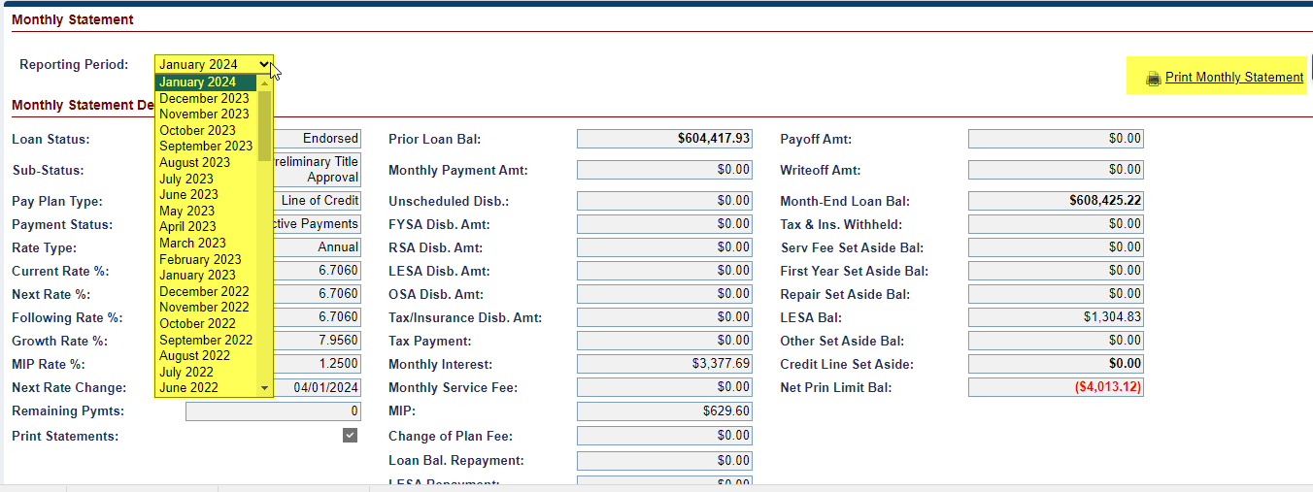

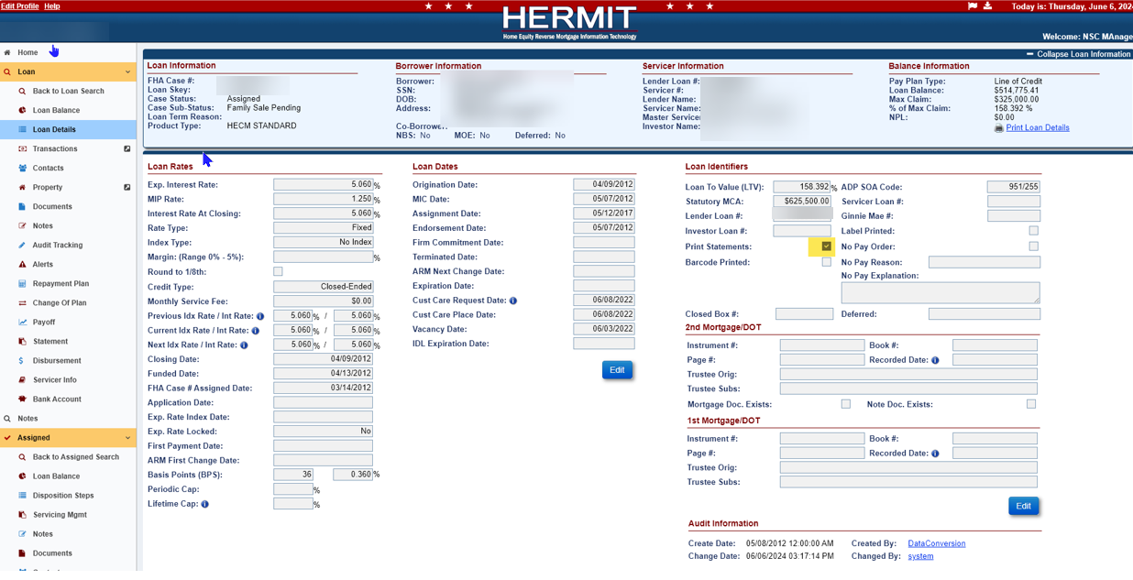

Endorsed > Disbursements: Remove ‘Cert of Occupancy’ Date Disbursement Error Message for Endorsed Loans (590037)
For HUD Borrower Disbursements made by HUD when the servicer or investor is unwilling or unable to make the payment, the Error Message "The ‘Cert of Occupancy’ date for this loan is greater than one year old, do you wish to continue?" has been removed for Endorsed loans only. This warning message previously appeared when a user creates a NEW HUD Borrower Disbursement (when Display Disbursement Page checkbox at Admin > Servicer level is checked), and servicer or HUD NSC manager is permitted to create a disbursement to be paid by HUD for an Endorsed Loan.

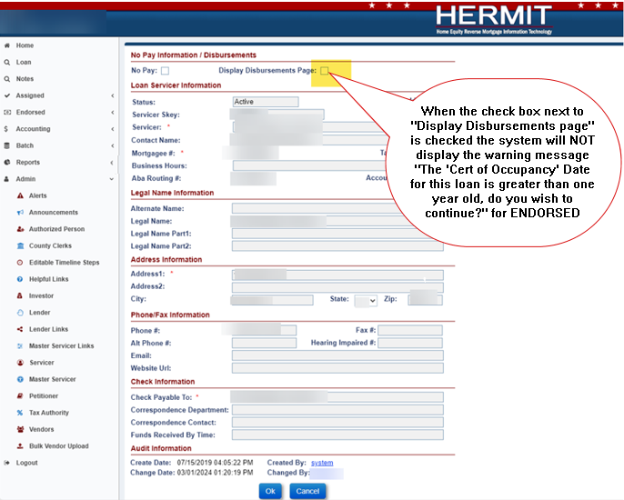

------ End of Document -----

