Home Equity Reverse Mortgage Information Technology
(HERMIT)

HERMIT System Changes – Release 7.8

Release Date: 09/28/24
Document Date: 09/28/24
Version 1.0

September 2024

INTRODUCTION
The Home Equity Reverse Mortgage Information Technology (HERMIT) software release version 7.8 consists of the following system changes:
Table of Contents
Servicer Related Changes 4
1. Updates to Debenture Interest Rate (591105) 4
2. Reimbursements to HUD for Borrower Disbursements on Endorsed Loans (589281) 5
3. Update to Preservation & Protection Transaction Excluded from Max options (592061) 10
4. Over Claims: New Reason Codes & Over Claims to apply toward Claim Capping for Maximum Claim Amount and Statutory Maximum Claim Amount (591144) 12
5. Reports: Allow Servicers to retrieve Assignment Claim paid data on Claims Detail Report (560286) 13
6. Timeline: Inactivate CT 22 Timeline when Repayment is made that Reduces Loan Balance Below 97% MCA (590504) 14
7. Loan: Monthly Statements on Repurchases for Servicer Access (581366) 14
8. Loan: Update to Endorsed Scheduled Payments (589116) 14
NSC / HUD Related Changes 16
9. Loan: "Statutory MCA" Field on the Loan Details Screen is editable for the HUD NSC Manager (590946) 16
10. Accounting: Updated the TCIS File to display Stop Codes. Updated the Disbursement Screen to display Stop Code dropdown and updated values on the Void Reason dropdown (587386) 16
11. Loan: System will Inform Users when LESA Funds are available when Disbursing Property Charges (590361) 19
12. Timeline: Updates made on the Assigned - Foreclosure & Assigned - Loss-Mit/Pre FCL-Timelines (588593 & 591830) 19
13. Timeline: Bankruptcy Form B10 – Require fields State Filed and Bankruptcy District (539349) 21
14. Timeline: Replace Bar Codes on Letters & Forms with the FHA Case Number (590651) 22
15. Report: Add 7 Fields to the Loan Principal Limit Detail Report (591187) 22
16. Loan: Add the Payee Address to the New Disbursement modal once a Payee is selected (592325) 23
17. Timeline: Updates to the Decision Letter on the Endorsed > Due & Payable w/HUD Approval Timeline (590141) 23
18. Loan: Update the Pay To field when selecting County Clerk for Disbursements (590485) 23
19. Loan: New “Disb – Unscheduled from LOC Title Report Fee” Transaction (590323) 24
20. Loan: New “Disb – Unscheduled from LOC Utilities” Transaction (589575) 24
21. Batch: NSC Bulk Servicing Steps New page (578293) 24
22. Batch: NSC Bulk Disbursements New page (578293 & 589574) 27
Servicer and NSC / HUD Related Changes: 29
23. Reports: Document Tracking (539465) 29
24. Loan: A Document Note will be added to the Documents page when Documents are Bulk Uploaded from the SFTP Site (588515) 30
25. Timeline: New Steps Added to the Claim Type 20 and Claim Type 22 Timeline (578293) 31

If you have any questions regarding the functionality of the software release, please contact the HERMIT Help Desk at 561-899-2610 or at servicingsupport@hermitsp.com. If you have any policy related questions, please send an email to HUD at answers@hud.gov.

Servicer Related Changes

Updates to Debenture Interest Rate (591105)
HUD directed HERMIT to make a change to the Debenture Interest (DBI) Rate used to calculate DBI on Claims to use the Rate set forth as stated in ML 2024-18 and listed below. The rates taken into account are: Semi Annual Rate as of the Endorsement Date, 10-Year-CMT Rate as of the loan’s Due & Payable Date, or the higher of those two rates on their respective dates. This change applies to all FHA Case numbers, regardless of case number Assigned Dates and all loans with Parent Claims Approved for Payment on or after the Release Date.
In January 2024, a HERMIT enhancement was implemented to update how the DBI rate would be set for calculating the DBI paid on a Claim. In that enhancement, the DBI rate was set to the Semi-Annual Rate as of the loan’s Due & Payable date. Prior to the January 2024 release, the DBI Rate was set based on the Semi-Annual Rate as of the loan’s Endorsement Date.
10 year CMT: The newly implemented “10-Year-CMT” Rate is obtained from the following location https://www.federalreserve.gov/datadownload/Choose.aspx?rel=H15 and is pulled according to the instructions found on HUD’s website (https://www.hud.gov/program_offices/housing/comp/debnrate):
The updated rules for setting DBI Rate are as follows:
- For loans with an Endorsement Date ON or BEFORE January 23, 2004: Set DBI Rate to “Semi-Annual Rate” as of the loan’s Endorsement Date.
- For loans with an Endorsement Date AFTER January 23, 2004, AND Due & Payable Date BEFORE September 19, 2017: set the Debenture Interest (DBI) Rate on the loan using the “Semi-Annual Rate” based on the loan’s Endorsement Date.
- For loans with an Endorsement Date AFTER January 23, 2004, AND Due & Payable Date between (On or After) September 19, 2017, and Before 9/28/2024: set the Debenture Interest (DBI) Rate on the loan to the HIGHER OF:
- “Semi-Annual Rate” on the Endorsement Date or
- “10-year-CMT” as of the Due & Payable Date (Default)
- For loans with an Endorsement Date AFTER January 23, 2004; AND Due & Payable Date ON or AFTER 9/28/2024: set the Debenture Interest (DBI) Rate on the loan using the “10-year-CMT” based on the loan’s Due & Payable date (Default).
- For Claims filed the same month as the Due & Payable Date, or where the 10-Year-CMT Rate is not yet published: the DBI rate shall not be set to zero but shall use the “Semi-Annual Rate” as of the loan’s Endorsement Date.
*Due and Payable Date for Claims is defined as follows:
- For Timeline Due and Payable w/o HUD Approval: Create Date of the D&P w/o HUD Approval timeline
- For Timeline Due and Payable with HUD Approval: “HUD Decision – Approved” step completion date
For loans that are not Due & Payable: the DBI rate will be set based on
- CT21 Block 29 for Claims Default Reason “16 - No Default – DIL”: Step Completion Date of the Loss Mitigation – Deed in Lieu timeline step “Date Borrower/Estate executed DIL Agreement”
- CT23 Block 8 when Disposition Information “Short Sale with no Due & Payable” box is checked: Step Completion Date of the Loss Mitigation – Short Sale timeline step “Deed Recorded Date”
The CT24 Supplemental Claim uses the same DBI rate used on the Parent Claim.
Table format setting DBI Rate:
Endorsement Date | Due & Payable Date | Rate | Rate as of
ON or BEFORE 1/23/2004 | All | Semi Annual | Endorsement Date
AFTER 1/23/2004 | ON or BEFORE 9/18/2017 | Semi Annual | Endorsement Date
AFTER 1/23/2004 | Between 9/19/2017 and 9/27/2024 | HIGHER OF: Semi Annual Rate on Endorsement Date, OR  10-Year-CMT Rate on Due & Payable Date* | HIGHER OF: Semi Annual Rate on Endorsement Date, OR  10-Year-CMT Rate on Due & Payable Date*
AFTER 1/23/2004 | ON or AFTER 9/28/2024 | 10-Year-CMT | Due & Payable Date*
AFTER 1/23/2004 | ON or AFTER 9/28/2024 (if 10-Year-CMT is not published yet) | Semi Annual | Endorsement Date

Reimbursements to HUD for Borrower Disbursements on Endorsed Loans (589281)
Background: In Release 7.5 completed in January 2024, new system functionality was added to HERMIT for Servicers to be able to request HUD Borrower Disbursements on Endorsed loans when they are unable or unwilling to make the required borrower disbursement. This change was related to ML 2023-15. At that time, it was stated that the capability for Servicers to reimburse HUD for these Borrower Disbursements would be implemented in the future release. This enhancement implements the Reimbursement to HUD for the HUD Borrower Disbursement. The functionality of creating and disbursing a HUD Borrower Disbursement has not been changed since implementation in Release 7.5.
- A new page under Accounting titled “Reimbursements to HUD” was created for the Servicer Manager to reimburse HUD for HUD Borrower Disbursements plus interest owed to HUD for the Disbursement. HUD NSC manager user role can view and search from the page but cannot Authorize reimbursements.
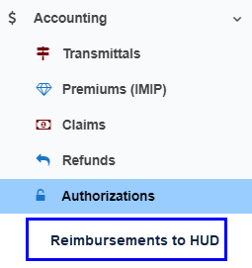
- Reimbursement Search fields:
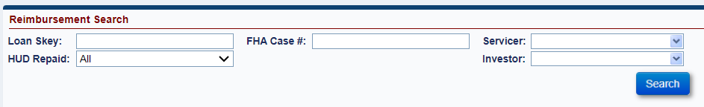
- Reimbursement Search Results columns:
- Loan Skey
- FHA Case #
- Borrower Name
- Disbursement Type
- Transactions Date
- Transaction Description
- Disbursement Amount
- Interest Amount
- Total Amount
- Servicer Name
- Servicer Mortgagee ID
- Investor Name
- Investor Mortgagee ID
- Batch Number
- Batch Status
- HUD Repaid Status
- Settled Date
- HUD Borrower Disbursements that are eligible to be Reimbursed to HUD will be displayed in the Reimbursements to HUD page. A Disbursement can only be Reimbursed to HUD once, and the total Reimbursement amount will include the Principal amount plus owed Interest calculated by the system. To be available for Reimbursement, the HUD Borrower Disbursement transaction must be displayed on the Loan > Transactions > Loan page with a Disbursement Status of “Disbursed” and the Disbursement must not be Voided.

- To search for all Disbursements under a specific Servicer that are eligible to be Reimbursed to HUD: go to Accounting > Reimbursements to HUD. Filter by field “HUD Repaid” status of Not Authorized, then click Search. This field also corresponds to the column in the Reimbursement Search Results grid “HUD Repaid Status”. To view, scroll to the right of the results.
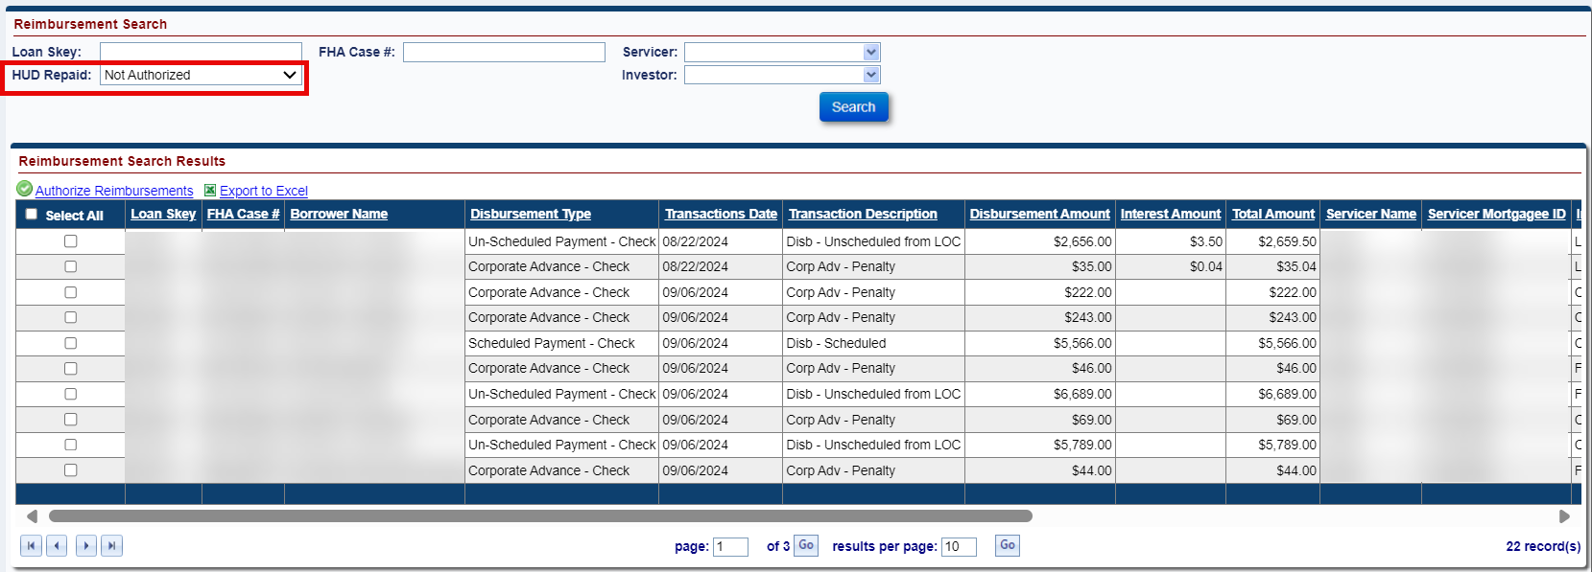
“HUD Repaid Status”
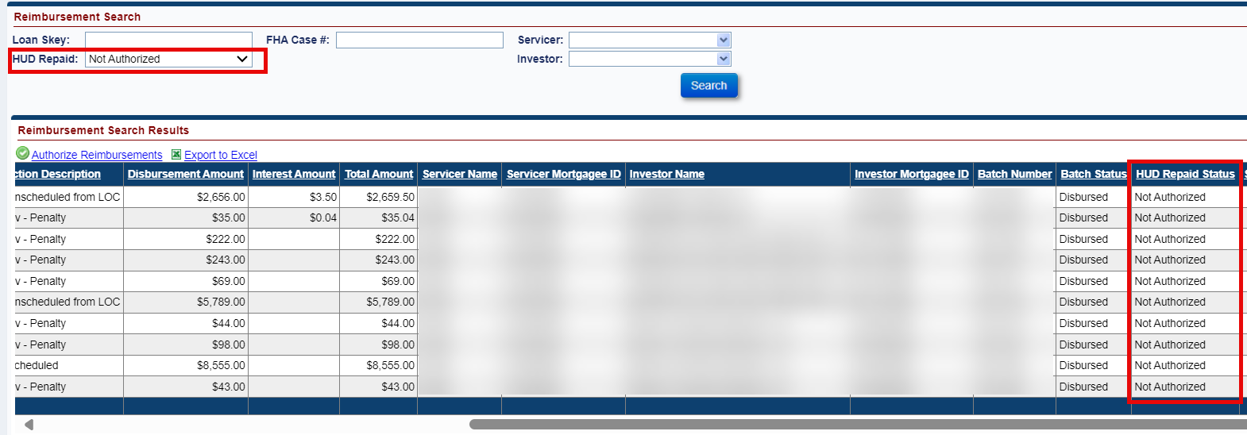
- A checkbox is displayed on each row under heading Authorize Reimbursements. The user may Select All records on the page by clicking the Select All checkbox at the top of the column, or may select certain records by clicking the box for specific rows. After choosing which Disbursements to Reimburse, click Authorize Reimbursements
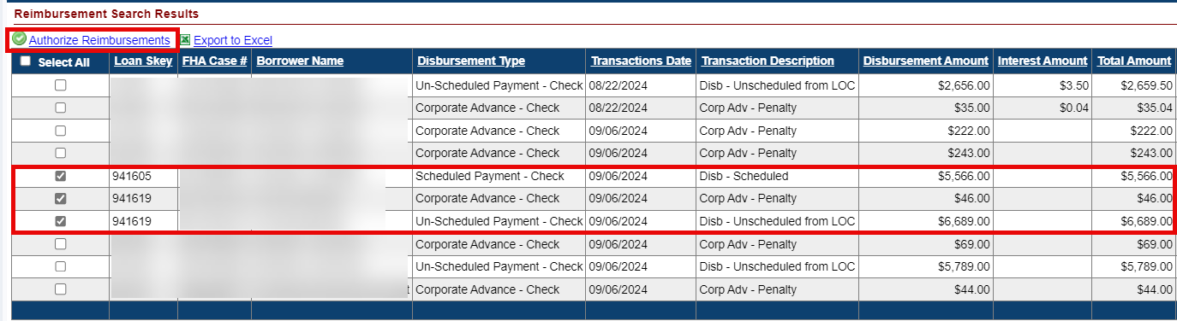

- The Authorization Information window will be displayed with FHA Case #, Authorization Type Reimburse HUD, Reimbursement Amount, Interest Amount, and Total Amount. The FHA Case # is only displayed if one row is selected, for multiple rows it will state “Multiple Case Numbers.” The Reimbursement Amount is the total of the selected HUD Borrower Disbursements. The Interest Amount is the total Interest owed on the selected HUD Borrower Disbursements. The Total Amount is the sum of the Reimbursement Amount plus the Interest Amount and is the final amount that will be paid to HUD for this Reimbursement action.
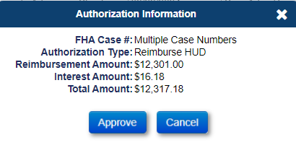
After clicking Approve, a window is displayed to confirm the collection. Click YES to proceed, or NO to cancel.
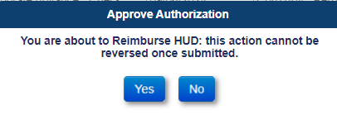

- After clicking YES, a window is displayed stating “Reimbursements processed successfully”: click OK.
- The collection is sent to the Accounting Module in the nightly process, similar to how the repayment of a HUD Advance occurs. The authorized records will be updated with the following:
- The checkbox next to the Authorized row will no longer be displayed
- “HUD Repaid” Status will be updated from Not Authorized to Authorized not Settled
- Interest Amount in the Reimbursement Search Results will be populated with total calculated interest as of the date the Reimbursement to HUD was Authorized.
- Total Amount in the Reimbursement Search Results will be populated with the final total of Disbursement Amount plus Interest Amount
- Accounting > Transmittals Batch Type “Claims Receivable-HUD Borrower Disb” will be created
- Loan > Transactions > Claims transactions will be created that correspond to the Reimbursement
Accounting > Reimbursements to HUD example:
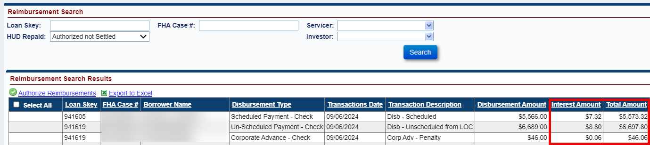
Accounting > Transmittals after the collection batch is created:
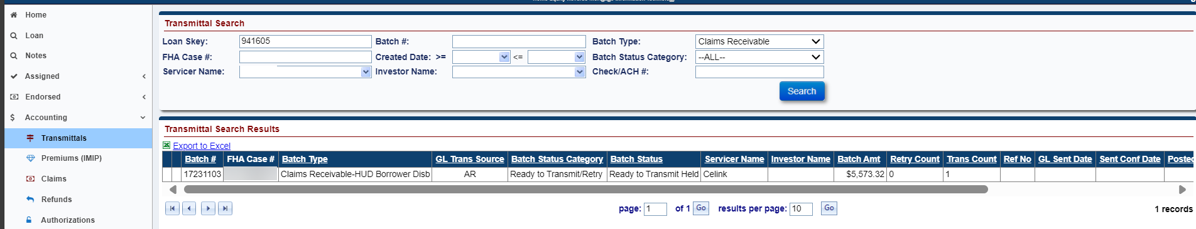
Loan > Transactions > Claims after the Reimbursement to HUD is Authorized:
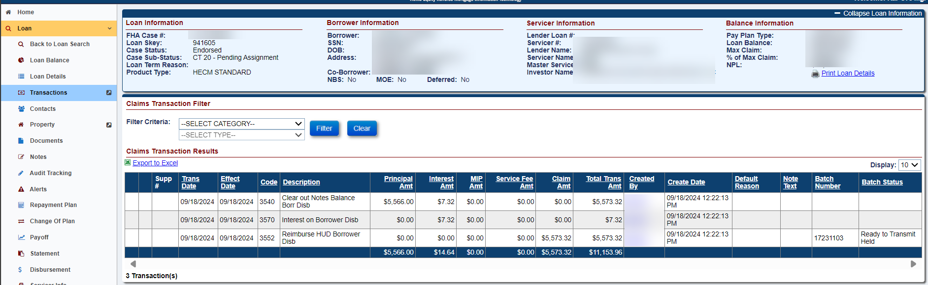

- Interest owed to HUD for HUD Borrower Disbursements. Interest shall begin accruing on the HUD Borrower Disbursement transaction’s Effective Date and go through the Reimbursement to HUD date / the date HUD is reimbursed for the HUD Borrower Disbursement.
The rate used to calculate Interest on HUD Borrower Disbursements is obtained from the following location: https://www.hud.gov/program_offices/housing/comp/premiums/sfhcvfr. The current rate is 4%.
- Terminations: A loan cannot be Terminated if the loan has a HUD Borrower Disbursement that has not been Reimbursed to HUD. An error message will be displayed stating the following “Loan Cannot be terminated because a HUD Borrower Disbursement exists on the loan which has not been Reimbursed.” After the Reimbursement to HUD is successful, the Termination can be posted.
- Claims Impacts: A Claim Type 20 – Demand Assignment may be filed if there is an unreimbursed HUD Borrower Disbursement on the loan. However, the system will prevent Claim Types 21, 23, and 24 Supplemental if the loan has a HUD Borrower Disbursement that has not been Reimbursed to HUD. After the Reimbursement to HUD is successful, the Claim can be filed.

Update to Preservation & Protection Transaction Excluded from Max options (592061)
When creating a new Corp Advance – Property Preservation transaction in the User Interface (UI) from Loan > Transactions > Loan, the options available to report an Excluded from Max transaction were updated.
- If “Excluded from Max” box is selected, one of the following Max Exclusion Types must be selected to add the transaction:
- Boarding
- Debris Removal
- Demolition
- Grass Cut
- Property Inspection
- Securing – Swimming Pool
- Sump Pump
- Utility Costs (existing)
- Vacant Property Registration (existing)
If none are selected, a popup modal will display error stating “Max Exclusion Type is required.” If none of the above available options describes the condition for the transaction, the “Excluded from Max” exception is not applicable and should not be selected.
- When the box “Excluded from Max” is selected, the following message is displayed at the bottom of the New Preservation & Protection Transaction window: “By checking Excluded from Max you are confirming the amount represents the actual cost and is supported by documentation in the claim package. HUD Approval may still be required if the amount exceeds the Single Line Item allowable as designated by HUD.”
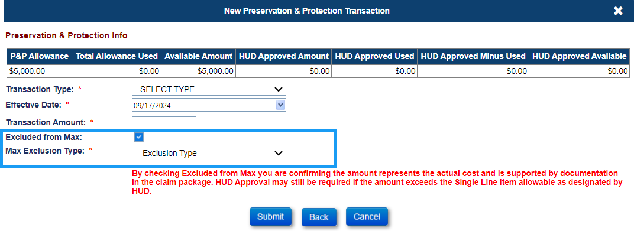
Available Max Exclusion Types:
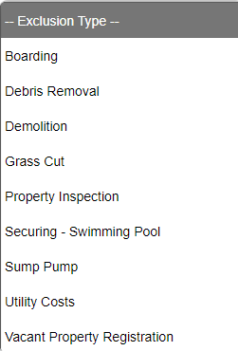
- Transactions > Loan Search Results: The prior columns “Utility Costs” and “Vacant Prop Reg” were removed and new column “Excluded from Max Type” was added to the Search Results grid and Export Transactions. For Excluded from Max transactions, the Excluded from Max Type is populated with the selection made during transaction entry.
Search Results grid columns example:
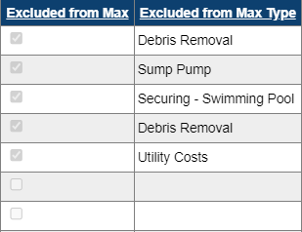
Export Transaction columns example:
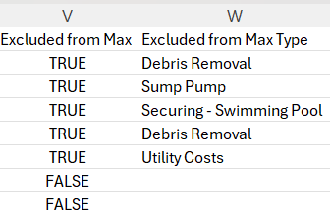
- Upon entry of a transaction with Excluded from Max selected, the following message is displayed. If HUD Approval is required for any reason, including that the transaction exceeds the Single Line Item allowable as designated by HUD; click Cancel and use the alternate process of requesting HUD approval on the P&P transaction instead of using Exclude from Max.
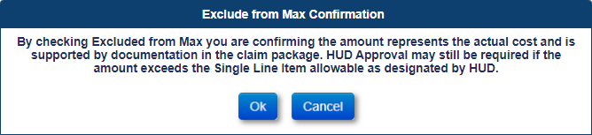
- Transactions previously entered as Utility Costs or Vacant Property Reg were updated to the new format.

Over Claims: New Reason Codes & Over Claims to apply toward Claim Capping for Maximum Claim Amount and Statutory Maximum Claim Amount (591144)
New Over Claim Reason Codes were added to the system and updates were made to the process of capping a claim at Maximum Claim Amount (MCA) and Statutory MCA to account for Over Claims transactions. Over Claim Amounts that are not excluded from the calculation will affect the Total Claim Amount payable on the Claim Type 24. See below for additional details.

- New Over Claims Reason Codes were added to New Over Claim Transaction for all Claim Types, available in Loan > Transactions > Claims:
- Part D/Block 305 - Cash for Keys
- Part D/Block 305 - Mortgagee Incentive
- Part D/Block 305 - Probate Cost

- MCA Cap for Final Rule loans with FHA Case # Assigned Date on or after 09/19/2017
  - Exclude the following Over Claim Transaction Reason Codes from the MCA cap since these transactions are permitted to be paid in excess of the loan’s MCA.
    - Part D/Block 305 - Cash for Keys
    - Part D/Block 305 - Mortgagee Incentive
    - Part D/Block 305 - Probate Cost
  - All remaining Over Claims reason codes will be considered in the MCA cap.

- MCA Cap for Non Final Rule loans with FHA Case # Assigned Date Before 09/19/2017
  - Exclude the following Over Claim Transaction Reason Codes from the MCA cap since these transactions are permitted to be paid in excess of the loan’s MCA.
    - Debenture Interest Back to HUD
    - Part D/Block 305 - Cash for Keys
    - Part D/Block 305 - Mortgagee Incentive
    - Part D/Block 305 - Probate Cost
  - All remaining Over Claims reason codes will be considered in the MCA cap.

- Statutory MCA Cap for all FHA Case # Assigned Dates. The total of all claims on a loan will continue to cap at the loan’s Statutory MCA.

Reports: Allow Servicers to retrieve Assignment Claim paid data on Claims Detail Report (560286)
Servicers may now view Assignment Claim details on the Servicer Reports > Daily Reports > Claim Detail Report after an Assignment claim is paid for CT 22 – Assignment or CT 20 – Demand Assignment. Previously, when the servicer changed from the assigning servicer to HUD’s contractor, the prior servicer was not able to view Claim Data for these loans.
- In the report results the “Servicer Name” column was renamed to “Current Servicer Name” and “Investor Name” column was renamed to “Current Investor Name”.
- In the report results two new columns were added to the Claim Detail Report: “Prior Servicer Name” located after “Current Servicer Name” and “Prior Investor Name” located after “Current Investor Name”.
- The search logic on field “Servicer Name” has been modified when the Current Servicer is the HUD Contractor the Report will include both Prior Servicer and Prior Investor.
- Note has been added to the bottom of the Claims Detail report search page stating “The Servicer Name will return the Current Servicer or Prior Servicer if the Current Servicer = Compu-Link Corporation.”

Timeline: Inactivate CT 22 Timeline when Repayment is made that Reduces Loan Balance Below 97% MCA (590504)
When there is a “Repayment/Adjustment” applied to the loan balance that reduces the outstanding balance below 97% MCA, the CT-22 Timeline will be inactivated. This only applies when the “MOE Assignment” box is unchecked on the Servicing Mgmt screen on the CT22 timeline.

Loan: Monthly Statements on Repurchases for Servicer Access (581366)
Servicers may access Monthly Statements on loans that were previously assigned after the loan has been Repurchased. The Servicers now will have access to the Loan > Statement tab and can view/print Monthly Statements during the Reporting Periods HUD was servicing the loan upon completion of an Assignment Repurchase and transfer of the loan back to the assigning mortgagee.

Loan: Update to Endorsed Scheduled Payments (589116)
The system’s Month End process will no longer add borrower Scheduled Payment (Disb – Scheduled) transactions to the loan balance on Endorsed Loans. Servicers will now be required to manually add borrower Scheduled Payments to the loan balance in HERMIT.
- The Servicer will need to manually add the “Disb – Scheduled” Transaction through either the Transaction > Loan page, Batch > Servicer Transaction page, or Batch > Servicer File Upload page using the Transaction link (B2G) to record the monthly scheduled payments as the system will no longer add the “Disb – Scheduled” Transaction.
- The # of Remaining Payments on the Loan Balance page will update according to the Effective Date of the “Disb Scheduled” Transaction and the Effective Date of the Current Active Payment Plan.
- If the Servicer inputs an Effective Date for the “Disb – Scheduled” Transaction On or After the Effective Date of the Current Active Payment Plan then the system will update the # of Remaining Payments and the # of Remaining Payments will decrease by one number.
- If the Servicer inputs an Effective Date for the “Disb – Scheduled” Transaction Before the Effective Date of the Current Active Payment Plan, then the system will not update the # of Remaining Payments and the # of Remaining Payments will remain the same.
- If the Servicer adjusts off a Scheduled Payment (Disb – Scheduled Adj) and the Effective Date for the “Disb – Scheduled Adj” Transaction is On or After the Current Active Payment Plans Effective Date, then the system will update the # of Remaining Payments to increase by one number.
- If the Servicer adjusts off a Scheduled Payment (Disb – Scheduled Adj) and the Effective Date for the “Disb – Scheduled Adj” Transaction is Before the Current Active Payment Plans Effective Date, then the system will not update the # of Remaining Payments and the # of Remaining Payments will remain the same.
- The Servicer will be allowed to report more Scheduled Payments than the total number of Term Payments in the Current Payment Plan.
- If the Servicer adds a “Disb – Scheduled” Transaction with an Effective Date On or After the Current Active Payment Plan’s Effective Date and the # of Remaining Payments is zero, then the system will allow the # of Remaining Payments to go negative.
  - Example: The # of Remaining Payment is zero. The user enters an “Disb – Scheduled” Transaction with an Effective Date On or After the Current Active Payment Plan’s Effective Date then the system will update the # of Remaining Payments to be -1.
- If the Servicer adds a “Disb – Scheduled” Transaction with an Effective Date Before the Current Active Payment Plan’s Effective Date and the # of Remaining Payments is zero, then the # of Remaining Payments will remain the same.

NSC / HUD Related Changes

Loan: "Statutory MCA" Field on the Loan Details Screen is editable for the HUD NSC Manager (590946)
The “Statutory MCA” field on the Loan Details page will only be editable for the Role “HUD NSC Manager.”

Accounting: Updated the TCIS File to display Stop Codes. Updated the Disbursement Screen to display Stop Code dropdown and updated values on the Void Reason dropdown (587386)
The Accounting Disbursement Screen has been updated to display a Stop Code dropdown and the Void Reason dropdown has been updated for certain Check Status criteria. A new value has been added to the Check Status dropdown. Treasury will send the TCIS file to Accounting with the Stop Code when a Check is voided through Treasury.
- The Incoming Interface TCIS File will now contain the Stop Code from Treasury when a Check is Voided through Treasury for Void Type of Unavailable Check Cancelled (“U”).
- Users will now be able to search by Stop Code on the Accounting > Disbursement Screen. The Stop Code dropdown will display select values when the Check Status “Unavailable Check Cancelled (due to claim)” is selected in the Check Status dropdown.
- The Stop Code reason will display the following values when “Unavailable Check Cancelled (due to claim)” is selected for the Check Status field.
- Entitlement – Recertified before status
- Entitlement – Recertified after status
- Nonentitlement – Deceased
- Nonentitlement
- Entitlement – Lost/Stolen After Endorsement
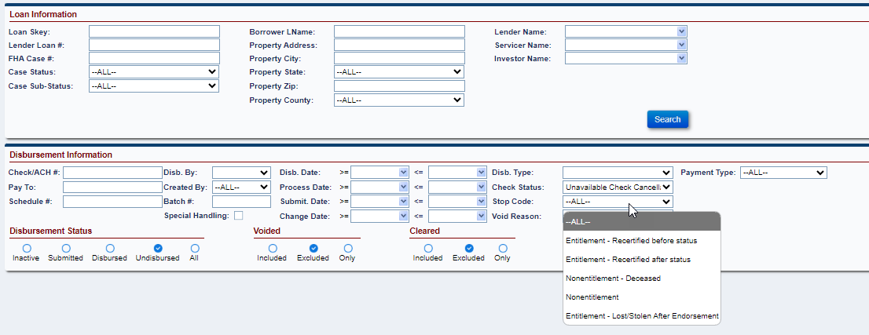
- The Check Status dropdown has been updated to include the value “ACH Cancellation from Treasury.”
- When “ACH Cancellation from Treasury” is selected in the Check Status dropdown, the following Void Reason will be displayed:
- Issue with Account (Closed, Invalid, Frozen, or Cannot Find)
- Beneficiary Deceased
- Misc Returned
- PAM Invalid
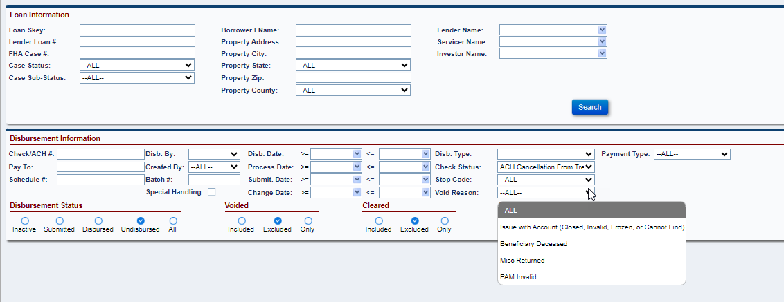
- The Void Reason dropdown has been updated with new values when the Check Status “Unavailable Check Cancelled (due to claim)” is selected and the old values are now displayed as the Stop Codes. The Void Reason dropdown will not be populated with the new values till the user selects a Stop Code from the dropdown.
- When “Unavailable Check Cancelled (due to claim)” is selected in the Check Status dropdown, the following new Void Reason will be displayed:
- UCC
- Address
- Beneficiary Deceased
- Agency Requested Cancel
- Misc
- Offset
- LPC
- PAM Invalid
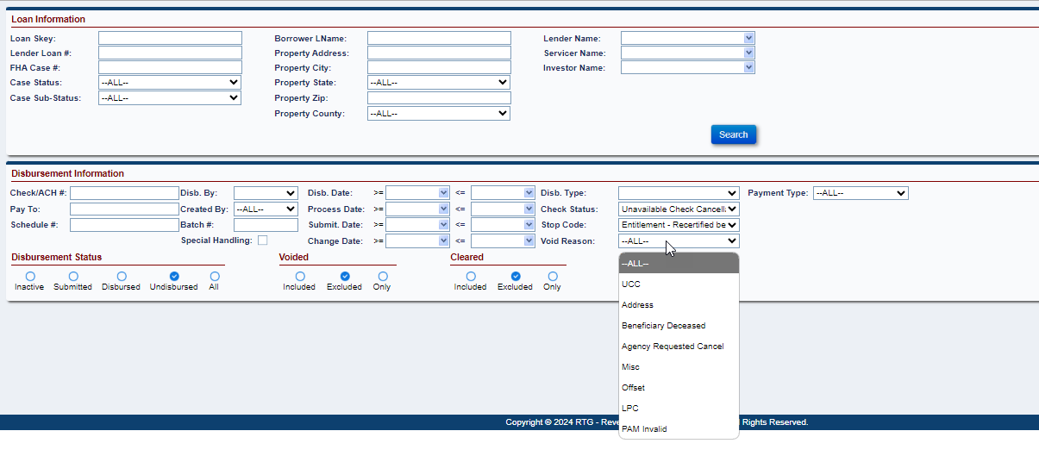
- The Void Reason dropdown has been updated with new values and some old values have been removed when the Check Status “ACH/Check Cancellation By User” is selected.
- When “ACH/Check Cancellation By User” is selected in the Check Status dropdown, the following values for Void Reason will be displayed:
- Issue with Account (Closed, Invalid, Frozen, or Cannot Find)
- Beneficiary Deceased
- Agency Hold/ Agency Req
- Misc Returned
- Checks with Corresp
- The following old values have been removed from the Void Reason drop for the Check Status “ACH/Check Cancellation By User”:
- Incorrect Account/Routing Information
- Deceased
- Miscellaneous/Other
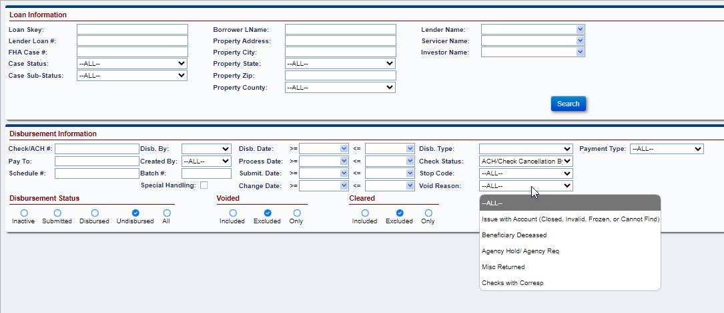

Loan: System will Inform Users when LESA Funds are available when Disbursing Property Charges (590361)
When a user tries to create a Property Charge Disbursement when LESA Funds are available the system will display a pop-up message informing the user there are available funds in the LESA Balance. The user will then be able to choose to create a LESA Disbursement instead of a Property Charge Disbursement.
  - The following pop-up message will display when certain Unscheduled from LOC Disbursements are created, and the LESA Balance is greater than $0.00.
  - Message: “The Property Charge Disbursement selected is eligible to be disbursed from the available Life Expectancy Set Aside (LESA) balance. Click "Ok" to process this transaction or Cancel and create a new Disbursement Transaction.”
  - The pop-up message will only display when the LESA Balance on the Loan Balance page is greater than $0.00, and the user creates one of the following Unscheduled from LOC Disbursements on the Loan > Disbursement page:
  - Disb – Property Charge – Flood Ins
  - Disb – Unscheduled from LOC Taxes
  - Disb – Unscheduled from LOC Insurance
  - When there are not enough available funds in the LESA Balance for the entered Disbursement Amount, the user should create two different disbursements. One Disbursement should be for the remaining LESA Amount and the other Disbursement should be the difference needed to equal the Total Disbursement Amount.
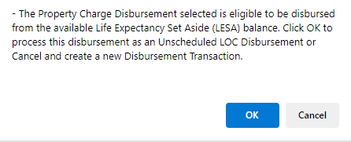

Timeline: Updates made on the Assigned - Foreclosure & Assigned - Loss-Mit/Pre FCL-Timelines (588593 & 591830)
Changes have been made to the Assigned > Disposition > Loss Mitigation – Pre-Foreclosure Timeline to no longer include the Foreclosure Attorney field. Changes have been made to the Assigned > Foreclosure Timeline to have the Foreclosure Attorney pull from a new Step within the Timeline.
  - The Field Foreclosure Attorney field has been removed from the following areas on the Assigned > Loss Mitigation Pre-Foreclosure Timeline:
- The field Foreclosure Attorney will no longer display on the New Step window for the Step “HUD Approval/Attorney Assignment”
- The field Foreclosure Attorney will no longer display on the Servicing Mgmt page under the Servicing Management Information
- The field Foreclosure Attorney will no longer be displayed in the Edit Servicing Management window.
  - A new HUD Contractor Template Step “Attorney Assignment” has been added to the Assigned > Foreclosure Timeline.
- The user will need select an Attorney from the required Foreclosure Attorney dropdown on Edit window for the Step “Attorney Assignment” before the Step is Completed.
- If the user tries to Complete the Step “Attorney Assignment” without an Attorney listed in the Foreclosure Attorney field, then an Error message will display stating “Foreclosure Attorney is required to complete this step.”
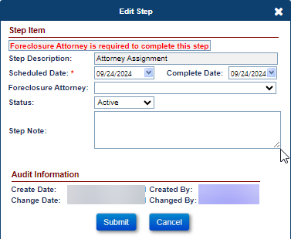
- The user will be able to select an Attorney on the Foreclosure Attorney field on the Edit window for the Step “Attorney Assignment” without having to Complete the step.
- The field Foreclosure Attorney will be an editable field on both the Edit Step window for the Step “Attorney Assignment” and on the Servicing Mgmt page in the Timeline.
- If the user selects an Attorney from the Foreclosure Attorney field on the Servicing Mgmt page, then the selected Attorney will flow over to the Foreclosure Attorney field on the Edit Step window for the Step “Attorney Assignment.”
- If the user selects an Attorney from the Foreclosure Attorney field on the Edit Step window for the Step “Attorney Assignment,” then the selected Attorney will flow over to the Foreclosure Attorney field on the
Servicing Mgmt page.
  - Updates have been made to viewing and printing of the Step “Loan referred to Commissioner.” If there is no Attorney listed in the Foreclosure Attorney field, then the user will not be able to view or print the letter on the Step “Loan referred to Commissioner.”
- When the field Foreclosure Attorney is blank on either the Servicing Mgmt page or the Edit Step window for the Step “Assignment Attorney” and the user tries to click the magnifying glass or printer icon on the Step “Loan referred to Commissioner” the system will display an Error Message.
- Error message will state “Foreclosure Attorney is required to print the letter.”
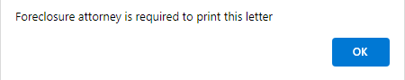
  - Existing Functionality remains for the system to automatically setup the Assigned > Foreclosure Timeline when the Step “Transfer to Foreclosure Department” is completed on the Assigned > Disposition > Loss Mitigation – Pre-Foreclosure Timeline.
  - Existing Functionality remains for the user to be able to setup the Assigned > Foreclosure Timeline manually.
- The field Foreclosure Attorney remains on the Servicing Management window when the user manually setups and the user can still select the Attorney on the Foreclosure Attorney dropdown menu.
- The field Foreclosure Attorney is not required when setting up the timeline.
- If the user selects an Attorney on the Foreclosure Attorney field on the Servicing Management window when setting up the timeline, the selected Attorney will populate in the Foreclosure Attorney field on the Edit Step window for the new Step “Attorney Assignment.”

Timeline: Bankruptcy Form B10 – Require fields State Filed and Bankruptcy District (539349)
When an Assigned > Bankruptcy > Chapter 13 or Assigned > Bankruptcy > Chapter 7 timeline is created or edited, the fields “State Filed” and “Bankruptcy District” will now be required fields and designated with a red asterisk. They will populate on the Bankruptcy Form B10 per existing functionality.
- If the User tries to create or Edit an Assigned > Bankruptcy > Chapter 13 or Assigned – Bankruptcy > Chapter 7 timeline without entering data in the field “State Filed” on the Servicing Management window, they will receive an error message.
- The error message will state “Please select the State Filed to be applied to the timeline.”
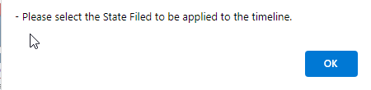
- If the User tries to create or edit an Assigned > Bankruptcy > Chapter 13 or Assigned > Bankruptcy > Chapter 7 timeline without entering data in the field “Bankruptcy District” on the Servicing Management window, they will receive an error message
- The error message will state “Please select the Bankruptcy District to be applied to the timeline.”
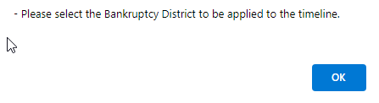

Timeline: Replace Bar Codes on Letters & Forms with the FHA Case Number (590651)
The Loan Skey in the lower right corner of letters and forms have been replaced with the FHA Case #. Also, all Bar Codes in the lower right corner of letters and forms have been removed.

Report: Add 7 Fields to the Loan Principal Limit Detail Report (591187)
The following seven new Fields were added to the Excel and CSV output of the Assigned Notes Reports > Daily Reports > “Loan Principal Limit Detail Report”:
- Property State
- Loss Draft Balance
- Hardest Hit Funds
- Property Charges
- Termination Date
- Custodial Care Date
- Vacancy Date

Loan: Add the Payee Address to the New Disbursement modal once a Payee is selected (592325)
A new read-only field called “Payee Address” has been added to the New Disbursement window and will display the Address for the chosen Payee.
  - The read-only field “Payee Address” will appear once a user selects a Payee from the Payee dropdown menu on the New Disbursement window.
  - The Payee Address field will display the chosen Payee’s Address 1, Address 2, City, State, and Zip.
  - The Payee Address field will update if a different Payee is selected from the Payee dropdown menu. The Payee Address will always correspond with the chosen Payee selected.
Note: The user will be able to see the whole address by hovering their cursor over the Payee Address field.
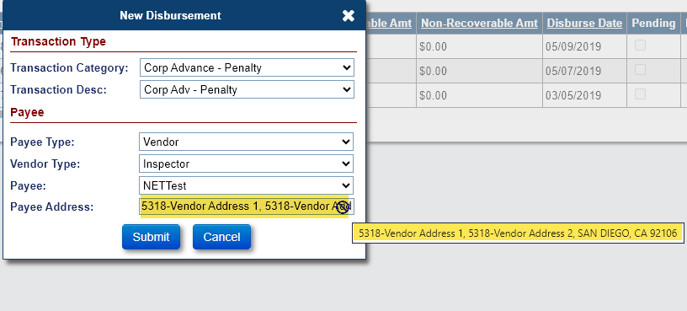

Timeline: Updates to the Decision Letter on the Endorsed > Due & Payable w/HUD Approval Timeline (590141)
Upon completion of HUD Contractor Step “Pending Additional Information from Servicer” or “HUD Decision – Pending Additional Information” from the Endorsed > Request > Due & Payable w/ HUD Approval timeline, the Step Note from the latest completion date for each step will now be displayed in the body of the Due & Payable Decision Letter that is imaged in Loan Documents.

Loan: Update the Pay To field when selecting County Clerk for Disbursements (590485)
The “Pay To” field in the Disbursement modal will now pre-populate the text from the “Pay to Name” field in the Admin > County Clerks page when a user selects “County Clerk” as a Payee when creating a new Disbursement. Prior to this enhancement, the “Pay To” field in the Disbursement modal would pre-populate with the text from the “County Clerk Name” field in the Admin > County Clerks page.

Loan: New “Disb – Unscheduled from LOC Title Report Fee” Transaction (590323)
A new Disbursement Transaction called “Disb – Unscheduled from LOC Title Report Fee” will be available for Loans assigned into HUD’s portfolio. The new Disbursement Transaction will be available through the New Disbursement window on the Loan > Disbursement page.
- The following below will show in the New Disbursement window:
- The Transaction Category will be “Disb – Unscheduled from LOC”
- The Transaction Description will be “Disb – Unscheduled from LOC Title Report Fee”
- The Payee Type will default to “Vendor”
- The “Disb – Unscheduled from LOC Title Report Fee” will have a corresponding Adjustment Transaction code if the disbursement is voided.

Loan: New “Disb – Unscheduled from LOC Utilities” Transaction (589575)
A new Disbursement Transaction called “Disb – Unscheduled from LOC Utilities” will be available for Loan assigned into in HUD’s portfolio. The new Disbursement Transaction will be available through the New Disbursement window on the Loan > Disbursement page.
- The following below will show in the New Disbursement window:
- The Transaction Category will be “Disb – Unscheduled from LOC”
- The Transaction Description will be “Disb – Unscheduled from LOC Utilities”
- The Payee Type will default to “Vendor”
- The “Disb – Unscheduled from LOC Utilities” will have a corresponding Adjustment Transaction code if the disbursement is voided.

Batch: NSC Bulk Servicing Steps New page (578293)
The NSC Bulk Servicing Steps page was added to HERMIT under the Batch Screen. Only Authorized users will be able to use and view this page. This page allows the user to add the HUD Contractor Step “Assignment of Mortgage (AOM) Rejected” to multiple loans for either an Endorsed > Claim Type 20 – Demand Assignment timeline or an Endorsed > Claim Type 22 – Assignment timeline in lieu of having to manually add the step in each timeline.
- The NSC Bulk Servicing Steps page is available under Batch on the left menu for the following users:
- CLS – First Mortgage
- CLS – Supervisor/Management
- HUD Claims – Mgr I
- HUD Claims – Mgr II
- HUD NSC -Mgr
- HUD NSC - Staff
- The following fields are displayed on the page:
- FHA Case #
- Timeline Group
- Timeline Category
- Servicing Type
- Step Name
- Complete Date
- Step Note
- Validation
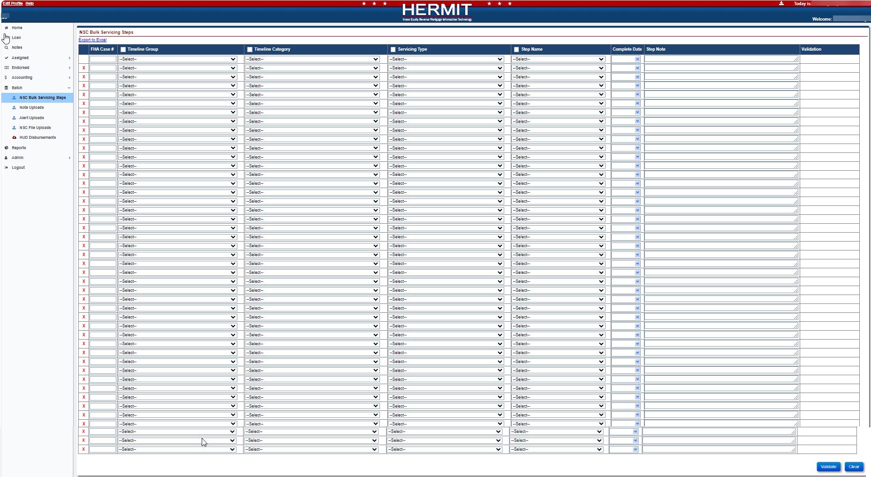
- The fields Timeline Group, Timeline Category, Servicing Type, and Step Name will have Checkbox which allows the user to copy the first row’s data for that column. Once the user clicks the checkbox on a column with the checkbox feature, the data from row one for that column will cascade down all 50 rows. Note: The Timeline Category is dependent on Timeline Group and the Servicing Type is dependent on Timeline Category and the Step Name is dependent on Servicing Type. The user will need to work left to right when entering data and using the checkbox features.
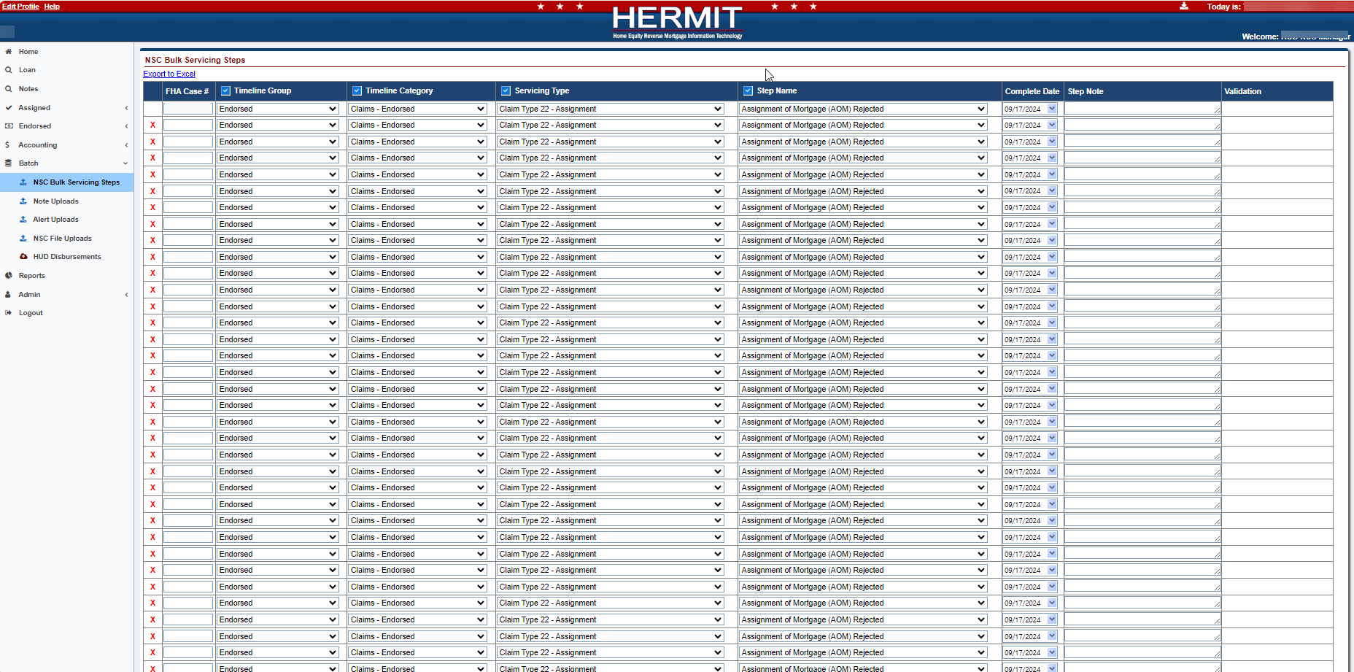
- The link Export to Excel will be displayed at the top left of the page and can be used at any time.
- The user will be able to delete a single row except for the first row by clicking the Red X next to the FHA Case #. The user will be able to Clear all data on the page by clicking the Clear button on the bottom right of the page.
- Once the user clicks the Validate Button on the bottom right of the page, the validation column will either display Pending, a Warning message, or an Error message.
- Pending indicates all the data entered for that row has passed validation.
- A Warning message will display to inform the user but does not prevent the user from submitting the data.
- An Error message will display when the user enters inaccurate data and does prevent the user from submitting the data.
- The user will only see the Submit Button on the bottom right of the page once all data has passed validation. If further changes are made after the validation process and before the user clicks submit, the submit button will disappear and the user will have to validate the data again.
- After the user clicks the Submit button the validation column will display Processed which indicates the Steps have been added to the Timeline. Only the Clear Button will appear on the bottom right of the page once all data has been processed.

Batch: NSC Bulk Disbursements New page (578293 & 589574)
The NSC Bulk Disbursements page was added to HERMIT under the Batch Screen. Only Authorized users will be able to use and view this page. This page allows the user to add “Disb – Unscheduled from LOC Utilities” and/or “Disb – Refunds/Payments Remittance Overage” disbursement transactions to multiple loans in one bulk submission in lieu of having to add them manually to each loan.
- The NSC Bulk Disbursement page is available under Batch on the left menu for the following user:
- HUD Contractor Cash
- The following fields are displayed on the page:
- FHA Case #
- Transaction Category
- Transaction Description
- Payee Type
- Vendor Type
- Payee
- Disb Amount
- Process Date
- Check Stub 1
- Check Stub 2
- Check Stub 3
- Invoice Date
- Invoice Number
- Disb Note
- Special Handling
- Validation
- The fields Transaction Category, Transaction Description, Payee Type, Vendor Type, Payee and Disb Amount will have a Checkbox which allows the user to copy the first row’s data for that column. Once the user clicks the checkbox on a column with the checkbox feature, the data from row one for that column will cascade down all 50 rows. Note: The Transaction Description is dependent on Transaction Category and the Payee Type is dependent on Transaction Description and the Vendor Type and/or Payee is dependent on Payee Type. The user will need to work left to right when entering data and using the checkbox features.
- The Checkbox will be Read Only for the fields Payee Type, Vendor Type, and Payee when the Payee Type is not Vendor.
- The link Export to Excel will be displayed at the top left of the page and can be used at any time.
- The user will be able to delete a single row except for the first row by clicking the Red X next to the FHA Case #. The user will be able to Clear all data on the page by clicking the Clear button on the bottom right of the page.
- Once the user clicks the Validate Button on the bottom right of the page, the validation column will either display Pending, a Warning message, or an Error message.
- Pending indicates all the data entered for that row has passed validation.
- A Warning message will display to inform the user but does not prevent the user from submitting the data.
- An Error message will display when the user enters inaccurate data and does prevent the user from submitting the data.
- The user will only see the Submit Button on the bottom right of the page once all data has passed validation. If further changes are made after the validation process and before the user clicks submit, the submit button will disappear and the user will have to validate the data again.
- After the user clicks the Submit button the validation column will display Processed which indicates the Disbursements have been added to the loan. Only the Clear Button will appear on the bottom right of the page once all data has been processed.

Servicer and NSC / HUD Related Changes:

Reports: Document Tracking (539465)
A new Report called “Document Tracking” was added to two locations in the Reports module: Assigned Notes Reports > Daily Reports for HUD and HUD Contractors and under Servicer Reports > Daily Reports for Servicers. This report includes all document types and dates uploaded into the system for tracking purposes.
HUD and HUD Contractor reports area:
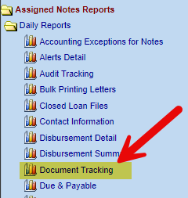
Servicer Reports area:
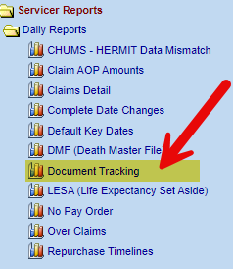
Document Tracking Report Search Criteria:
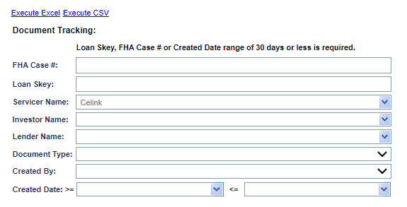

- Search Criteria includes:
- FHA Case #
- Loan Skey
- Servicer Name
- Investor Name
- Lender Name
- Document Type
- Created By
- Create Date (Date Range)

- The output will be in EXCEL and CSV format and have the following fields:
- Loan Skey
- FHA Case #
- Lender Name
- Servicer Name
- Investor Name
- Record Number
- Document Note
- Document Type
- File Name
- Created By
- Created Date

- HUD and HUD Contractors will be able to pull the document types for all loans in HERMIT and Servicer will only be able to view the document types for loans in their portfolio.

Loan: A Document Note will be added to the Documents page when Documents are Bulk Uploaded from the SFTP Site (588515)
A Document Note will automatically be added on the Loan > Documents screen, when uploading documents from the SFTP server folder. This applies to both Servicers and HUD’s portfolio.
- The Note will be the Receiving File in name and display in the following format:
- FHACASE#_DOCTYPESKEY_YYYYMMDDHHMMSS
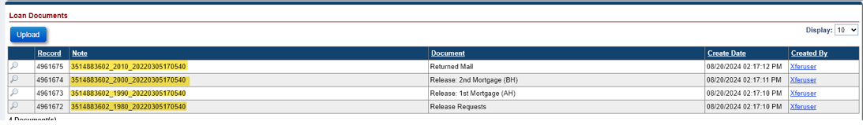

Timeline: New Steps Added to the Claim Type 20 and Claim Type 22 Timeline (578293)
Three New steps have been added to the Endorsed > Claim Type 20 – Demand Assignment Timeline and the Endorsed > Claim Type 22 – Assignment Timeline.
- Assignment of Mortgage (AOM) Rejected
- Corrected AOM has been submitted
- Contractor received AOM for review

- List of new Endorsed > Claim Type 20 – Demand Assignment Timeline and the Endorsed > Claim Type 22 – Assignment Timeline steps.
- The Servicing Type column indicates how the step is added to the timeline: “O” for Optional and “S” for Triggered.
Data Group | Step Description | Servicing Type | Trigger Step Description (if applicable)
HUD Contractor | Assignment of Mortgage (AOM) Rejected | O | N/A
Servicer | Corrected AOM has been submitted | S | Assignment of Mortgage (AOM) Rejected
HUD Contractor | Contractor received AOM for review | S | Corrected AOM has been submitted

- An Auto Note will be added automatically when either of the three new steps are completed.
- Message states “{Timeline Group: Endorsed or Assigned} – {Servicing Type}. {Step Name} was completed on MM/DD/YYYY by User ID. Step Note: (Text)*”

------ End of Document -----

