
United States Department of Housing and Urban Development

Home Equity Conversion Mortgage Business Service Provider (HECM BSP)

Process Document for Monthly MIP (MMIP) Approval

HERMIT Release 7.60

Document Version 1.0

March 23, 2024
At HUD’s request in Release 7.6 on March 23, 2024, HERMIT implemented a system enhancement for Monthly MIP (MMIP) batches to be grouped at the Servicer / Investor level, and to require MMIP batches to be Approved by the Servicer before MMIP is collected via Treasury. The grouping of MMIP batches by Servicer / Investor replaces the previous grouping of one MMIP batch per day per Servicer. The Approval of MMIP replaces the previous process of automatically attempting to collect any MMIP without the Servicer taking action to initiate the collection. These changes affect all MMIP on the loan including large batches generated after month end accruals are posted to the loan, and Daily MIP activity due to Payoffs, MIP adjustments, or other changes to loan data that affect a loan’s MIP accruals. As a result of these changes, multiple batches under the same Servicer could be created and therefore MIP approvals could be required every day.
Late fees and Penalty Interest will be charged on each batch when Approval of MIP is completed after the HUD established deadlines. There is no change to the established deadlines and calculations.
The processes outlined in this document do not impact Initial MIP collection.

MIP Batches by Investor:
The Monthly MIP Batches created after Release 7.6 are grouped by Servicer > Investor and each batch must be approved by the Servicer on the Accounting > Transmittals page in HERMIT. (See approving MIP Batches section). The batch will continue to be sent to Treasury on a regular basis after the MIP has been approved. The Servicer will be able to search by and sort by Investor Name under the Transmittal Search Results for batches created after Release 7.6. Batches prior to Release 7.6 will not have an Investor assigned to them in the Investor Name column.
There is no change to the current Investor transfer process. If an Investor is changed during the month through the HERMIT user interface or the B2G process where the change is immediate the Monthly MIP Accrual will be associated with the Investor the loan was changed to. If the Investor is changed through the B2G process and is scheduled for the next month the Monthly MIP will be associated with the Investor of record at the end of the month.
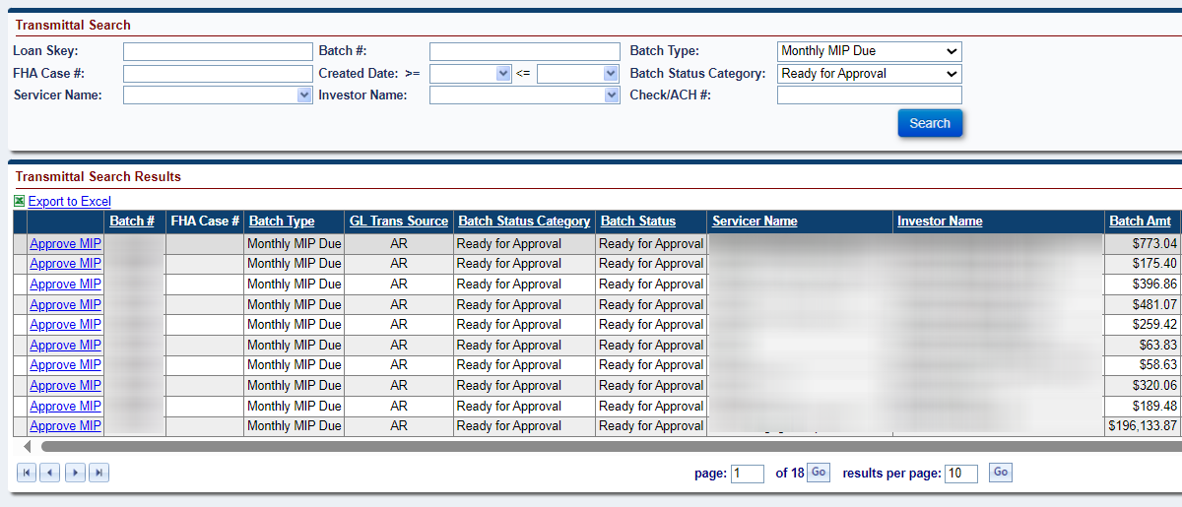

Approving MIP Batches:
The Approve MIP link is displayed on the Accounting > Transmittal screen on the left menu in HERMIT. This screen displays the MIP Batches that need Approval from a servicer. Each Investor’s Batch must be approved by the Servicer. Upon Approval, the Approve MIP link will no longer be displayed on the screen. Monthly MIP Batches will need to be Approved once generated in the Servicing Module. Daily MIP batches will need to be approved as needed based on a Servicer’s loan activity. There is no bulk approval capability. MMIP batches cannot be removed from an Investors batch once it is batched up on the Accounting Transmittal screen. Servicers will need to ensure the loans in their portfolio are assigned to the correct Investor prior to the transaction being created.

To Approve a MIP Batch:
- Enter the search criteria and click Search on the Transmittals screen to display the Approve MIP link(s).
- The search results matching the search criteria are displayed in the Search Results section.
Available search criteria are:
- Loan Skey
- FHA Case #
- Servicer Name
- Batch #
- Created Date
- Investor Name (User can filter by Investor Name to see the batches for a given Investor after Release 7.6)
- Batch Type
- Batch Status Category (User can filter by Ready for Approval to display Batches with Approve MIP link)
- Check/ACH #
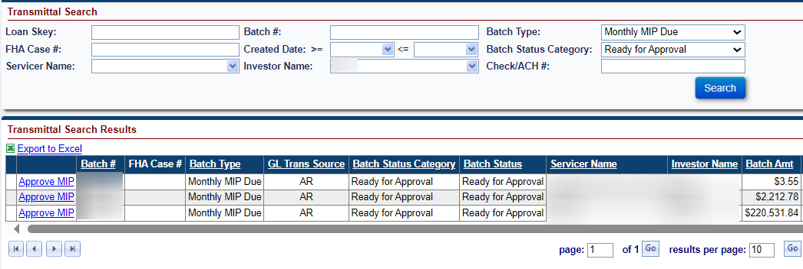
- Click Approve MIP link on the record in the search results. The Approve MIP window is displayed. (The Approve MIP window will display Penalty Interest and Late Charge when the servicer approves the MIP late if applicable)
- Click Submit on the Approve MIP window. To exit without approving click Cancel.
- Click OK on the pop-up message “Are you sure you want to approve this batch” to approve the batch. To exit without approving click Cancel.
- Once approved, the MIP Batch is released to the Accounting Module for payment collection. The updated batch status will be displayed in the Transmittals Search Results.
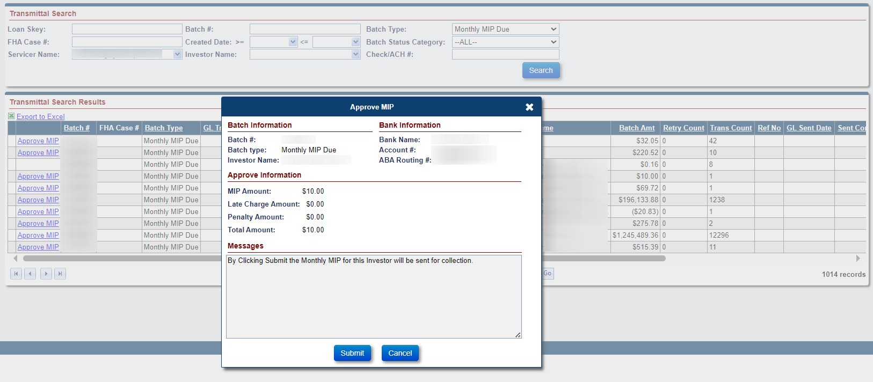

- Repeat previous steps for each Batch available for approval (with Approve MIP link).

Once the Servicer has approved the MIP Batch a note will be added to the MIP Batch record. The Note will read: “The Monthly MIP was Approved by User ID on MM/DD/YYYY in the amount of $xxxxxx.xx for the Investor (Investor Name).” The Servicer can view this note by clicking on the approved MIP Batch record under the Transmittal search results. Once the Batch Details window pops up click Batch Note on the left menu to see the added Batch Note.

