Home Equity Reverse Mortgage Information Technology
(HERMIT)

HERMIT System Changes – Release 7.20

Release Date: 03/25/23
Document Date: 03/25/23

March 2023

INTRODUCTION
The Home Equity Reverse Mortgage Information Technology (HERMIT) software release version 7.20 consists of the following system changes:
Table of Contents
Servicer Related Changes 3
1. Claim Type 23 Not Due & Payable – Restrict claim filing with certain Expenses (577449) 3
2. Corp Advance – Property Preservation Transaction: Modify Checkboxes (578116) 4
3. Preservation & Protection Transaction Servicer Remarks Box (583432) 5
4. Lender Link to Investor (537089) 6
Servicer / NSC Related Changes 7
5. System Use Notification window added to HERMIT (585055) 7
6. Update system to display Co-Borrower’s Middle Name under Borrower Information (547010) 7
7. Add Auto Note when Step Note is added for Steps on the Endorsed > Request for HUD Advance (Assignment) Timeline (583716) 8
8. Added New Steps to Endorsed – Partial Release Timeline (577203) 8
9. Report: Repurchase Timelines (575679) 9
10. Reports: Claims Detail (584951) 10
11. Reports: Audit Tracking (44644) 10
12. Reports: Audit Tracking – Non Loan (44644) 10
NSC / HUD Related Changes 11
13. Pending Loss Draft or Hardest Hit Fund Disbursements will not prevent Assigned Loans from being Terminated. (581232) 11
14. An Auto Note will be added for Part Repay Transaction, Termination Transaction, or Disbursement Transaction on Assigned Loans. (539478) 11
15. Updated the TCIS File to display Void Reason and Updated the Disbursement Screen to display Void Reason dropdown. (581597) 13
16. Add Change Date range to Accounting > Disbursement Search Criteria. (581792) 15
17. Add Note field to Accounting > Transmittals, Batch Details page for failed batches. (570448) 16
18. Reports: Indemnification Data (585014) 16

If you have any questions regarding the functionality of the software release, please contact the HERMIT Help Desk at 561-899-2610 or at servicingsupport@hermitsp.com. If you have any policy related questions, please send an email to HUD at answers@hud.gov.

Servicer Related Changes

Claim Type 23 Not Due & Payable – Restrict claim filing with certain Expenses (577449)
Claim Type 23 that are not Due & Payable (D&P); new claims hard stop validations have been put in place to prevent claim filing with ineligible Corporate Advance Expense Types populated on the claim.
- When the checkbox “Short Sale with no Due & Payable” is selected on the CT23 Claims Worksheet and the claim is not D&P, a hard stop validation will prohibit the claim from being filed if any of the following categories have an amount greater than zero:
Block | Part B Description
110 | Total Disbursements for Protection and Preservation (from line 264, Part C)
111 | Total Disbursements (from line 305, Part D)
112 | Attorney/Trustee Fees Paid (from line 306, Part D)
113 | Foreclosure, Acquisition, Conveyance, and Other Costs (from line 307, Part D)
114 | Bankruptcy Fee (if applicable) (from line 310, Part D)
117 | Total Taxes on Deed (from line 308, Part D)
120 | Special Assessments (Do Not Use for Coinsurance) (from line 309, Part D)
- The hard stop validation message will display “Short Sale with no D&P timeline only permits Closing Cost transactions, MIP, Rental Income, and Rental Expense. Please adjust necessary transactions accordingly.”
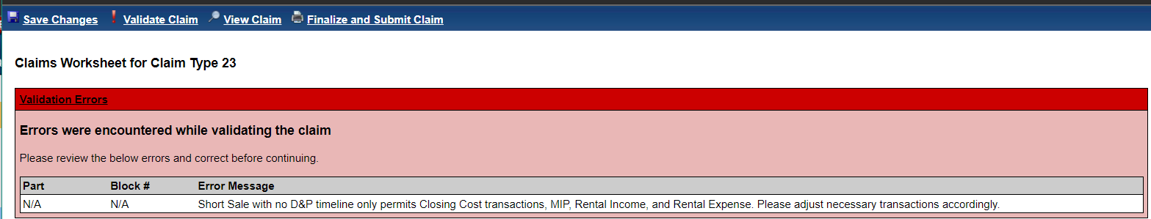
- To clear the hard stop claims validation message(s), adjust / reverse the transactions from the HERMIT Transactions > Loan page, then refresh the claim form and execute validation again. After all necessary transactions are removed, the claim will pass validation.
- Appraisal costs can be charged to the borrower by adding it to the UPB if Net Principal Limit is available on the loan.

Corp Advance – Property Preservation Transaction: Modify Checkboxes (578116)
When creating a new Corp Advance – Property Preservation transaction from the User Interface (UI), the checkbox options available for user selection have been brought into alignment with current HUD guidance.
- On the popup titled “New Preservation & Protection” Transaction when the user selects New transaction with Transaction Category “Corp Advance - Property Preservation”, one exception checkbox option will be available: “Excluded from Max”.
- When the box “Excluded from Max” is selected, one of the following must describe the cost and be selected in order to post the transaction:
- Utility Costs
- Vacant Property Registration
If none are selected, a popup modal will display error stating “Must select Utility Costs or Vacant Property Registration.” If neither of the above describes the condition for the transaction, the “Excluded from Max” exception is not applicable and should not be selected.
- When the box “Excluded from Max” is selected, the following message is displayed at the bottom of the popup window: “By checking the Excluded from Max checkbox you are confirming the amount represents the actual cost and is supported by documentation in the claim package.”
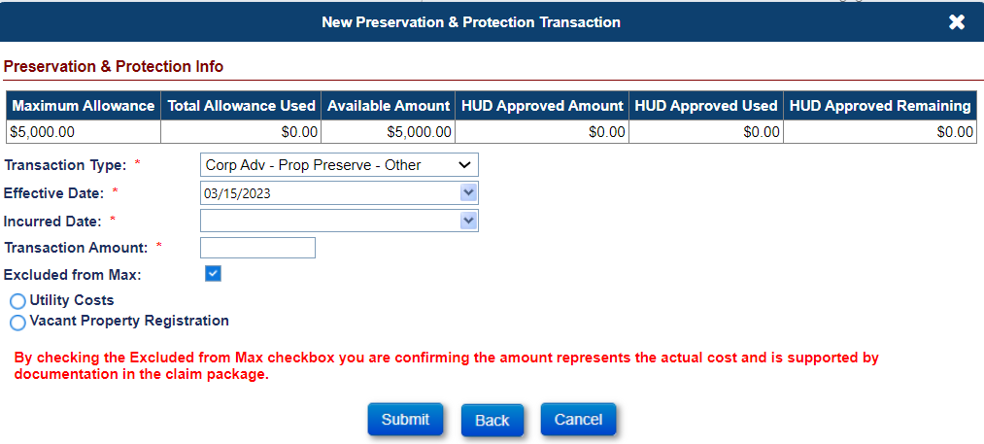
- Transactions > Loan search results: column name was updated from “Prev. Approved” to “Excluded from Max”, and 2 new columns were added to display the selection that was made on the transaction: “Utility Costs” and “Vacant Property Reg”.
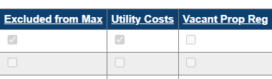
- Transactions > Loan link for Export Transactions: column name was updated from “Prev. Approved” to “Excluded from Max”, and 2 new columns were added to display the selection that was made on the transaction: “Utility Costs” and “Vacant Property Reg”.
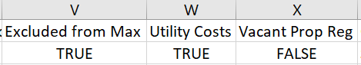

Preservation & Protection Transaction Servicer Remarks Box (583432)
On the Endorsed > Requests timeline “Preservation and Protection”, when entering a New request from the left menu Preserve & Protect tab: the Servicer Remarks box will accept copy and pasted text to be entered into the field. Certain characters will automatically be removed if pasted in the box: such as “<” and “>”.
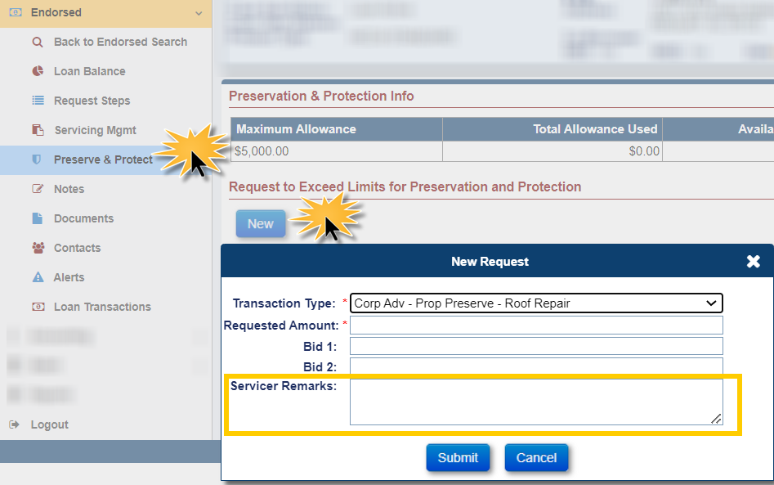

Lender Link to Investor (537089)
Servicer and Investor transfers done in the User Interface and B2G have been updated to allow the user to select any valid Mortgagee ID and no longer requires an existing linked Mortgagee ID combination.
On the Edit Servicer page, the Field Servicer Name will no Longer display a dropdown with only Servicer names. The User will be able to do an Open search for a Servicer either by the Name or Mortgagee ID #. (The user will be able to Transfer the loan to any servicer just like on the Loan Setup Screen).

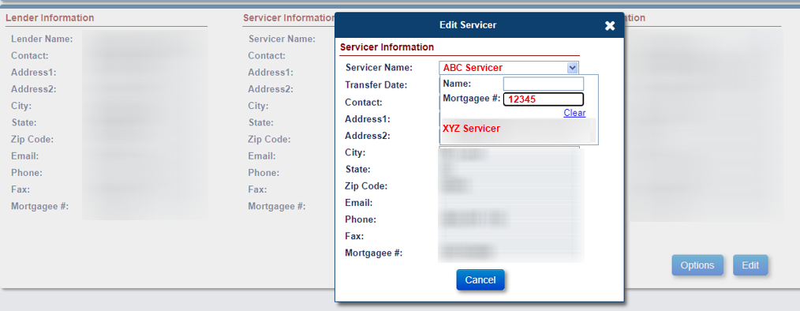
Once the User selects the Servicer to which they want to Transfer the Loan, they still need to select a Transfer Date before the Submit Button Appears.
After submitting successfully, the queued transfer will appear as usual on the Servicer Transfer Search page.

Servicer / NSC Related Changes

System Use Notification window added to HERMIT (585055)
The Legal Notice and Equal Housing Opportunity icon have been removed from the HERMIT Login Screen. New Legal Notice text will be displayed in the new System Use Notification popup window after the Multi-Factor Authentication code process has been completed.
- Once the Multi-Factor Authentication process has been completed, a popup window called System Use Notification will display the new Legal Notice text. Once you have read the text and click the OK button, the system will log you into HERMIT.
- On the System Use Notification window if you click Cancel, the system will not log you in and you will be brought back to the login page.
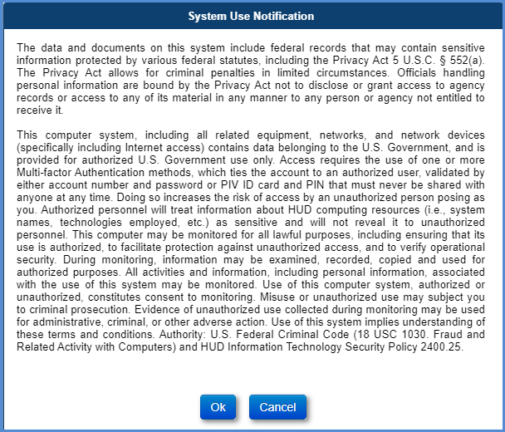

Update system to display Co-Borrower’s Middle Name under Borrower Information (547010)
The Co-Borrower’s Middle Name now appears in the Borrower Information area in HERMIT. Users without access to edit contacts can now view the co-borrower’s middle name in the Borrower Information area at the top of the loan.

Add Auto Note when Step Note is added for Steps on the Endorsed > Request for HUD Advance (Assignment) Timeline (583716)
When the user adds or revises a Step Note for a given Step, the Step Note will be automatically saved as an Auto Note on the Notes screen. When a Step Note is blank an Auto Note will not be added.
- Message: “Request for HUD Advance (Assignment) – {Step Description} – {Step Note Text}”
- Example: Request for HUD Advance (Assignment) – Unscheduled Request for Funds Received – pushes MCA > 100% - Step Note: Test

- The following Steps will automatically add an Auto Note when a Step Note is added:
- Unscheduled Request for Funds Received – pushes MCA > 100%
- Upload Request for HUD Advance package
- Request for HUD Advance Received from Servicer
- Request for HUD Advance Processed
- Assignment Denied/Payoff Issued
- Servicer Notified of Intent to Offset
- Advance Denied – No funds Issued

- The following Steps will automatically add a new Auto Note when a Step Note is revised:
- Unscheduled Request for Funds Received – pushes MCA > 100%
- Upload Request for HUD Advance package
- Request for HUD Advance Received from Servicer
- Request for HUD Advance Processed
- Servicer Authorizes Repayment of Claim
- Assignment Denied/Payoff Issued
- Servicer Notified of Intent to Offset

Added New Steps to Endorsed – Partial Release Timeline (577203)
Four new steps have been added to the Endorsed > Partial Release timeline.
- Partial Release Documents Executed
- Executed Documents sent to Servicer
- Sent for HOC Review (Optional)
- HOC Review Complete (Triggered when “Sent for HOC Review” is added)
These timeline steps will be available on all new Endorsed > Partial release timelines created going forward after Release 7.2 For Active timelines that were created prior to the release, the Template steps will be added to existing timelines.
- List of new Endorsed – Partial Release Timeline steps.
- Servicing Type column indicates how the step is added to the timeline: T for Template, O for Optional, and S for Triggered.
Data Group | Step Description | Servicing Type
HUD Contractor | Partial Release Document Executed | T
HUD | Sent for HOC Review | O
HUD | HOC Review Complete | S
HUD Contractor | Executed Documents sent to Servicer | T

- An Auto Note will be added automatically when the Step “Executed Documents sent to Servicer” is completed. Message states “Endorsed – Partial Release Timeline. Executed Documents sent to Servicer was completed on {Step Complete Date} by {User ID}. Step Note: {Text}”.

Report: Repurchase Timelines (575679)
A new report called Repurchase Timelines has been added to the HERMIT reports area under Servicer Reports/Daily Reports. The Report will generate data for Active Repurchase Timelines. The Prior Servicer linked to the Repurchase Timelines will only be able to generate the report when specific criteria are met.
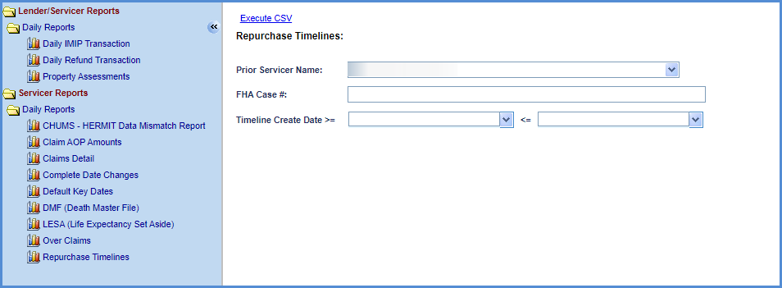
- Search Criteria includes:
- Prior Servicer Name (Auto populated for Servicer Roles): This is the servicer listed on the Servicing Management page of the Repurchase timeline
- FHA Case #
- Timeline Create Date Range
- Report output will be in CSV and have the following fields:
- Loan Skey
- FHA Case #
- Current Lender Name
- Current Servicer Name
- Current Investor Name
- Prior Lender
- Prior Servicer
- Prior Investor
- Case Status
- Case Sub-Status
- Status
- Repurchase Reason (Reason for Request from Servicing Mgmt Tab)
- HUD Comments
- Create Date
- Created By
- Last Complete Step
- Last Step Complete Date
- Approved Pre-Repurchase Date (HUD Decision – Approved Pre-Repurchase Complete Date)
- Approved Repurchase Date (HUD Decision – Approved Repurchase Complete Date)
- When HUD users run this Report, the Report will run wide open. No specific criteria are needed for HUD users.
- The Prior Servicer user will only be able to see this Report when the Repurchase Timeline has either the Step “HUD Decision – Approved Pre-Repurchase” completed and/or Step “HUD Decision – Approved Repurchase” completed, and the Step “Servicer Authorizes Repayment of Claim” is not completed. After “Servicer Authorizes Repayment of Claim” is completed, the loan is viewable in the servicer’s portfolio.
- Inactive Repurchase Timelines will not be displayed on the Report.

Reports: Claims Detail (584951)
For the Claims Detail report under Servicer Reports > Daily Reports, the date range has been increased to 2 years from 6 months.

Reports: Audit Tracking (44644)
For the Audit Tracking report under Assigned Notes Reports > Daily Reports, the maximum number of records permitted in the results has been increased to 300,000 from 10,000.

Reports: Audit Tracking – Non Loan (44644)
For the Audit Tracking – Non Loan report under HERMIT Support > Daily Reports, the maximum number of records permitted in the results has been increased to 300,000 from 10,000.

NSC / HUD Related Changes

Pending Loss Draft or Hardest Hit Fund Disbursements will not prevent Assigned Loans from being Terminated. (581232)
The user will now be allowed to Terminate an Assigned Loan when there is a Pending Loss Draft Disbursement or Hardest Hit Funds Disbursement which does not affect loan balance. Assigned Loans with a Pending Disbursement other than a Loss Draft Disbursement or Hardest Hit Funds Disbursement will not be able to Terminate an Assigned loan. The Following Loss Draft or Hardest Hit Funds Disbursements Transactions will allow Termination on an Assigned Loan when they are pending Disbursement:
- 6550 – Loss Draft Not Final – Disb
- 6551 – Loss Draft Final – Disb
- 6552 – Loss Draft Inspection – Disb
- 6750 – Hardest Hit Funds Not Final – Disb
- 6751 – Hardest Hit Funds Final – Disb

An Auto Note will be added for Part Repay Transaction, Termination Transaction, or Disbursement Transaction on Assigned Loans. (539478)
Notes will be saved to the Notes page in HERMIT going forward when certain actions occur in the system.
- When a Part Repay Transaction or Part Repay Adjustment Transaction is created for an Assigned Loan the system will automatically add an Auto Note to the Notes page in HERMIT.

- Message: “{Transaction Description} in the amount of {Amount} occurred on {Transaction Date}”
- Example: Part Repay – Reduce Loan Balance in the Amount of ($300.00) occurred on 03/27/2023.
- The Following Part Repay Transactions and Part Repay Adjustment Transactions will have an Auto Note added when created:
- 2710 – Part Repay – Reduce Loan Balance
- 2717 – Part Repay – Prop Chrg/T&I Repayment
- 2720 – Part Repay – Increase CLSA+Reduce LB
- 2731 – Part Repay – LESA
- 2739 – Part Repay – LESA Adj
- 2780 – Part Repay – Increase CLSA+Reduce LB
- 2790 – Part Repay – Reduce Loan Balance Adj
- 2797 – Part Repay – Prop Chrg/T&I Repayment Adj
- When a Termination Transaction or Termination Adjustment Transaction is created for an Assigned Loan, the system will automatically add an Auto Note to the Notes page in HERMIT.

- Message: “{Transaction Description} in the amount of {Amount} occurred on {Transaction Date}”
- Example: Terminate – Paid in Full in the amount of ($100,000) occurred on 03/27/2023.
- The Following Termination Transactions and Termination Adjustment Transactions will have an Auto Note added when created:
- 2831 – Terminate – Paid in Full
- 2841 – Terminate – Paid in Full Adj
- 2877 – Terminate – Refinance
- 2880 – Terminate – 3rd Party FCL Sale (PIF)
- 2882 – Terminate – Full Write-Off
- 2883 – Terminate – Asset Sale
- 2885 – Terminate – Short Sale (PIF W/Write-Off)
- 2886 – Terminate – 3rd Pty FCL Sale (PIF w/WOff)
- 2887 – Terminate – FCL Conveyed
- 2888 – Terminate – DCL Conveyed
- 2890 – Terminate – PIF Adj
- 2892 – Terminate – Full Write-off Adj
- 2897 – Terminate – FCL Conveyed – Adj
- 2898 – Terminate – DIL Conveyed – Adj

- When a Disbursement Transaction is Authorized on the Accounting > Disbursements page for an Assigned Loan, the system will automatically add an Auto Note to the Notes page in HERMIT.

- Message: “{Transaction Description} in the amount of {Amount} submitted to Treasury on {Authorized Date}”
- Example: Disb – Unscheduled from LOC in the amount of $400.00 submitted to Treasury on 03/27/2023.
- The Following Disbursement Transactions will have an Auto Note added when Authorized:
- 1250 – Disb – Scheduled
- 1350 – Disb – Unscheduled from LOC
- 1351 – Disb – Unscheduled from LOC Release Fee
- 1352 – Disb – Unscheduled from LOC Inspections
- 1353 – Disb – Unscheduled from LOC Appraisals
- 1354 – Disb – Unscheduled from LOC Prop Preserv
- 1355 – Disb – LOC – Property Charge – Ground Rent
- 1356 – Disb – LOC – Property Charge – Flood Ins
- 1357 – Disb – LOC – Property Charge – HOA Dues
- 1358 – Disb – LOC – Property Charge – Condo Dues
- 1359 – Disb – LOC – Property Charge – Attorney Fee
- 1650 – Disb – 1st YR TI Set Aside Not Final
- 1651 – Disb – 1st YR TI Set Aside Final
- 1750 – Disb – Repair Set Aside Not Final
- 1751 – Disb – Repair Set Aside Final
- 2050 – Disb – LESA Not Final
- 2051 – Disb – LESA Final
- 2130 – Corp Adv – S305 – State Prohibited Legal
- 2211 – Corp Adv – Penalty
- 2350 – Disb – Unscheduled from LOC Taxes
- 2351 – Disb – LOC – Property Charge – Assessment
- 2450 – Disb – Unscheduled from LOC Insurance
- 2550 – Disb – Refund Remittance Overage
- 6550 – Loss Draft Not Final – Disb
- 6551 – Loss Draft Final – Disb
- 6552 – Loss Draft Inspection – Disb
- 6750 – Hardest Hit Funds Not Final – Disb
- 6751 – Hardest Hit Funds Final – Disb

Updated the TCIS File to display Void Reason and Updated the Disbursement Screen to display Void Reason dropdown. (581597)
Going forward the Void Reason will be displayed when a Check or ACH Disbursement is voided. Treasury will send the TCIS file to Accounting with the Void Reason when a Check is voided through Treasury. The ACH Disbursements will now display a Void Reason when the HUD NSC Manager Voids the ACH Disbursements through HERMIT.
- The Incoming Interface TCIS File will now contain the Void Reason from Treasury when a Check is Voided through Treasury for Void Type of Unavailable Check Cancelled (“U”).
- User will now be able to Search by Void Type on the Accounting > Disbursement Screen. A Void Type dropdown will be displayed when acceptable values are selected on the Check Status dropdown.
- When Check Status “Unavailable Check Cancelled (due to claim)” is selected the following Void Reasons will display in the Void Reason dropdown:
- Entitlement – Recertified before status
- Entitlement – Recertified after status
- Nonentitlement – Deceased
- Nonentitlement
- Entitlement – Lost/Stolen After Endorsement
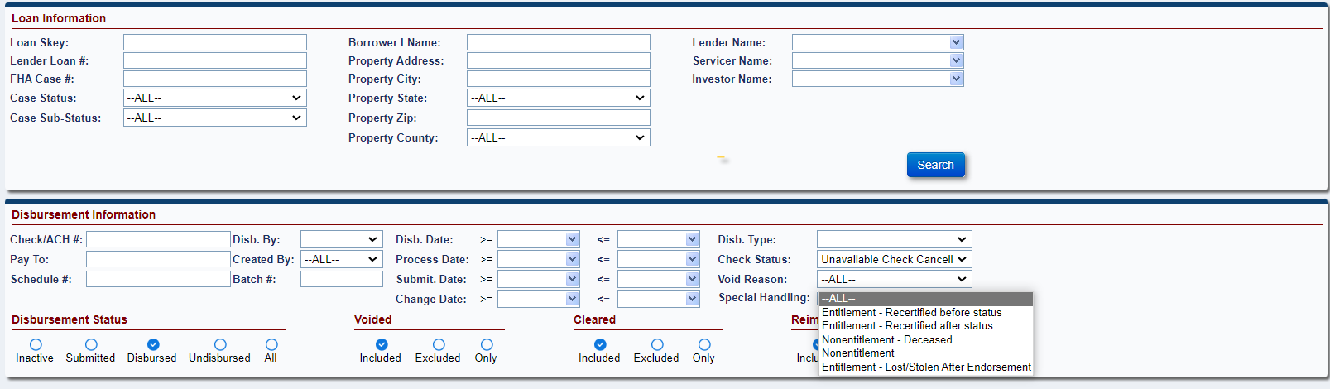
- When Check Status “Available Check Cancellation (Returned)” is selected the Void Reason “Returned to Treasury” will display in the Void Reason dropdown.
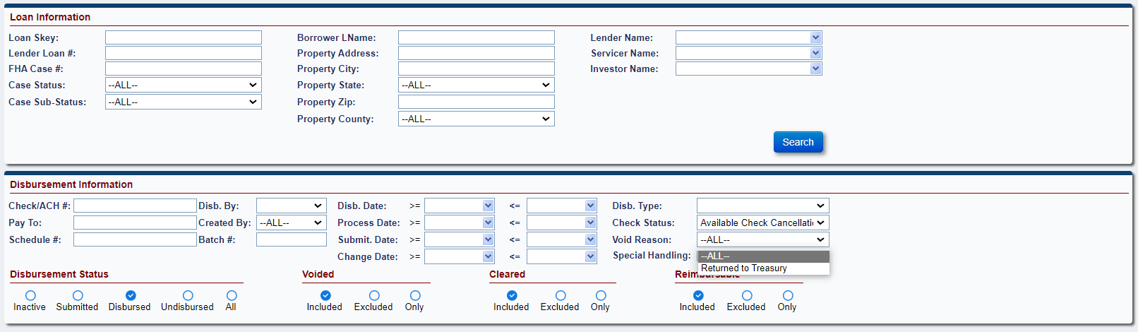
- When Check Status “Limited Pay Cancellation (stale dated, 14th month)” is selected the Void Reason “Stale Dated Check” will display in the Void Reason dropdown.
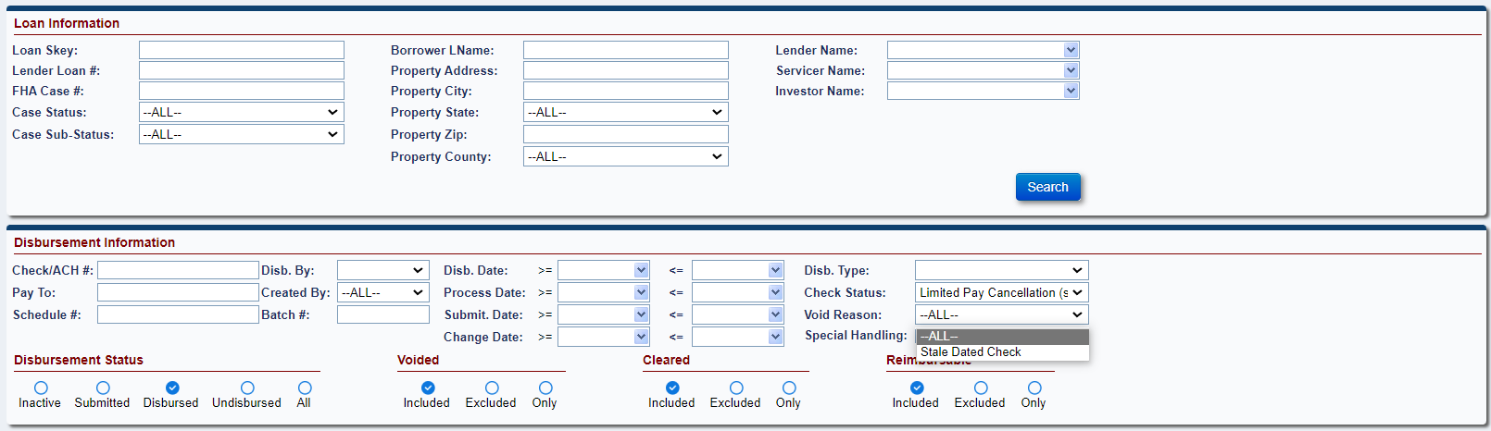
- When Check Status “ACH/Check Cancellation by user” is selected the following Void Reasons will display in the Void Reason dropdown:
- Incorrect Account/Routing Information
- Deceased
- Agency Hold/Agency Req
- Miscellaneous/ Other
- Checks with Corresp
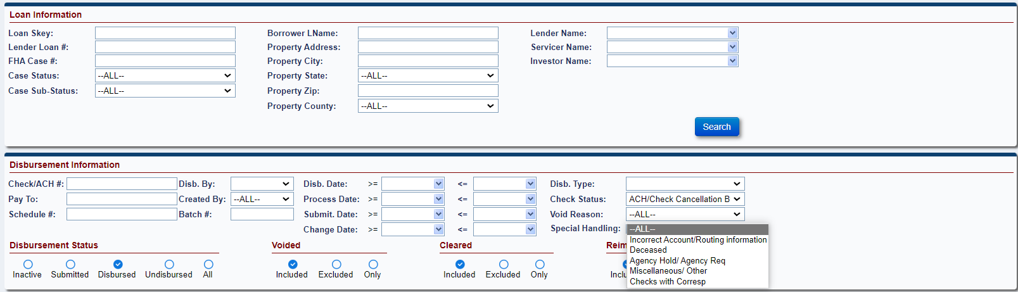
- When the HUD NSC Manager Voids an ACH Disbursement by checking the Void checkbox, a Void Reason dropdown will display allowing the user to select the Void Reason. Void Reason dropdown options are stated above.
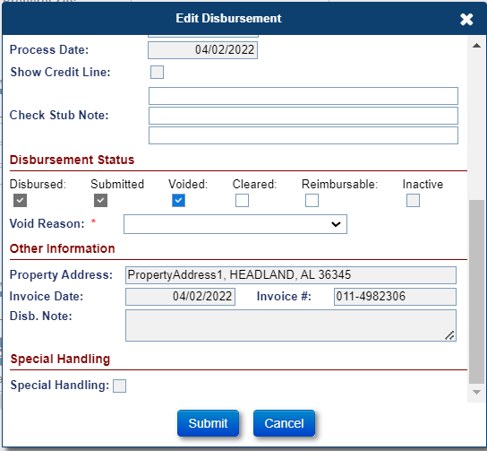
- An Auto Note will be added to the Notes screen when a Disbursement is Voided either through the UI or TCIS. Message states: “Void – {Transaction Description} in the amount of {Amount} authorized on {Disbursement Submitted} – {Void Reason}
- Example: Void – Disb – LOC – Property Charge – Ground Rent in the amount of ($400.00) authorized on 03/08/2023 – Agency Hold/ Agency Req

Add Change Date range to Accounting > Disbursement Search Criteria. (581792)
The Change Date range has been added to the Accounting > Disbursement search page, permitting the user to search by specific Change Dates. Change Date previously existed in the system but will now be searchable in the screen.

Add Note field to Accounting > Transmittals, Batch Details page for failed batches. (570448)
A note field has been added to the Accounting > Disbursements, Batch Details page. Going forward, the field will be automatically populated with the message received from Accounting Module on failed batches for Debit Vouchers. The field is not editable but can be viewed by authorized users.
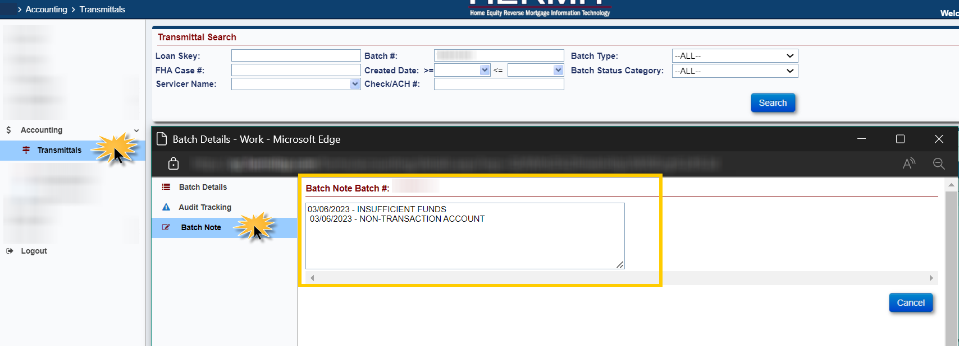

Reports: Indemnification Data (585014)
Indemnification Data will be sent to HERMIT from CHUMS on a daily basis. A new Indemnification Data report has been added under Management/ Budgetary section of the Reports page for authorized users to view Indemnification data.
The search criteria for this report includes the following:
- Mortgagee #
- FHA Case Number
- Date added to/updated in HERMIT (To & From)
The report results include the following:
- Loan Skey
- FHA Case No
- Case Status
- Case Sub Status
- Claim Type (if applicable)
- Trans Date (if applicable)
- Trans Amt (if applicable)
- HERMIT Create Maint
  - This is the same date as in the Report Search criteria “Date Indemn Record created/changed/deleted”: it is the later of the date the record was created or changed in HERMIT
- Create Date - from CHUMS Indem data
- Update Date - from CHUMS Indem data
- Delete Date - from CHUMS Indem data
- Expiration Date - from CHUMS Indem data
- Endorse Date - from CHUMS Indem data
- Indem Term - from CHUMS Indem data
- Bill Mortgagee - from CHUMS Indem data
- Mortgagee Name - Servicer Name of CHUMS Bill Mortgagee ID
- Servicer Name – Current servicer in HERMIT
- Agree Date - from CHUMS Indem data
- QAD file No - from CHUMS Indem data
- Docket No - from CHUMS Indem data
- Status Field - Values: I, A, X
  - Set I for Inactive or Deleted Records
  - Set X for Active records and Expiration Date is in the past / already expired
  - Set A when Expiration Date is in the future / not expired yet

