Rents disappear when users do not go to OCAF/Final review tab before executing Rent Adjustments (RA).
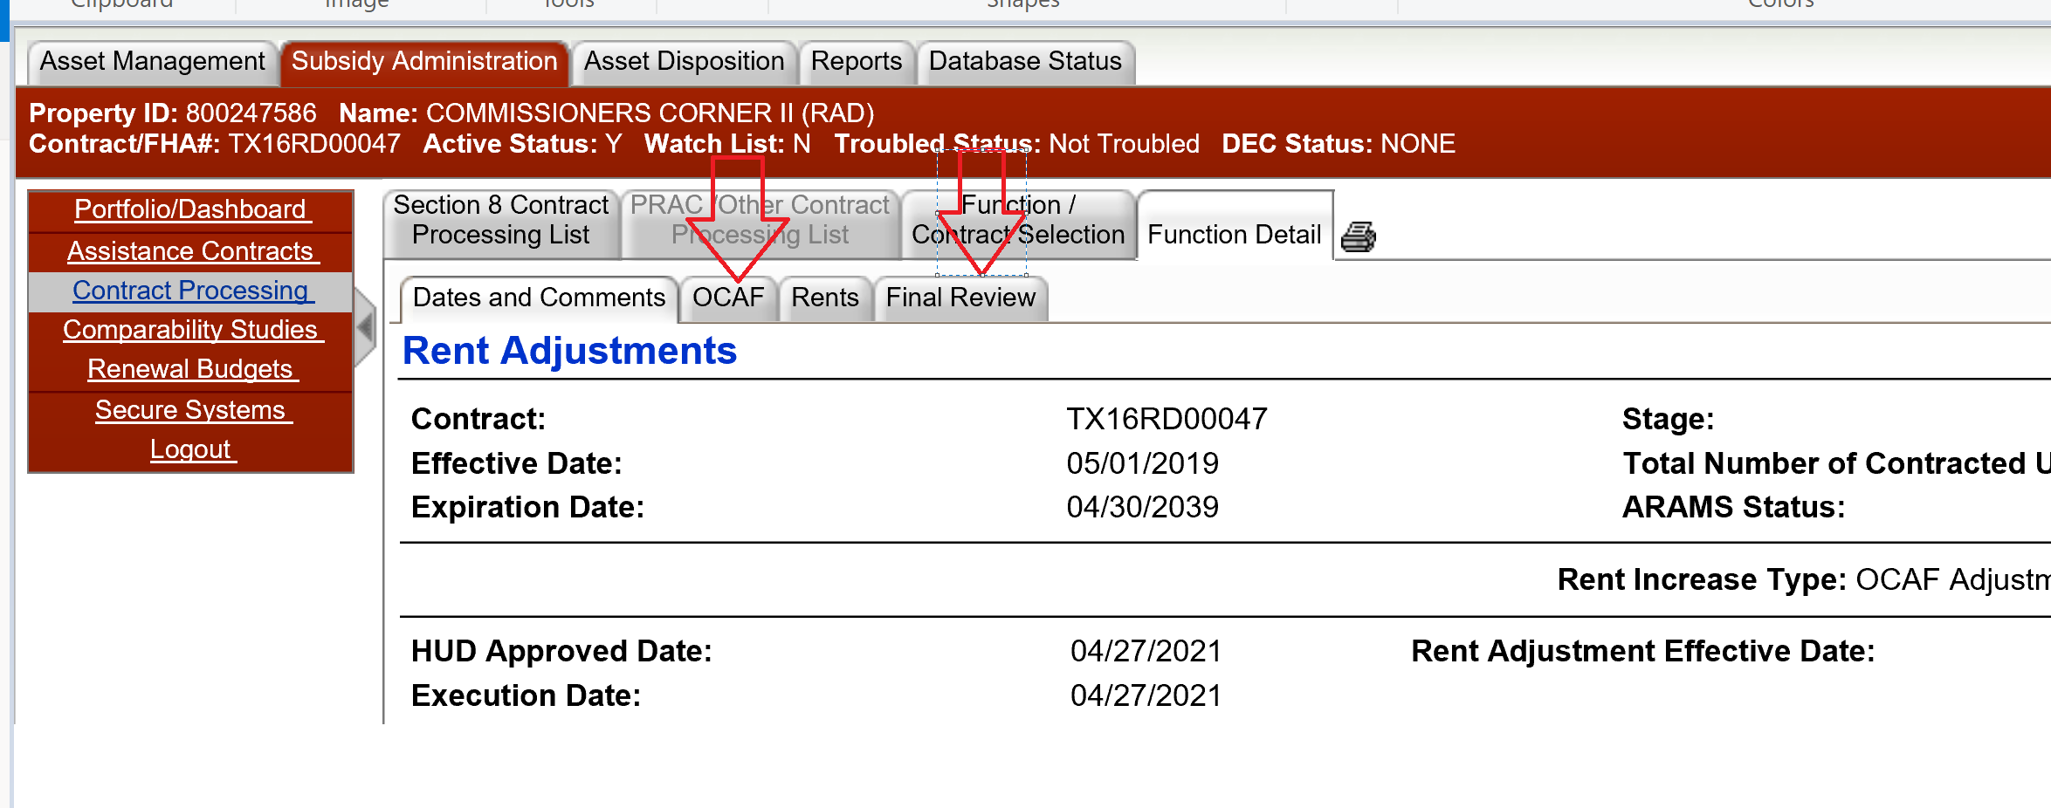
If the user had to update the dates in 'Function/Contract Selection' tab just before executing, they should either go to OCAF/Final Review tab to review or click Save on Rents tab before performing execute.
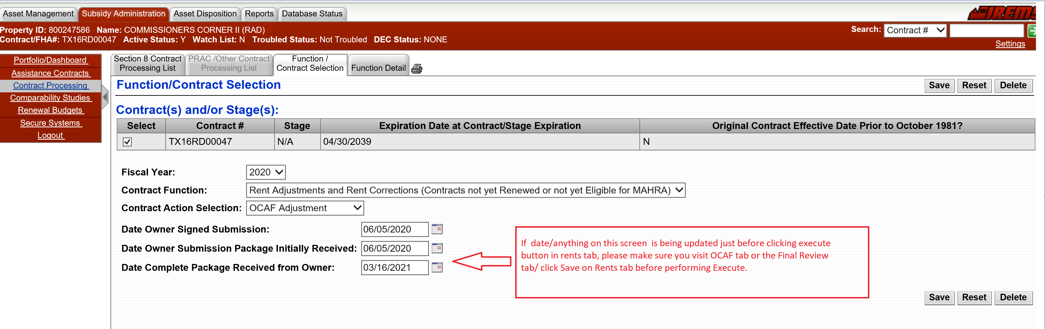
In simple terms, before you execute the rents please do below
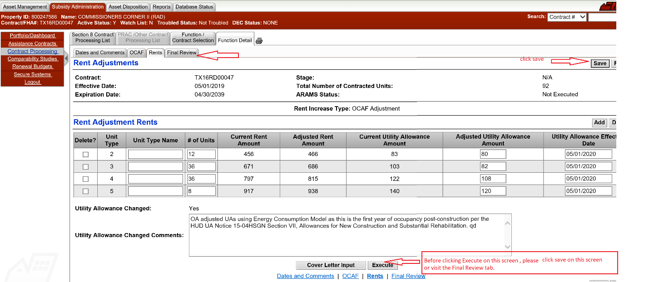

If for some reason, the sequence is not followed and iREMS Team unlocks the rent adjustment, please click delete from function/contract tab and start over.
