
United States Department of Housing and Urban Development

Home Equity Conversion Mortgage Business Service Provider (HECM BSP)

Servicer & NSC B2G File Format and Layout
For HECM HUD Systems
And HERMIT/P271

HERMIT Release 7.5

Document Version 1.0

January 26, 2024
Revision History

COPIES CONTROLLED BY: Configuration Management

Version | Date | Revision Description | Author
1.0 | 01/26//2024 | Initial release | HECM BSP

Table of Contents

1 General Information 5
1.1 Purpose and Scope 5
1.2 Contents 5
1.3 Points of Contact 5
1.4 Acronyms 6
1.5 Security Controls 6
2 Technical specifications 7
2.1 HUD Disbursements 7
2.1.1 Upload File Requirements 7
2.1.2 HUD Disbursement Import – Record Layout 9
2.1.3 HUD Disbursement Import Transaction Codes and Descriptions 11
2.1.4 HUD Disbursements Import File layout 11
3 Quality Control and Verification 12
3.1 File Verification 12

List of Tables

Table 1: HERMIT System Support Points of Contact 6
Table 2: HERMIT Program Organization Points of Contact 6
Table 3: Acronyms, Abbreviations, System Names/Codes 6
Table 4: HECM File Upload Types 9
Table 5: Data Item Descriptions for File HUDDisbursementImport 9
Table 6: Transaction Codes and Descriptions 11

List of Figures
Figure 1: NSC Batch Left Menu 7
Figure 2: Servicer Batch Left Menu 7
Figure 3: HERMIT Upload Screen 8
Figure 4: File Processing In HERMIT 8
Figure 5: HUD Disbursements File 11

General Information
This document serves as a reference for authorized users in the HERMIT application who are responsible for enabling the functionality to upload data to the Home Equity Reverse Mortgage Information Technology (HERMIT) system. The specification describes the file layouts and outlines the upload processes a Servicer and HUD may consider.
This document is organized to provide:
- General information
- Technical specifications for upload
- Quality control and verification
- HERMIT – system categorization

Purpose and Scope
The function of this document is to define and describe the data upload process into the HERMIT system. This document specifies the file record layout required for the upload of loan-level HECM data to the HERMIT system.

Contents
The data upload process described in this document comprises the method and data elements involved in the data upload into the HERMIT system. The specifications presented are:
- Define the requirements, design, procedures, and other relevant characteristics required for data uploads to HERMIT.
- Provide the syntax rules (file formats) and the semantic conventions (names, meanings, and physical units) used to upload data into the HERMIT system.
Note: Please be advised that this is the current up to date Servicer & NSC B2G File Layout document. It is imminent that changes will be made to the Servicer & NSC B2G File Layout document in the future when system changes are made. When those system changes are prioritized for release by HUD, this document will be updated and distributed per direction from HUD.

Points of Contact
Questions about specifications within this document should be directed to the servicingsupport@hermitsp.com email address. The key points of contact for the HERMIT system are displayed below for escalation purposes.
Table 1: HERMIT System Support Points of Contact
Function | Name | Phone | E-mail Address
HERMIT Help Desk | HERMIT Help Desk | 561-899-2610 | servicingsupport@hermitsp.com

Table 2: HERMIT Program Organization Points of Contact

Function | Name | Phone | E-mail Address
NSC SME | Theresa Coffman | 918-292-8965 | Theresa.J.Coffman@hud.gov

Acronyms
Table 3: Acronyms, Abbreviations, System Names/Codes
Acronym/Abbreviation/System Name | Definition
FHA | Federal Housing Administration
B2G | Business To Government
HECM | Home Equity Conversion Mortgage
HERMIT | Home Equity Reverse Mortgage Information Technology
HUD | U.S. Department of Housing and Urban Development
HECM SP | Home Equity Conversion Mortgage Service Provider
.csv | Comma Separated Values File extension
.txt | Flat Text File extension
Seq. # | Sequence Number

Security Controls
HERMIT system security is under the ownership, operation, and maintenance of an external service provider, HECM BSP. It follows the guidance and directives of the HUD Technical Reference Model, Federal Security Standard: NIST Special Publication 800-53 Revision 4, and HUD Handbook 2400.25 Information Technology Security Policy.

Technical specifications
The location of the HUD Disbursement page is displayed as follows, based on User Role. HUD NSC Manager (Figure 1). Servicer manager (Figure 2).
- HUD Disbursements
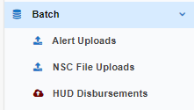
Figure 1: NSC Batch Left Menu

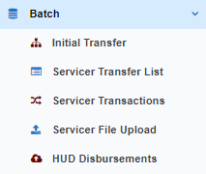
Figure 2: Servicer Batch Left Menu

This section documents the method of upload and the file requirements for each upload type. This section also addresses the data transfer process and operational requirements. A sample record layout for each upload file type can be found in each section.

HUD Disbursements
HUD Disbursements: There is one upload type that can be used to update loan-level data from this page.
- HUD Disbursements

Upload File Requirements
This section documents the record layout requirements used to generate a file that will successfully upload HUD Disbursements to the HERMIT system. Below is a view of the HERMIT HUD Disbursements Screen. It allows the authorized user to browse their internal sources for HECM data to retrieve the various files to be uploaded for the day. Once a file is selected using the Choose File button, the authorized user clicks the Upload button for immediate processing of the file into HERMIT. The user would repeat this process for each file type as needed.
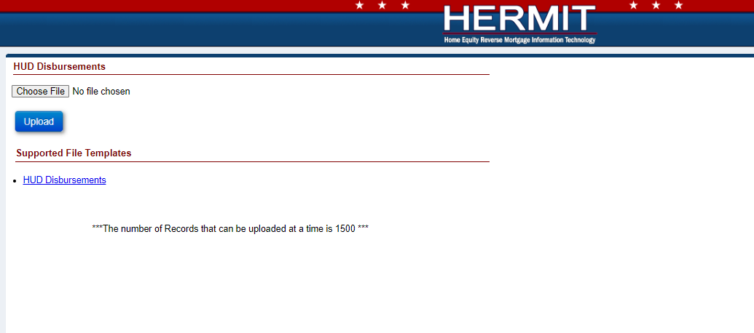
Figure 3: HERMIT Upload Screen

Each file may contain up to 1,500 records. The processing time to upload a file containing up to 1,500 records will normally take a few minutes. If there are any posting errors, the user will be notified during the process. The upload is deemed to be complete when the user is notified via a success or failure message on the screen. The message consists of three types of notifications:
- Error records
- Warnings/success records
- Success records
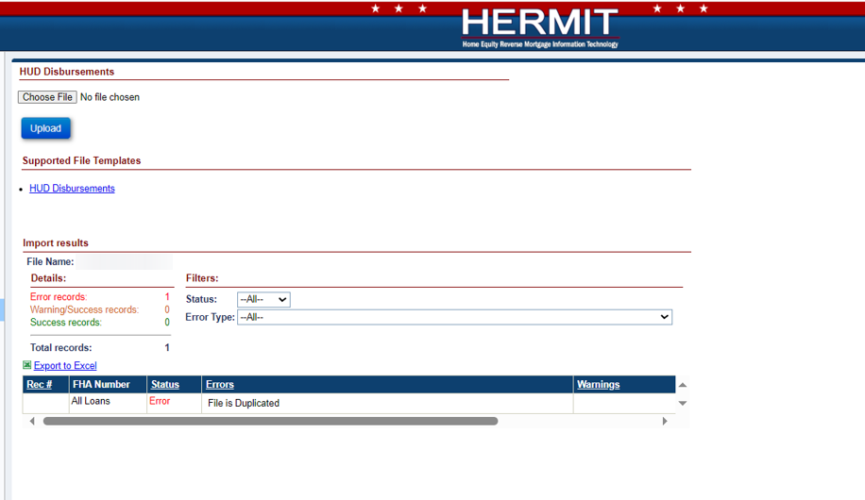
Figure 4: File Processing In HERMIT
File name and type:
- Any file name may be used, there are no naming requirements.
- A flat Text (Tab delimited) file is required. The valid file extension is .txt
- Each row must contain only one record.
Frequency of upload file:
There is no restriction on the number of files uploaded on a given day. File layout examples can be found in each section.
The Servicing Module provides a feature to allow a Servicer and HUD to upload a volume of transactions for the following activities in Table 4.
Table 4: HECM File Upload Types
File Upload Type | Description
HUD Disbursements | Is used to inform HERMIT of all HUD Borrower Disbursements

Data formatting:
Dashes (-) and decimal points (.) are permitted within the upload file; no other special characters or symbols should be present.
File Header Description:
The first row of each file must contain the file type identifier. No other header row or header information is permitted. The presence of any other header information will result in file upload failure.
The valid file type identifier is as follows:
- “HUDDisbursementImport”

HUD Disbursement Import – Record Layout
This table describes the required data elements, formats and their sequence within the file.
Table 5: Data Item Descriptions for File HUDDisbursementImport
File Type Identifier: VendorDisbursementImport
Data Item | Description | Format/Range of Values | Required | Seq. #
FHA Case # | FHA case number | Numeric(10); | Yes | 1
Pay Plan Type | Type of Payment Plan | Informational | NO | 2
Transaction Code | Transaction Description | String(4);  See Table 8 for Transaction Codes and Description reference; | Yes | 3
Disbursement Amount | The Amount of the Disbursement | Integer followed by decimal (2);  Must be > 0.00 and <= $1,000,000 | Yes | 6
Payment Method | Payment Method | String(1);  ‘A’ = ACH  ‘C’ = Check | NO | 11
ABA Routing # | Bank Routing # | String(9); Must be 9 digits. | Conditional; if Payment Method is AC | 12
Account # | Bank Account # | String(30); | Conditional; if Payment Method is ACH | 13
Confirm Account # | Confirm Bank Account # by entering same as Bank Account # | String(30); Must match Account # | Conditional; if Payment Method is ACH; if Account # is added | 14
Account Type | Account Type | String(1);  Checking  Savings | Conditional; if Payment Method is ACH; if Account # is added | 15
Mailing Address 1 | Mailing Address 1 | String(60); | YES | 16
Mailing Address 2 | Mailing Address 2 | String(60); | NO | 17
Mailing City | Mailing City | String(50); | YES | 18
Mailing State | Mailing State | String(2); | YES | 19
Mailing Zip | Mailing Zip Code | String(9); | YES | 20

HUD Disbursement Import Transaction Codes and Descriptions

Table 6: Transaction Codes and Descriptions
Category | Transaction Code | Transaction Category | Transaction Description Name | Transaction Description
Disbursement
 | 1250 | Disb –Scheduled | Disb – Scheduled | This transaction is initiated by the Servicer or HUD to add a Borrower Disbursement for Scheduled payments.
 | 1350 | Disb – Unscheduled from LOC | Disb – Unscheduled from LOC | This transaction is initiated by the Servicer or HUD to add a Borrower Disbursement for Unscheduled from LOC.
 | 2211 | Corp Advance – Penalty | Corp Adv – Penalty | This transaction is initiated by the Servicer or HUD to add a Borrower Disbursement for Corp Advance – Penalty.

HUD Disbursements Import File layout
This embedded template can be used as a guide for creating the upload file. It can also be found on the upload screen within HERMIT.
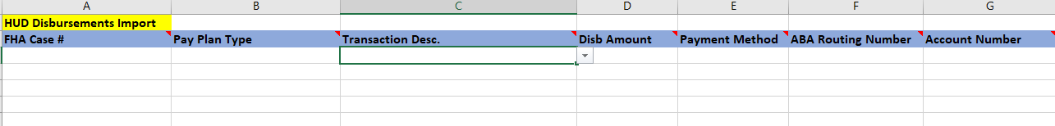
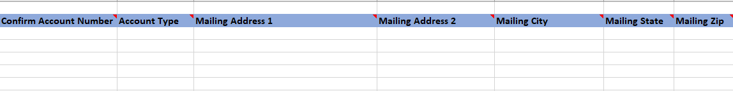
Figure 5: HUD Disbursements File

Quality Control and Verification

File Verification
HECM files uploaded to HERMIT must pass multiple levels of validation to ensure the following:
- File extension
- Record layout aligns to file type identifier.
- Data contained in the file is valid and formatted correctly for each expected data item.
- A value is provided for every data item defined.
In case of error due to file format validation, the upload process will be stopped, and an error message generated indicating the cause. If validation determines that individual records do not comply with business rules, data processing may continue, and a report will be generated listing those records. This report will detail:
- Warnings – An unexpected value is present, but record uploaded successfully.
- Errors – Record was found to be out of compliance with business rules and record was not uploaded.
All uploads will be immediately integrated and visible in HERMIT upon completion of a successful B2G upload. Any issues you encounter during the file upload process should be directed to HECM SP Help Desk – servicingsupport@hermitsp.com

