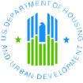 | North Carolina  Eviction Prevention Toolkit | 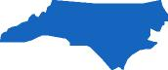
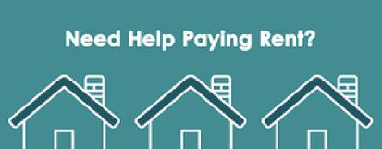
As the eviction moratorium comes to an end, thousands of North Carolina renters are finding themselves at risk of losing their home due to:


Inability to pay arrears rental payments

Increased rental rates

Resources to assist in the event of eviction:

Consumer Federal Protection Bureau (CFPB)
Allows renters and landlords to find rental assistance programs in their area.

Legal Aid of North Carolina
Legal Aid of North Carolina is a statewide, nonprofit law firm that provides free legal services in civil matters
to low-income people in order to ensure equal access to justice and to remove legal barriers to economic
opportunity.
Housing Helpline 1-877-201-6426
Monday – Thursday 8:30 AM – 1:30 PM
Apply Online 12:30pm – 4:00pm
Call for help with eviction, landlords refusing rental assistance (NC HOPE, etc.), mobile home evictions,
public and subsidized housing lease terminations, repairs and maintenance, and other landlord-tenant
issues.
Fair Housing
If you feel that you have been evicted on the basis of your: Race, Color, National Origin, Religion, Sex (including gender identity and sexual orientation), Familial Status, Disability, then we encourage you to file a fair housing complaint.
You can file a complaint with FHEO online in English or Spanish.
You can speak with an FHEO intake specialist by calling 1-800-669-9777 or 1-800-877-8339.

Did you know that HUD has affordable housing resources throughout the state of North Carolina?

- Rental Help: North Carolina

Subsidized Apartments
HUD helps apartment owners offer reduced rents to low-income tenants. To apply, contact or visit the
management office of each apartment building that interests you.
- Search for a subsidized apartment by clicking here.

Public Housing and Housing Choice Vouchers (Section 8)
To apply for either type of help, visit your local Public Housing Agency (PHA).
- Public Housing Authorities in North Carolina
  - Some PHAs have long waiting lists, so you may want to apply at more than one PHA. Your PHA can also give you a list of locations at which your voucher can be used.

Need Help Locating Housing and Other Resources?
- Contact a housing counseling agency
- HUD Resource Locator - search for HUD offices, public housing agencies, multifamily and public housing locations, and homeless coordinated entry system points of contacts.

Other North Carolina Resources:
Help with your utility bills
Find units for rent in rural North Carolina
Information for disabilities
Independent living centers - for seniors and people with disabilities
North Carolina Housing Finance Agency - resources for housing education and programs
SocialServe.com - find affordable rental housing
Search for Federal Tax Credit rental housing

