



Report to the Commissioner on Post Sale Reporting
Distressed Asset Stabilization Program

March 2017 REPORT

U.S. Department of Housing and Urban Development

Federal Housing Administration

BACKGROUND | DASP SERVICING REQUIREMENTS
HUD’s Distressed Asset Stabilization Program (DASP), introduced in 2012, is one of a suite of disposition options that aids in the Secretary’s fiduciary responsibility to ensure the Mutual Mortgage Insurance (MMI) fund remains financially sound. FHA can accept assignment and sell distressed mortgages at auction prior to a foreclosure sale, thereby avoiding the costly and potentially lengthy foreclosure process. This generates savings by avoiding claim, holding, and sales expenses that would be incurred through the REO program.  FHA servicers are required to evaluate all of the loss mitigation options that would lead to home retention prior to including the loan in a note sale, including mortgage modification, special forbearance, pre-foreclosure sale or a deed in lieu of foreclosure.  Selling the loans removes the requirements associated with FHA insurance and provides the Purchaser a wider range of loss mitigation options, and may offer Borrowers another chance at remaining in their homes. | - Loans must be serviced by a servicer that the Purchaser certifies is:  - Either an FHA-approved mortgagee or a Fannie Mae or Freddie Mac approved servicer; and  - In good standing and rated average or above by the agencies.  o For properties that are occupied Purchasers are not permitted to foreclose for at least 12 months absent extenuating circumstance.  o Purchasers are required to evaluate the Borrower for modifications, and principal forgiveness is one of the first options investors must consider offering to Borrowers.  - Purchasers are encouraged to offer specific payment shock protection: limiting interest rate increases to no more than 1% per year after a five-year period where the rate is fixed.  - Prohibitions designed to prevent Purchasers from “walking away” from vacant properties are included to help protect communities from blight.
POST-SALE REPORTING | HISTORICAL BID PRICES
- Note that in contrast with prior reports on HUD’s single family loan sales this report reflects only DASP transactions. Data on all pre-DASP sales has been removed from this report as the Purchasers have completed their required post-sale reporting.  - Post-sale reporting to HUD on Borrower outcomes and modification activity is required for four years after sale by Purchasers.  - HUD has continued its efforts to obtain better post-sale reporting data from Purchasers in order to provide clear, reliable and transparent reporting on Borrower outcomes. | EXHIBIT 1: AVERAGE BID BY FISCAL YEAR  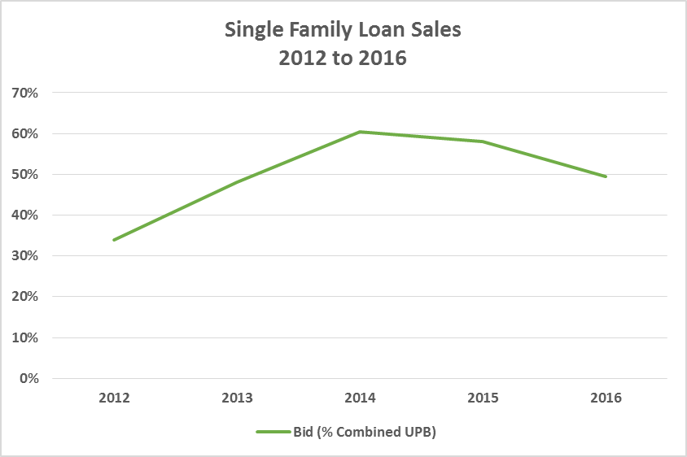  DASP bid prices have improved since DASP’s inception in 2012.
DASP UPDATE | DASP HIGHLIGHTS
- There has been one DASP sale since the last report. SFLS 2016-2 was held on September 14, 2016, and approximately 3,500 loans were sold in National pools and 2,900 loans were sold in NSO pools.  - A non-profit pilot was successfully introduced in SFLS 2016-2 whereby qualified non-profit organizations could select a “carve-out” pool of up to 5% of the assets in one of the National pools to bid on competitively versus other non-profit organizations. | - Of the DASP loans that have been resolved, approximately 16.5% are currently re-performing. This is up from 13.4% from the reporting period six months prior. The re-performance is primarily due to the Purchaser’s modification activity.  - Of the DASP loans that have been resolved, over 42.6% of them have avoided foreclosure. This is up from approximately 41.2% from the reporting period six months prior.

EXHIBIT 2: DASP NATIONAL OFFERINGS
Sale Name | Sale Date | Loan Count | Approximate UPB | Number of Pools
DISTRESSED ASSET STABILIZATION PROGRAM - NATIONAL
SFLS 2012-3 | 9/12/2012 | 3,257 | $599,380,589 | 6
SFLS 2013-1 | 3/20/2013 | 10,405 | $1,867,712,416 | 10
SFLS 2013-2 | 6/26/2013 | 13,177 | $2,033,081,967 | 14
SFLS 2014-1 (Part 1 & 2) | 10/30/2013 & 12/17/2013 | 17,201 | $3,029,135,481 | 23
SFLS 2014-2 (Part 1 & 2) | 6/11/2014 & 9/30/2014 | 27,527 | $4,536,417,833 | 26
SFLS 2015-1 | 7/16/2015 | 4,282 | $661,793,348 | 5
SFLS 2016-1 | 11/18/2015 | 3,157 | $427,588,142 | 5
SFLS 2016-2 | 9/14/2016 | 3,528 | $560,266,376 | 7
DASP National Total |  | 82,534 | $13,715,376,151 | 96
Note: Data as of January 24, 2017.
EXHIBIT 3: DASP NSO OFFERINGS

Sale Name | Sale Description | Sale Date | Loan Count | Approximate UPB | Number of Pools
DASP NEIGHBORHOOD STABILIZATION OUTCOME
SFLS 2012-3 | NSO - Chicago, Newark, Phoenix, Tampa | 9/27/2012 | 2,860 | $554,477,501 | 7
SFLS 2013-1 | NSO - Atlanta, Ohio, Orlando, Florida, California | 03/27/2013 | 3,284 | $522,807,467 | 5
SFLS 2013-2 | NSO - California, Ohio, North Carolina, Chicago | 07/10/2013 | 3,158 | $492,220,506 | 6
SFLS 2014-1 | NSO - Atlanta, California, Las Vegas, Indianapolis, Baltimore, Prince George County, Other | 12/19/2013 | 3,179 | $655,600,127 | 7
SFLS 2014-2, Part 1 | NSO - Atlanta, Chicago, Cumberland County, Detroit, Miami, Philadelphia, San Antonio, San Bernardino | 6/25/2014 | 3,319 | $543,176,203 | 10
SFLS 2014-2 Part 2 | NSO- Baltimore, New York, Texas, Florida, California, Philadelphia | 11/19/2014 | 3,517 | $662,116,329 | 15
SFLS 2015-1 | NSO- NJ Northern, NY Nassau Suffolk, Chicago, Baltimore, PA,DE,MD | 7/16/2015 | 1,498 | $342,938,149 | 7
SFLS 2016-1 | NSO - FL, NY, NJ, IL, IN, OH, PA, AL, GA, NC, TN, AZ, CO, ID, NM, NV, UT, CA, OR, WA, CT, ME, NH, RI, IA, KY, MO, LA, OK, TX, MI, MN, WI | 11/18/2015 | 2,630 | $472,434,740 | 18
SFLS 2016-2 | NSO: AL, AR, AZ, CA, CO, DE, FL, GA, IA, ID, IL, IN, KS, KY, LA, MD, MI, MN, MO, MS, NC, ND, NE, NJ, NM, NV, NY, OH, OK, OR, PA, SC, SD, TN, TX, VA, WA, WI | 9/14/2016 | 2,885 | $482,923,164 | 8
DASP NSO Total | NSO |  | 26,330 | $4,728,694,187 | 83
TOTAL | National and NSO (all DASP Sales) |  | 108,864 | $18,440,070,338 | 179
Notes:
1. This report only includes DASP transactions, which began with SFLS 2012-3. Data on all pre-DASP sales has been removed since the Purchasers have completed their required post-sale reporting.
2. The total number of loans captured in this report, 108,864, is up from 104,258, despite the exclusion of pre-DASP sales. This is primarily due to the inclusion of 2016-2 loans.
3. Data as of January 24, 2017.

Notes: Includes permanent and trial modifications from SFLS 2012-3 through 2016-1. Data as of January 24, 2017.

For SFLS 2012-3 through SFLS 2016-1 approximately 16% of the loans were modified by the Purchasers. Approximately 31% of the modified loans had a payment decrease of 40% or more. Over 66% of the modified loans had a payment decrease of 20% or more.

Notes:
1. Loan Modification Type data has not been provided in the updated reporting format by four of the Purchasers on approximately 1,022 loans representing 6% of the modified loan population. Therefore the Modification Type was classified in the “Other/Unknown” category for these loans.
2. Some of the loans in the “Other” category are Trial Modifications, although some Trial Modifications have modification types.
3. Includes permanent and trial modifications from SFLS 2012-3 through 2016-1. Data as of January 24, 2017.

For SFLS 2012-3 through SFLS 2016-1 approximately 16% of the loans were modified by the Purchasers. Most loans had multiple modification features. By far the most common modification feature was a Rate Reduction, used for 73% of the loans modified. Capitalization of Interest, Capitalization of Other Indebtedness and Term Extensions were also common modification types, and they were each used for approximately 60% - 62% of the loans modified.

EXHIBIT 6: LOAN POPULATIONS BY HISPANIC OR LATINO ORIGIN AND RACE

Demographic Characteristics |  | Insurance in Force |  | Defaulted Loans |  | DASP Sale Portfolio
RACE |  | Number | Percent | Number | Percent | Number | Percent
TOTAL POPULATION |  | 7,838,495 |  | 385,767 |  | 102,451
 | No Race Reported/ Unknown…...…………………………………………… | 850,958 |  | 42,955 |  | 11,712
RACE by HISPANIC OR LATINO ORIGIN |  | Number | Percent | Number | Percent | Number | Percent
TOTAL POPULATION (with Race Reported) |  | 6,987,537 | 100.0 | 342,812 | 100.0 | 90,739 | 100.0
HISPANIC OR LATINO
 | Total……………………………………………………………………………………. | 1,088,352 | 15.6 | 40,903 | 11.9 | 11,869 | 13.1
Race
One Race……………………………………………………………………. |  | 1,083,198 | 15.5 | 40,440 | 11.8 | 11,663 | 12.9
 | White………………………………………………………..………….. | 1,040,568 | 14.9 | 37,988 | 11.1 | 10,927 | 12.0
 | Black or African American……………………………………… | 17,083 | 0.2 | 1,274 | 0.4 | 310 | 0.3
 | American Indian and Alaska Native……………………….. | 14,289 | 0.2 | 660 | 0.2 | 155 | 0.2
 | Asian……………………………………………………………………… | 3,451 | 0.05 | 106 | 0.03 | 44 | 0.05
 | Native Hawaiian and Other Pacific Islander…………… | 7,807 | 0.1 | 412 | 0.1 | 227 | 0.3
Two or More Races……………………………………………….…… |  | 5,154 | 0.1 | 463 | 0.1 | 206 | 0.2
NOT HISPANIC OR LATINO
 | Total…………………………………………………………………………………… | 5,899,185 | 84.4 | 301,909 | 88.1 | 78,870 | 86.9
Race
One Race…………………………………………….…………………….. |  | 5,874,898 | 84.1 | 300,298 | 87.6 | 78,248 | 86.2
 | White……………………………………………………………………. | 4,618,513 | 66.1 | 200,005 | 58.3 | 57,272 | 63.1
 | Black or African American…………………………………….. | 1,024,061 | 14.7 | 92,888 | 27.1 | 18,602 | 20.5
 | American Indian and Alaska Native……………………… | 27,907 | 0.4 | 1,549 | 0.5 | 414 | 0.5
 | Asian……………………………………………………………………… | 165,306 | 2.4 | 3,998 | 1.2 | 1,173 | 1.3
 | Native Hawaiian and Other Pacific Islander…………… | 39,111 | 0.6 | 1,858 | 0.5 | 787 | 0.9
Two or More Races……………………………………..…………….. |  | 24,287 | 0.3 | 1,611 | 0.5 | 622 | 0.7
Notes: The Exhibit above compares the demographic data from the Single Family 203(b) Insurance in Force (IIF) loans and IIF loans that were 90+ days delinquent as of September 2016, and available data for the DASP Sale Portfolio for SFLS 2012-3 through 2016-1. Co-borrower data was not included.
EXHIBIT 7: PORTFOLIO METRICS FOR DASP SALES
Portfolio by Foreclosure Law Type  Based on data from HUD’s Conveyance (REO) Program, in judicial foreclosure states the average time to foreclosure was approximately 10 months longer than in non-judicial foreclosure states. Thus, holding period times and holding costs are greater in the states where a majority of the loans sold are located.  For example, on the top four states comprising approximately 43% of the sale portfolio, average times to foreclosure were: Florida- 55 months, New Jersey- 56 months, Illinois- 42 months, and New York- 56 months. | Portfolio by Occupancy Type  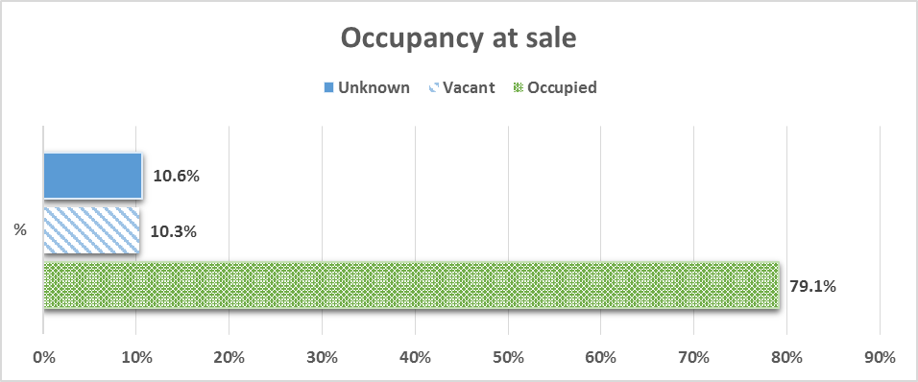
Portfolio by Status Outcome  Notes: Data as of January 24, 2017. The Foreclosure Avoided loans are comprised of loans in the following status outcome categories: Re-Performing; Forbearance; Paid in Full/Short Payoff; Short Sale and Deed-in Lieu. | Portfolio by Purchaser Profile  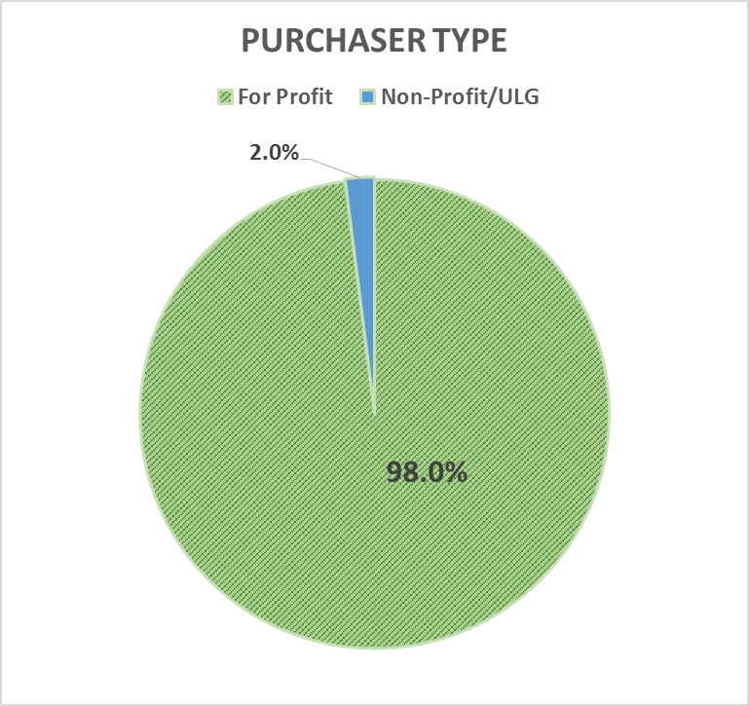  Note: Population includes both competitive DASP Sales (108,864) and Direct Sales (750), unlike other charts and tables within this report. Data as of January 24, 2017.
Unless otherwise noted data includes DASP Sales from SFLS 2012-3 through SFLS 2016-1.

Notes: The Exhibit above includes loans from SFLS 2012-3 through SFLS 2016-2. Data as of January 24, 2017.

EXHIBIT 9: DASP PURCHASERS
DASP National Pools
Purchaser | Count | UPB | Percentage of Total
Bayview Asset Management | 18,544 | $3,221,675,530 | 22%
Lone Star Funds | 18,000 | $3,098,159,180 | 22%
Angelo, Gordon & Co., L.P. | 6,633 | $1,061,677,583 | 8%
Selene Residential Partners | 6,388 | $1,025,041,890 | 8%
RBS Financial Products Inc | 5,489 | $955,634,250 | 7%
Kondaur Capital Corporation | 3,515 | $492,995,539 | 4%
Neuberger Berman - PRMF | 3,167 | $603,911,167 | 4%
One William Street Capital Management | 2,853 | $460,318,259 | 3%
OHA Newbury Ventures, LLC/MCM | 2,618 | $412,873,223 | 3%
Varde Management, L.P / V Mortgage, LLC | 2,445 | $365,089,267 | 3%
Credit Suisse /DLJ Mortgage Capital | 2,214 | $314,153,812 | 3%
Altisource Residential Corporation | 1,966 | $307,418,583 | 2%
Rushmore Loan Management Service LLC | 1,944 | $296,440,521 | 2%
25 Capital Partners | 1,895 | $332,455,256 | 2%
PIMCO/LVS | 1,536 | $231,653,890 | 2%
Others | 3,327 | $535,878,202 | 4%
National Total | 82,534 | $13,715,376,151 | 100%
NSO Pools
Purchaser | Count | UPB | Percentage of Total
Bayview Asset Management | 12,752 | $2,398,422,539 | 48%
Oaktree Capital Management/DC Residential | 4,762 | $806,158,977 | 18%
The Corona Group | 3,191 | $654,331,071 | 12%
25 Capital Partners | 2,339 | $399,774,588 | 9%
Pretium Mortgage Credit Management, LLC | 1092 | $150,253,336 | 4%
MRF (Non-profit) | 970 | $131,414,729 | 4%
Kondaur Capital Corporation | 549 | $66,933,715 | 2%
Community Loan Fund of New Jersey, Inc. (Non-profit) | 352 | $76,321,821 | 1%
Hogar Hispano, Inc (Non-profit) | 162 | $27,155,687 | 1%
Altisource Residential Corporation | 135 | $15,210,744 | 1%
AMIP Management, LLC | 26 | $2,716,978 | 0%
NSO Total | 26,330 | 4,728,694,187 | 100%
Overall Total | 108,864 | 18,444,070,338 | 100%
Notes: The Exhibit above includes loans from SFLS 2012-3 through SFLS 2016-2. The loan counts for the more recent transactions continue to be subject to change as the final Post-Sale Reporting and settlement data becomes available, and any repurchases under the representations and warranties are finalized. Data as of January 24, 2017.
EXHIBIT 10: LOAN STATUS OUTCOMES – DASP PORTFOLIO
Category | Count | Percentage of Loans Sold | Percentage of Resolved Loans
RESOLVED
Foreclosure Avoided
Total Re-Performing | 11,107 | 12.81% | 16.53%
Re-Performing with Loan Modification | 10,353 | 11.94% | 15.40%
Re-Performing - Other | 754 | 0.87% | 1.12%
Forbearance | 224 | 0.26% | 0.33%
Paid in Full/Short Payoff | 1,147 | 1.32% | 1.71%
Short Sale | 8,599 | 9.92% | 12.79%
Deed-in-Lieu | 7,555 | 8.71% | 11.24%
Total Foreclosure Avoided | 28,632 | 33.03% | 42.60%
Foreclosure | 36,711 | 42.34% | 54.62%
Held For Rental | 1,870 | 2.16% | 2.78%
Total Resolved Outcomes | 67,213 | 77.53% | 100.00%
NOT YET RESOLVED
Delinquent Servicing | 19,483 | 22.47%
Total Loans Sold | 86,696 | 100.00%
Notes:
1. Data includes loans for SFLS 2012-3 through 2016-1, and represents post-sale reports received through January 24, 2017. Post-sale reporting on SFLS 2016-2 was not yet due at the time of this report.
2. An additional 15,755 loans which were reported as being sold in whole loan sales, charged off or the status was unknown based on the post-sale reporting are excluded from this Exhibit since no current outcome data is available at this time.
3. For further detail on Loan Status Outcomes for individual sale and pools, see the HUD Library Appendices. The link is provided below.

Only loans headed to foreclosure after all FHA prescribed loss mitigation efforts have failed are eligible for DASP sales, and the loans are on average approximately two and a half years delinquent at the time of settlement. The DASP provides an alternative to nearly assured foreclosure by offering homeowners a second chance to keep their home.

STATUS OUTCOME DATA: Loans may change from one status category to another over time even if they were previously reported in a “resolved” category. The most recently reported status category provided is utilized for Exhibits 7 and 10 in this Report. The reasons for status changes include the following:
- Whole Loan Sales (WLS): The data on loans that purchasers report as whole loan sale loans is considered missing for the purposes of the status outcomes since the current status is not known. In later sales reporting is required to continue for the required period even after loans are sold.
- Re-Performing and Forbearance Loans: Re-Performing loans and loans in Forbearance are categorized as resolved loans. However they could revert to Delinquent Servicing, become Re-Performing and/or move to other status categories depending on future activities.
- Held for Rental Loans: Some assets in this status category may have been previously reported in the Deed in Lieu or Foreclosure categories, or may change to those categories if the properties are no longer Held for Rental.
- Other Revisions: Status reporting for some assets may change from one reporting period to the next based on a more thorough review of the loans by the Purchaser, a better understanding of the definition of the status categories, or minor changes to the manner in which loans are categorized based on feedback from Purchasers.

EXHIBIT 11: GLOSSARY OF TERMS
Term | Definition
Borrower | A borrower whose mortgage loan was sold through HUD’s SFLS-DASP sales.
Charge-Off | The Purchaser has written off the mortgage as uncollectible or bad debt.
Deed-in-Lieu | A Borrower willingly conveys property to the new servicer in lieu of undergoing foreclosure proceedings.
Delinquent Servicing | Loans that remain delinquent that the purchaser continues to actively service.
Forbearance | A Borrower and new servicer enter into an agreement whereby all or a portion of the Borrower’s debt service obligations are suspended temporarily. This agreement delays foreclosure and provides Borrowers with an opportunity to recover from a short-term financial issue.
Foreclosure | The servicer undergoes legal proceedings to take control of the property which serves as security for the FHA-insured mortgage. This includes instances where the property is sold at the foreclosure sale.
Foreclosure Avoided | The Foreclosure Avoided loans are comprised of loans in the following status outcome categories: Re-Performing; Forbearance; Paid in Full/Short Payoff; Short Sale and Deed-in Lieu.
Held for Rental | The Purchaser has acquired REO via a deed-in-lieu or foreclosure, then offers the property for rent.
Paid in Full | A Borrower repays the entire remaining principal balance on a loan, often via a refinancing transaction.
Purchaser | An entity who purchased mortgage loans through HUD’s SFLS-DASP sales.
Re-Performing | Loans are considered Re-Performing only if there have been six consecutive on-time payments at the time of the current reporting period. The mortgage may or may not have been modified through a permanent or trial modification.
Re-Performing with Loan Modification | Loans are considered Re-Performing only if there have been six consecutive on-time payments at the time of the current reporting period. The loan has been modified through a permanent or trial modification since the Purchaser took ownership of the loan.
Re-Performing Other | Loans are considered Re-Performing only if there have been six consecutive on-time payments at the time of the current reporting period. The loan does not appear to have been modified by the Purchaser.
Repurchase | The Purchaser has put the loan back to FHA due to a breach of the representations and warranties included in the sale agreement.
Resolved Loans | All loans not reported as delinquent servicing, whole loan sale loans or charge offs, including re-performing loans which notably may be reported in delinquent servicing in future reporting cycles in the event of future missed payments.
Short Payoff | The Borrower repays a portion of the remaining principal balance, the remainder of which is written off by the Purchaser.
Short Sale | The Purchaser and/or Borrower arrange the sale of a property to a third party, allowing the borrower to leave the home and avoid foreclosure proceedings.
Whole Loan Sale | The Purchaser sells the mortgage to another entity, and the current underlying reporting status category is unknown.

EXHIBIT 12: NOTES ON THE REPORT POPULATION
Cause | Explanation
New Transactions | New transactions are added to various Exhibits in the Report as they occur, and important notes on the population captured in each Exhibit are provided in the notes to the Exhibit.  Post-sale reporting data on a new sale is added to the Portfolio Metrics, Status Outcome and Modification Exhibits as it is received. The post-sale reporting begins a few months after the settlements have been completed and the servicing has been transferred.
Final Settlement | The population for the more recent transactions are subject to change as the final post-sale reporting and settlement data becomes available. Not all loans that were offered for sale reach final settlement and have the servicing transferred because they may become ineligible.
Repurchases | Some repurchases may occur under the representations and warranties for more recent sales.

The overall population in the Report and in the Exhibits change over time for a variety of reasons including those listed in the Exhibit above. SFLS 2016-2 was added since the last Commissioner’s Report dated October 2016, but post-sale reporting data had not yet been received at the time of the cut-off date for this Report.

HUD LIBRARY APPENDICES

The HUD Library Appendices, dated as of January 24, 2017, have been prepared as separate series of data tables that accompany this Report, and it contains both sale level and pool level data on each of the HUD DASP loan sales. It includes date on borrower outcomes, NSO status and geographic and demographic information on the loans included in each transaction. The HUD Library Appendices can be found at
http://portal.hud.gov/hudportal/documents/huddoc?id=comreport.docx​

There are 2,055 Pre-DASP loans, less than 2% of the loans previously reported, that are no longer included in this report. Given the small size of this population the impact on the data is minimal.
The re-performance rate of 13.13% for resolved loans reported in the last Commissioner’s Report dated October 2016 included the 2,055 pre-DASP loans.
The foreclosure avoidance rate of 41.48% for resolved loan reported in the last Commissioner’s Report also included the pre-DASP loans.

